Flower Expeditions


A Hiker’s Guide to the Common Flowers of the
Santa Monica Mountain Range

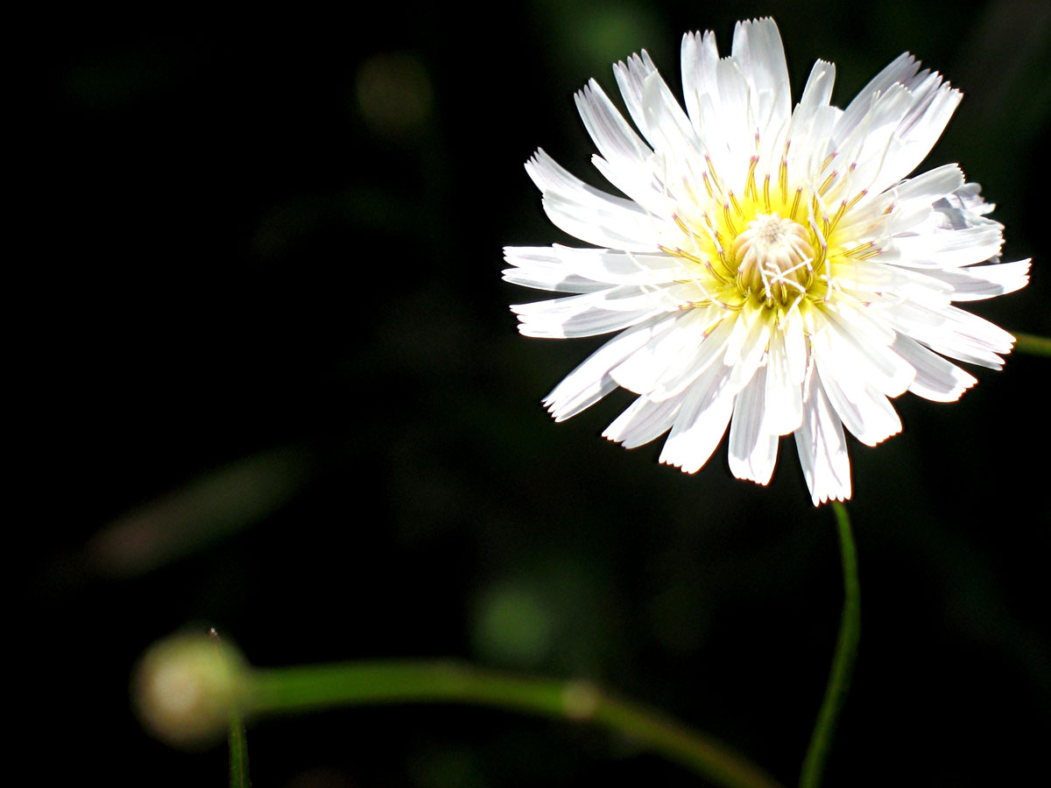

Photography and Editing by Julie Brett

To Mom and Dad

Acknowledgements

This field guide was helped along its path with the expertise of a few lovely people. Thank you to Keith Lombardo, the Director of the Southern CA Research Learning Center who kindly checked over each common and scientific flower name I’ve presented here; Mary Montes, Treasurer of the Santa Monica Chapter of the California Native Plant Society who gave her advice and recommendations; and Pauline Geisler who connected me with folks in the California State Park System.

Contents

Introduction iii

Yellow Flowers 1
White Flowers 48
Red Flowers 117
Blue Flowers 157
Invasive and Naturalized Flowers 191

Index 231

Introduction

My fascination with the flowers of the Santa Monica Mountain Range began as an avid hiker, exploring the back hills of Los Angeles. I can still remember taking my first flower photo in the Santa Susana Pass, not yet realizing how it would launch me into a decade-long passion.
From afar, it was a sprawling shrub with white, bulb-ish flowers. Up close, it was a cluster of delicate blossoms intertwining into the head of California Buckwheat:

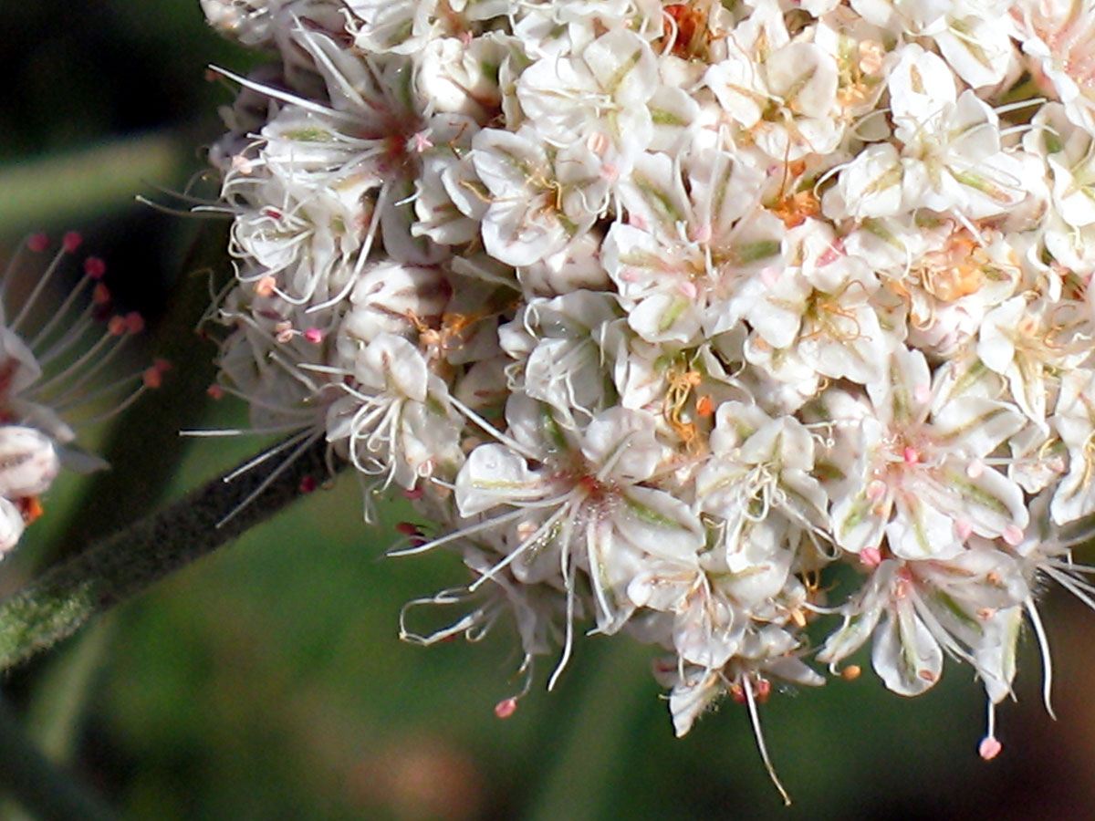

As I began taking more photographs, I discovered even greater surprises. Plants I once thought weeds, were actually fireworks of delight. For example, plain Black Mustard:

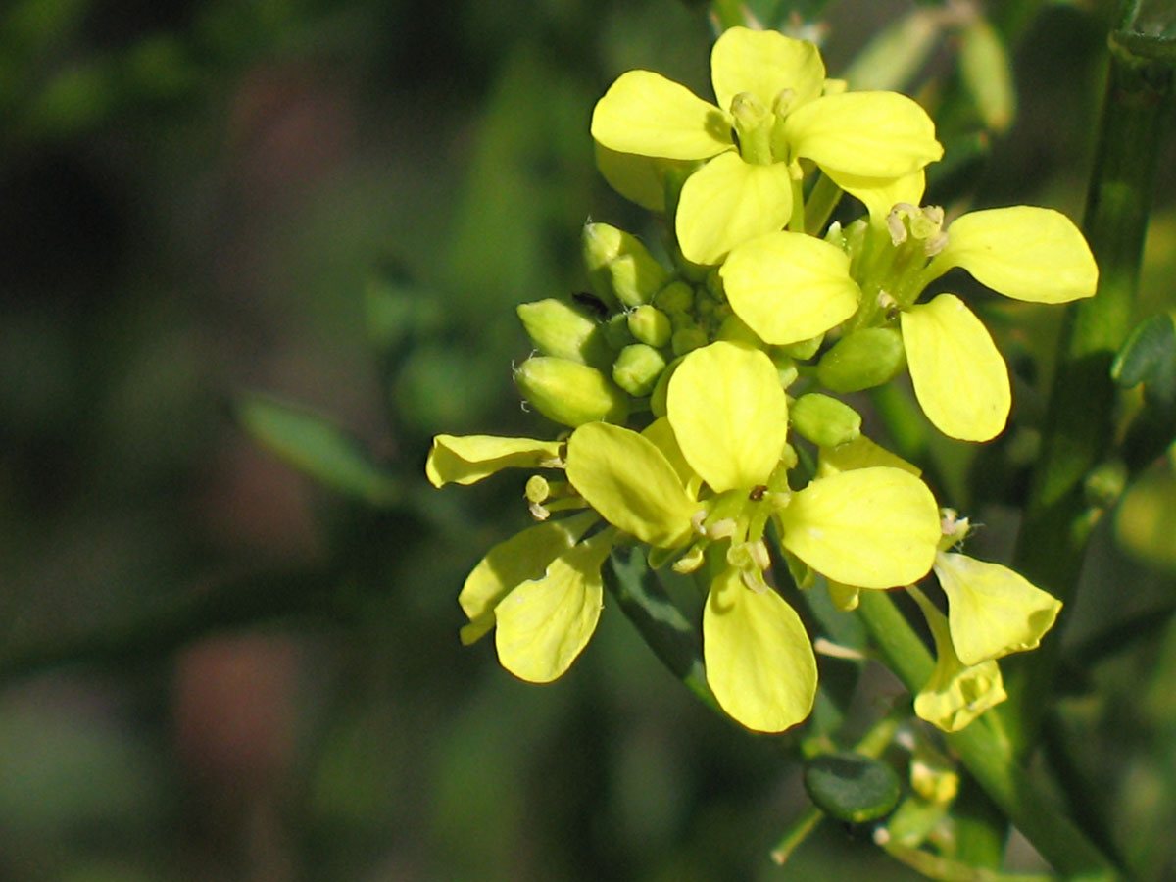

After each “flower expedition,” as I took to calling my hikes, I would take my photographs to the library for identification. That’s where I learned how special my home was. California is one of five Mediterranean climates in the world. It boasts five distinct habitats: chaparral, riparian woodland, oak woodland, grassland, and coastal sage scrub. Seasons are often joked as non-existent here, but once you pay attention, you’ll find magnificent seasonal changes with short burst of flowers in the spring before the long, lingering summer. Most native plants are drought deciduous, which means they go dormant in the summer, not winter. More significantly, our ecosystem relies on the flux of fires that annually role through our mountains. Some flowers are even called “fire followers” and will only germinate after a fire. What it amounts to, is that Los Angeles is the perfect home for more than 1200 known species of plants. The flowers presented in this book are the ones most likely to be seen by a moderate hiker.
Each flower has been designated into its corresponding color category and alphabetized by its family name to utilize visual similarities. Some flowers, while not native, are so widespread it’s necessary to include them as invasive or naturalized. I’ve not included all the invasive/naturalized species I’ve come across, only the ones you cannot ignore. These are compiled under the black tab at the back, so if you don’t find what you’re looking for under your flower’s color, check there. The scientific names I’ve included are up-to-date as of printing but may change as research develops.

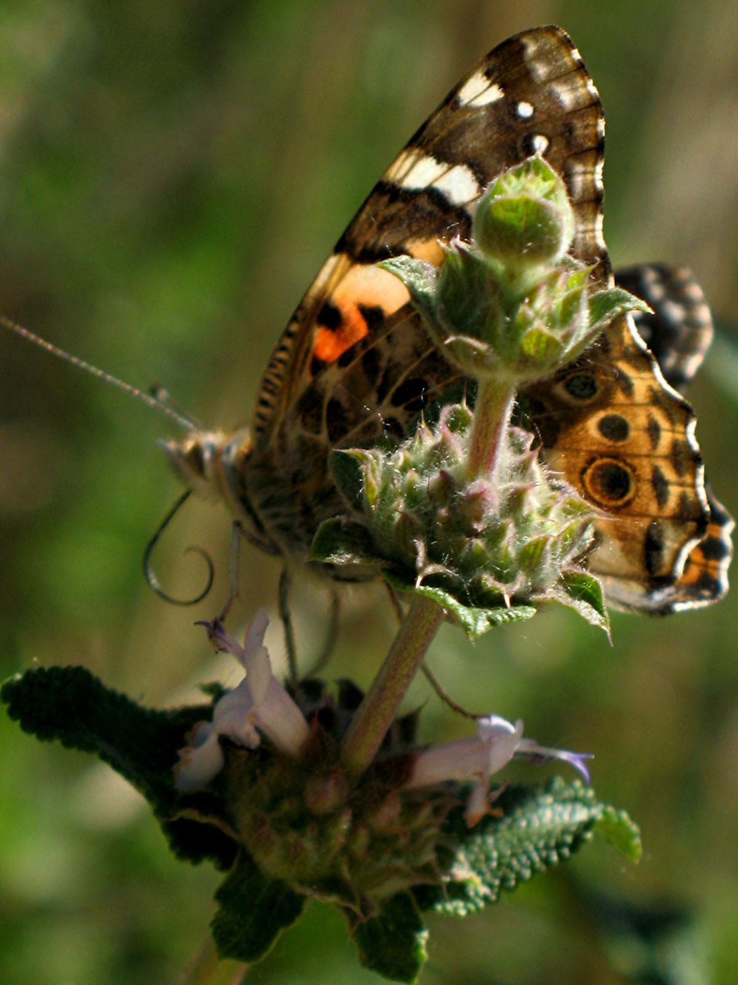

On a personal note, these flower expeditions were solitary adventures, yet the names and faces of these plants became as familiar to me as friends and family. Every summer I would mourn their absence, every spring I’d welcome them back, “Hello, prickly phlox! It’s good to see you again, old friend!” And even though it was a little insane to say it out loud, I always did.
Many of my favorite memories were gathered on mountain tops, dripping with sweat, panting for breath, and gazing out across a blanket of clouds high above the Pacific Ocean. Flower expeditions saw me through mental health struggles, aimlessness, recessions, and life-altering pandemics. Every mountain I scaled became a private triumph; the wildlife I encountered as dazzling as coming across one of LA’s many celebrities. Once, while walking along a sea cliff above the PCH, a golden eagle swooped up in front of me warning me I was nearing too close to the edge. Another time, I climbed a grassy hill, oblivious to everything but the lupine I was after on top, when I nearly stepped on this guy:

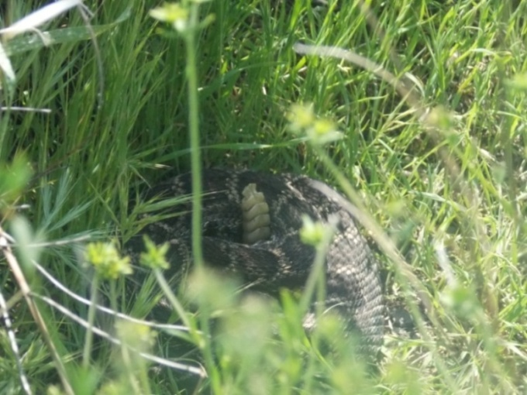

Coyotes, bobcats, deer, hawks, quail, spiders, snakes, all have been represented in my photography, as has the most stunning vistas Southern California has to offer. But in spite of the countless experiences over a decade of searching, this book is dedicated to the beauty, detail, and variety of the flowers. This book is not only intended as a hiker’s guide, but the chronicling of a remarkable time of exploration in my life. I hope it proves useful in your own flower expeditions through the Santa Monica Mountain Range, and I hope, like me, you’ll never be the same for it.

J.Brett 2025

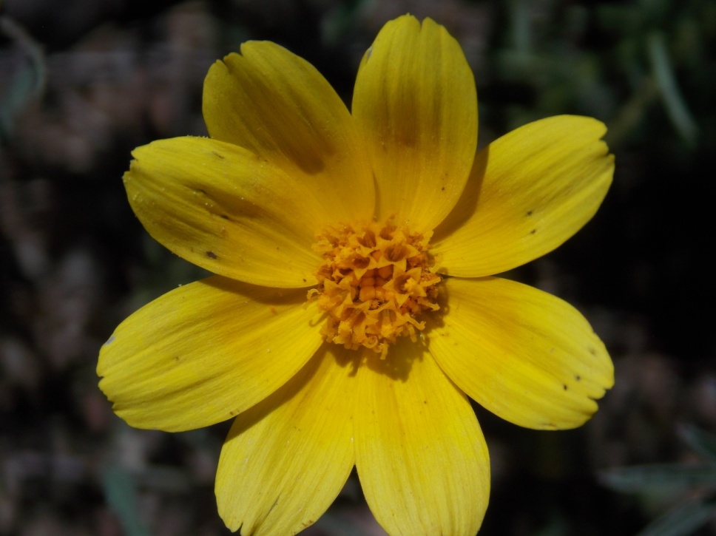
Annual Coreopsis
Leptosyne bigelovii
ASTERACEAE - Sunflower Family

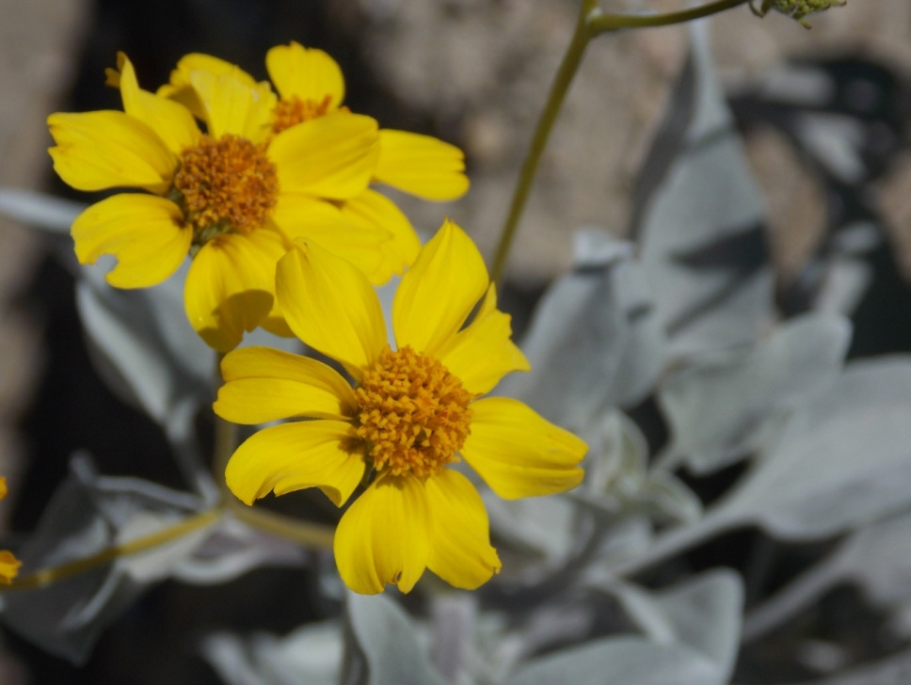
Brittlebush
Encelia farinosa
ASTERACEAE – Sunflower Family

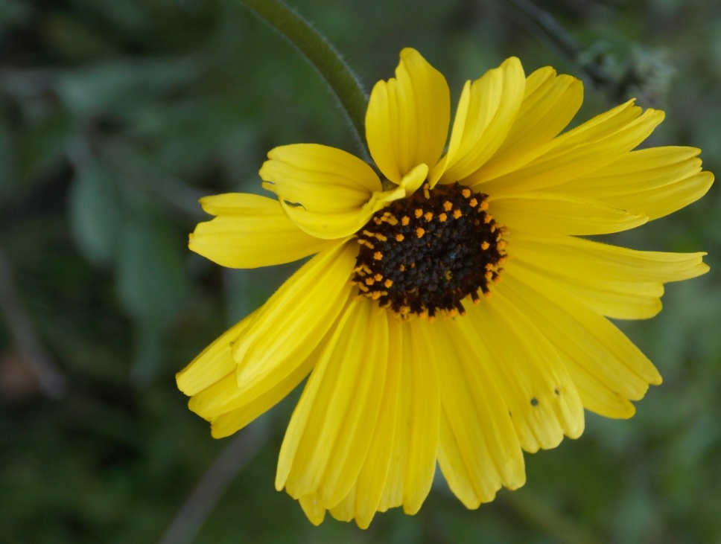
Bush Sunflower
Encelia californica
ASTERACEAE - Sunflower Family

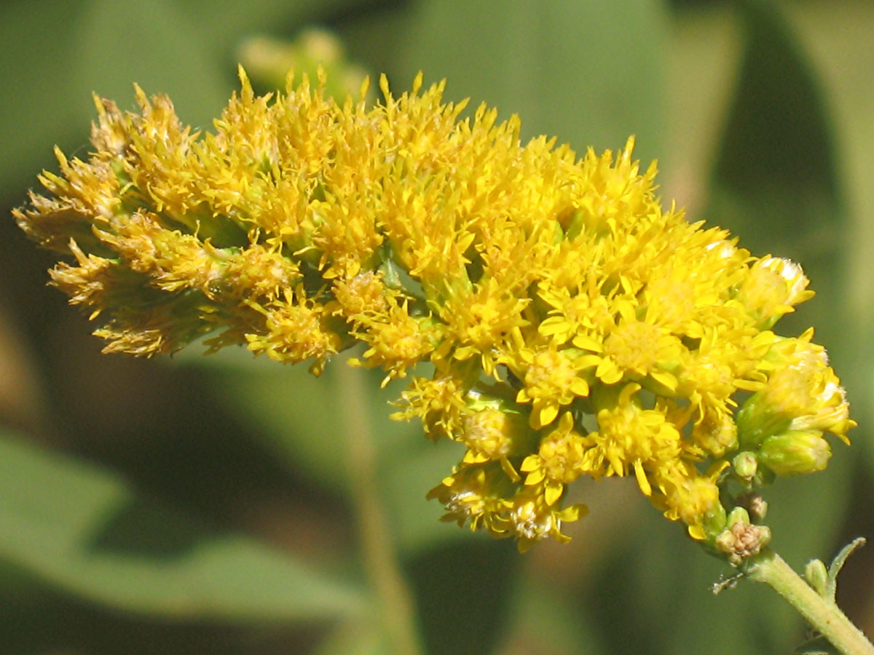
California Goldenrod
Solidago velutina
ASTERACEAE – Sunflower Family

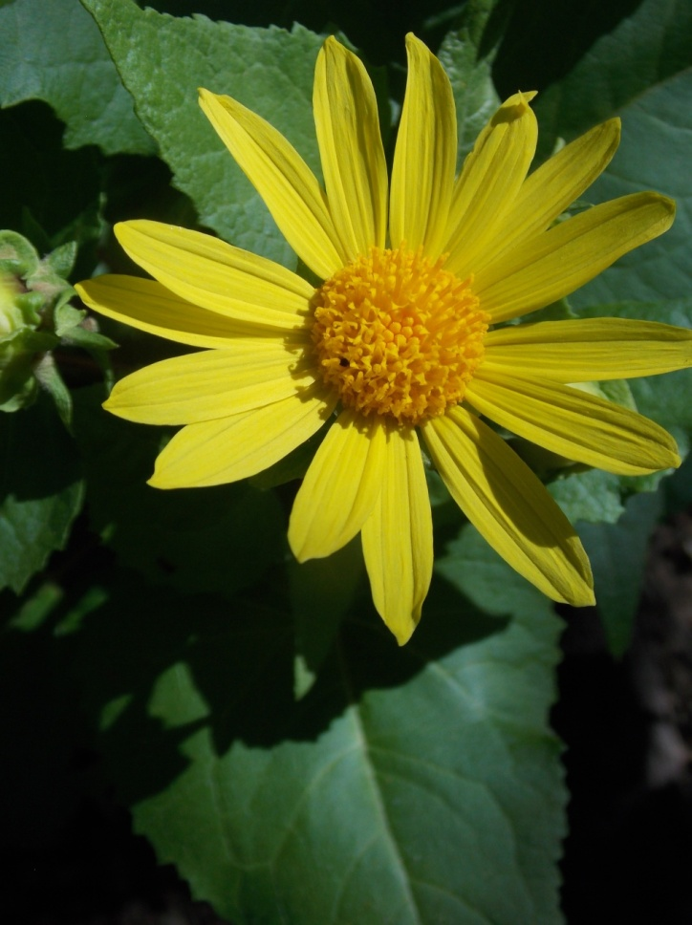
Canyon Sunflower
Venegasia carpesioides
ASTERACEAE - Sunflower Family

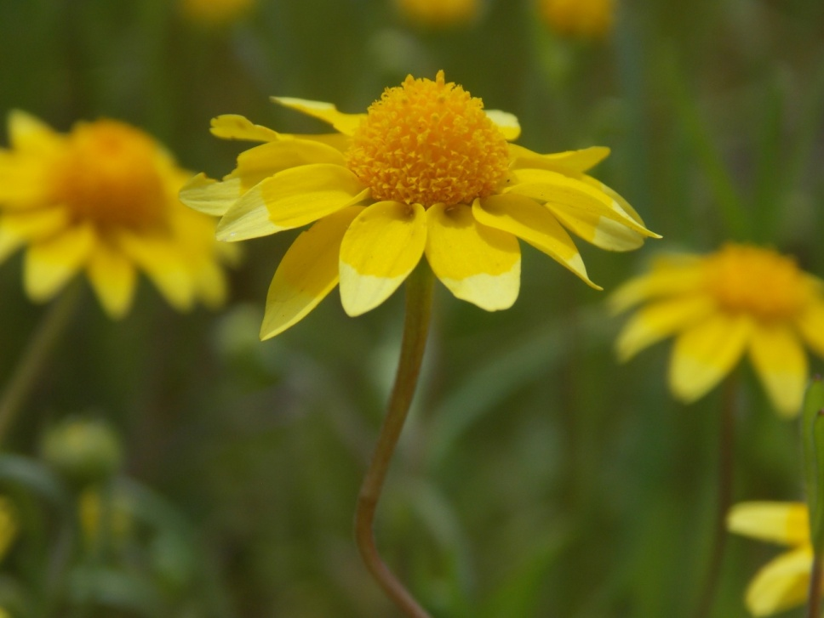
Common Goldfields
Lasthenia californica
ASTERACEAE – Sunflower Family

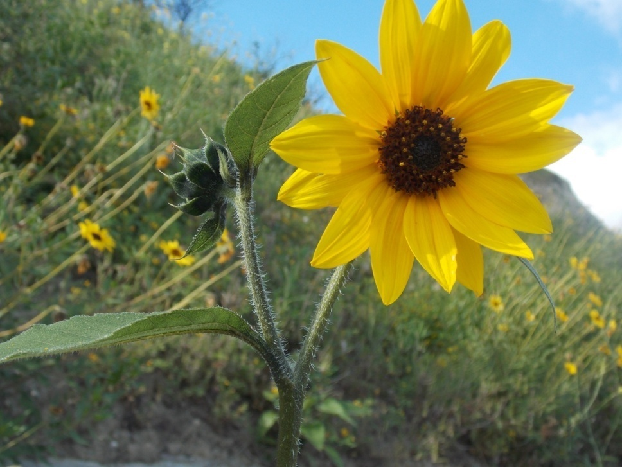
Common Sunflower
Helianthus annus
ASTERACEAE – Sunflower Family

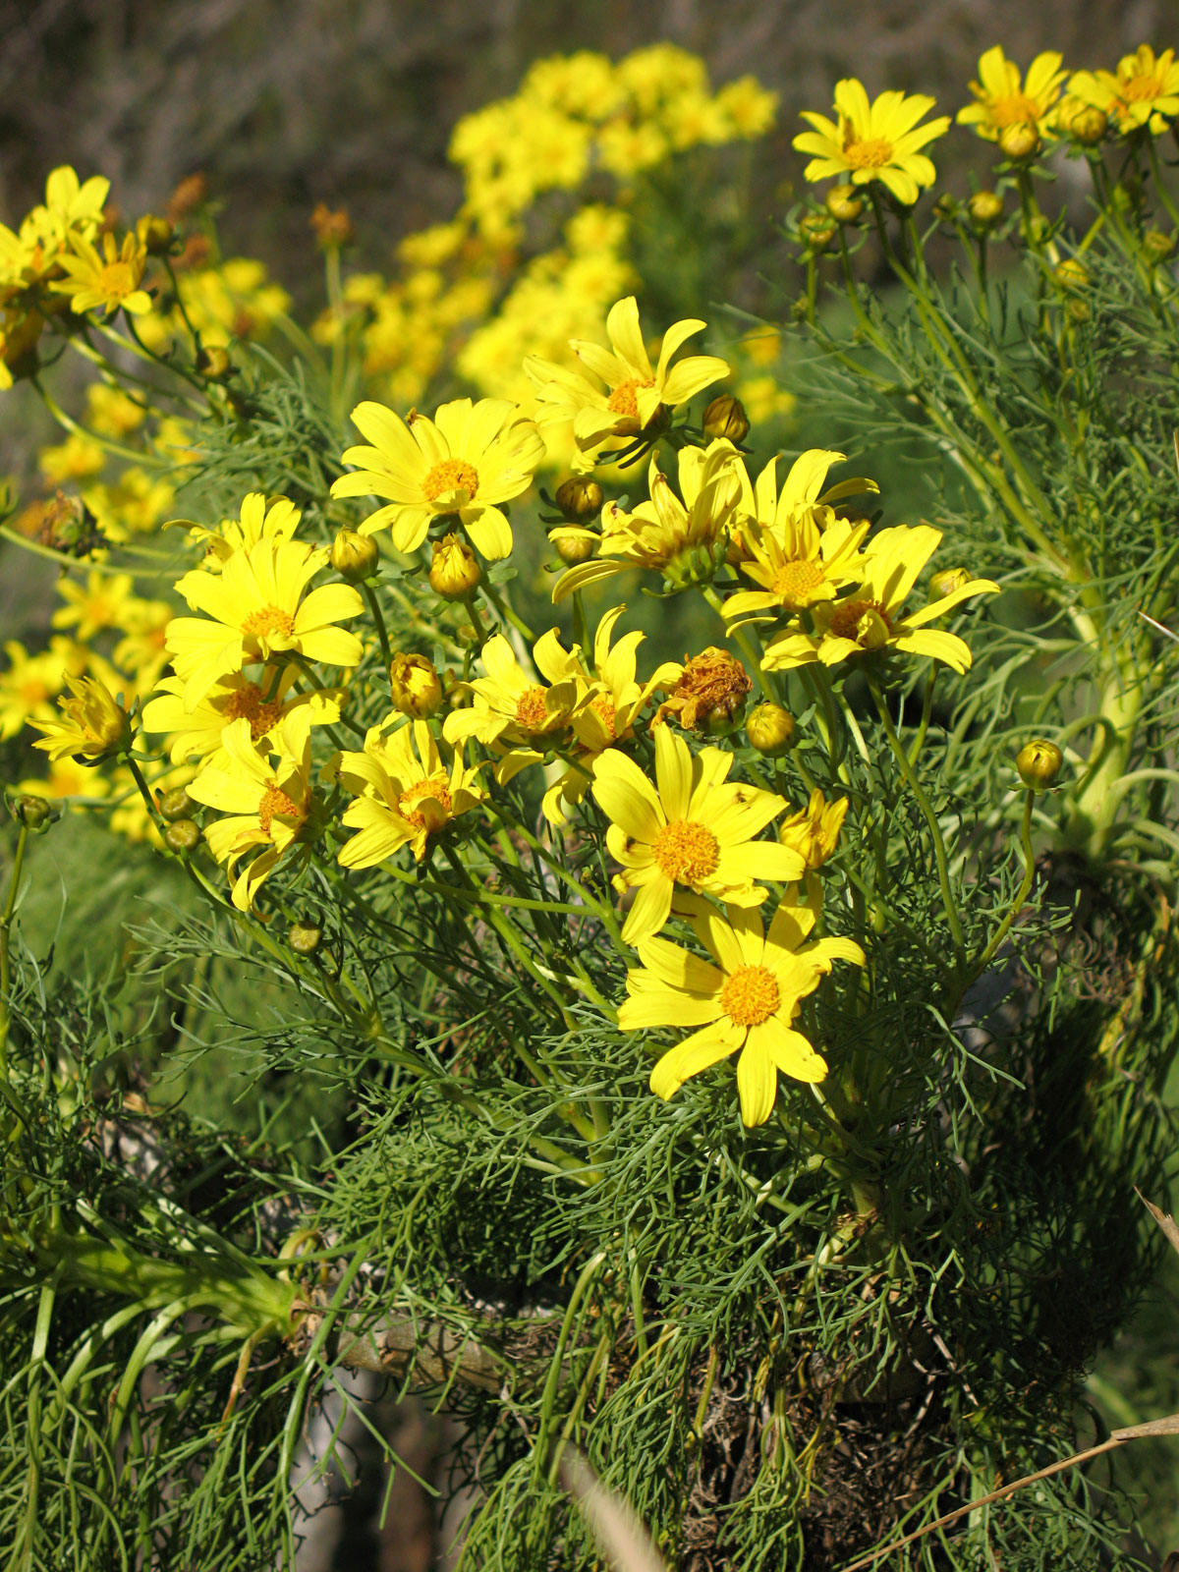
Giant Coreopsis
Coreopsis gigantea
ASTERACEAE - Sunflower Family

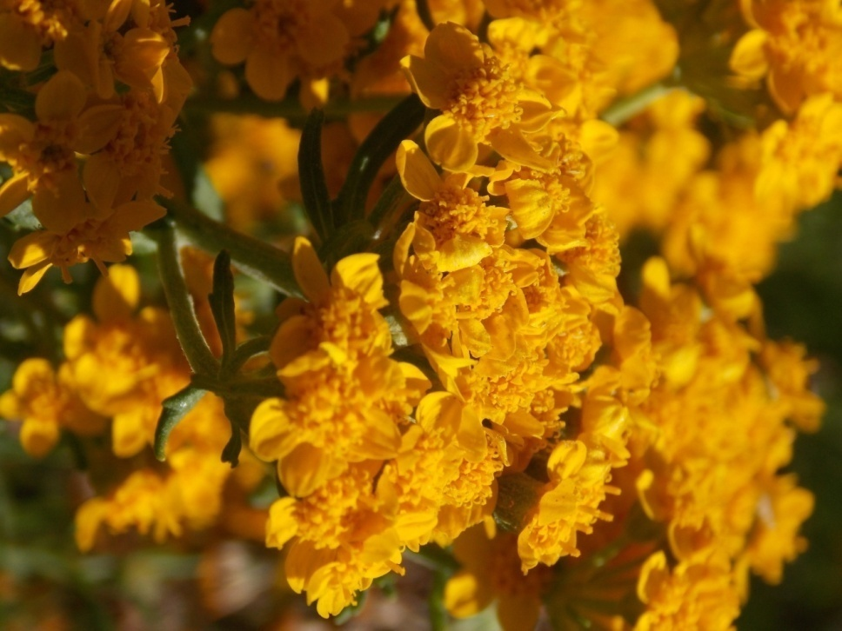
Golden Yarrow
Eriophyllum contertiflorum
ASTERACEAE - Sunflower Family

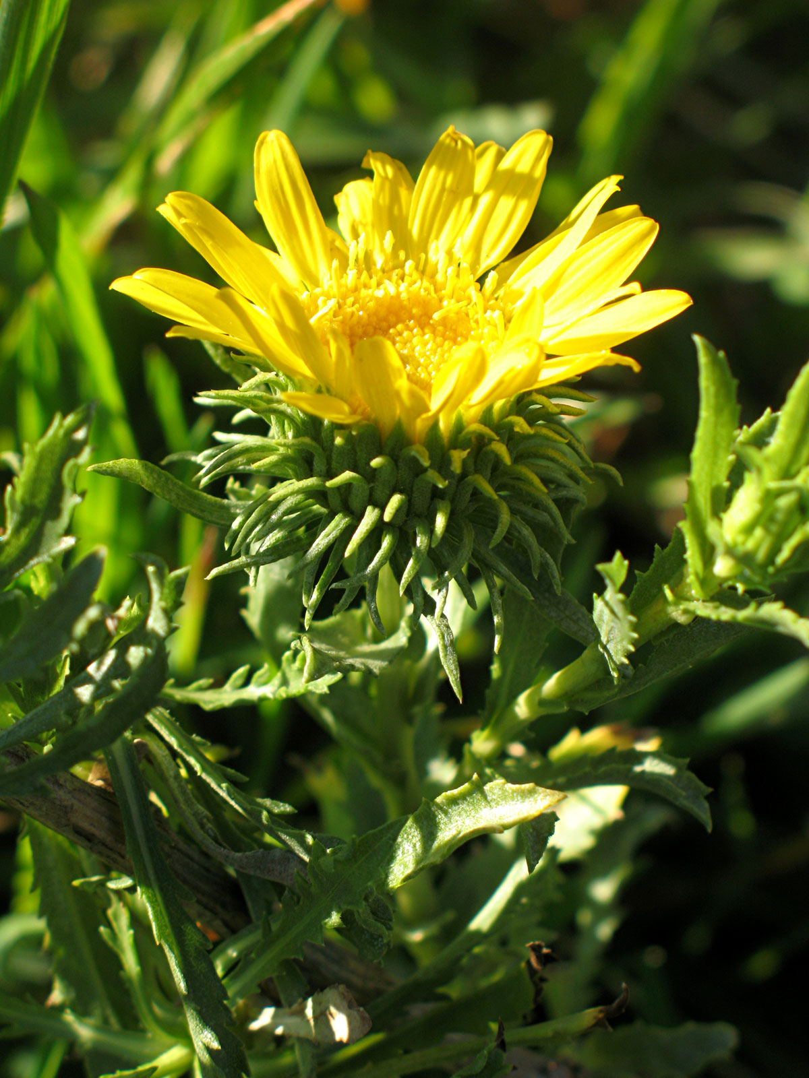
Gum Plant
Grindelia camporum
ASTERACEAE - Sunflower Family

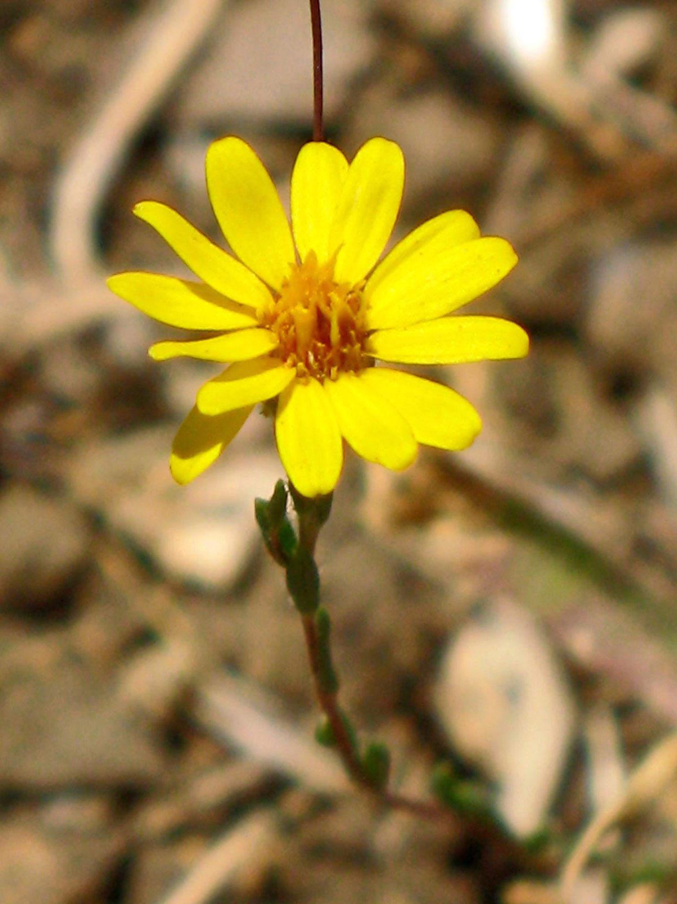
Lyon’s Pentachaeta
Pentachaeta lyonii
ASTERACEAE - Sunflower Family

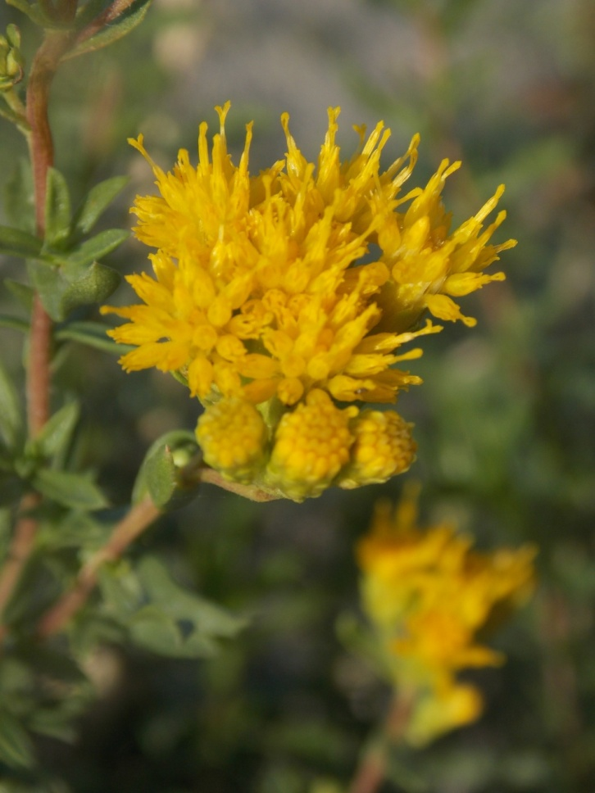
Menzies’ Goldenbush
Isocoma menziesii
ASTERACEAE - Sunflower Family

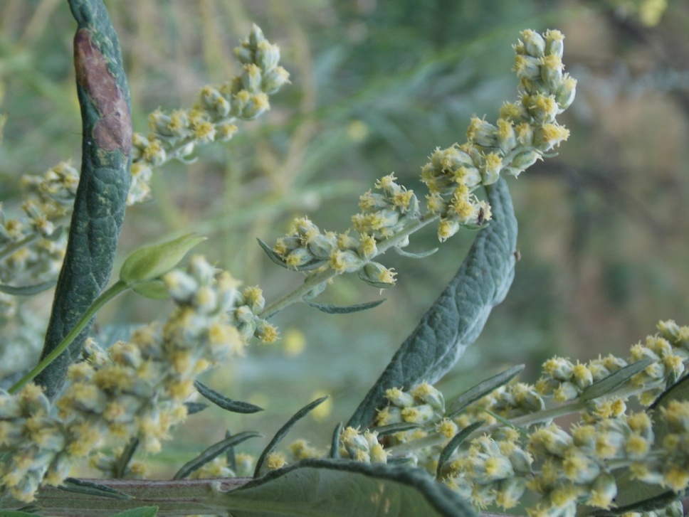
Mugwort
Artemisia douglasiana
ASTERACEAE - Sunflower Family

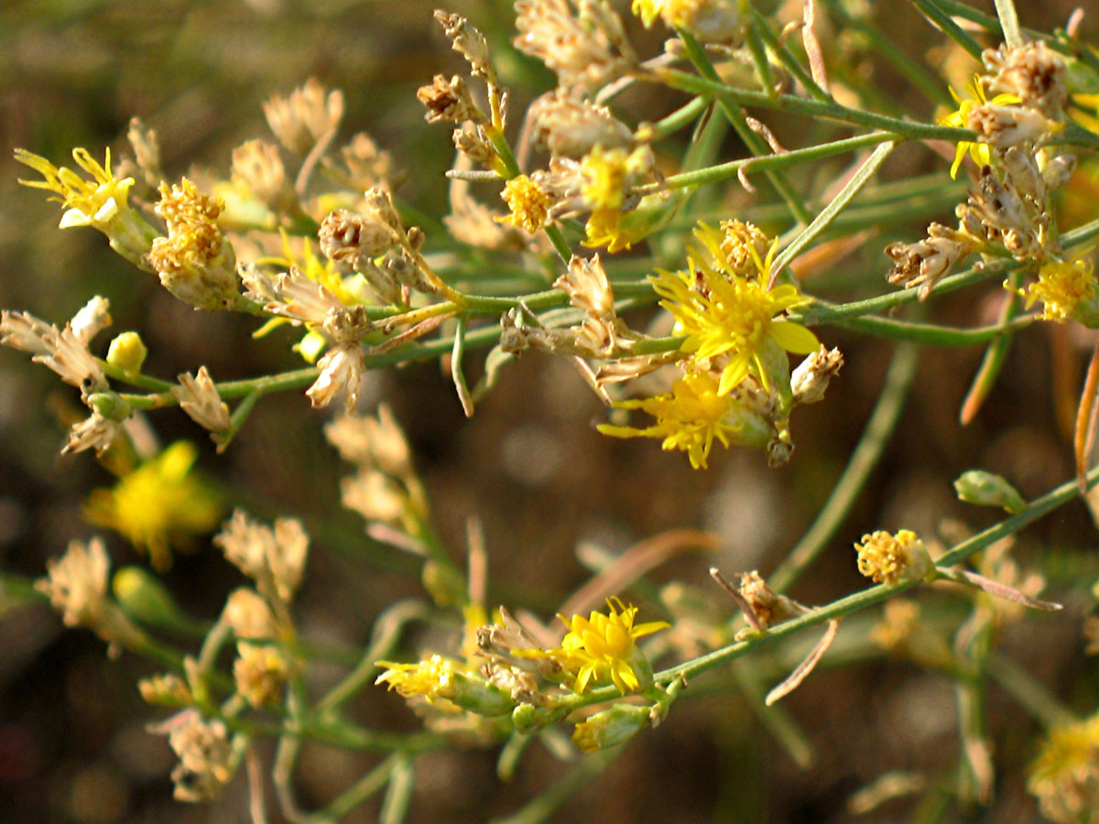
Palmer’s Goldenbrush
Ericameria palmeri
ASTERACEAE – Sunflower Family

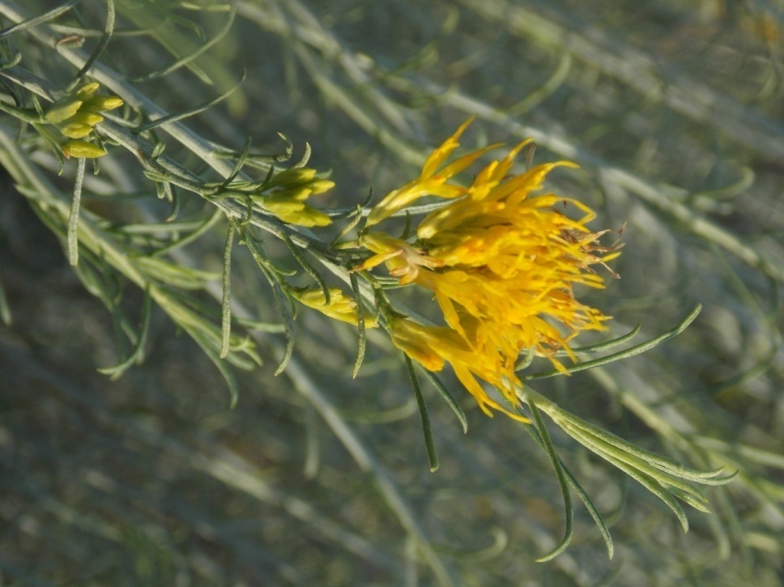
Rabbitbrush
Ericameria nauseosa
ASTERACEAE – Sunflower Family

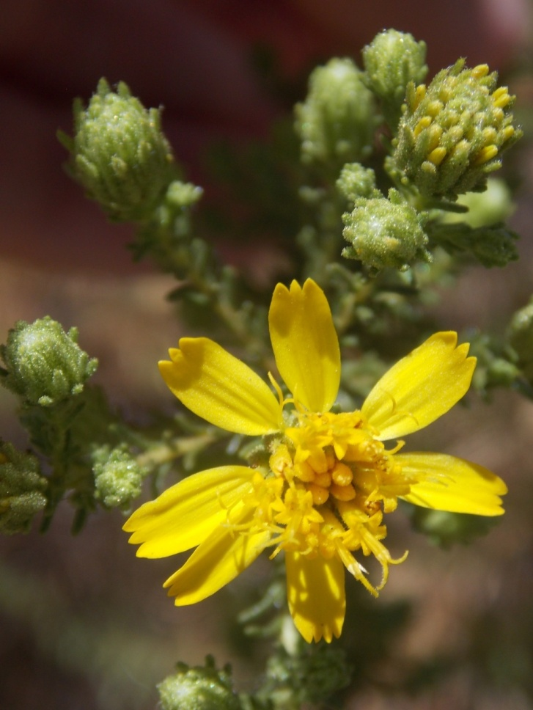
Santa Susana Tarweed
Deinandra minthornii
ASTERACEAE – Sunflower Family

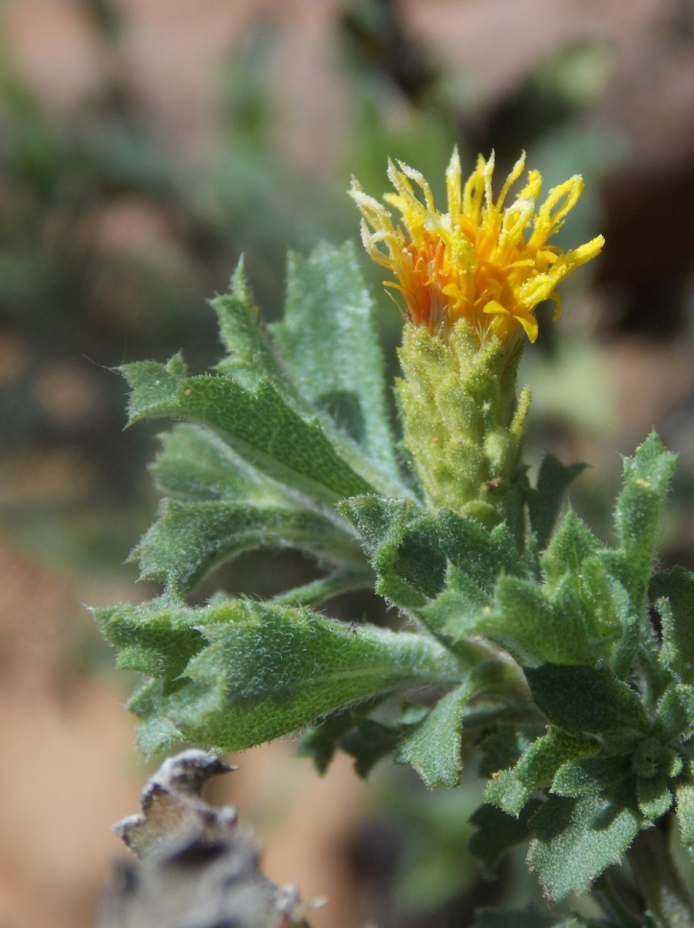
Sawtooth Goldenbush
Hazardia squarrosa
ASTERACEAE – Sunflower Family

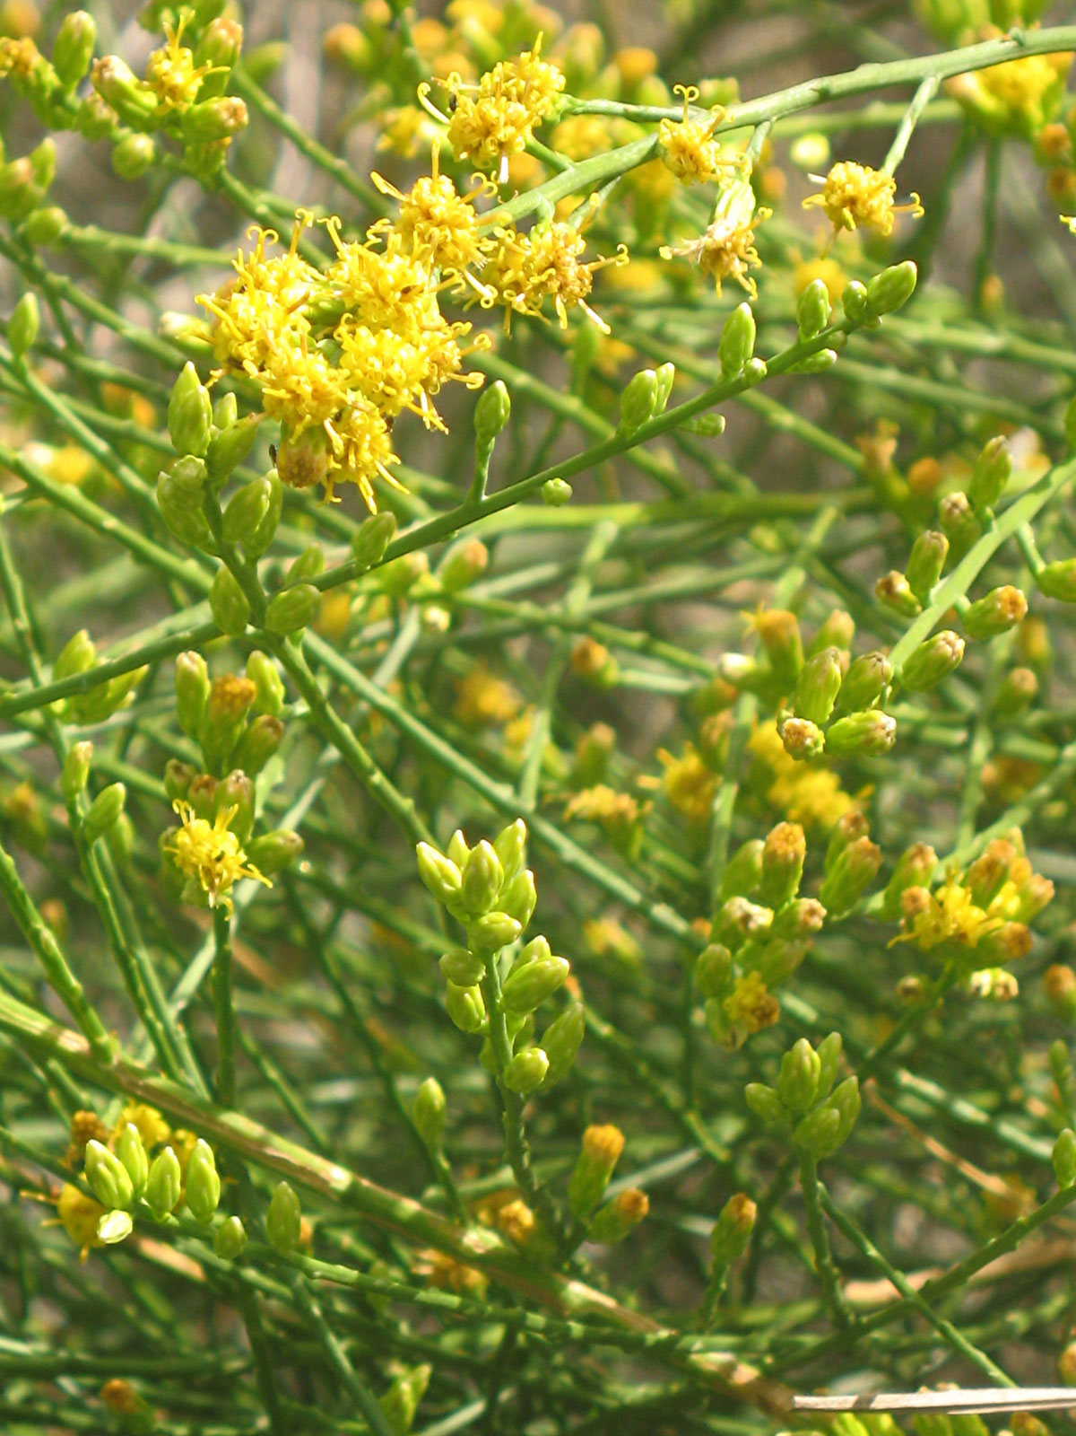
Scale Broom
Lepidospartum squamatum
ASTERACEAE – Sunflower Family

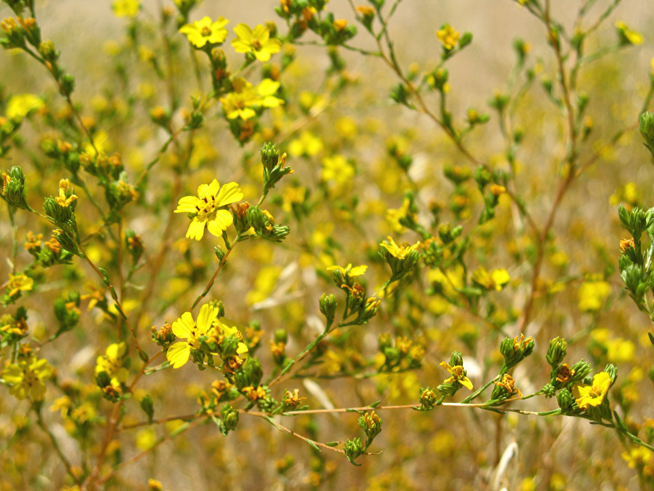
Slender Tarweed
Deinandra fasciculata
ASTERACEAE – Sunflower Family

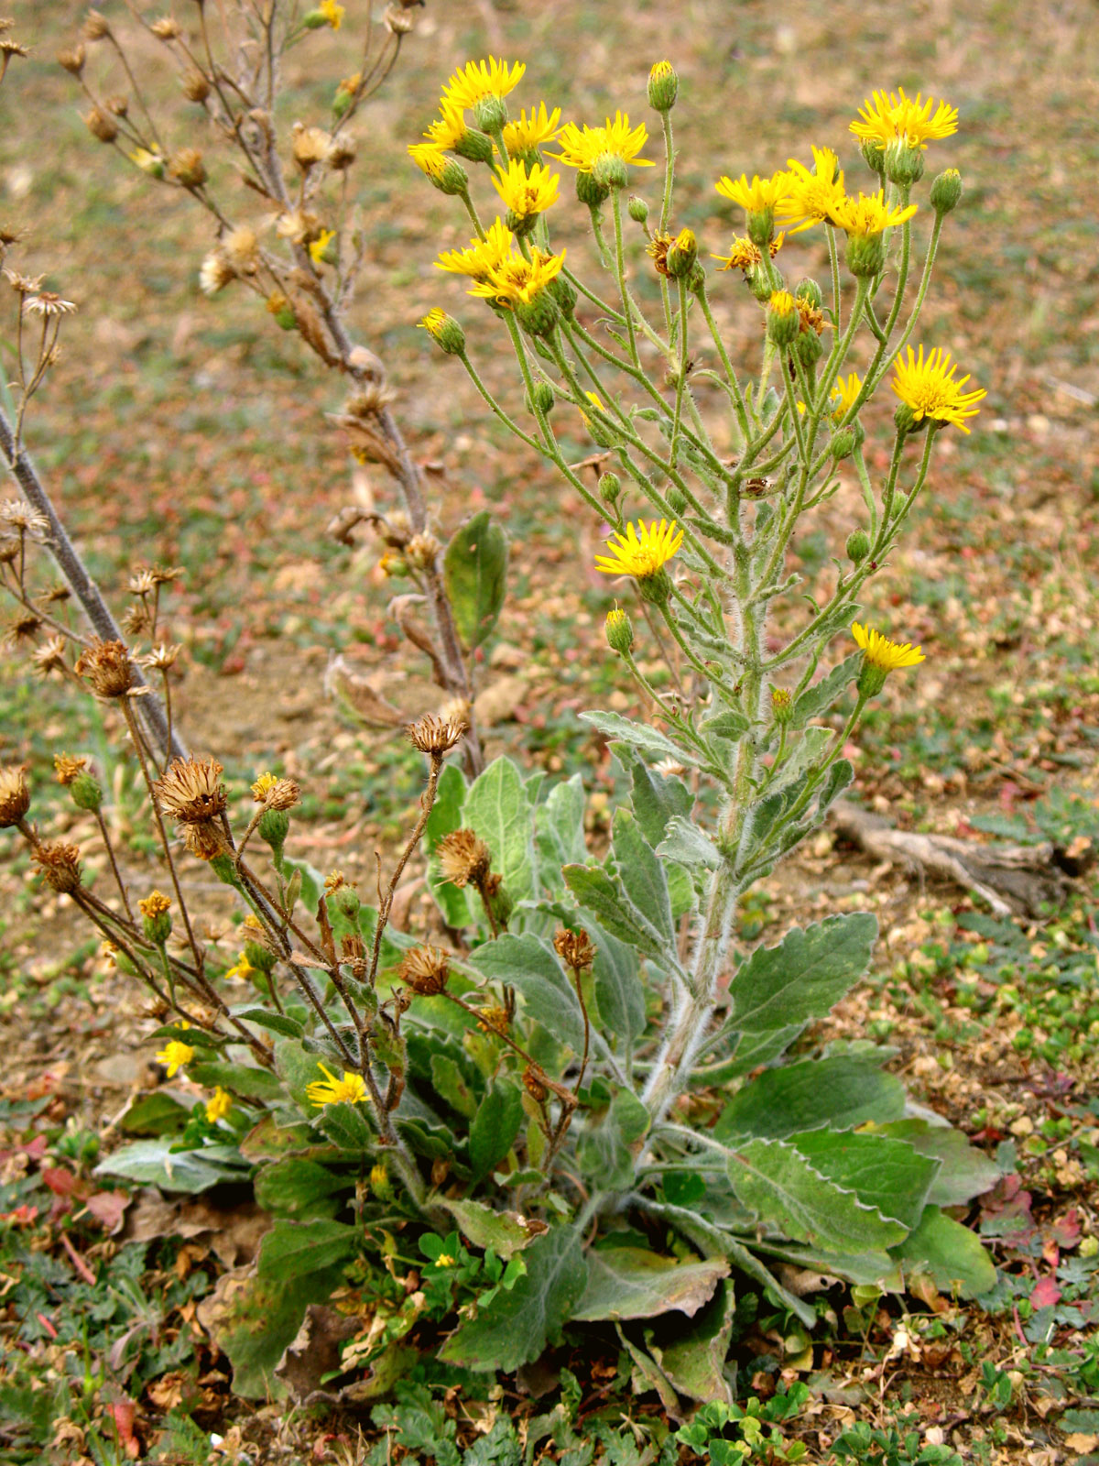
Telegraph Weed
Heterotheca grandiflora
ASTERACEAE – Sunflower Family

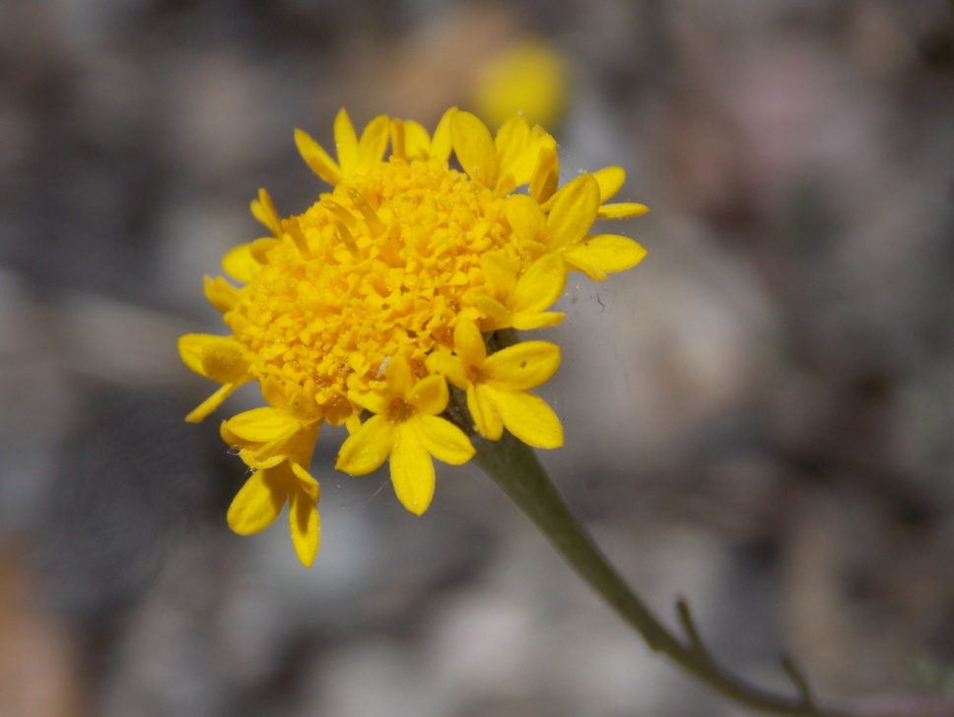
Yellow Pin Cushion
Chaenactis glabriuscula
ASTERACEAE – Sunflower Family

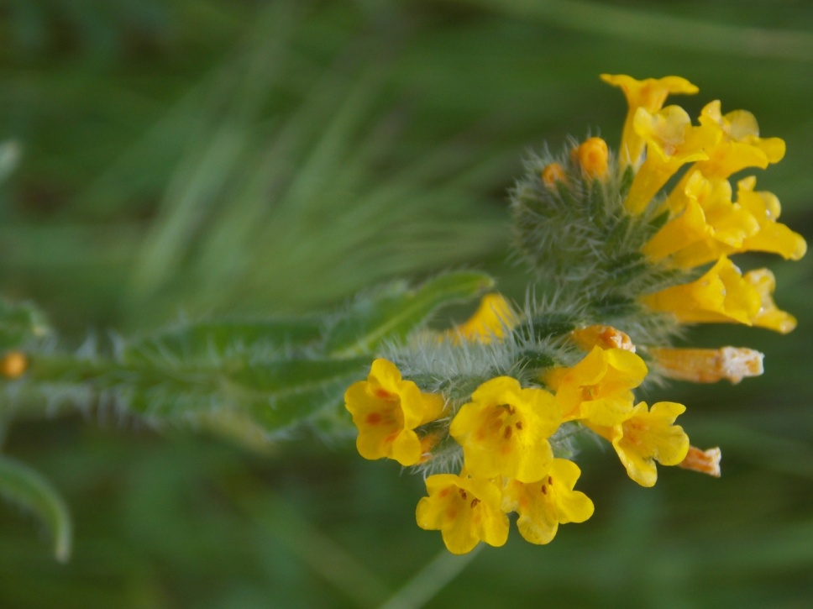
Common Fiddleneck
Amsinckia intermedia
BORAGINACEAE - Borage Family

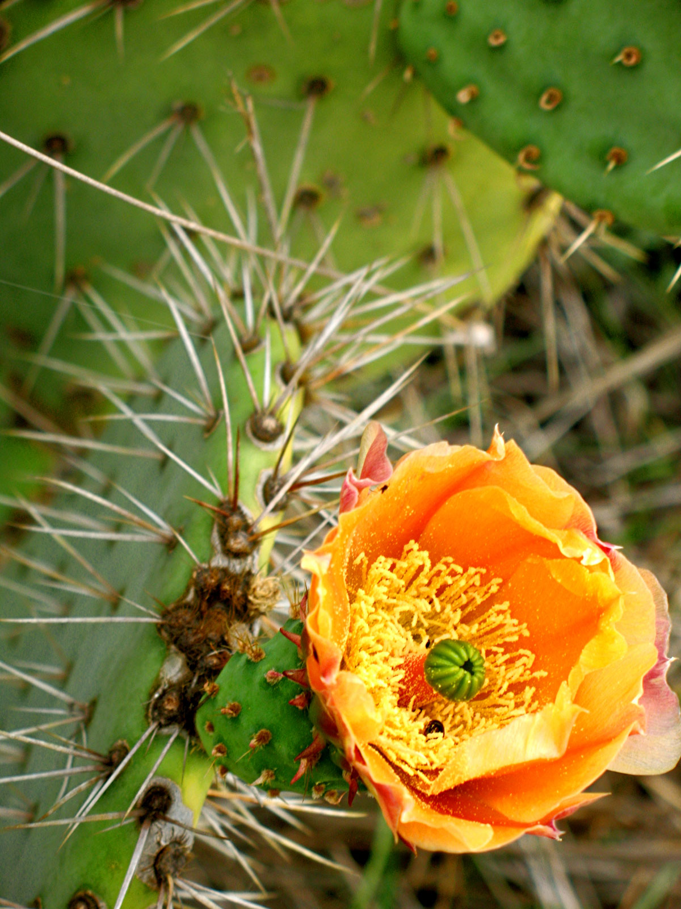
Coastal Prickly Pear
Opuntia littoralis
CACTACEAE - Cactus Family

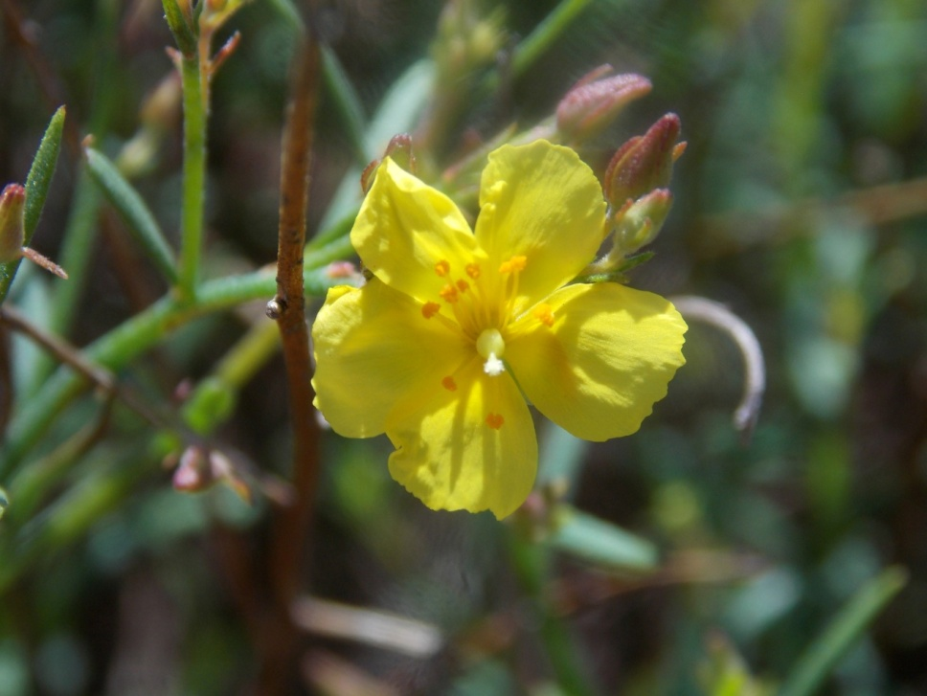
Rush Rose
Crocanthemum scoparium
CISTACEAE – Rock Rose Family

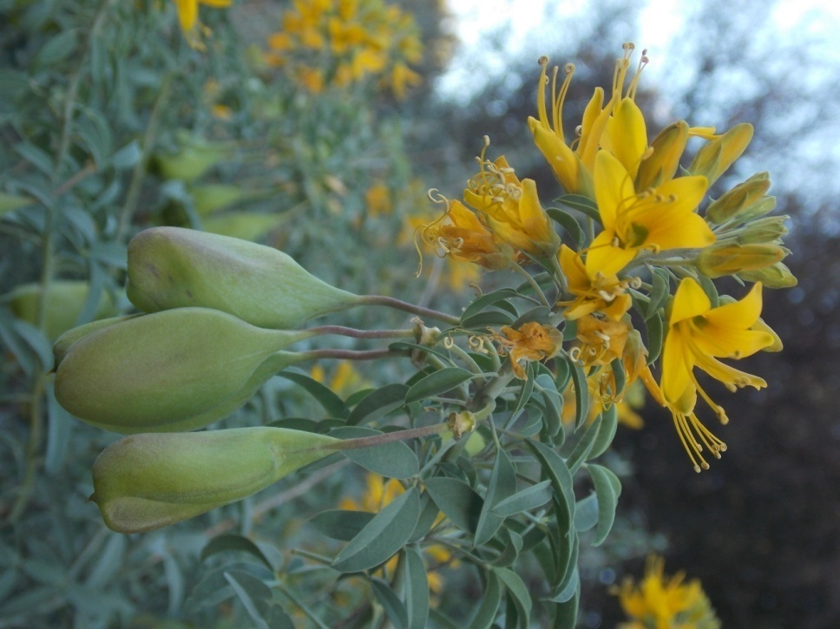
Bladderpod
Cleomella arborea
CLEOMACEAE- Caper Family

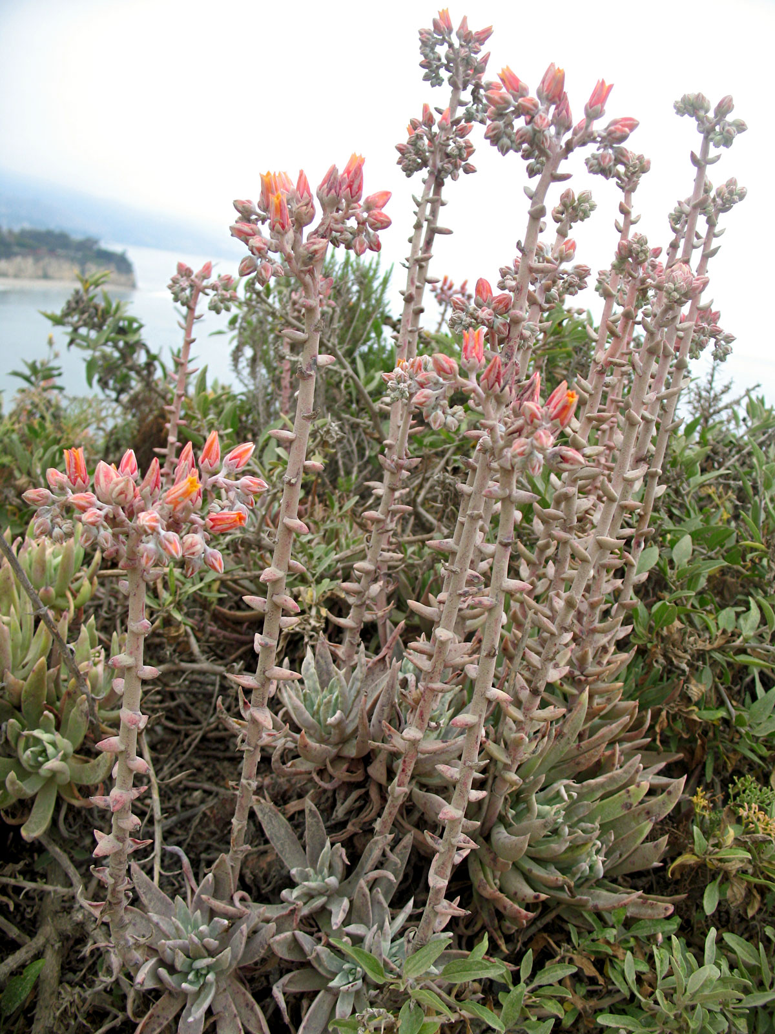
Chalk Live-Forever
Dudleya lanceolata
CRASSULACEAE - Stonecrop Family

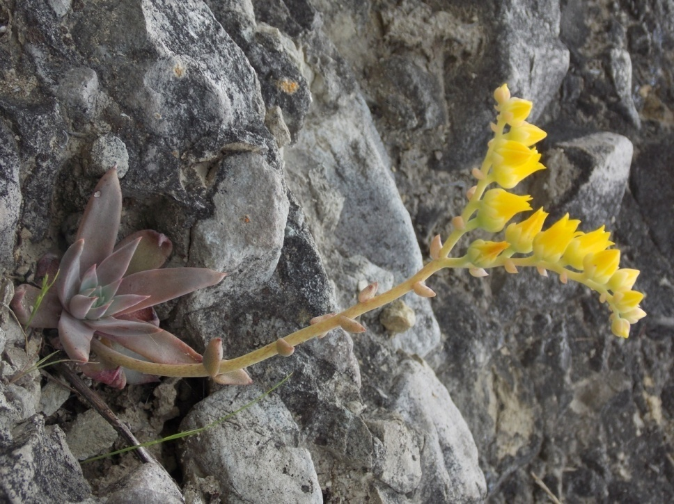
Verity’s Dudleya
Dudleya verityi
CRASSULACEAE - Stonecrop Family

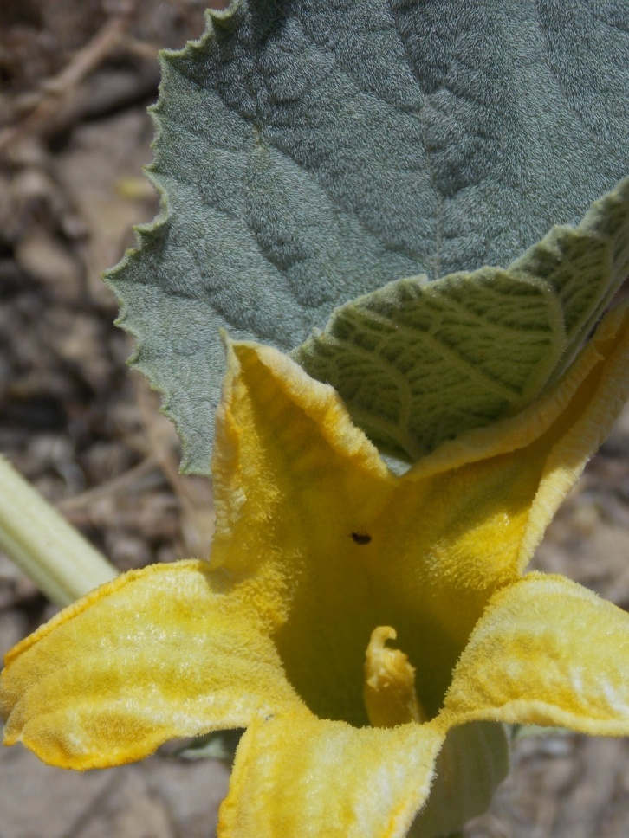
Calabazilla

Cucurbita foetidissima
CUCURBITACEAE – Gourd Family

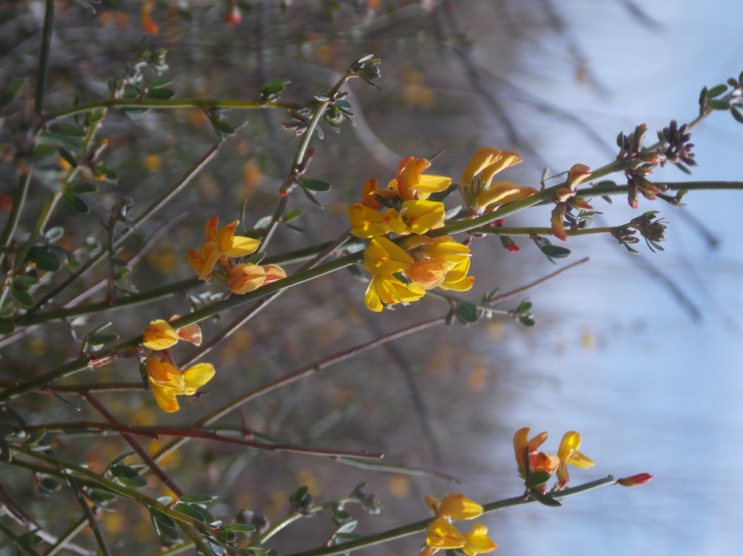
California Broom
Acmispon glaber
FABACEAE - Pea Family

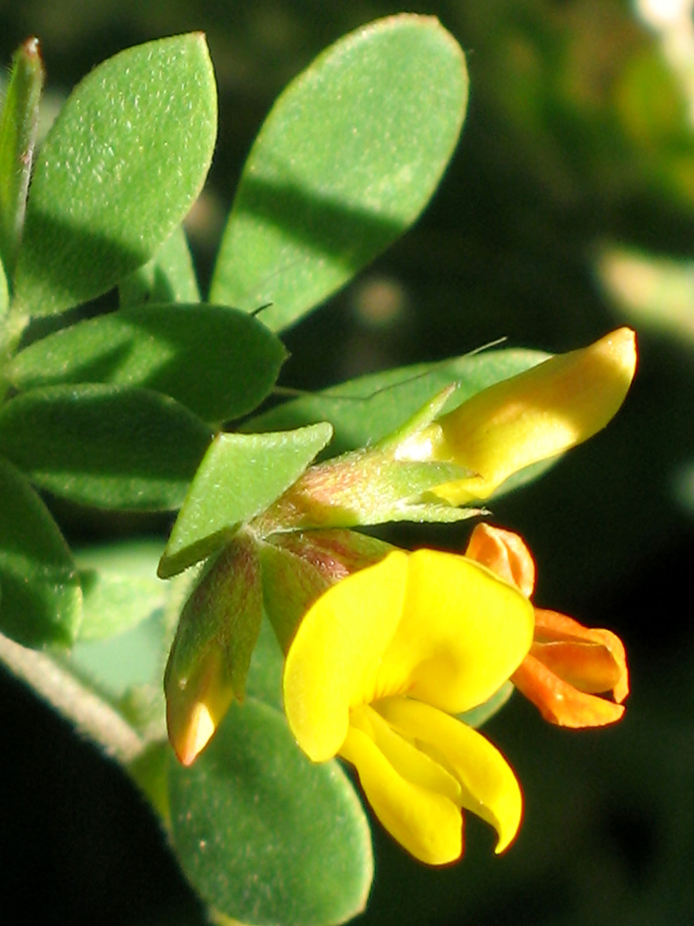
California Lotus
Acmispon wrangelianus
FABACEAE - Pea Family

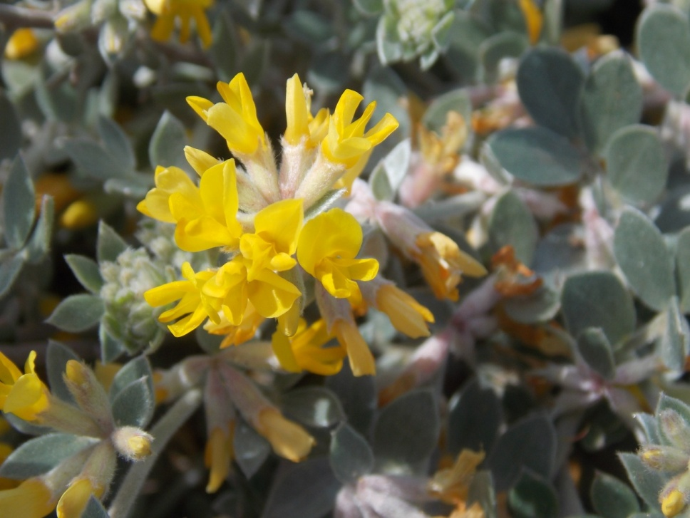
Silver Lotus
Acmispon argophyllus
FABACEAE – Pea Family

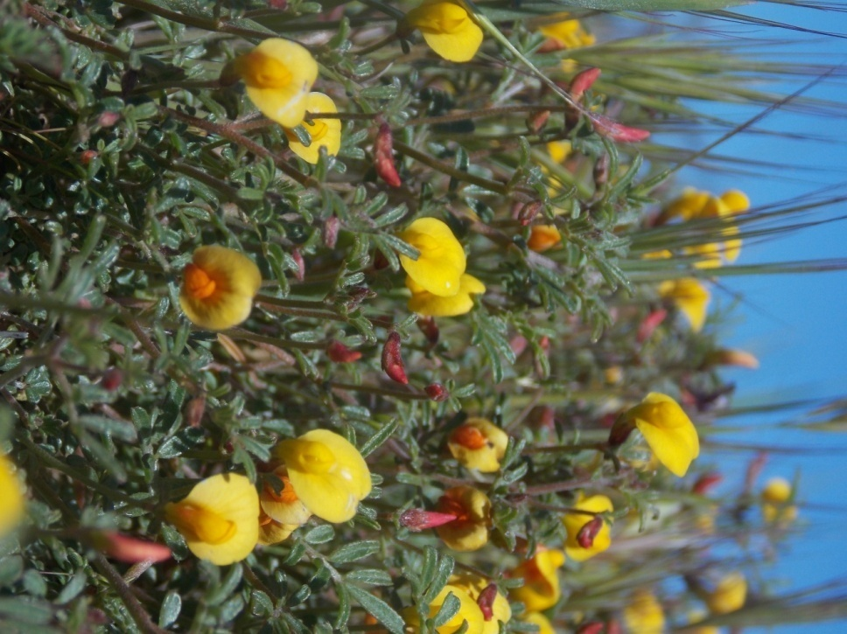
Strigose Lotus
Acmispon strigosus
FABACEAE – Pea Family

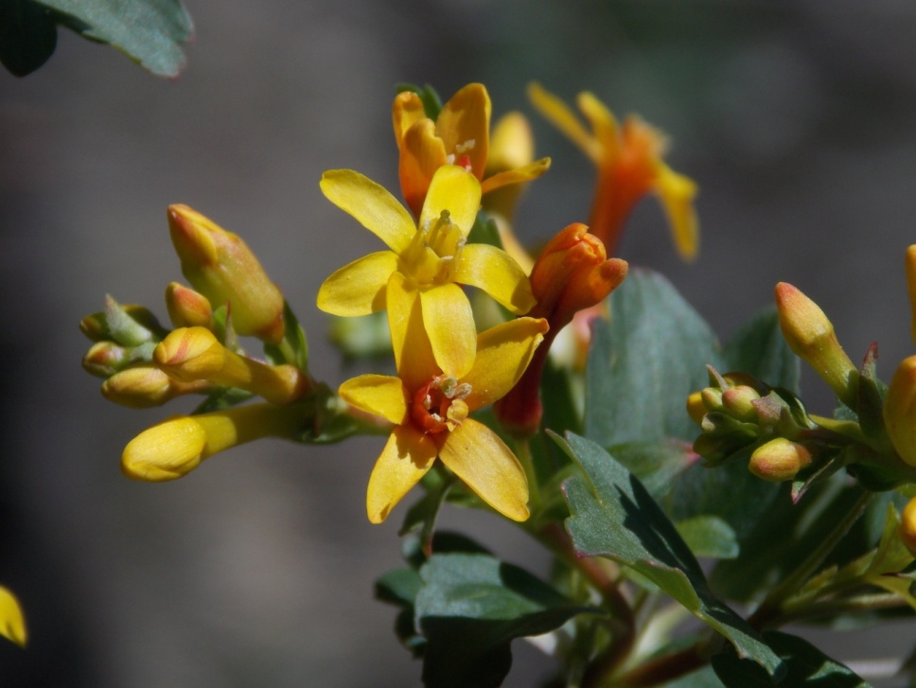
Golden Currant
Ribes aureum
GROSSULARIACEAE - Gooseberry Family

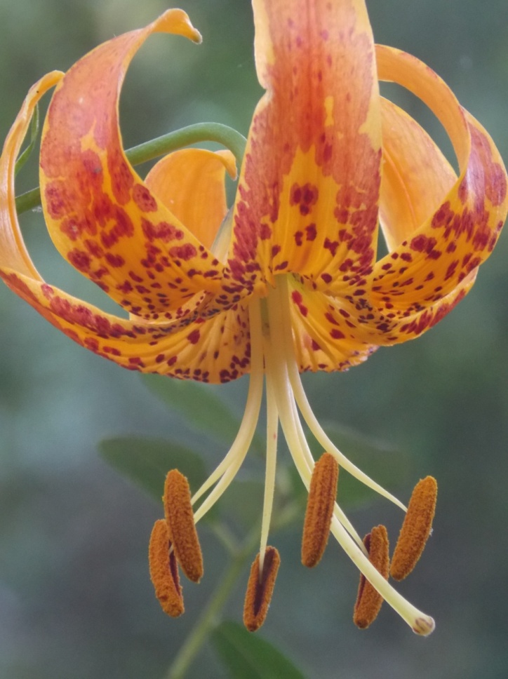
Humboldt Lily
Lilium humboldtii
LILIACEAE - Lily Family

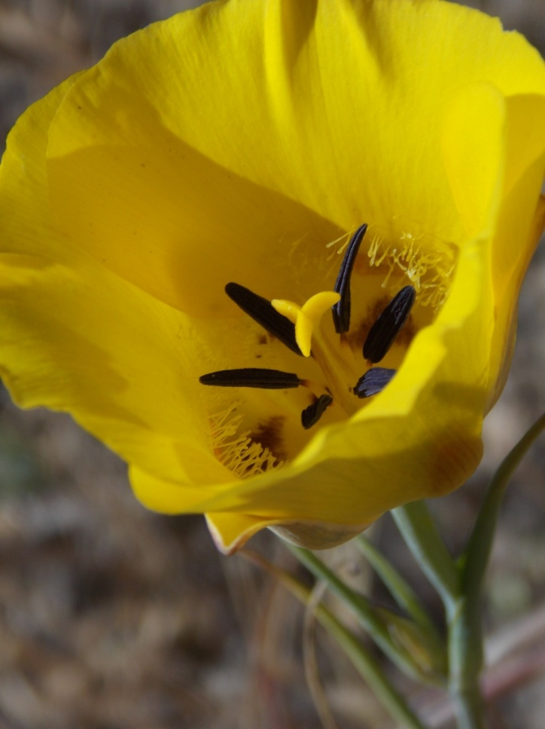
Slender Mariposa Lily
Calochortus clavatus var. gracilis
LILIACEAE – Lily Family

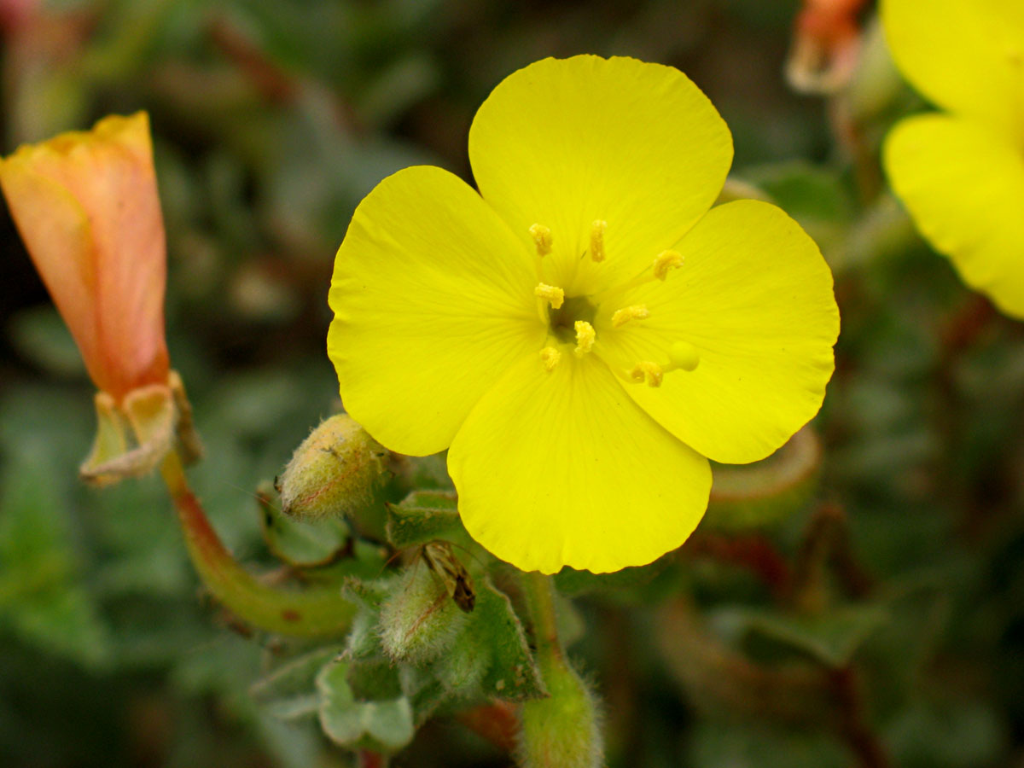
Beach Evening Primrose
Camissoniopsis cheiranthifolia
ONAGRACEAE – Evening Primrose Family

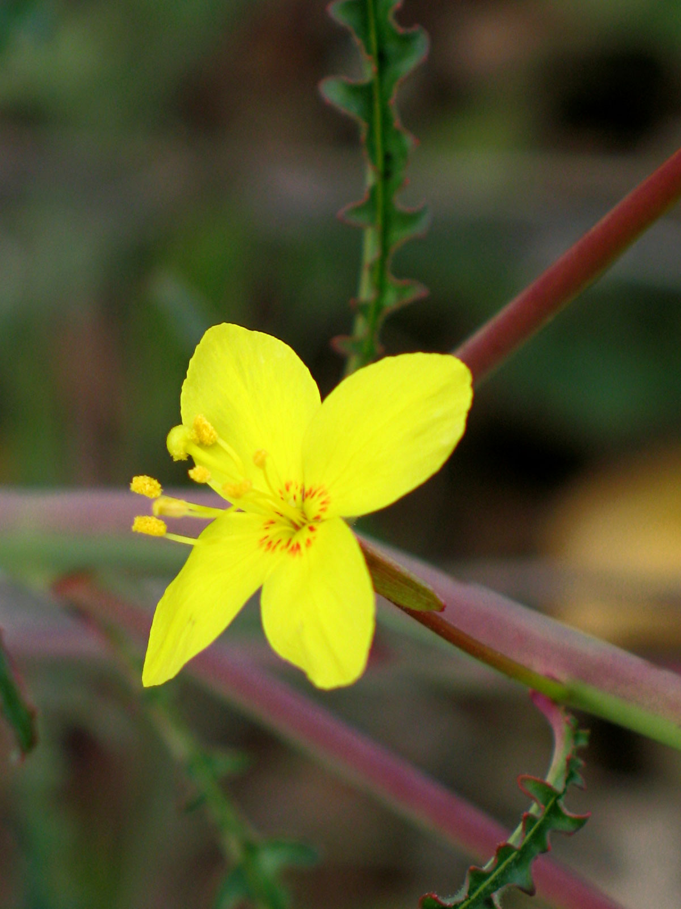
Mustard Evening Primrose
Eulobus californicus
ONAGRACEAE – Evening Primrose Family

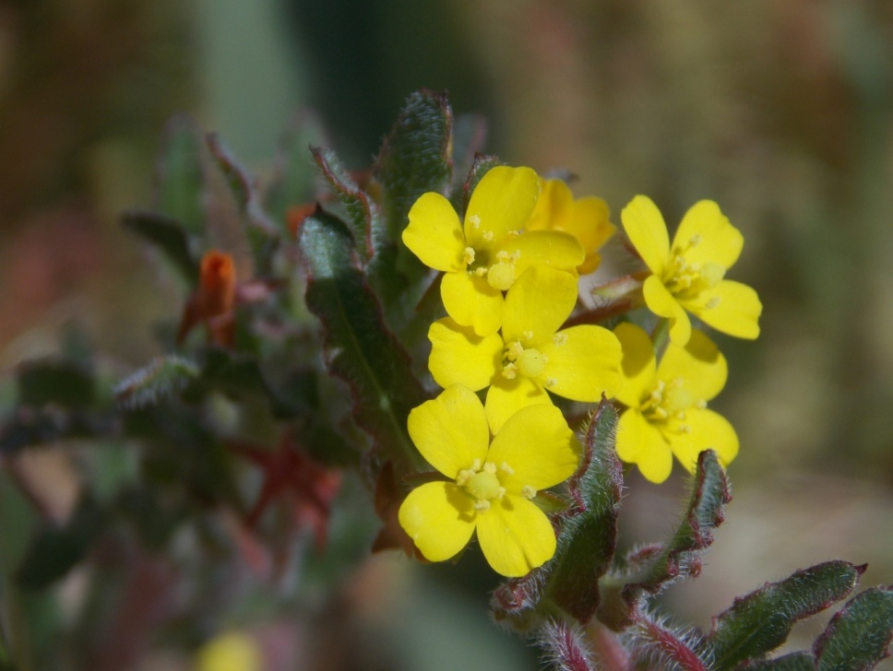
Small Flowered Evening Primrose
Camissoniopsis micrantha
ONAGRACEAE – Evening Primrose Family

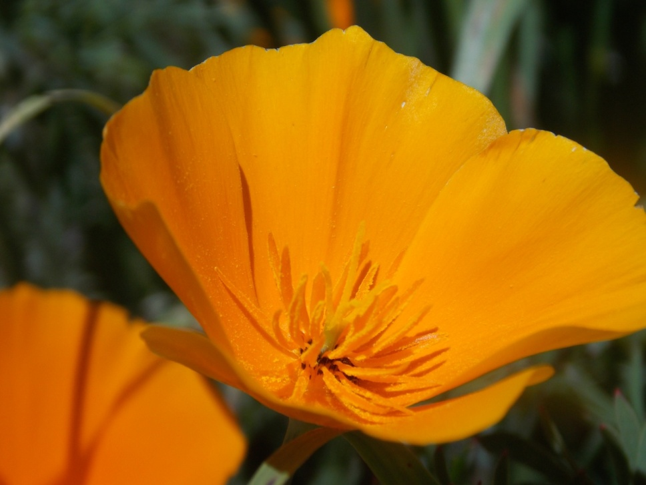
California Poppy
Eschscholzia californica
PAPAVERACEAE – Poppy Family

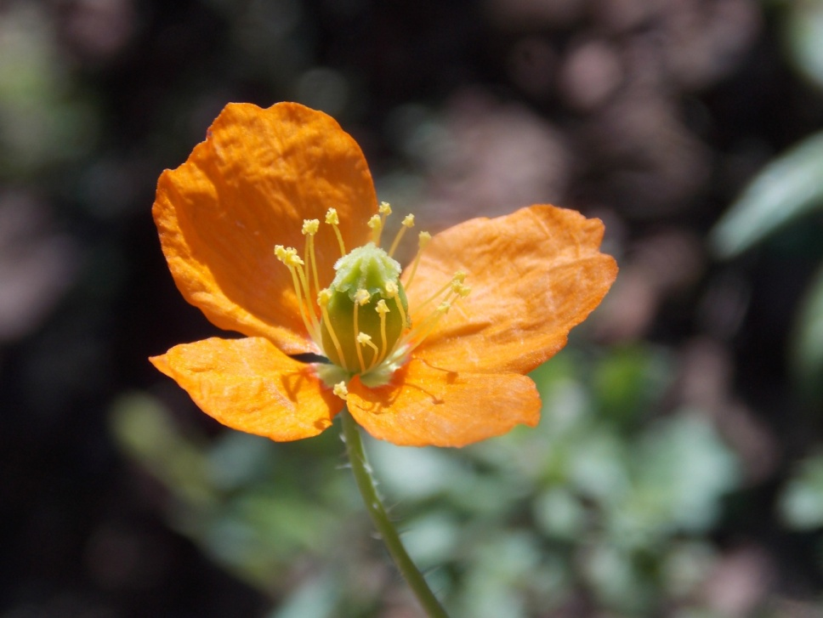
Fire Poppy
Papaver californicum
PAPAVERACEAE – Poppy Family

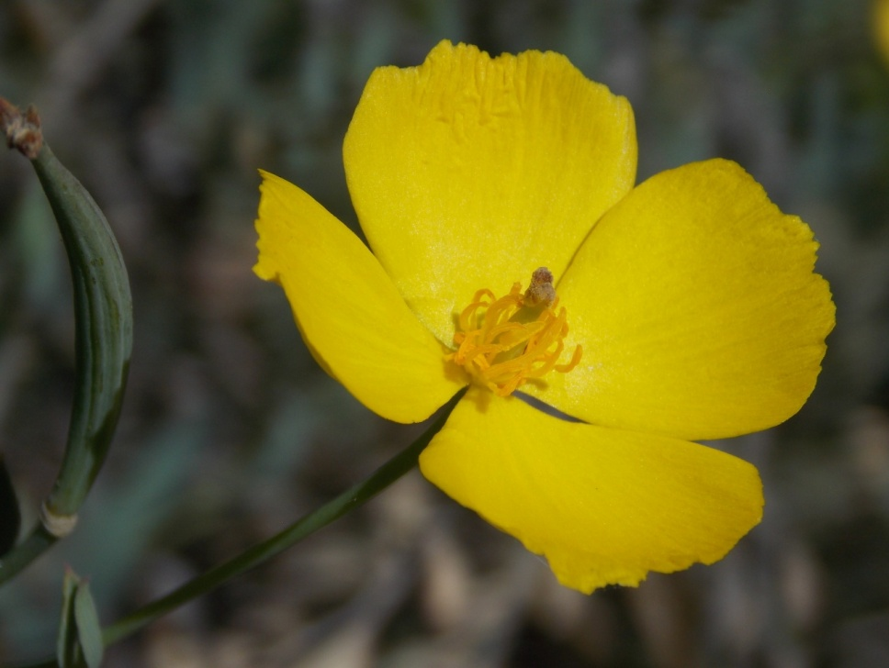
Tree Poppy
Dendromecon rigida
PAPAVERACEAE – Poppy Family

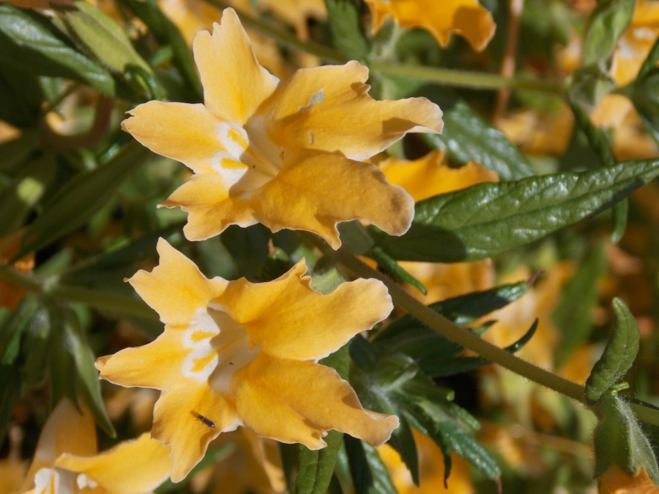
Bush Monkey Flower
Diplacus longiflorus
PHRYMACEAE – Lopseed Family

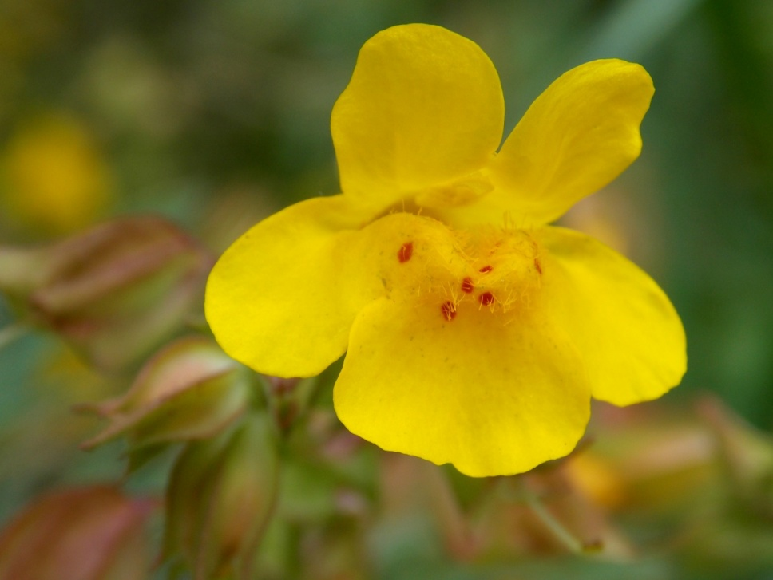
Creek Monkey Flower
Erythranthe guttata
PHRYMACEAE – Lopseed Family

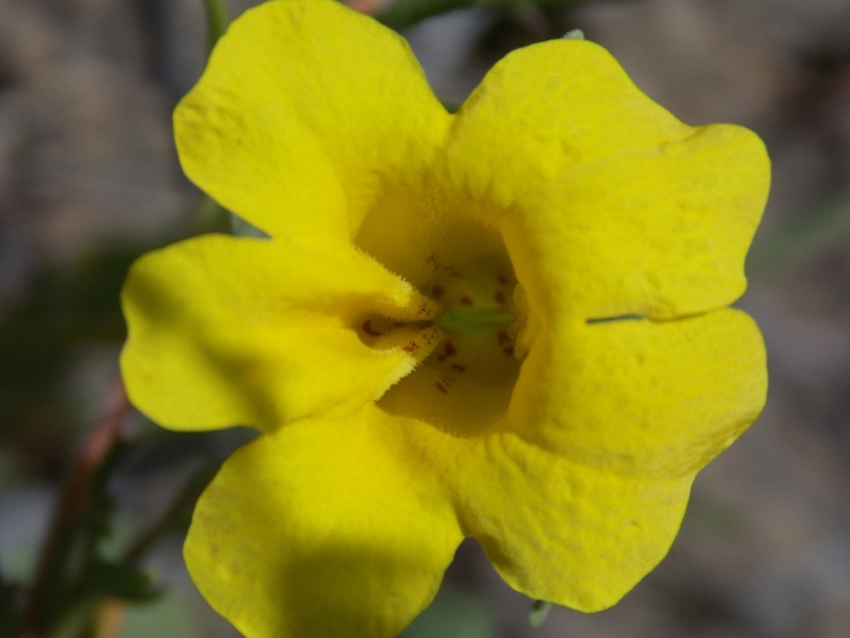
Yellow Monkey Flower
Diplacus brevipes
PHRYMACEAE – Lopseed Family

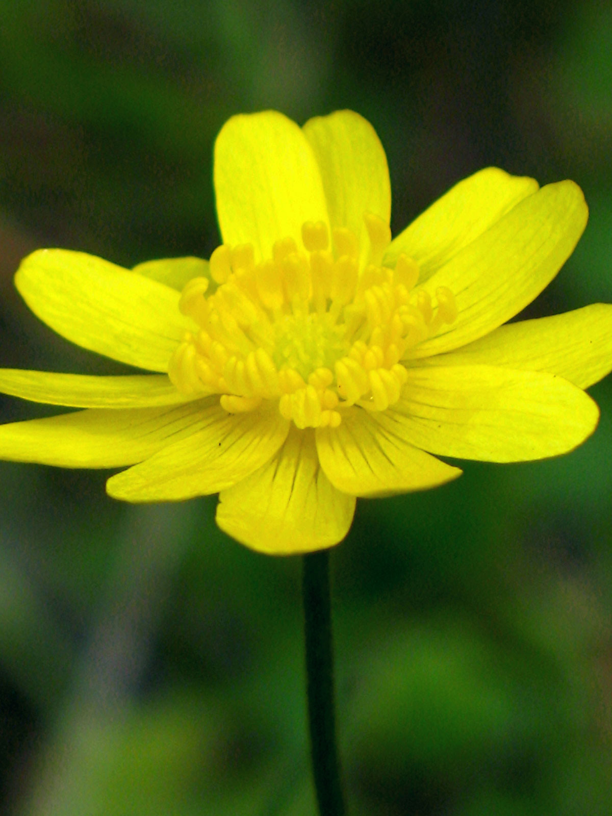
California Buttercup
Ranunculus californicus
RANUNCULACEAE - Buttercup Family

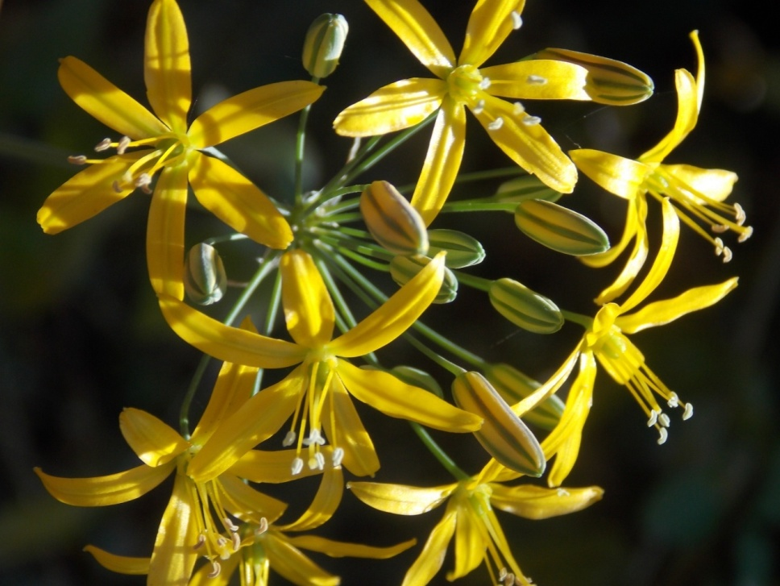
Golden Star
Bloomeria crocea
THEMIDACEAE - Brodiaea Family

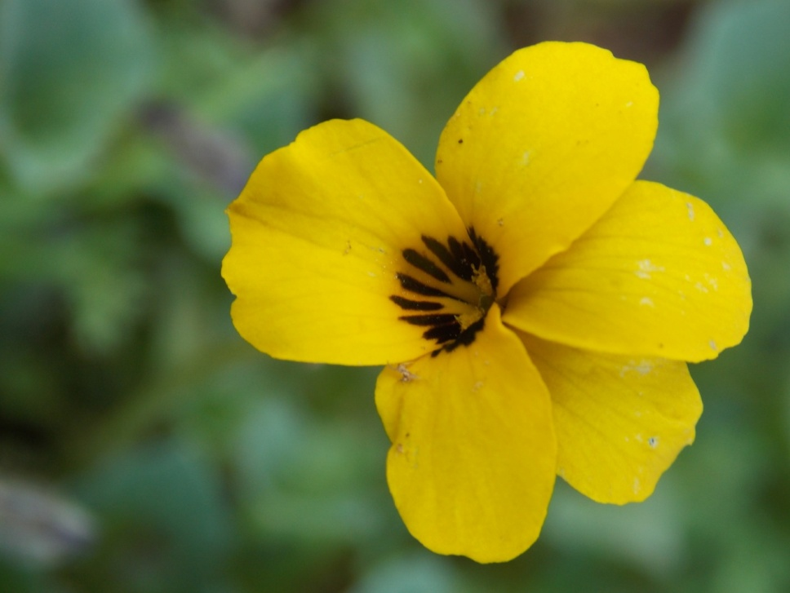
Johnny-jump-up
Viola pedunculata
VIOLACEAE - Violet Family

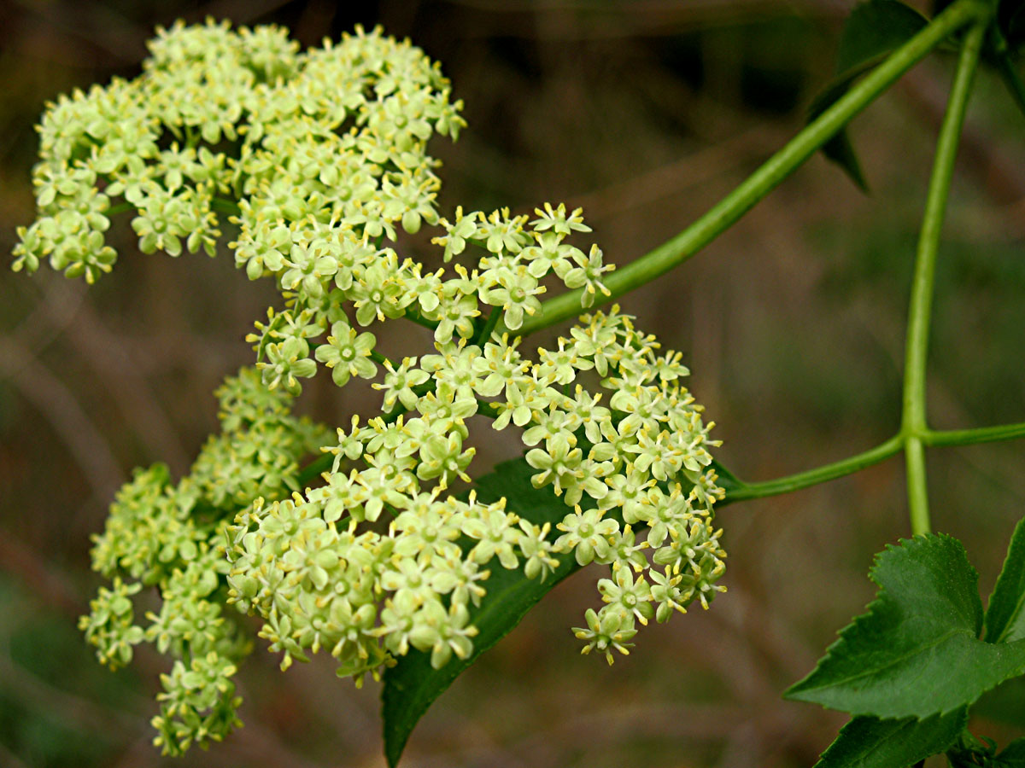
Elderberry
Sambucus nigra ssp. caerulea
ADOXACEAE – Muskroot Family

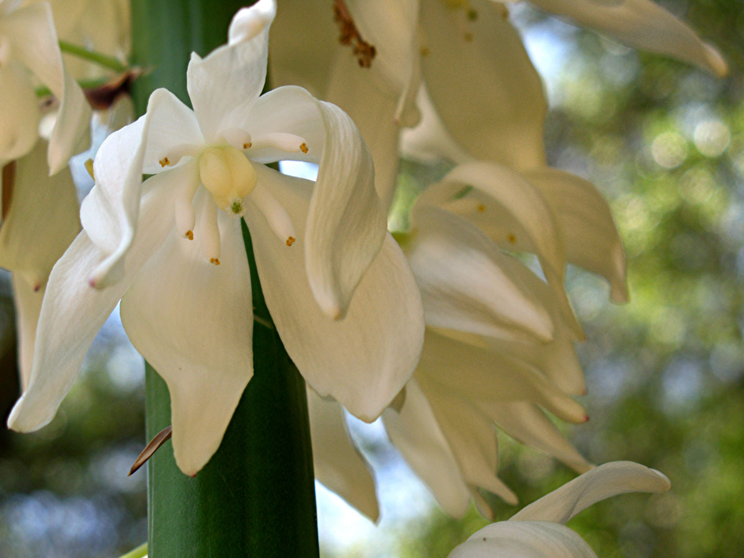
Yucca
Hesperoyucca whipplei
AGAVACEAE – Agave Family

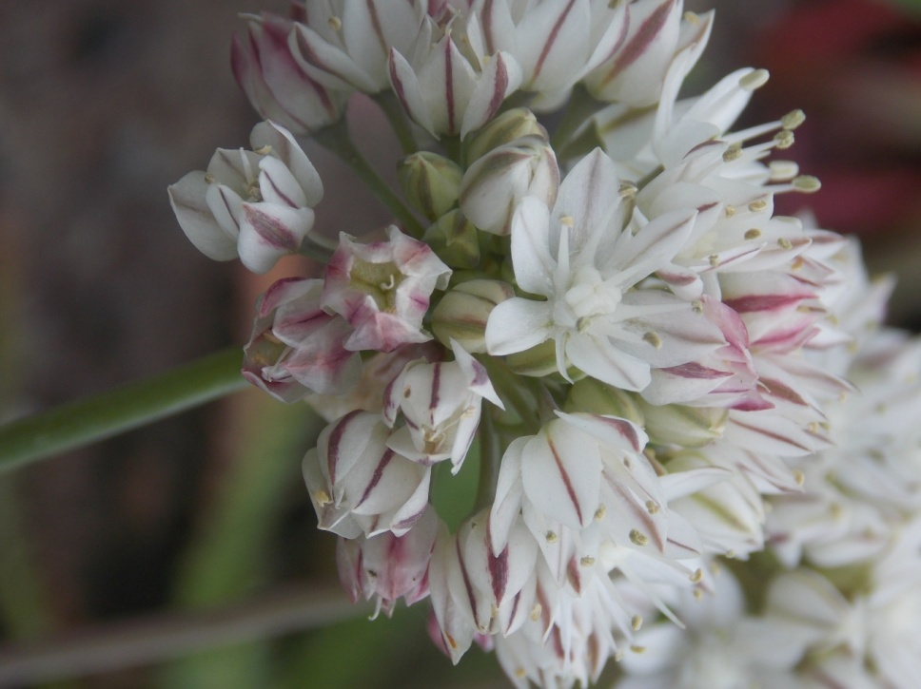
Red Skinned Onion
Allium haematochiton
ALLIACEAE – Onion Family

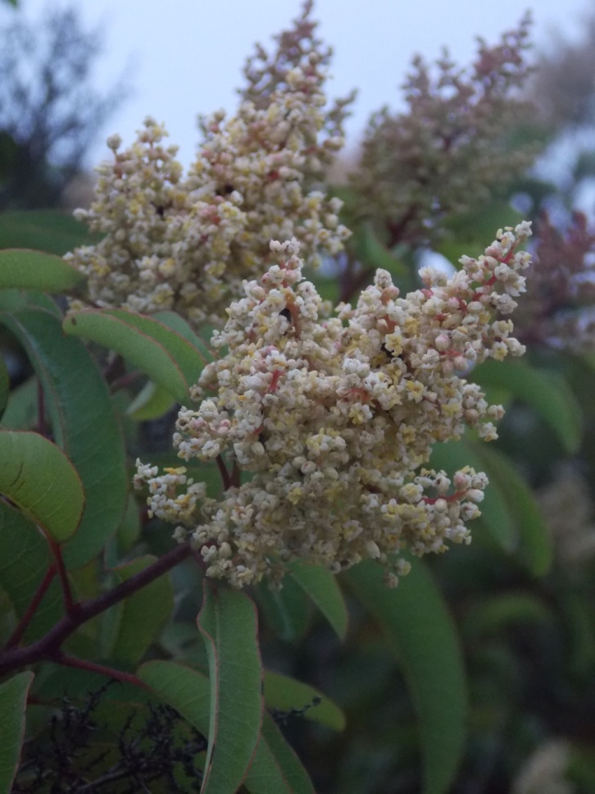
Laurel Sumac
Malosma laurina
ANACARDIACEAE – Sumac Family

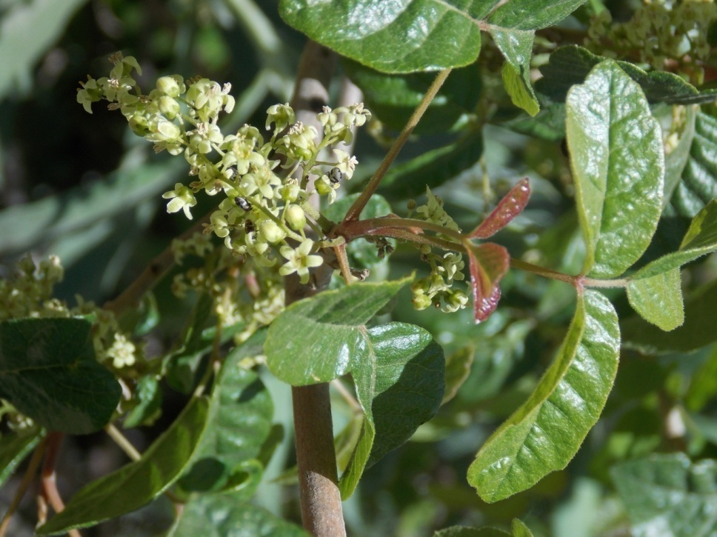
Poison Oak
Toxicodendron diversilobum
ANACARDIACEAE – Sumac Family

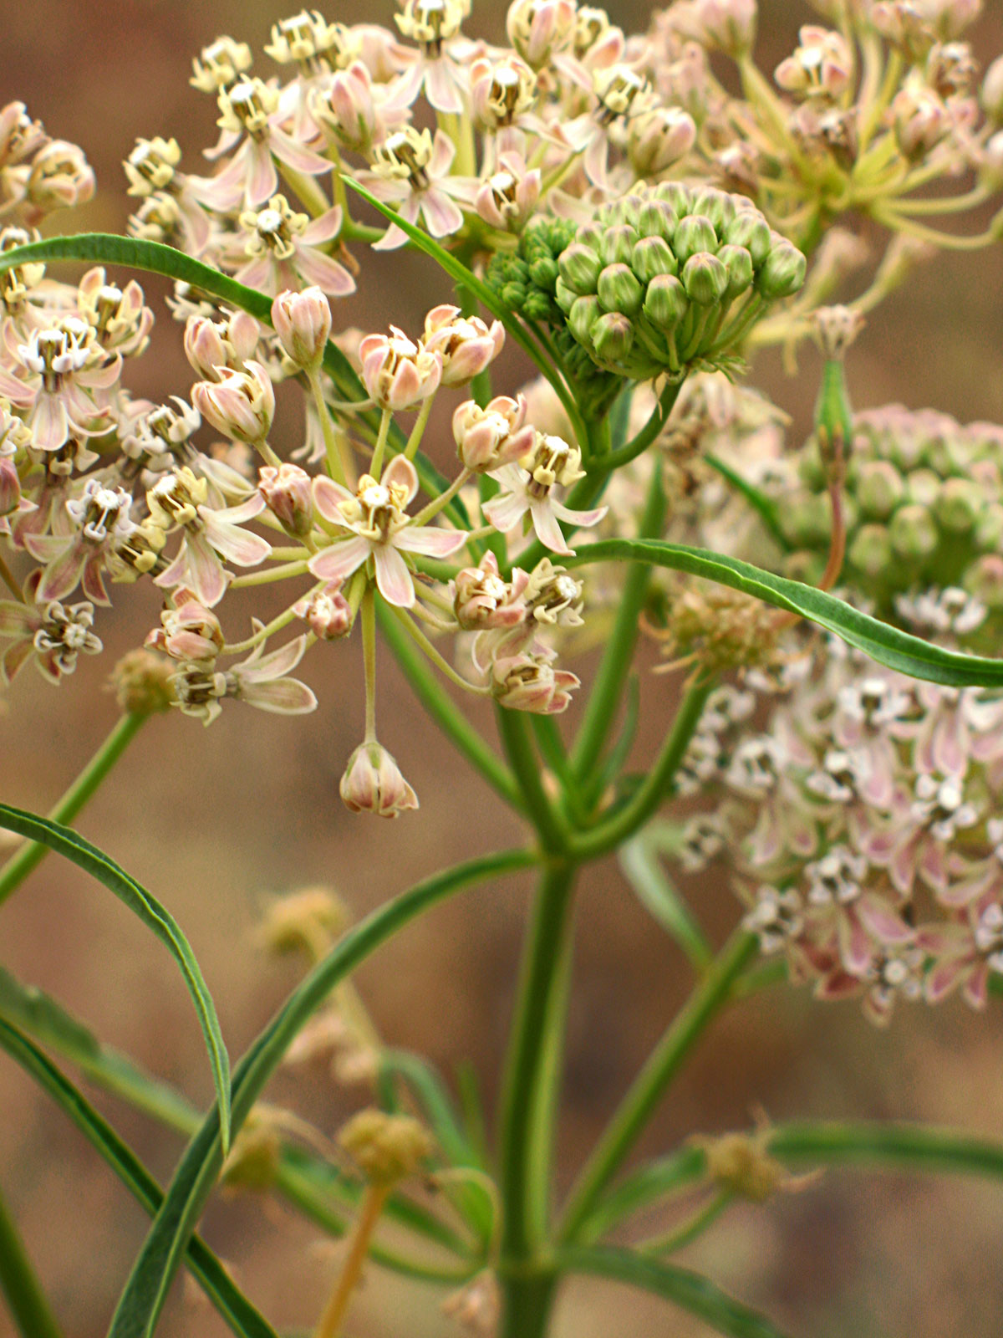
Narrow Leaved Milkweed
Asclepias fascicularis
APOCYNACEAE – Dogbane Family

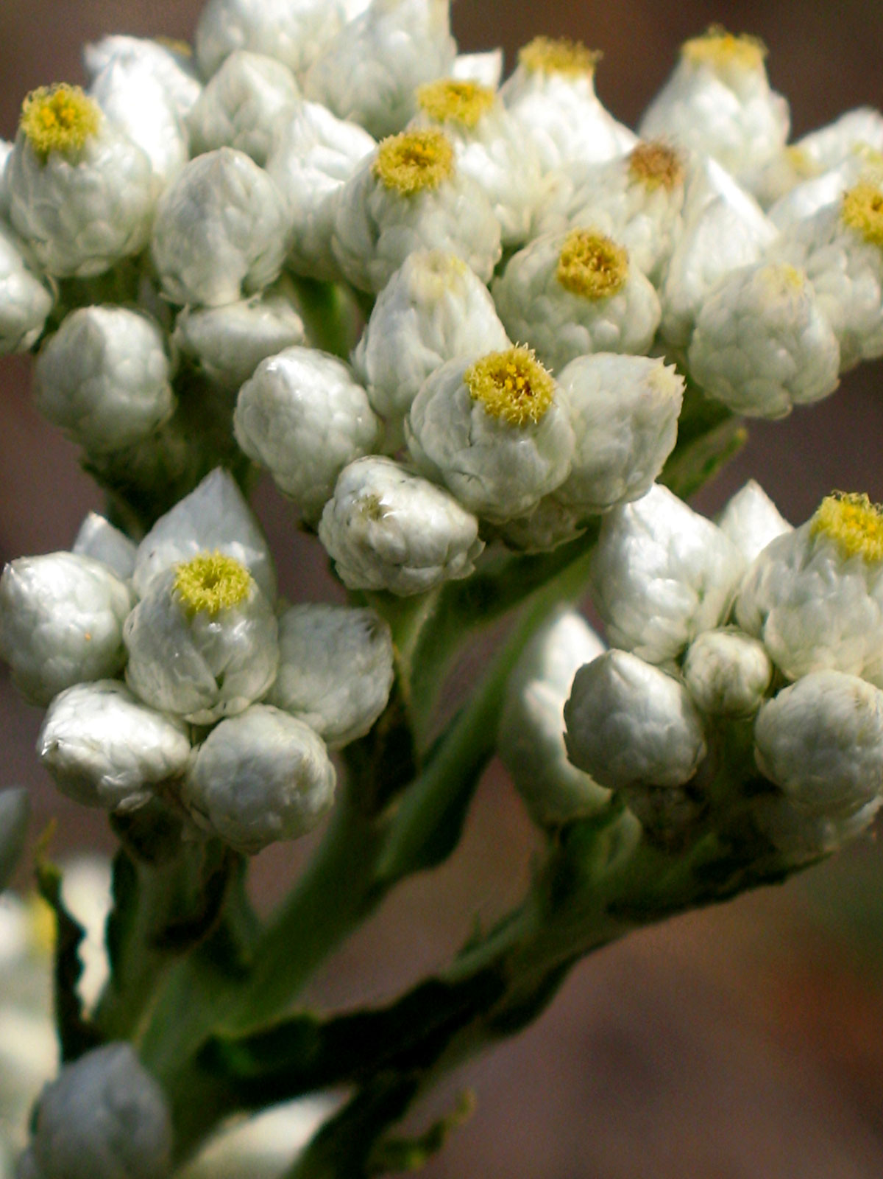
California Everlasting
Pseudognaphalium californicum
ASTERACEAE – Sunflower Family

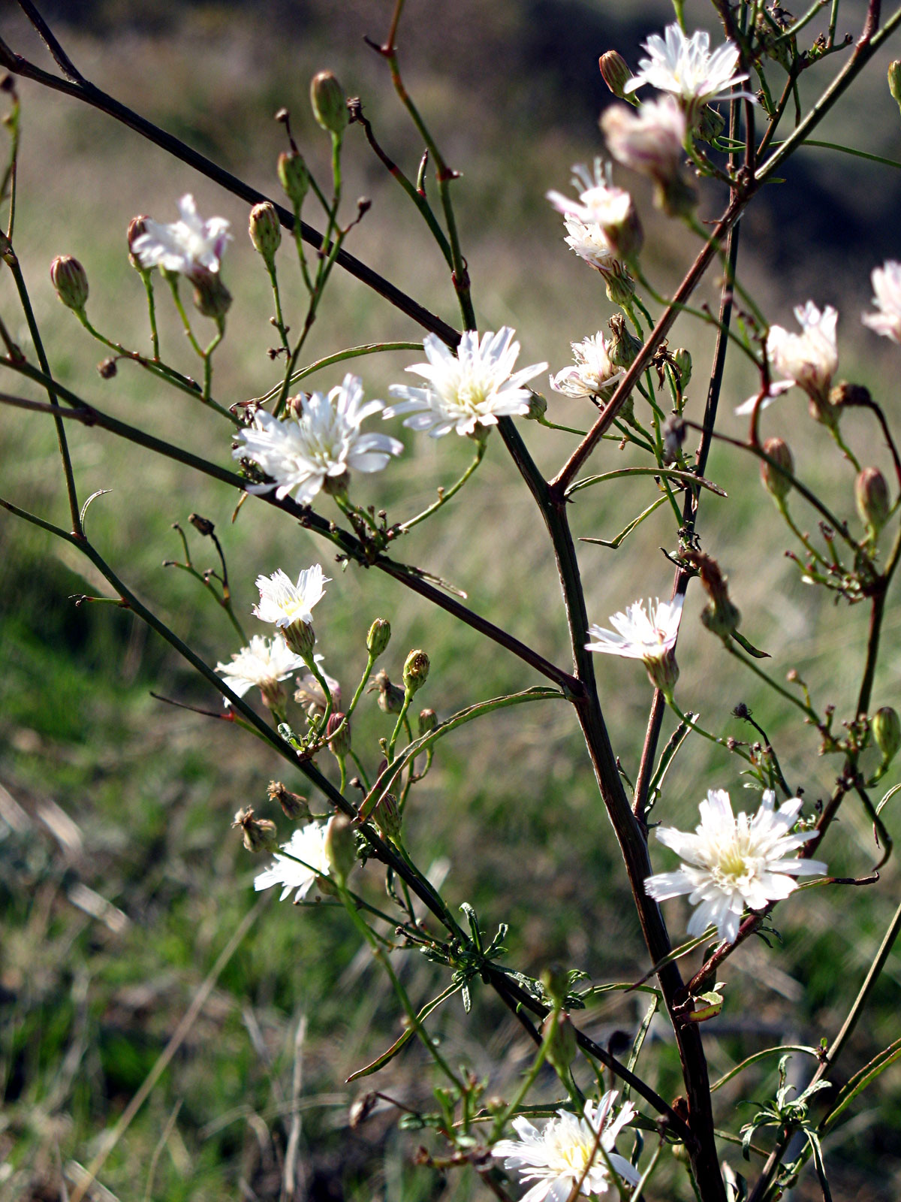
Cliff Aster
Malacothrix saxatilis
ASTERACEAE – Sunflower Family

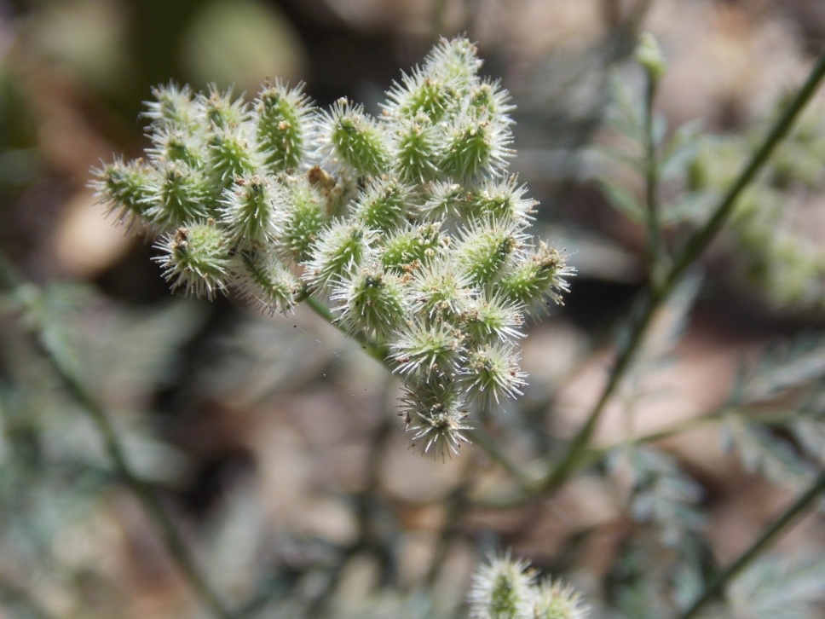
Cocklebur
Xanthium strumarium
ASTERACEAE – Sunflower Family

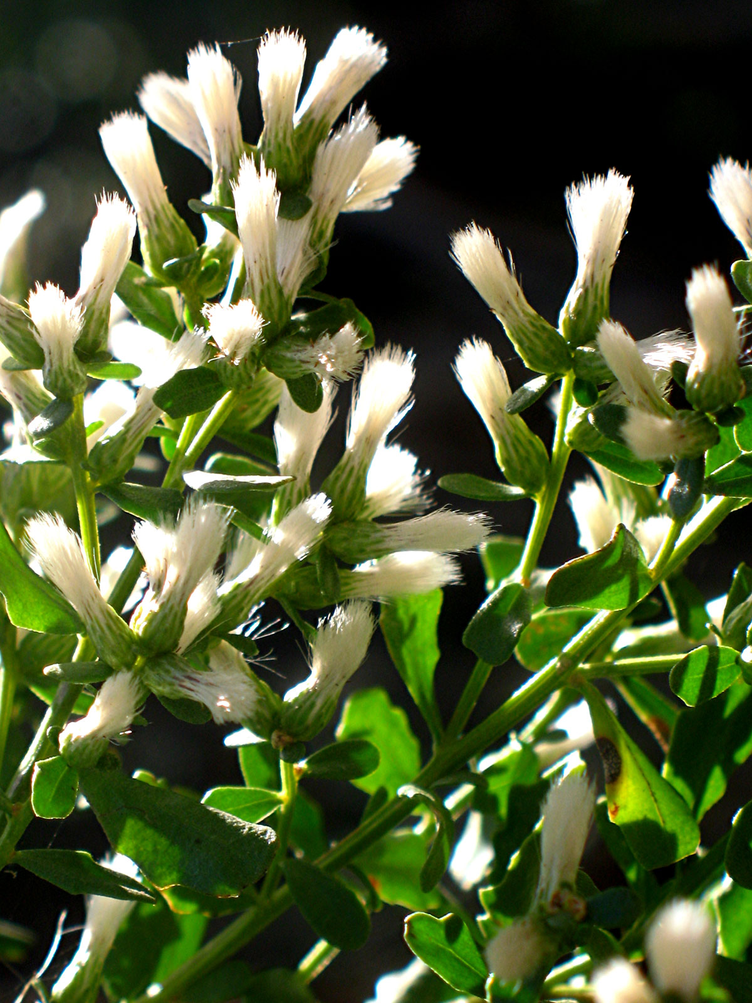
Coyote Brush
Baccharis pilularis
ASTERACEAE – Sunflower Family

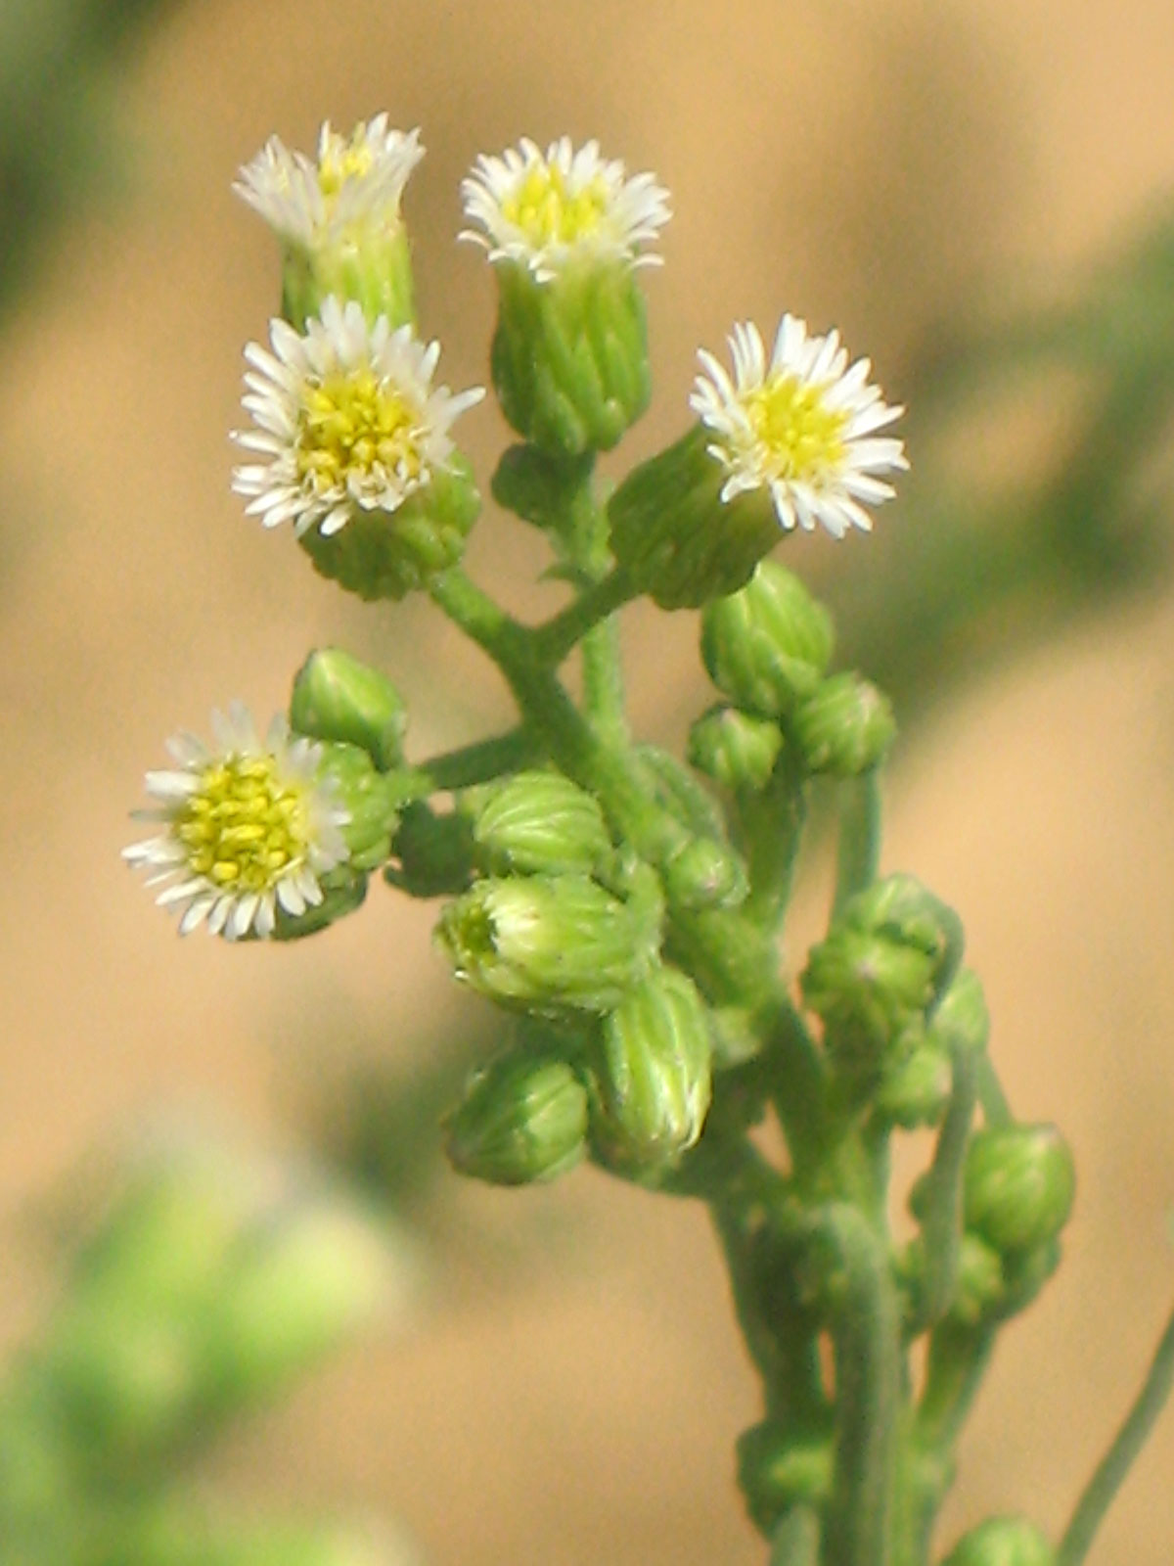
Horseweed
Erigeron canadensis
ASTERACEAE – Sunflower Family

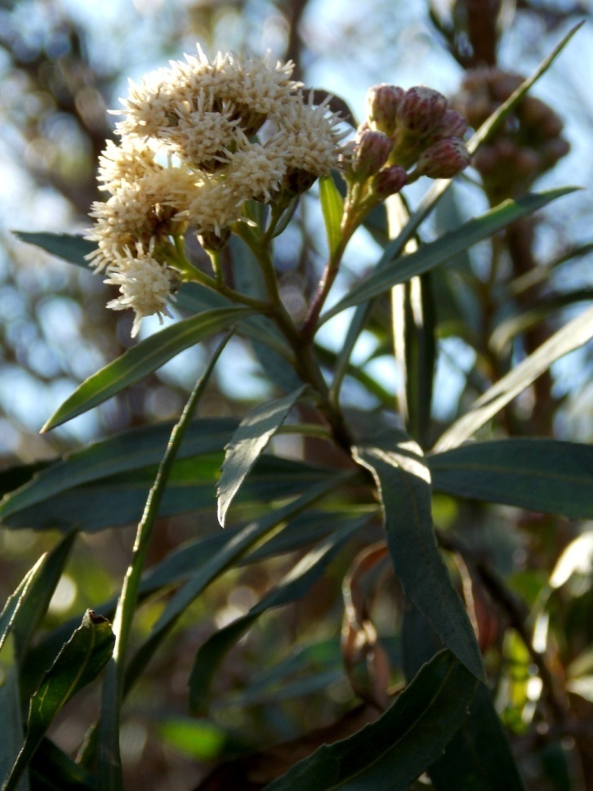
Mule Fat
Baccharis salicifolia
ASTERACEAE – Sunflower Family

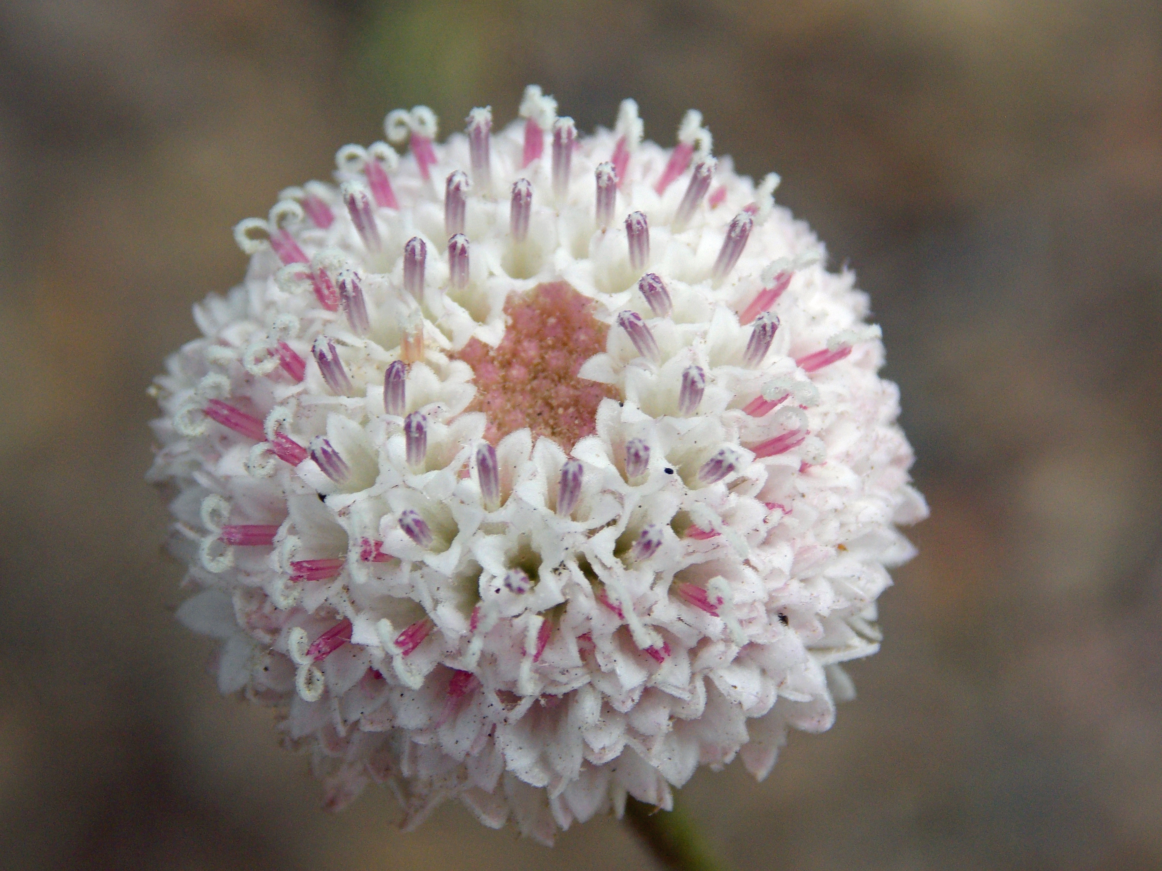
White Pin Cushion
Chaenactis artemisiifolia
ASTERACEAE – Sunflower Family

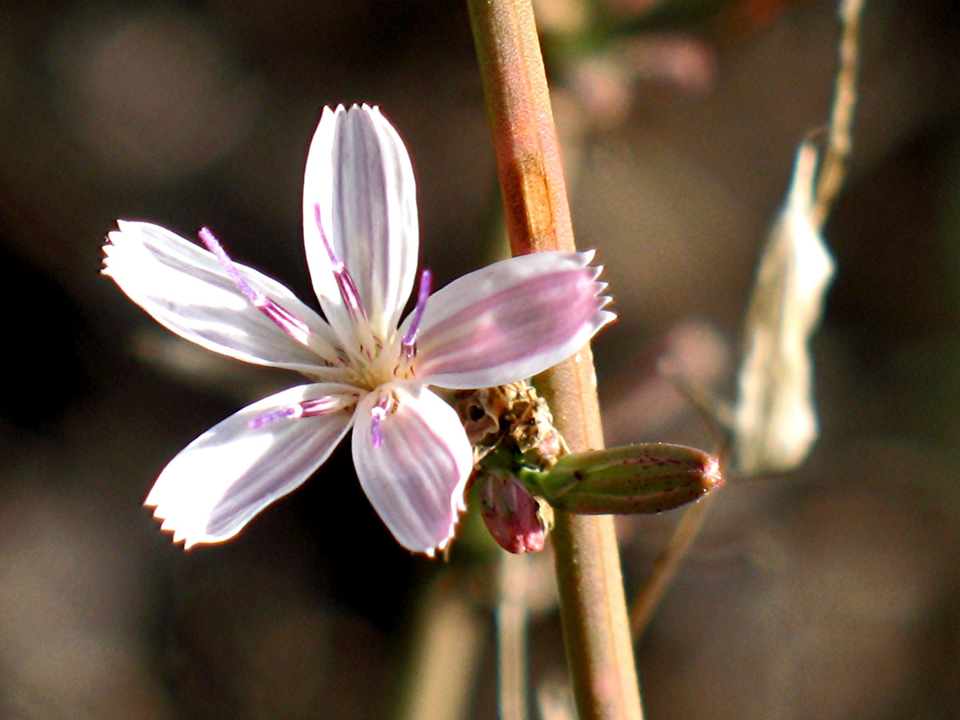
Wirelettuce
Stephanomeria pauciflora
ASTERACEAE – Sunflower Family

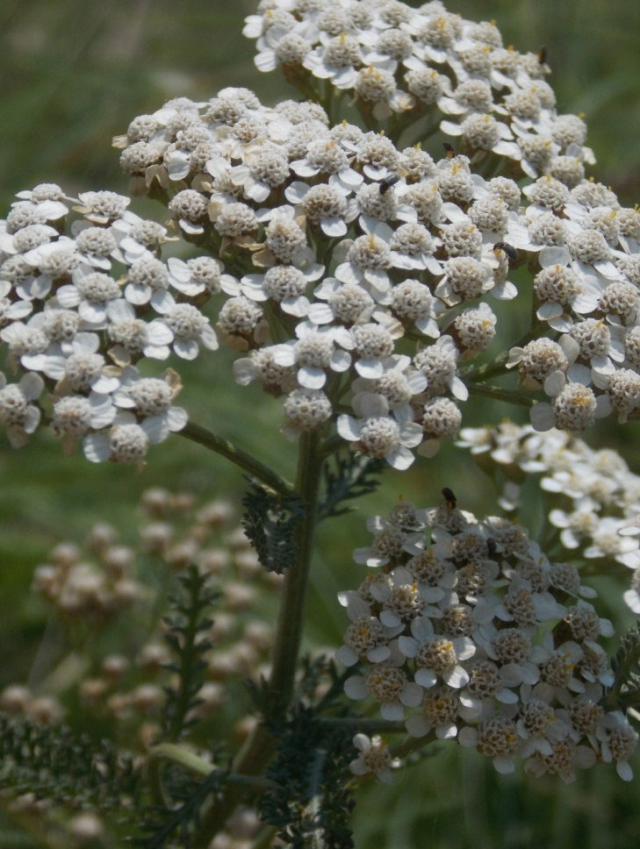
Yarrow
Achillea millefolium
ASTERACEAE – Sunflower Family

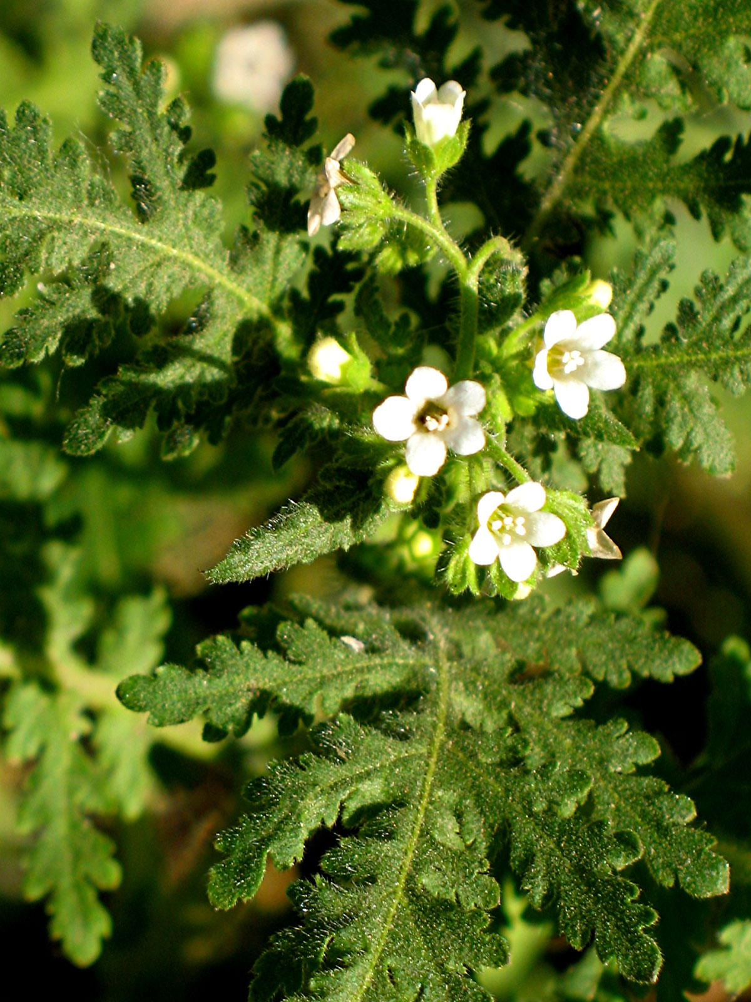
Eucrypta
Eucrypta chrysanthemifolia
BORAGINACEAE – Borage Family

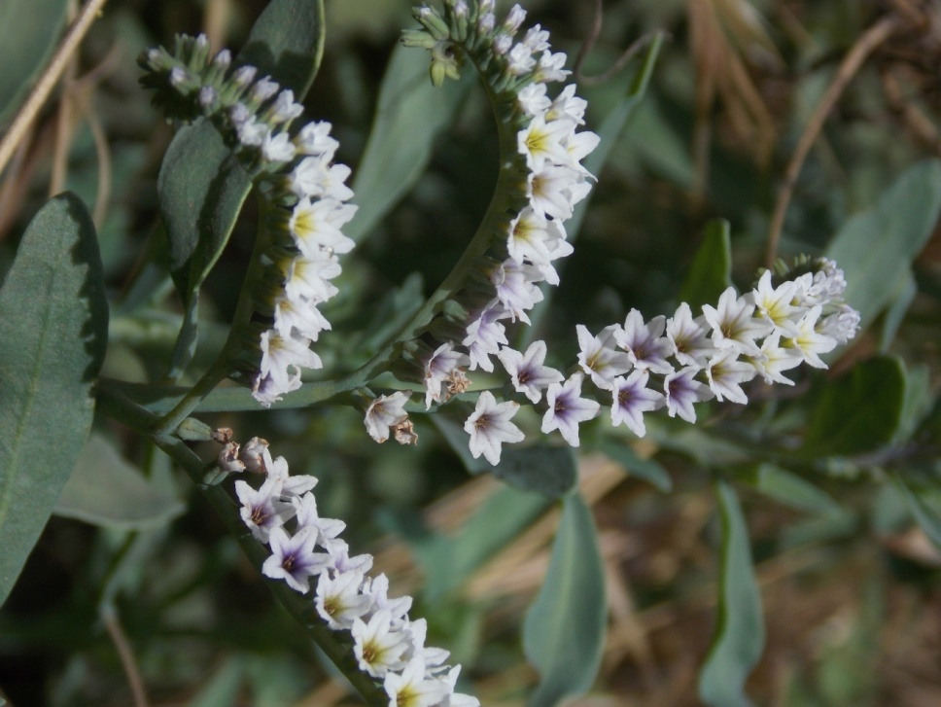
Heliotrope
Heliotropium curassavicum
BORAGINACEAE – Borage Family

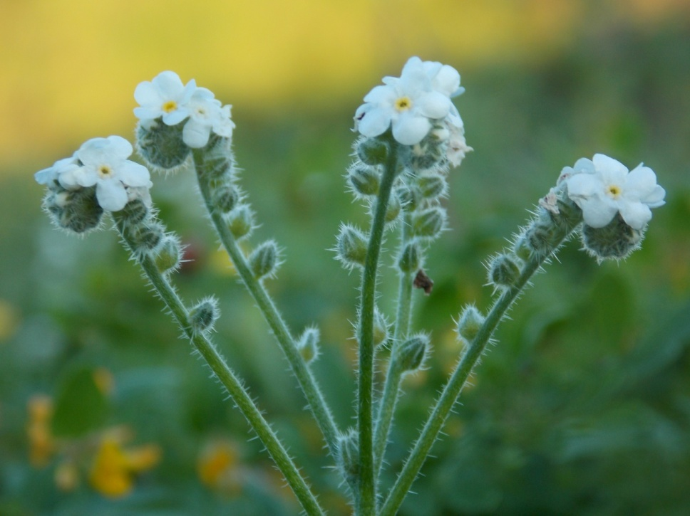
Prickly Popcorn Flower
Cryptantha muricata
BORAGINACEAE – Borage Family

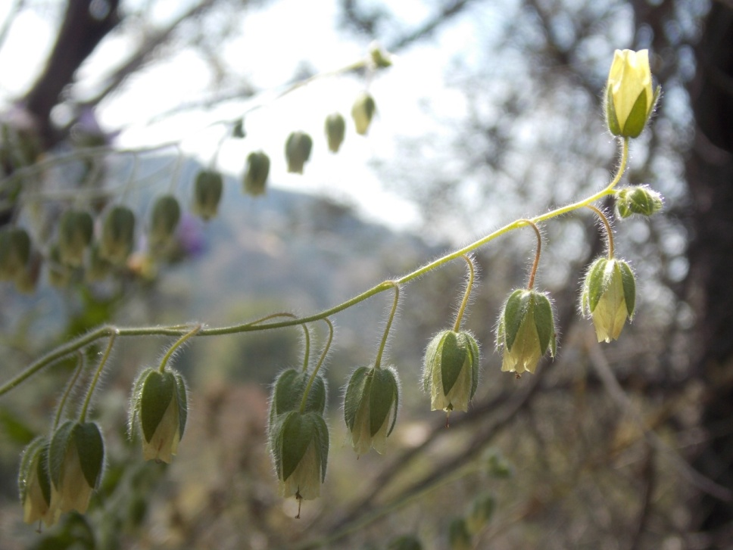
Whispering Bells
Emmenanthe penduliflora
BORAGINACEAE – Borage Family

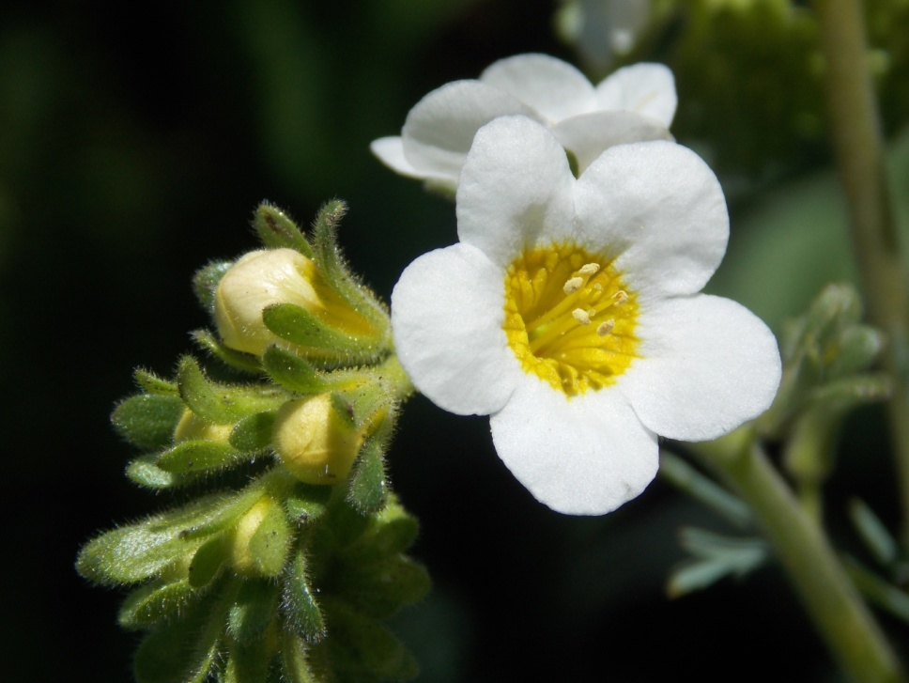
Yellow Throated Phacelia
Phacelia brachyloba
BORAGINACEAE – Borage Family

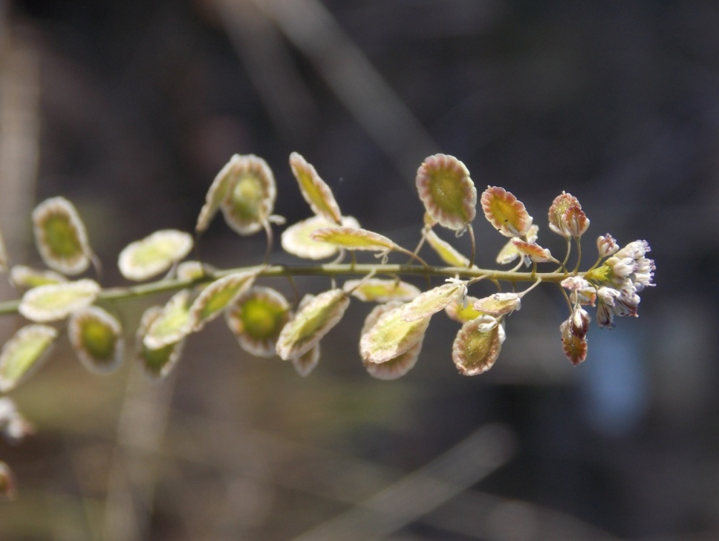
Lacepod
Thysanocarpus curvipes
BRASSICACEAE – Mustard Family

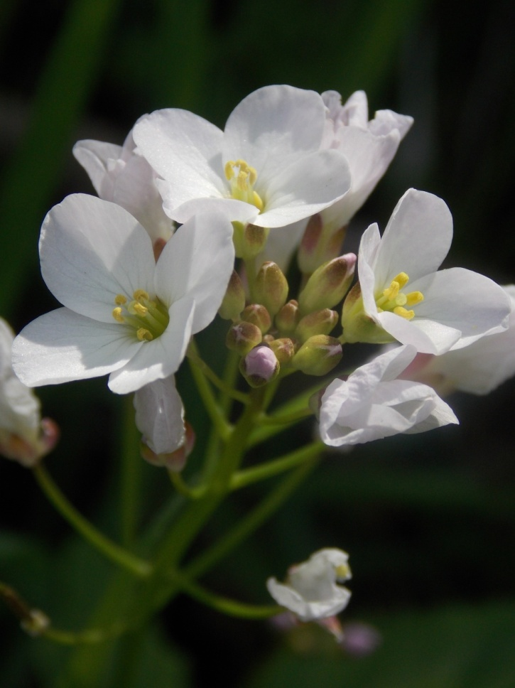
Milkmaids
Cardamine californica
BRASSICACEAE – Mustard Family

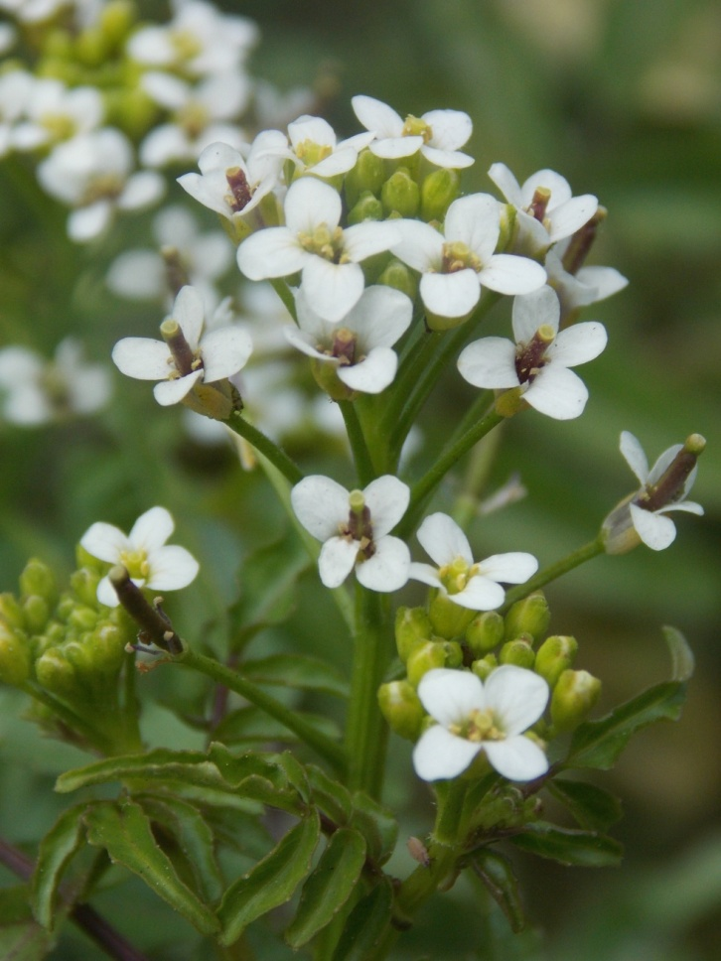
Watercress
Nasturtium officinale
BRASSICACEAE – Mustard Family

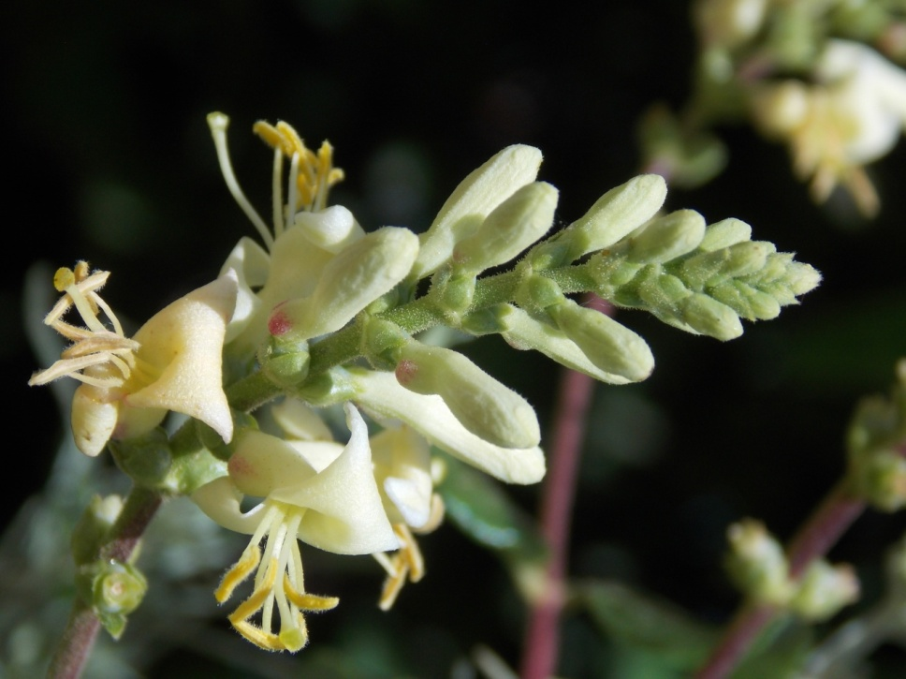
Chaparral Honeysuckle
Lonicera subspicata
CAPRIFOLIACEAE – Honeysuckle Family

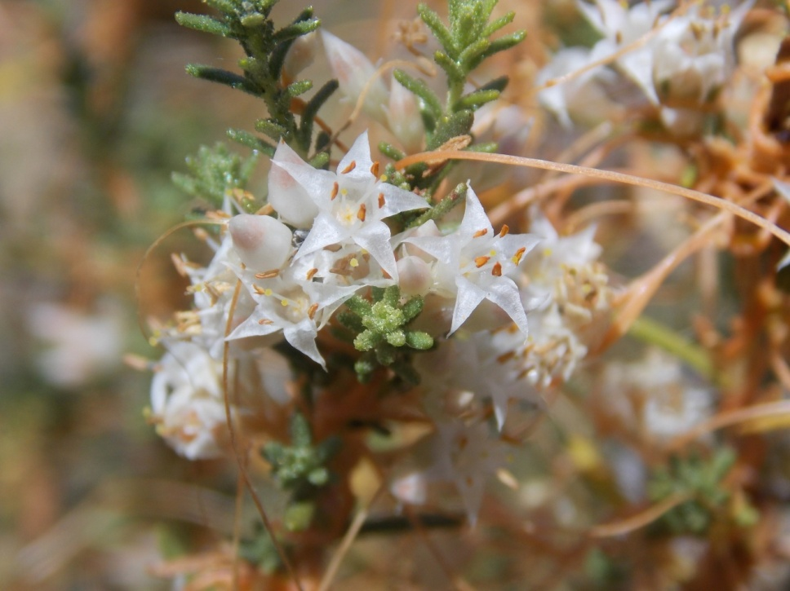
California Dodder
Cuscuta californica
CONVOLVULACEAE – Morning Glory Family

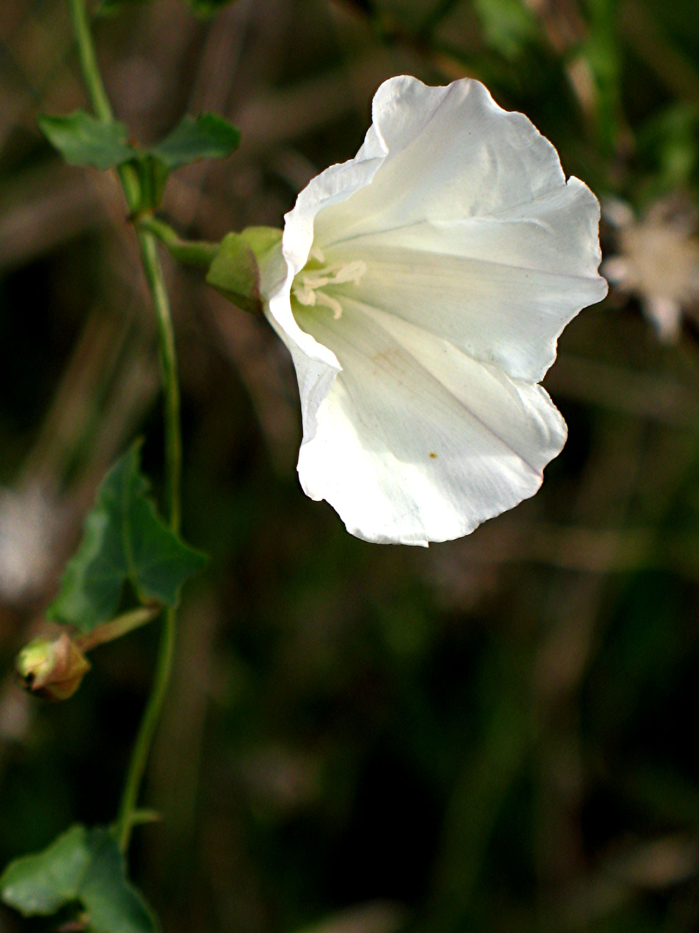
Morning Glory
Calystegia macrostegia
CONVOLVULACEAE – Morning-Glory Family

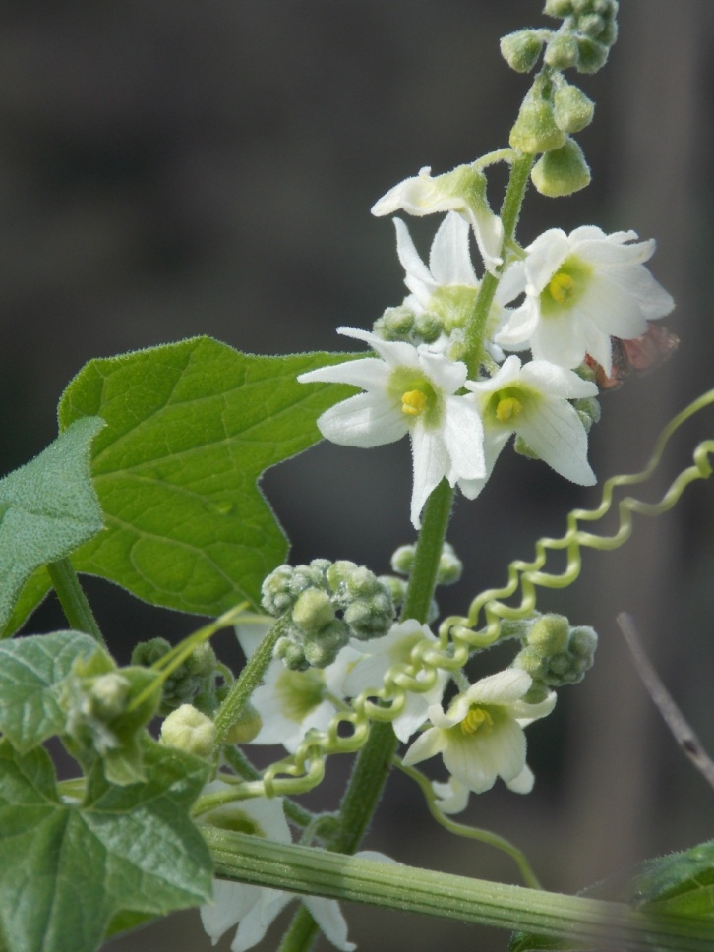
Wild Cucumber
Marah macrocarpus
CUCURBITACEAE – Gourd Family

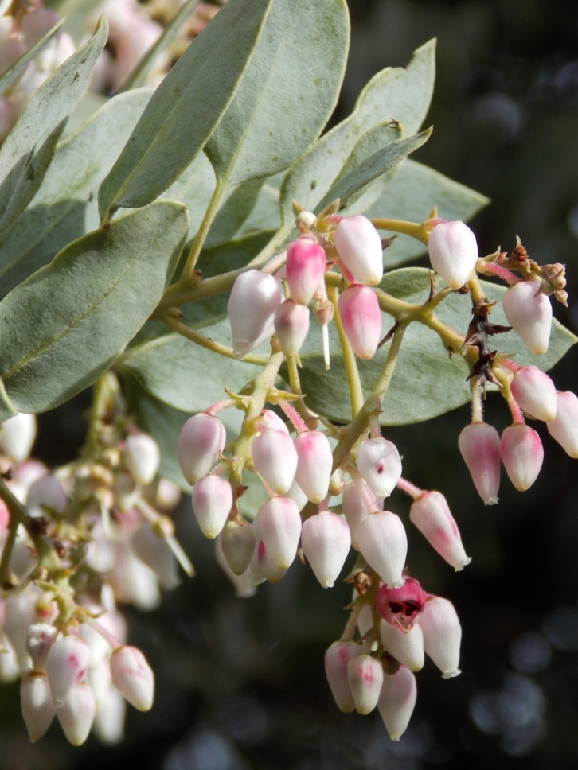
Bigberry Manzanita
Arctostaphylos glauca
ERICACEAE – Heath Family

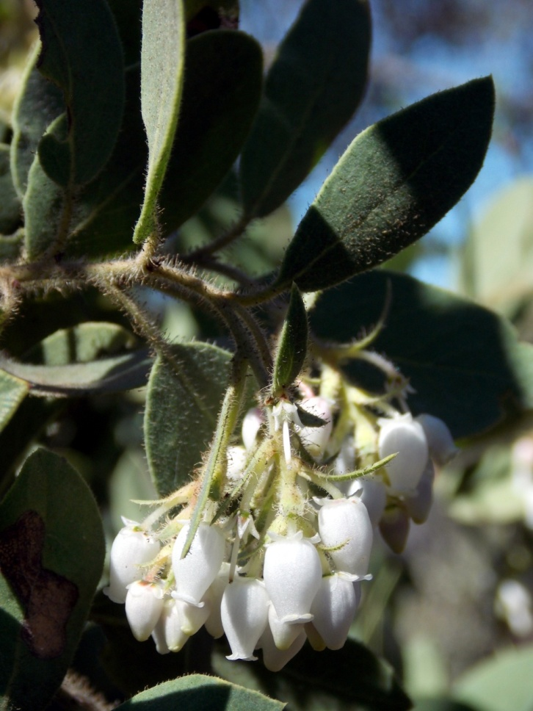
Eastwood Manzanita
Arctostaphylos glandulosa
ERICACEAE – Heath Family

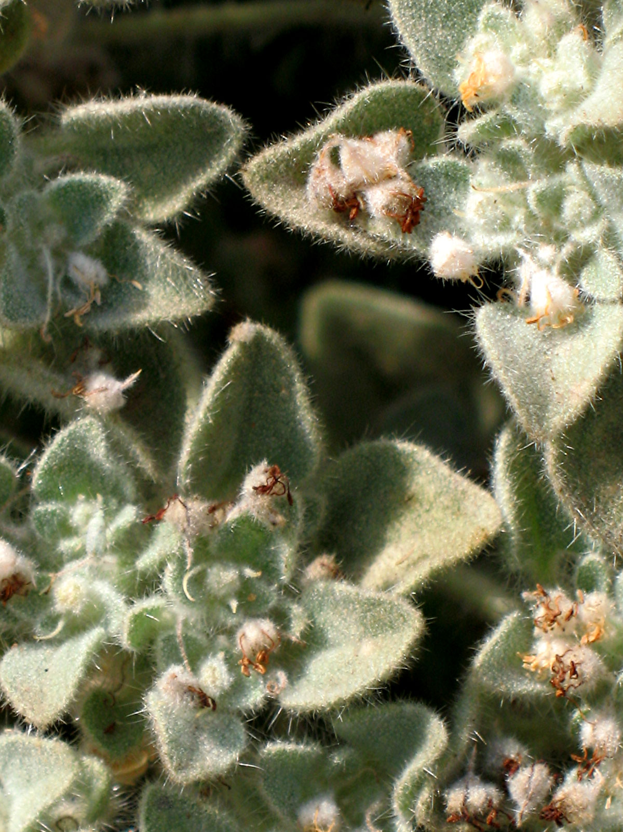
Doveweed
Croton setiger
EUPHORBIACEAE – Spurge Family

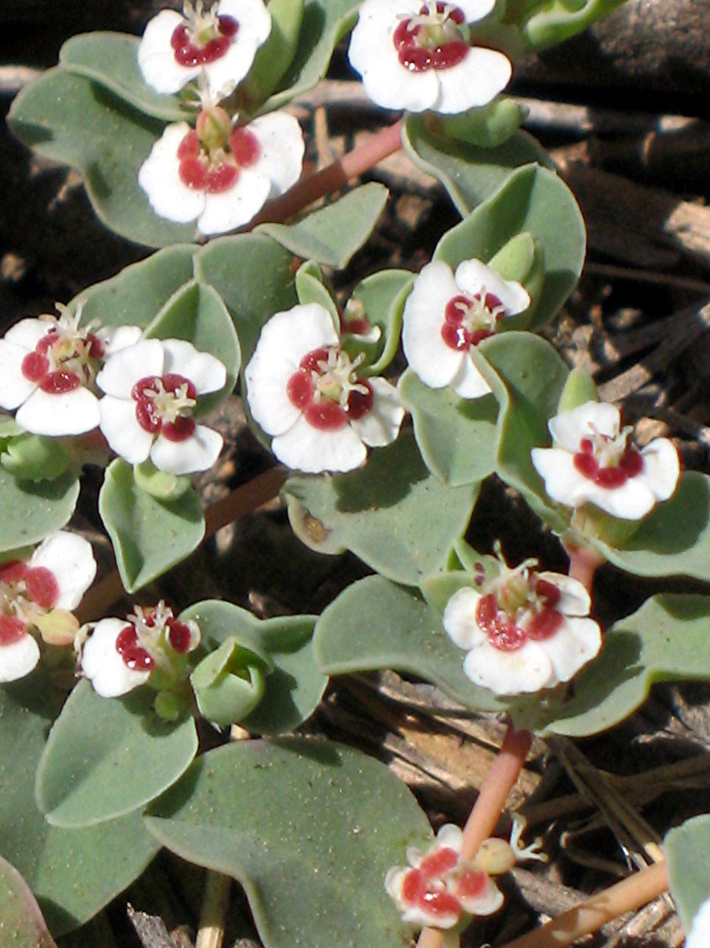
Rattlesnake Weed
Euphorbia albomarginata
EUPHORBIACEAE – Spurge Family

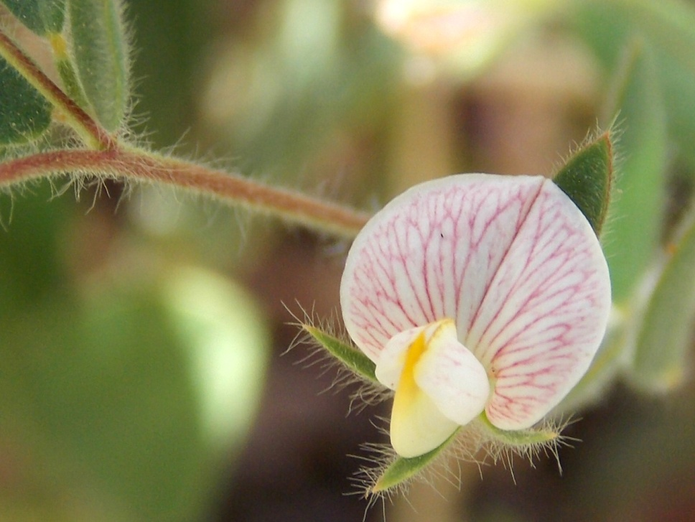
American Bird’s Foot Trefoil
Acmispon americanus
FABACEAE – Pea Family

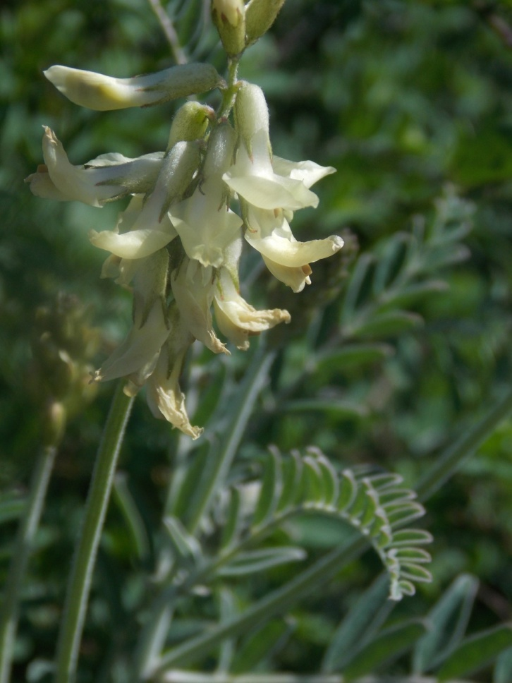
Milkvetch
Astragalus trichopodus var. lonchus
FABACEAE – Pea Family

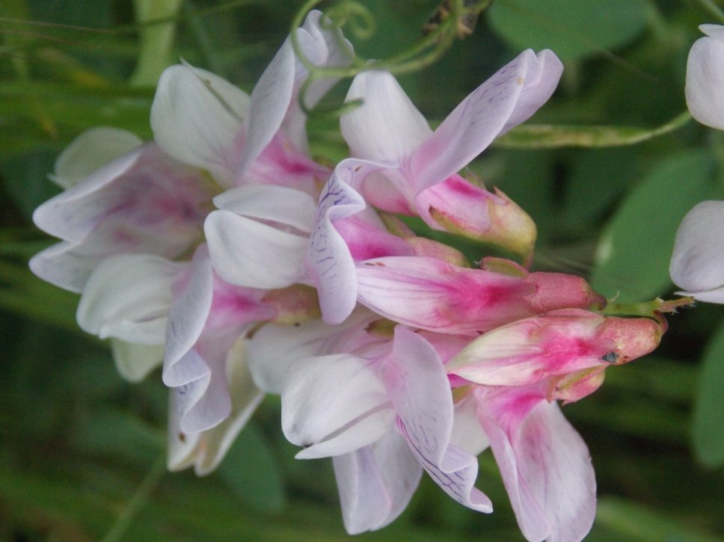
Wild Sweet Pea

Lathyrus vestitus
FABACEAE – Pea Family

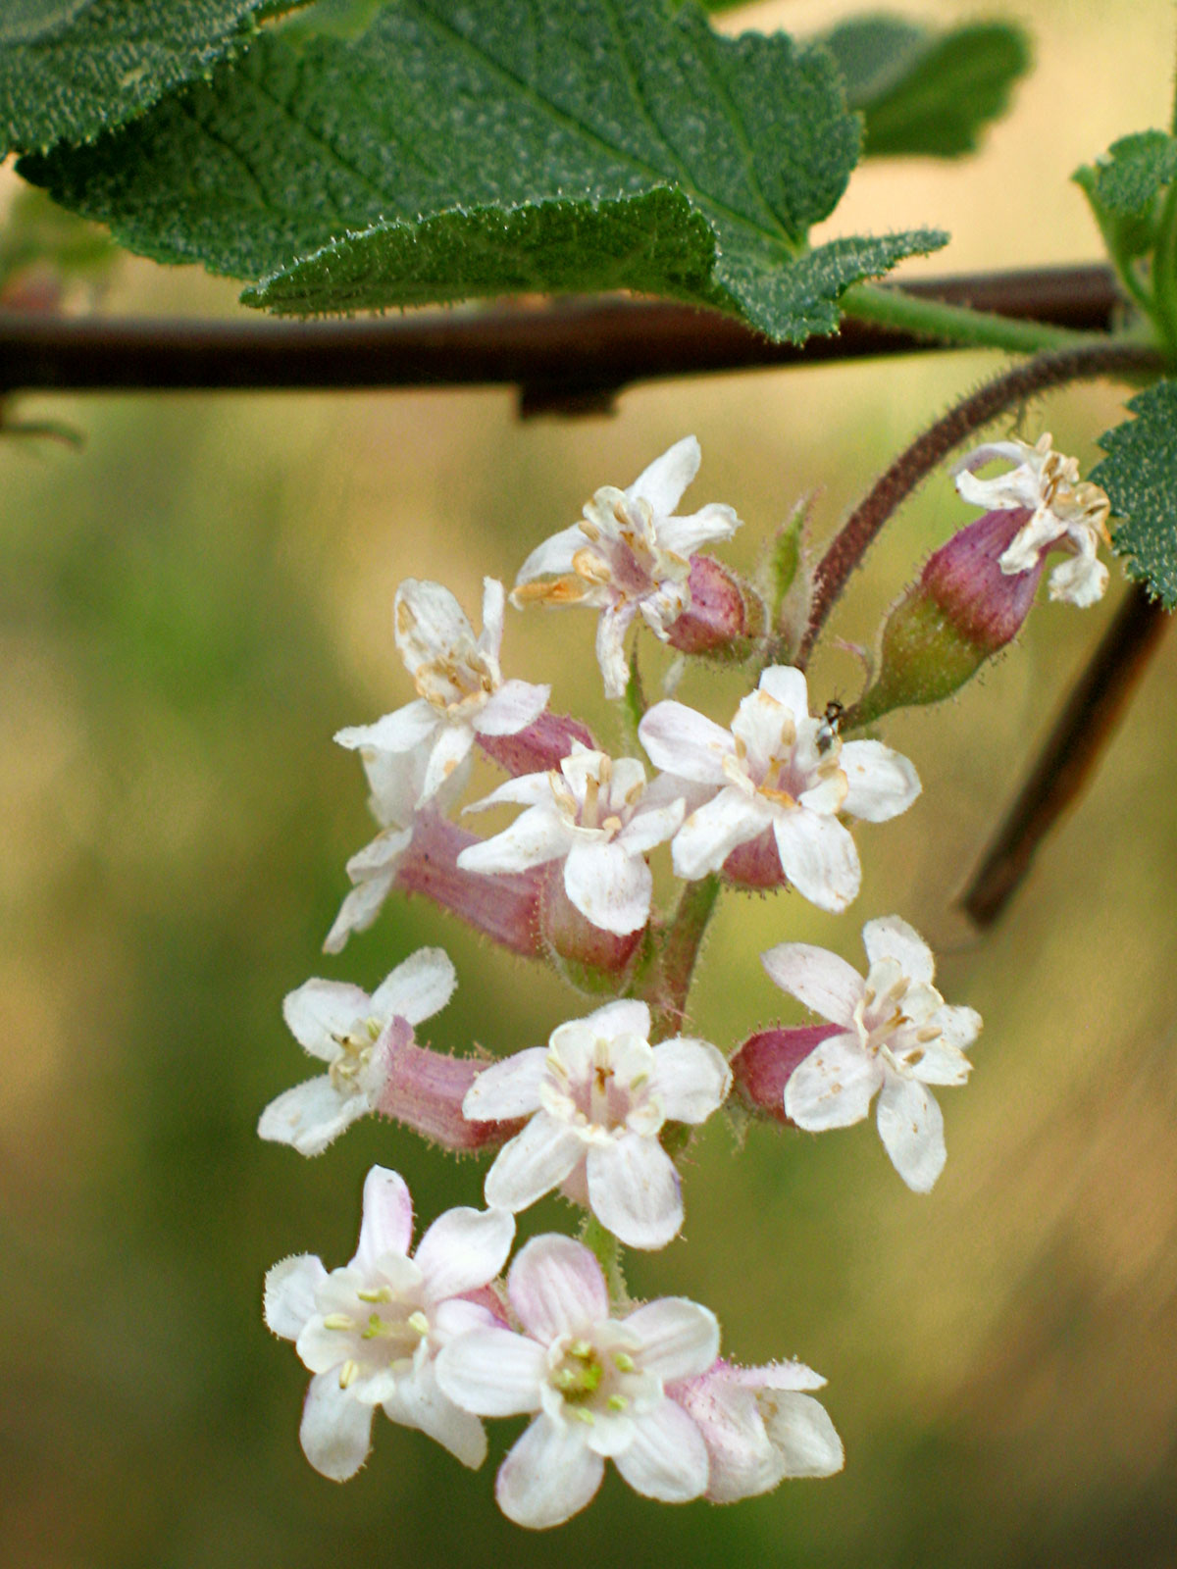
White Currant
Ribes indecorum
GROSSULARIACEAE – Gooseberry Family

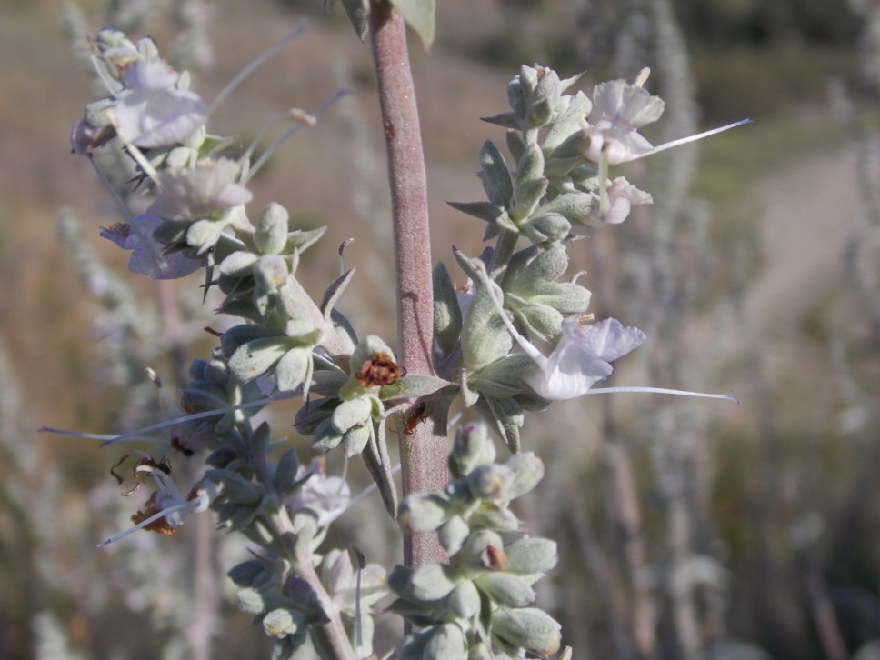
White Sage
Salvia apiana
LAMIACEAE – Mint Family

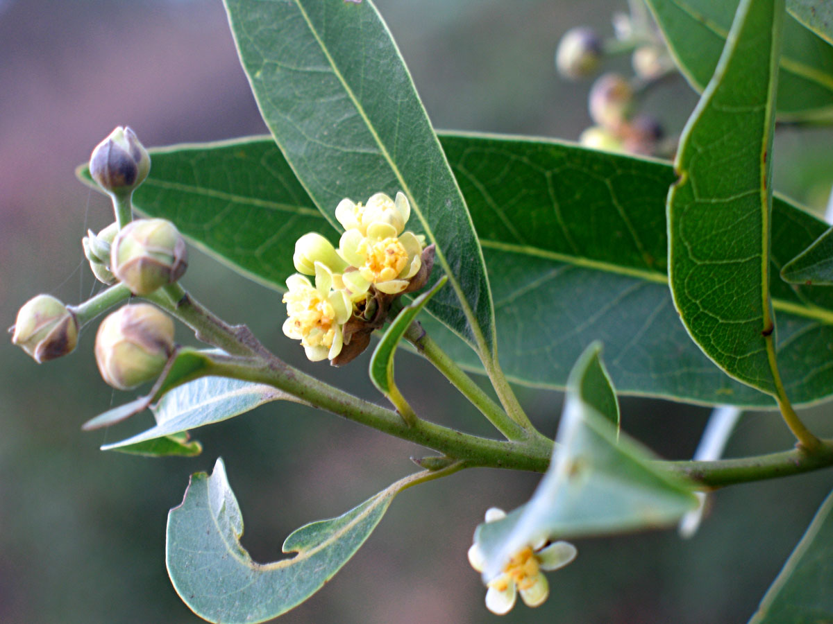
California Bay
Umbellularia californica
LAURACEAE – Laurel Family

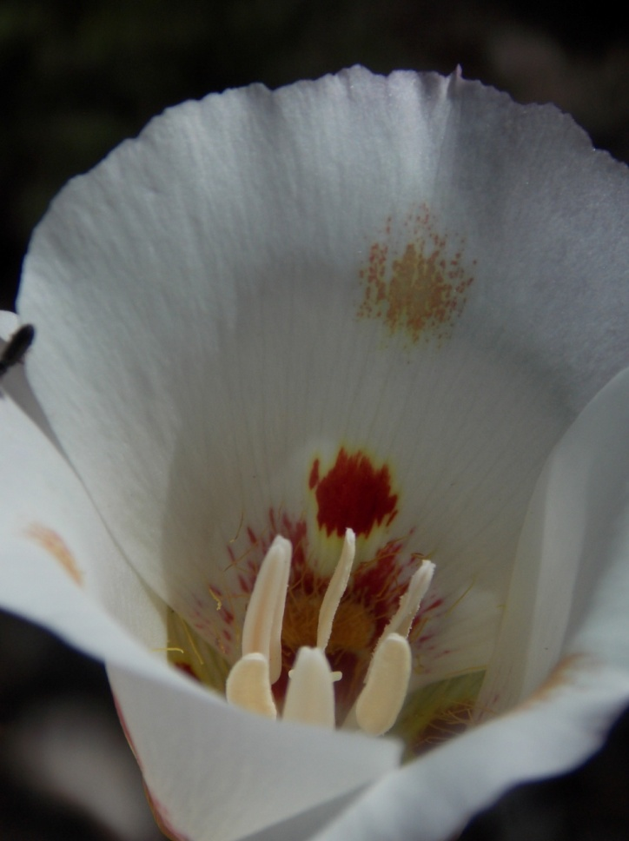
Butterfly Mariposa Lily
Calochortus venustus
LILIACEAE – Lily Family

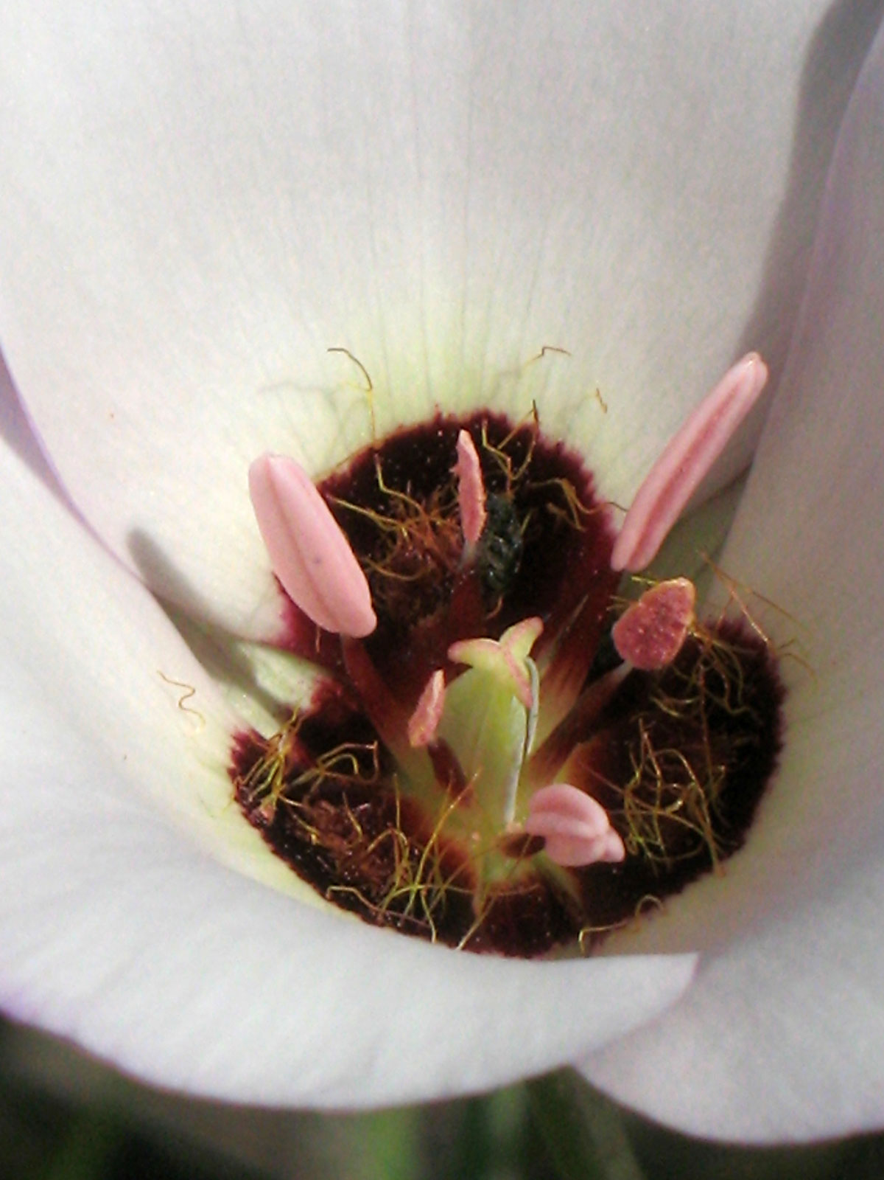
Catalina Mariposa Lily
Calochortus catalinae
LILIACEAE – Lily Family

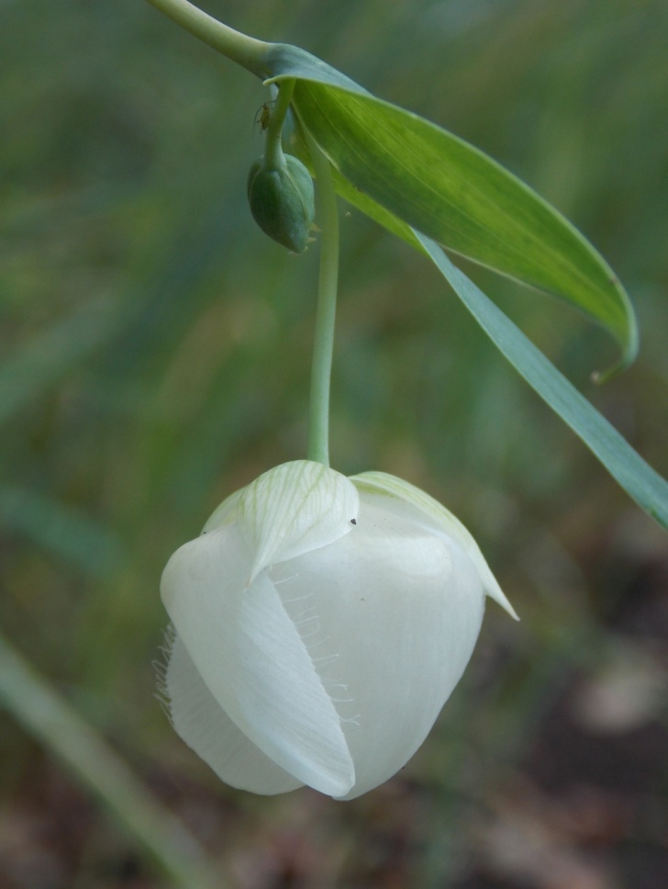
Globe Lily
Calochortus albus
LILIACEAE – Lily Family

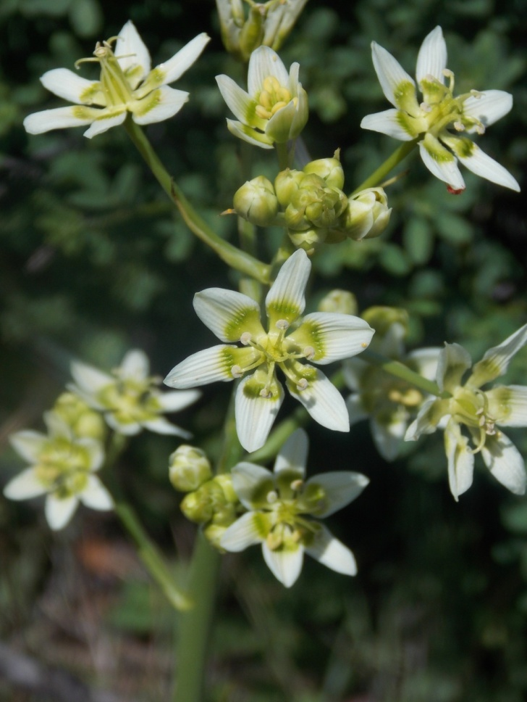
Star Lily
Toxicoscordion fremontii
MELANTHIACEAE – Bunchflower Family

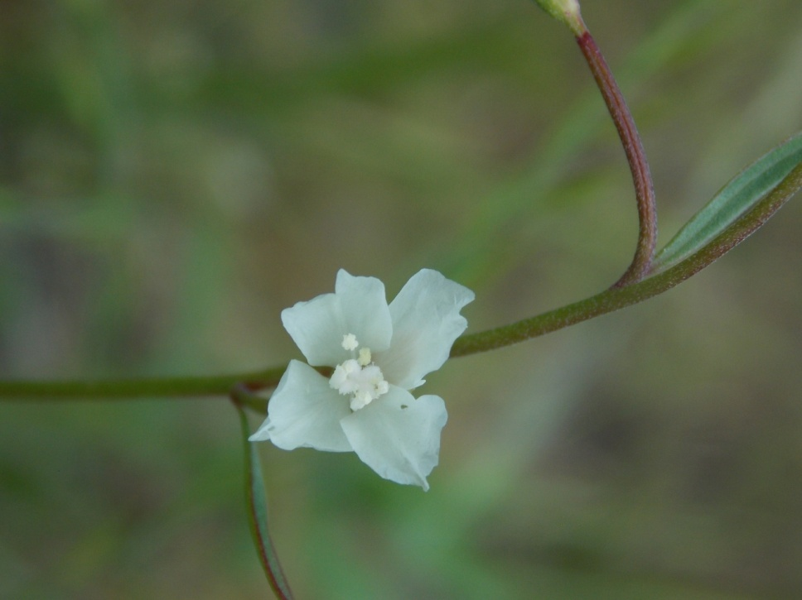
Willow Herb Clarkia
Clarkia epilobioides
ONAGRACEAE – Evening Primrose Family

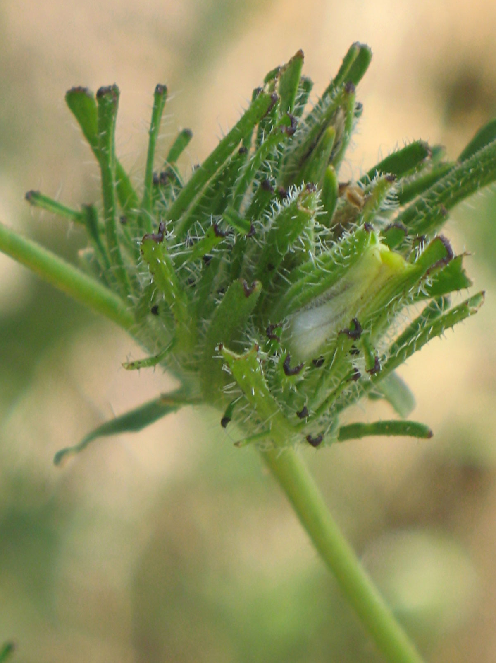
Bird’s Beak
Cordylanthus rigidus
OROBANCHACEAE – Broomrape Family

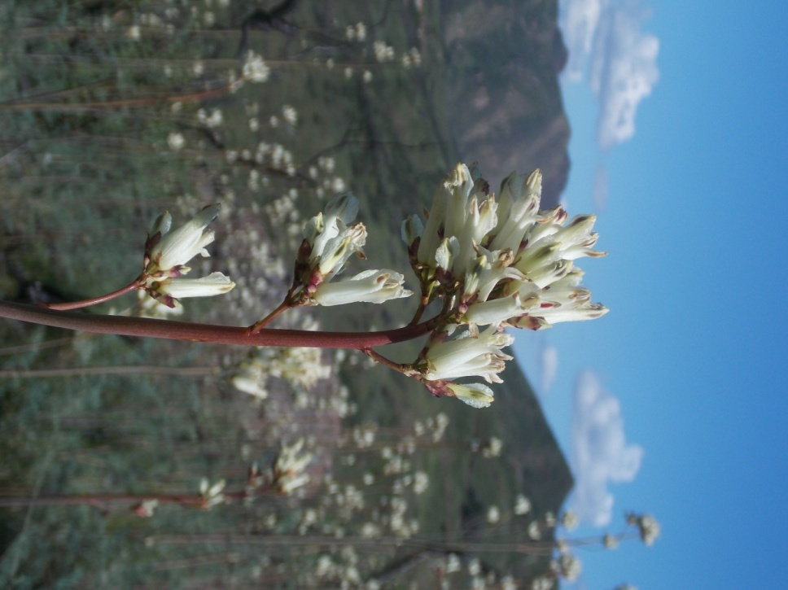
Bleeding Heart
Ehrendorferia ochroleuca
PAPAVERACEAE – Poppy Family

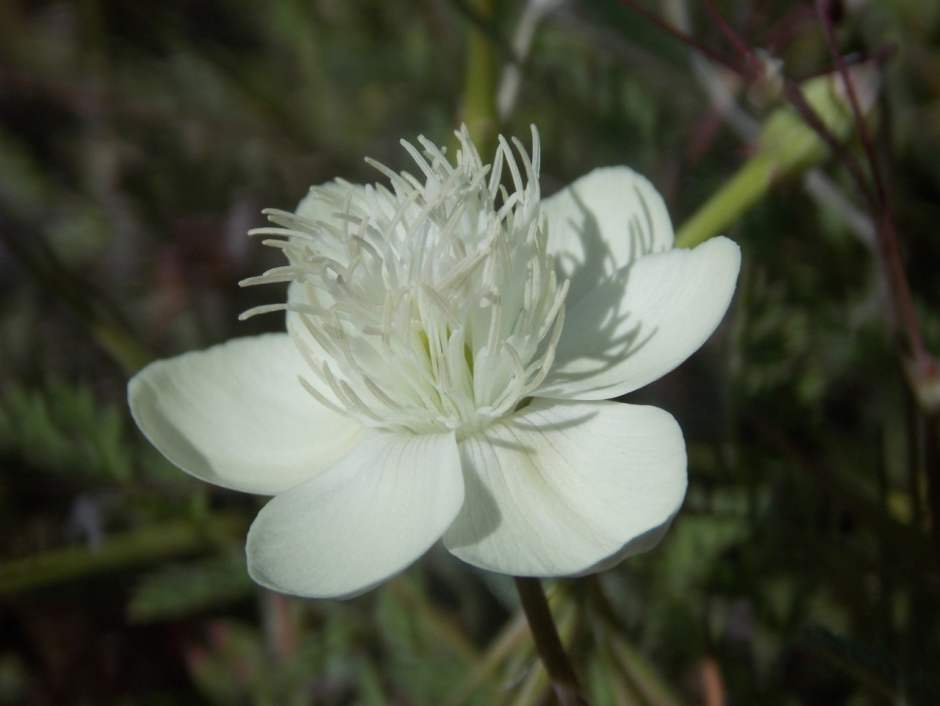
Cream Cups
Platystemon californicus
PAPAVERACEAE – Poppy Family

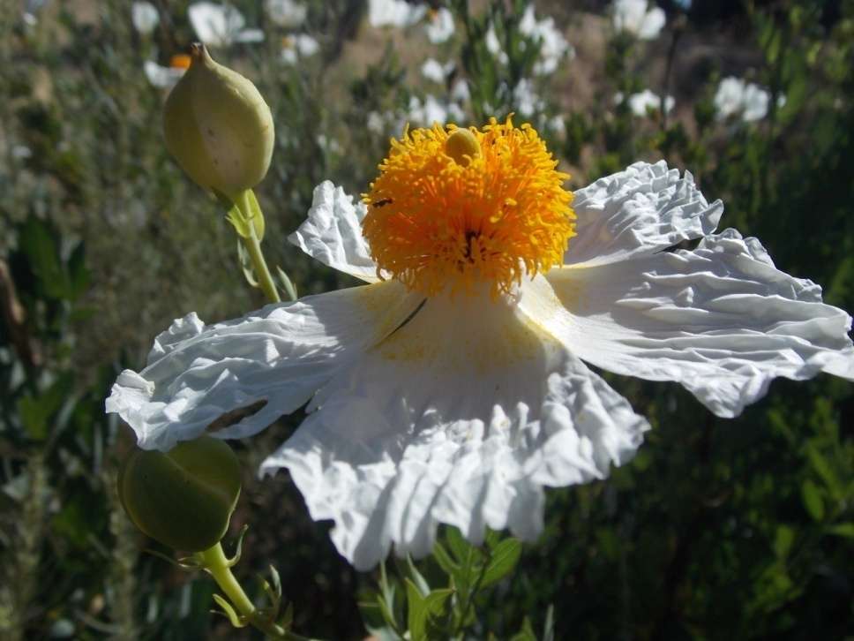
Matilija Poppy
Romneya coulteri
PAPAVERACEAE – Poppy Family

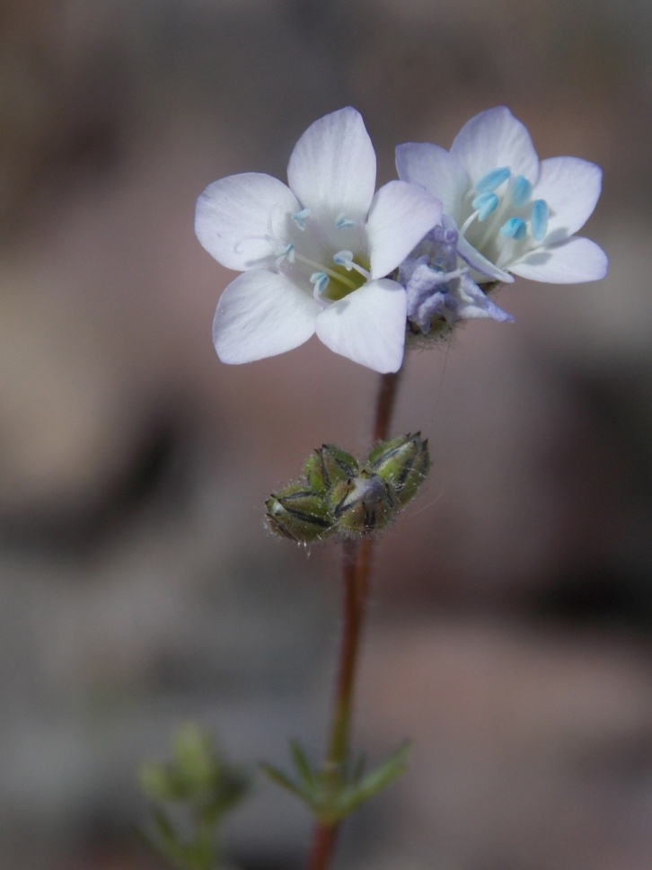
Angels Gilia
Gilia angelensis
POLEMONIACEAE – Phlox Family

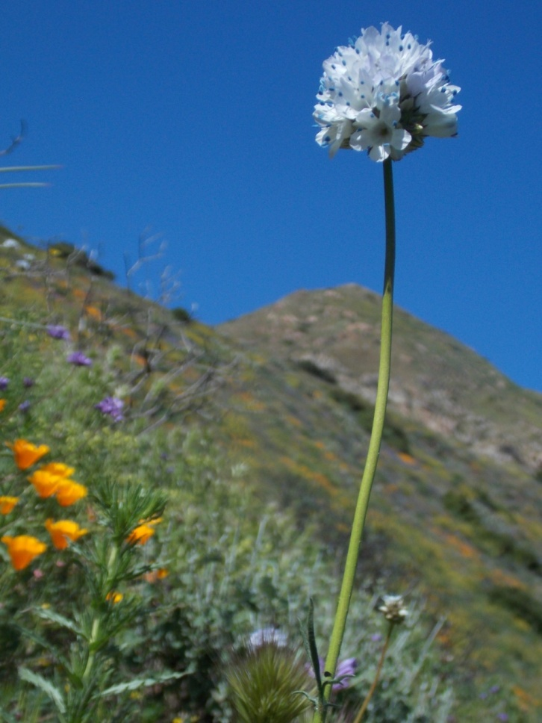
Globe Gilia
Gilia capitata
POLEMONIACEAE – Phlox Family

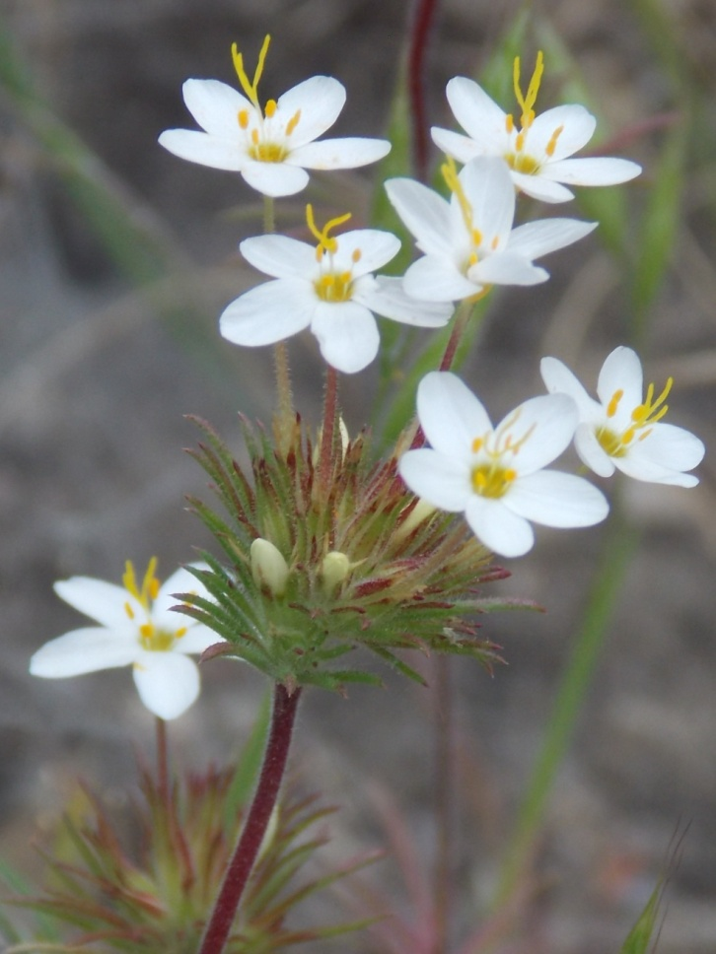
Linanthus
Leptosiphon parviflorus
POLEMONIACEAE – Phlox Family

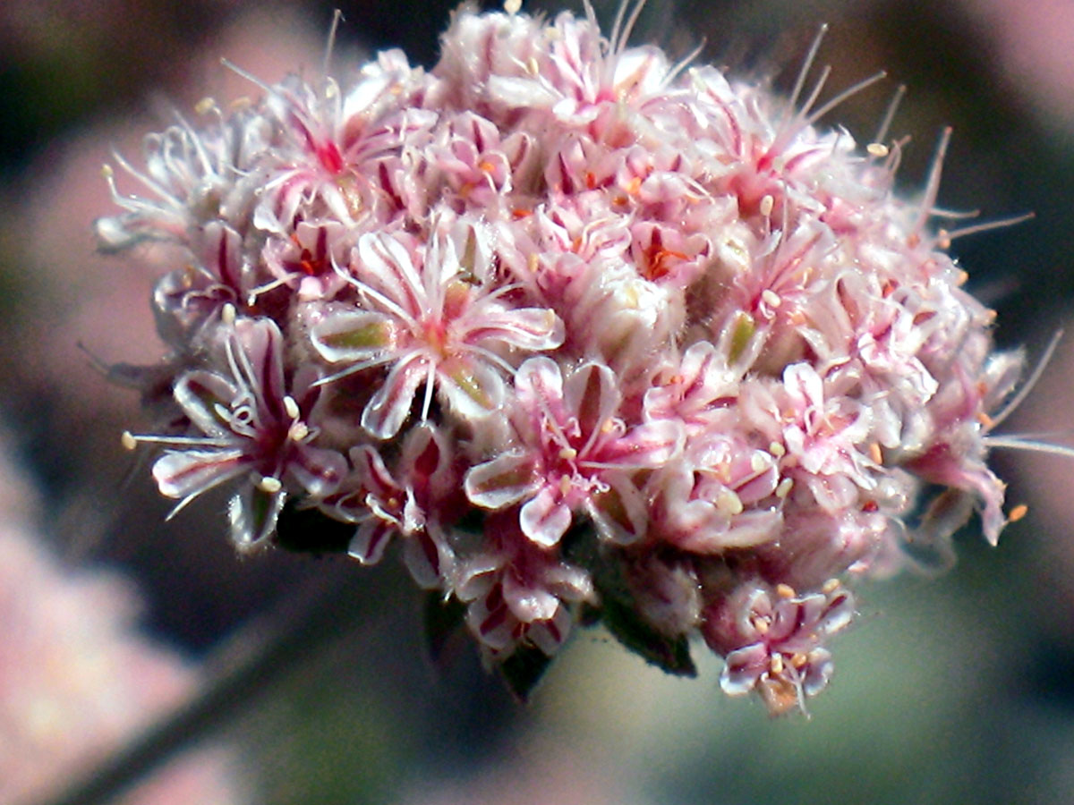
Ashy Leaved Buckwheat
Eriogonum cinereum
POLYGONACEAE – Buckwheat Family

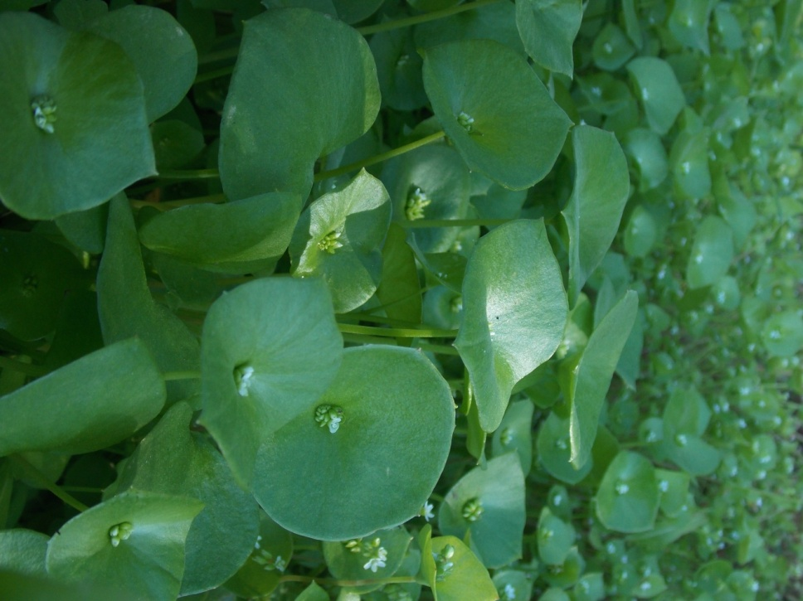
Miner’s Lettuce
Claytonia perfoliata
PORTULACACEAE – Purslane Family

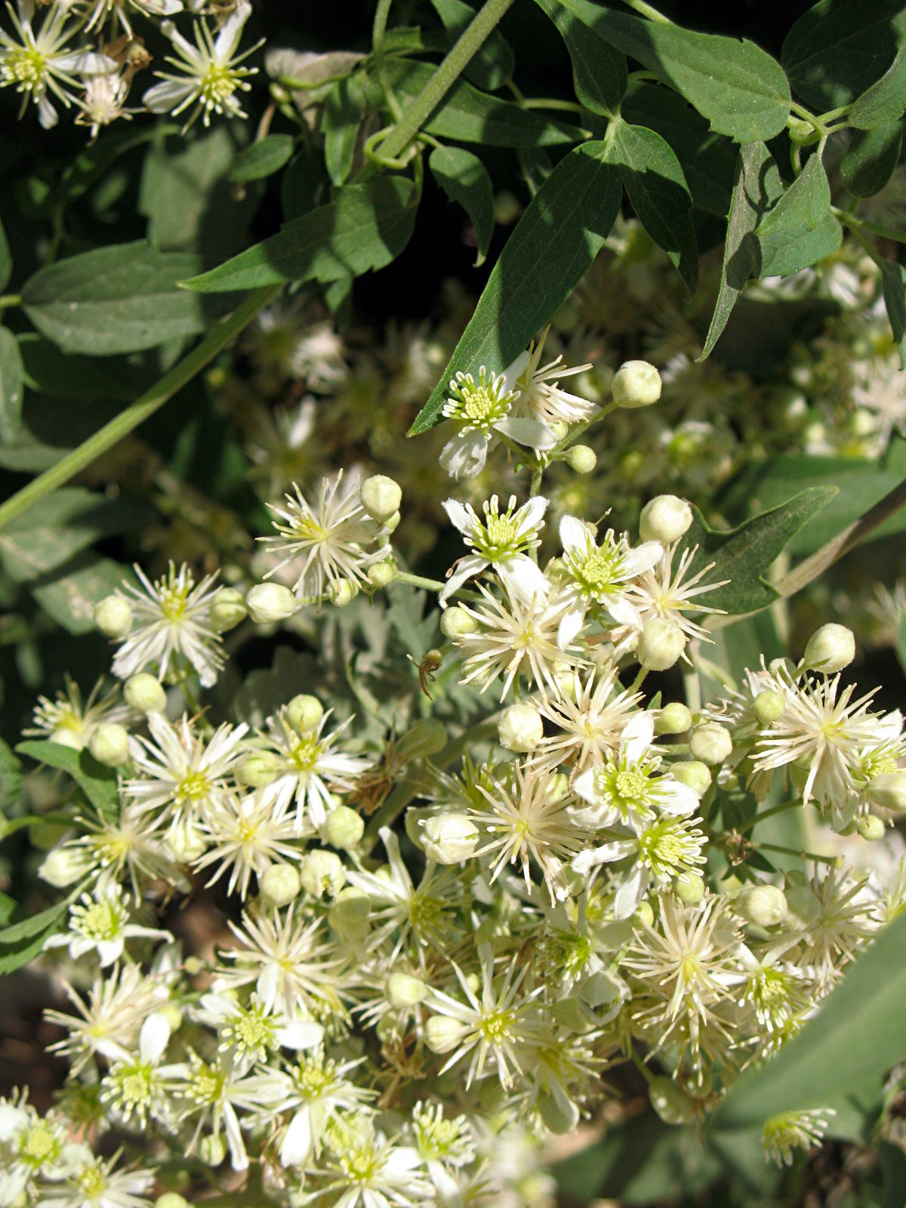
Virgin’s Bower
Clematis lasiantha
RANUNCULACEAE – Buttercup Family

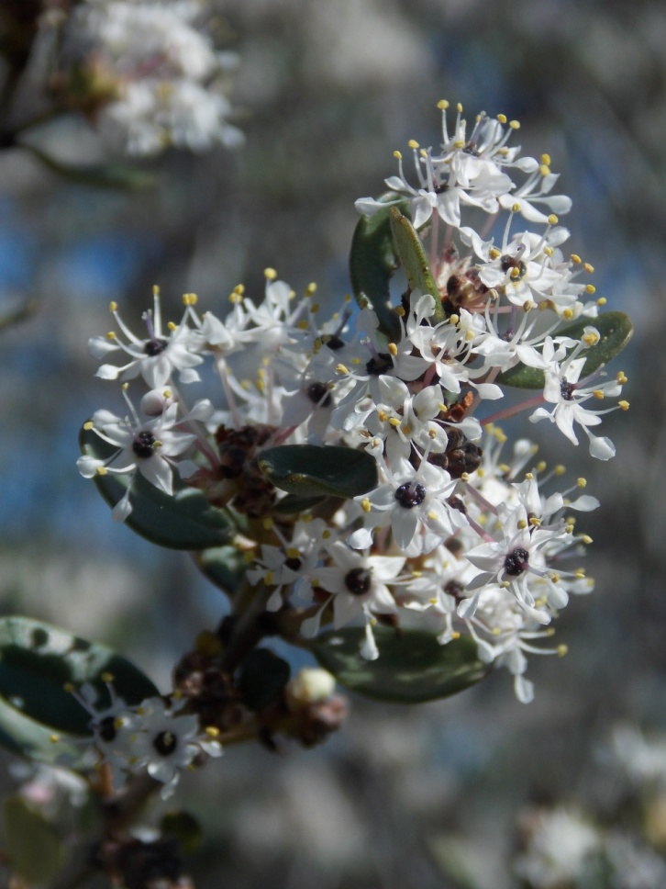
Big Pod Ceanothus
Ceanothus megacarpus
RHAMNACEAE – Buckthorn Family

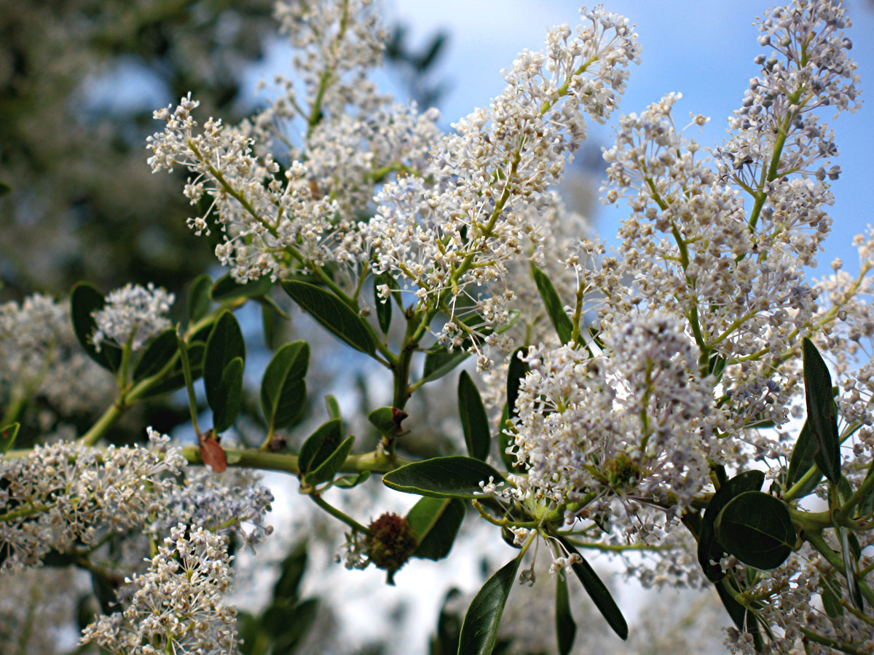
Greenbark Ceanothus
Ceanothus spinosus
RHAMNACEAE – Buckthorn Family

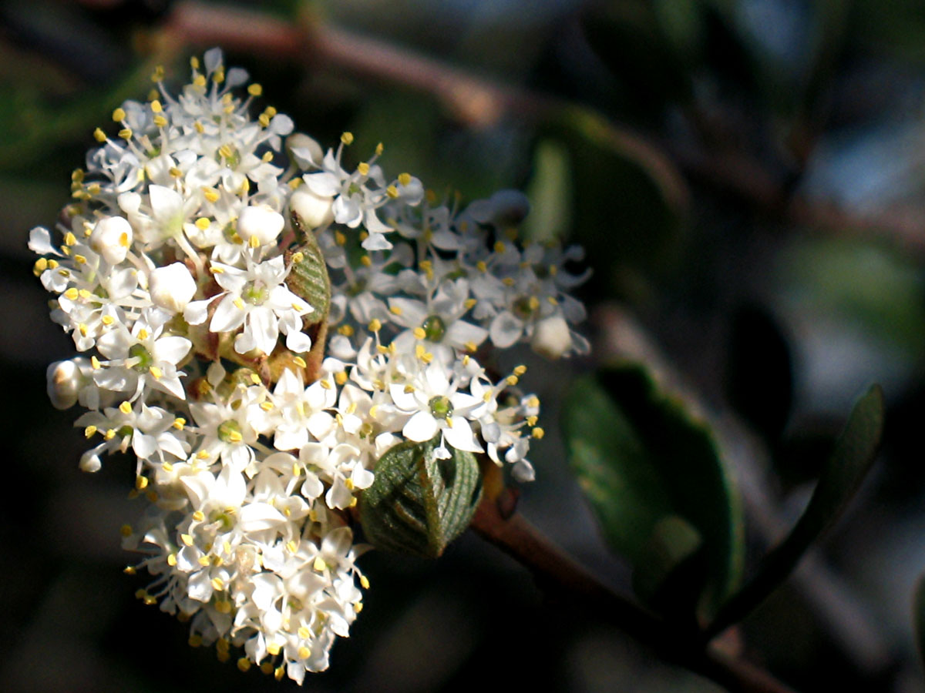
Hoary Leaved Ceanothus
Ceanothus crassifolius
RHAMNACEAE – Buckthorn Family

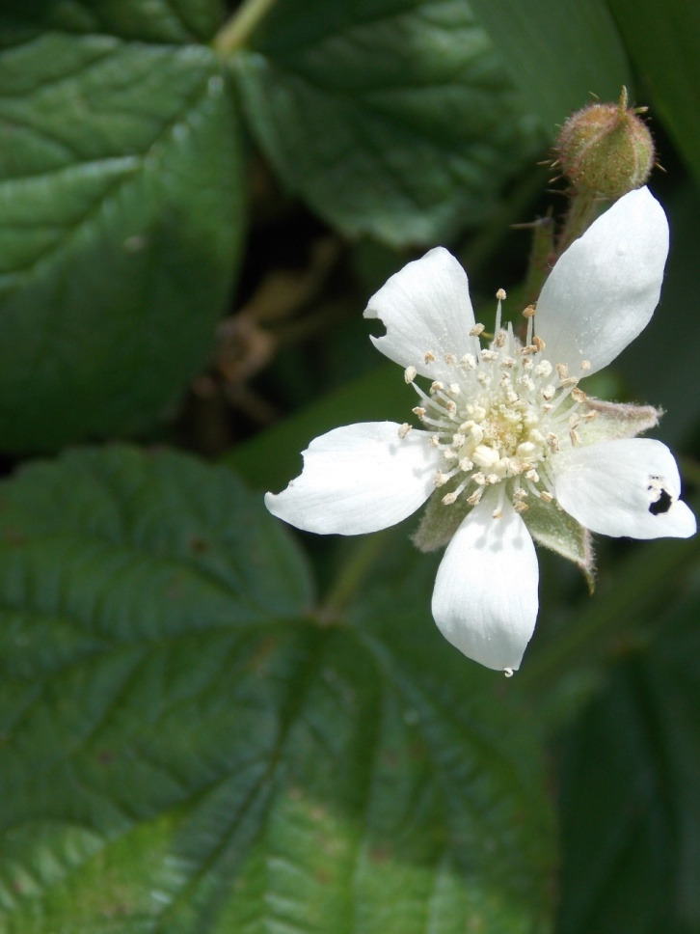
California Blackberry
Rubus ursinus
ROSACEAE – Rose Family

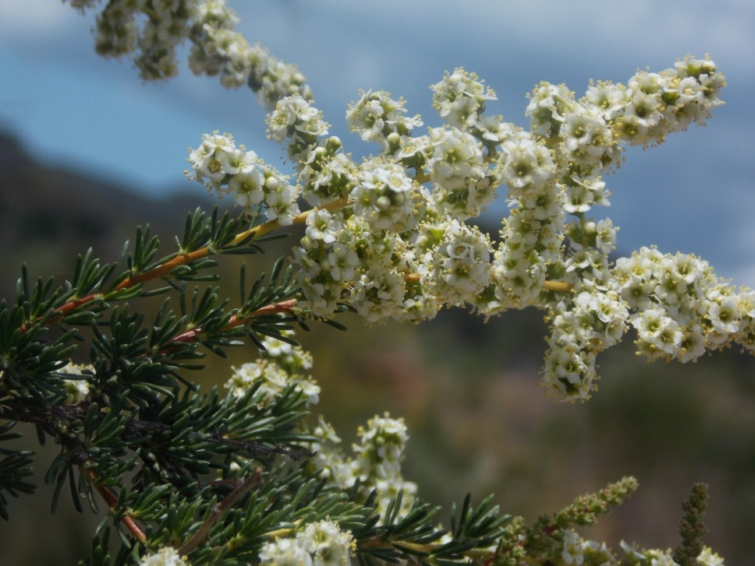
Chamise
Adenostoma fasciculatum
ROSACEAE – Rose Family

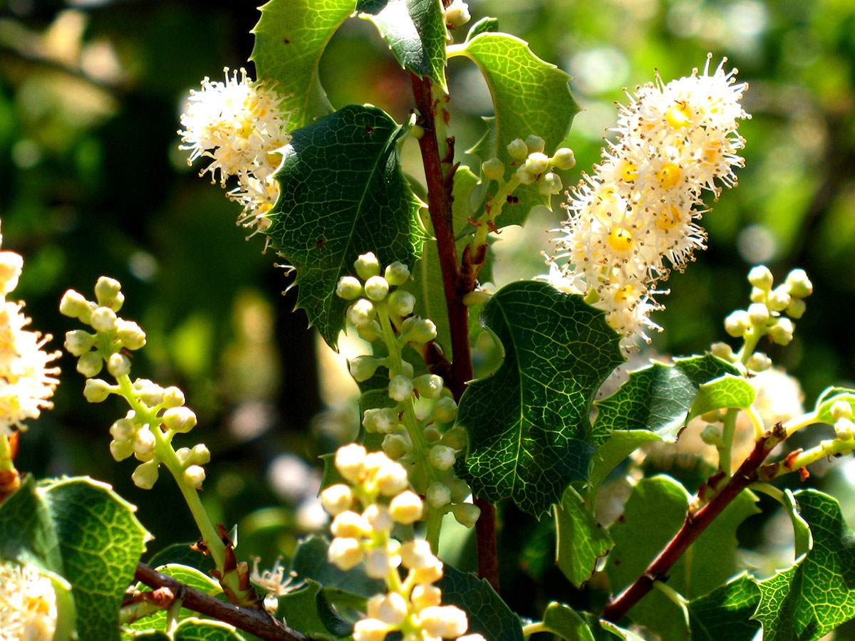
Hollyleaf Cherry
Prunus ilicifolia
ROSACEAE – Rose Family

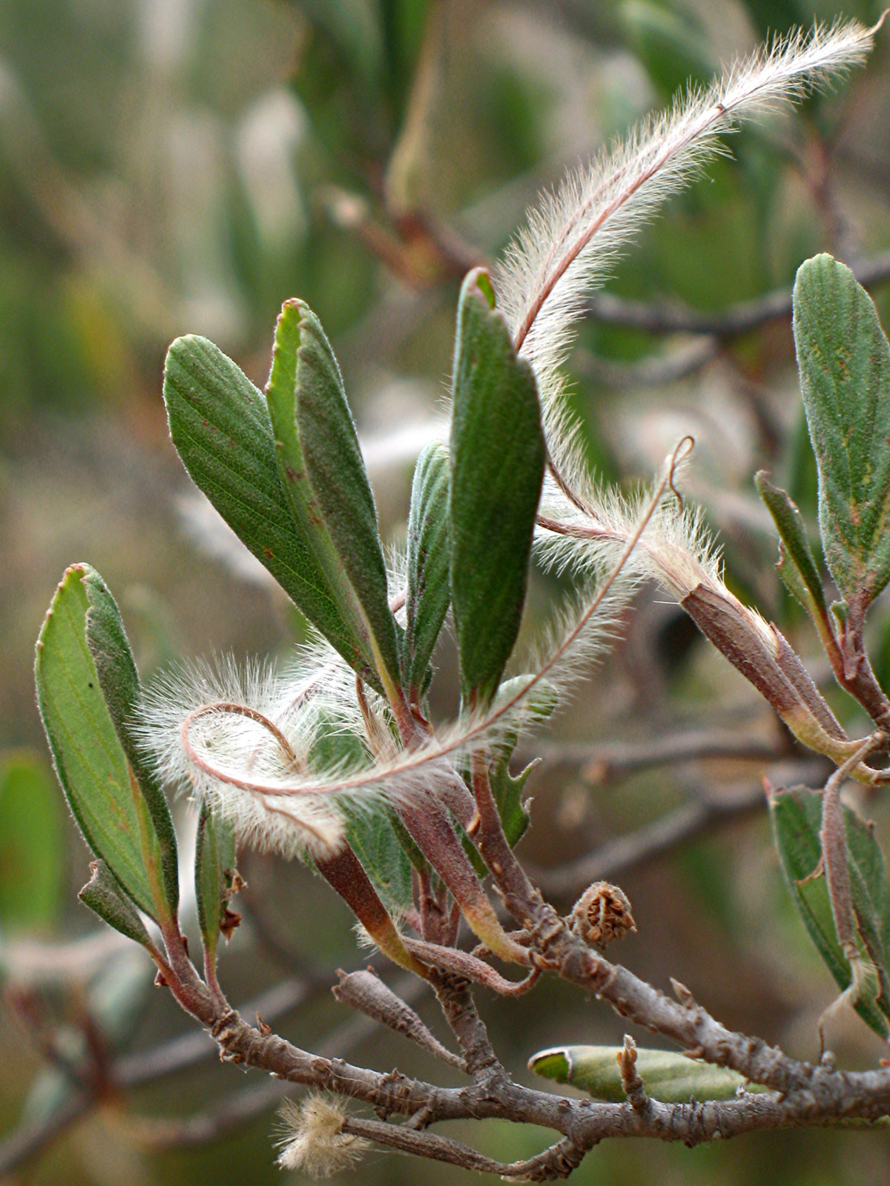
Mountain Mahogany
Cercocarpus betuloides
ROSACEAE – Rose Family

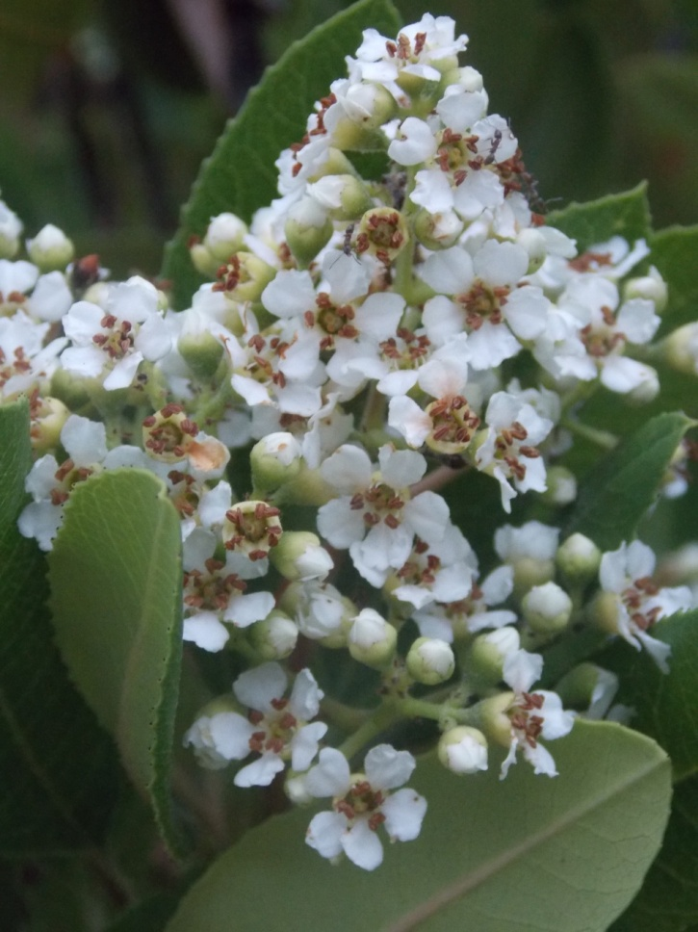
Toyon
Heteromeles arbutifolia
ROSACEAE – Rose Family

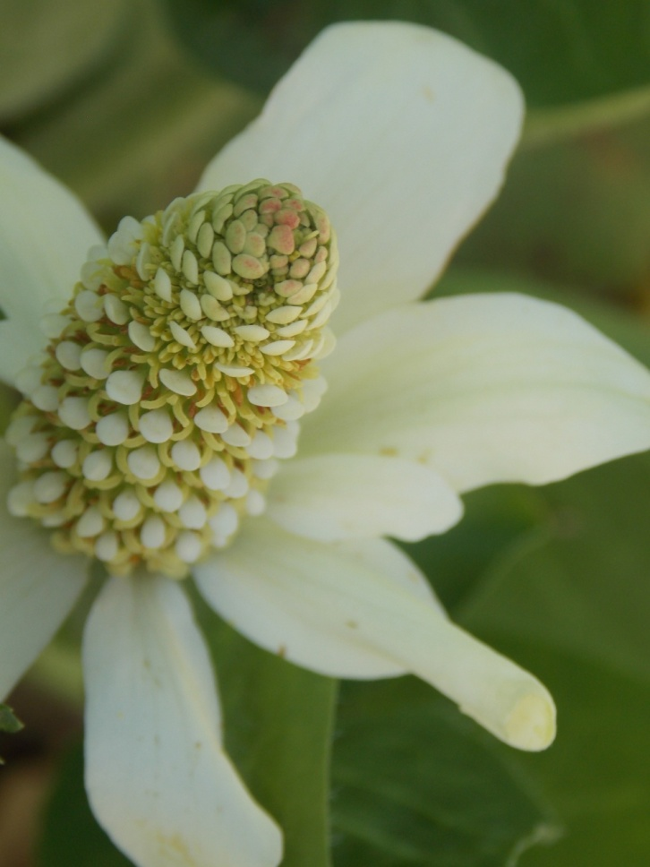
Yerba Mansa
Anemopsis californica
SAURURACEAE – Lizard-tail Family

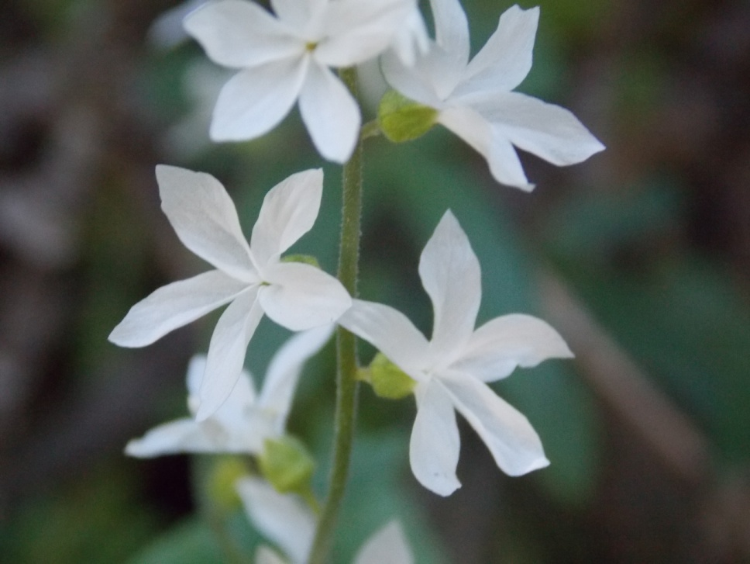
Woodland Star
Lithophragma cymbalaria
SAXIFRAGACEAE – Saxifrage Family

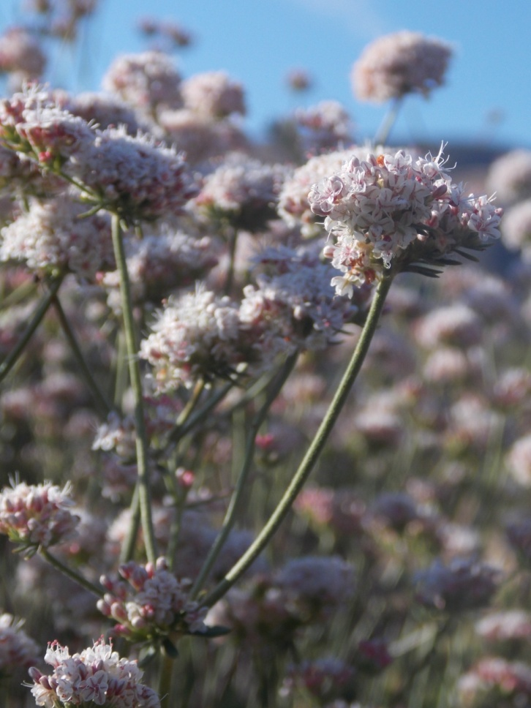
California Buckwheat
Eriogonum fasciculatum
SCROPHULARIACEAE – Figwort Family

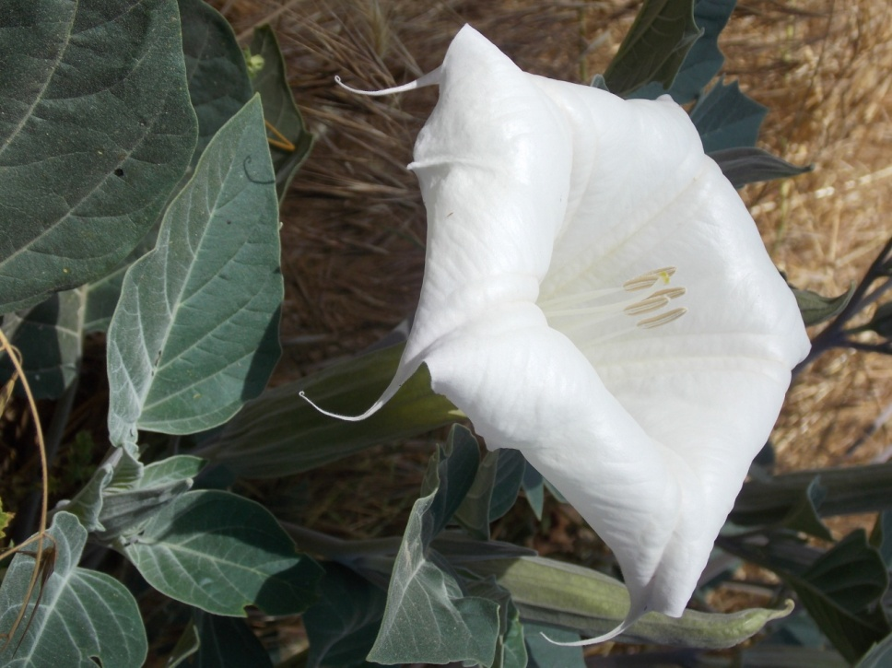
Datura
Datura wrightii
SOLANACEAE – Nightshade Family

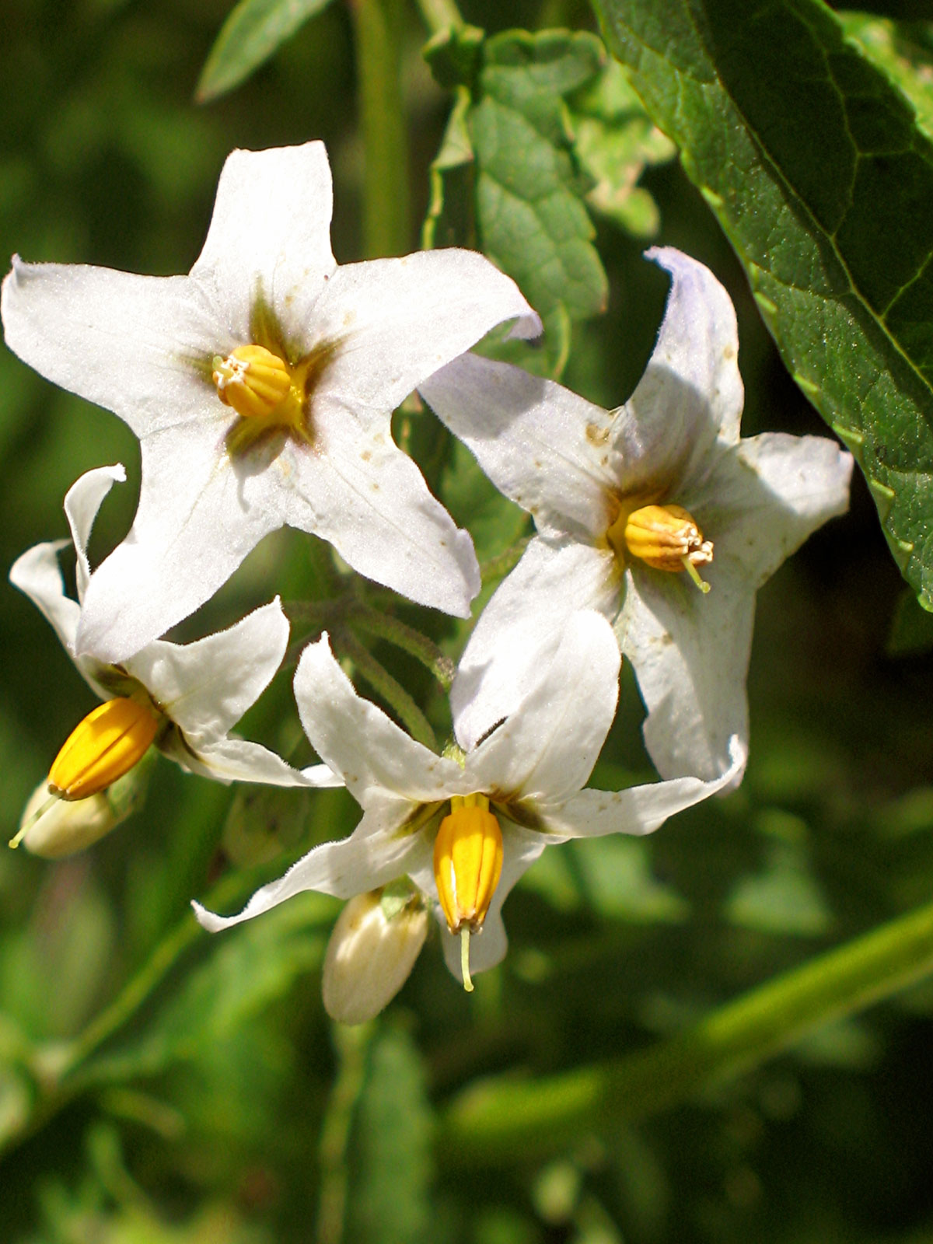
White Nightshade
Solanum douglasii
SOLANACEAE – Nightshade Family

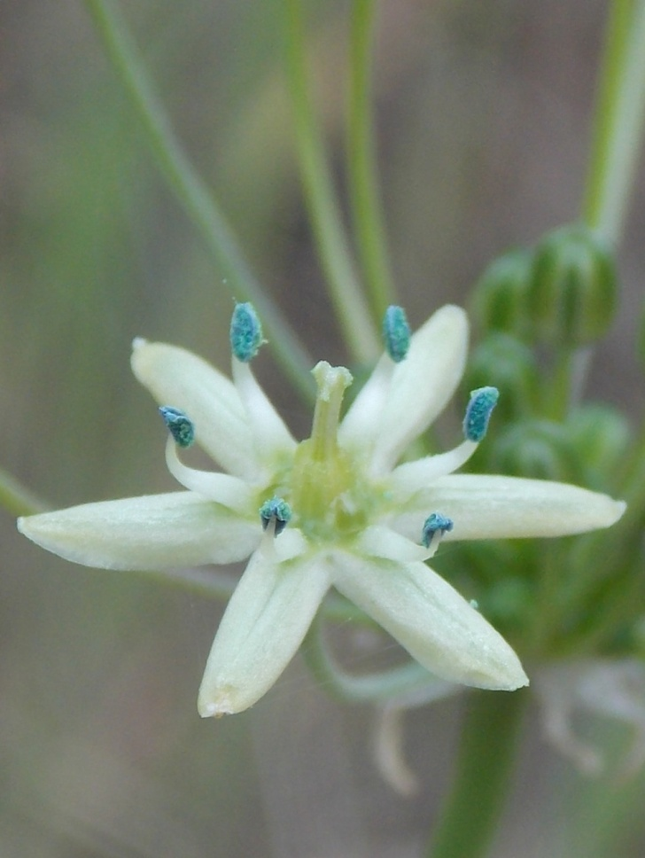
Common Muilla
Muilla maritima
THEMIDACEAE – Brodiaea Family

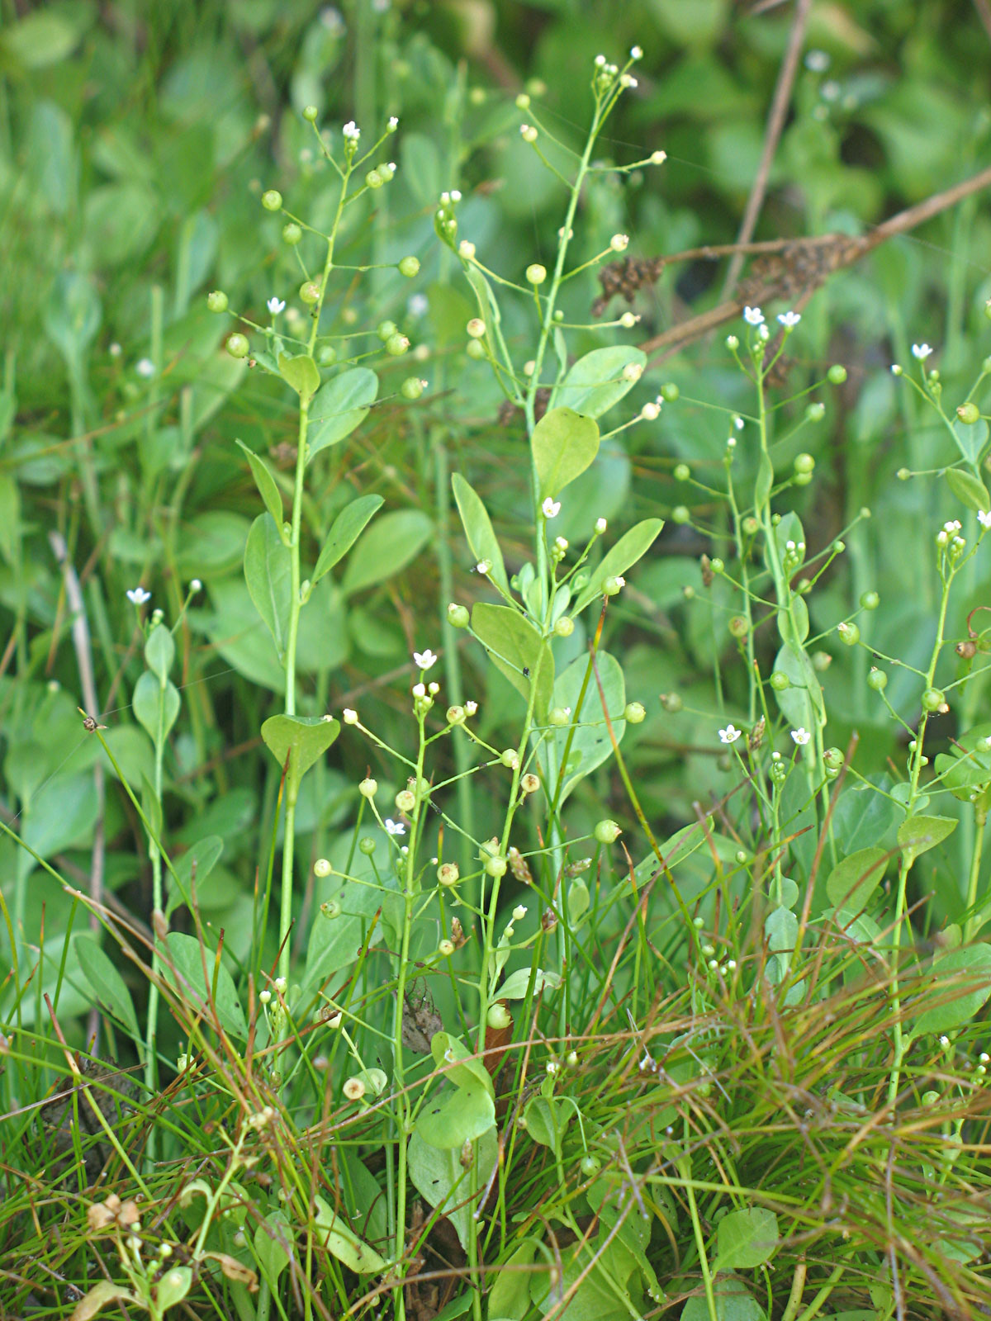
Water Pimpernel
Samolus parviflorus
THEOPHRASTACEAE – Theophrasta Family

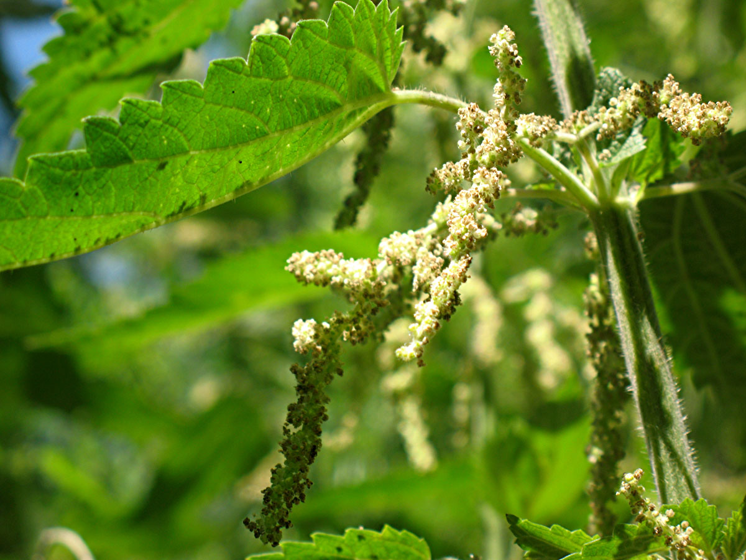
Hoary Nettle
Urtica dioica ssp. holosericea
URTICACEAE – Nettle Family

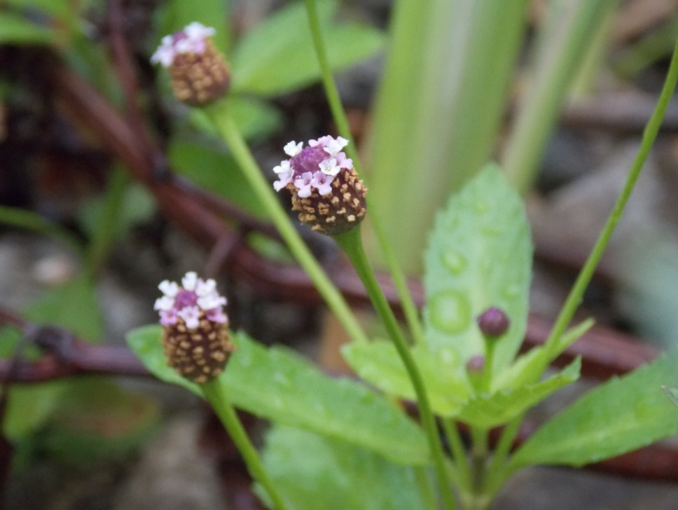
Frog Fruit
Phyla lanceolata
VERBENACEAE – Vervain Family

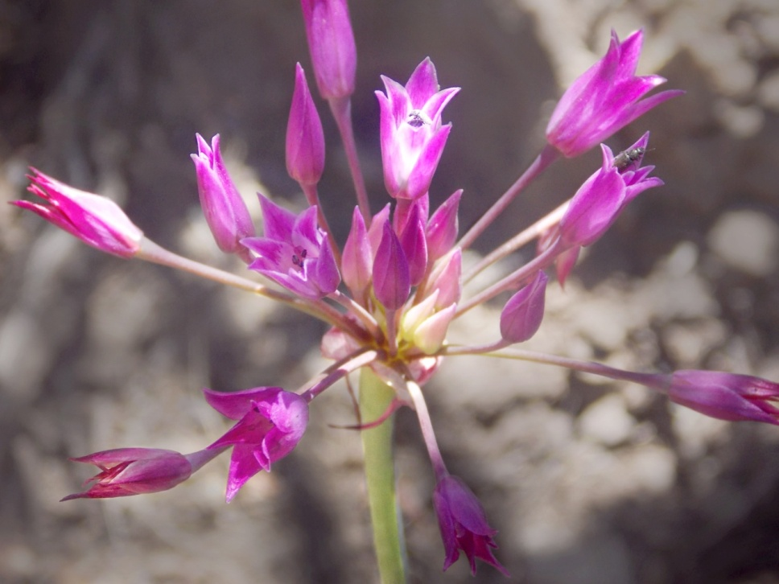
Peninsular Onion
Allium peninsulare
ALLIACEAE - Onion Family

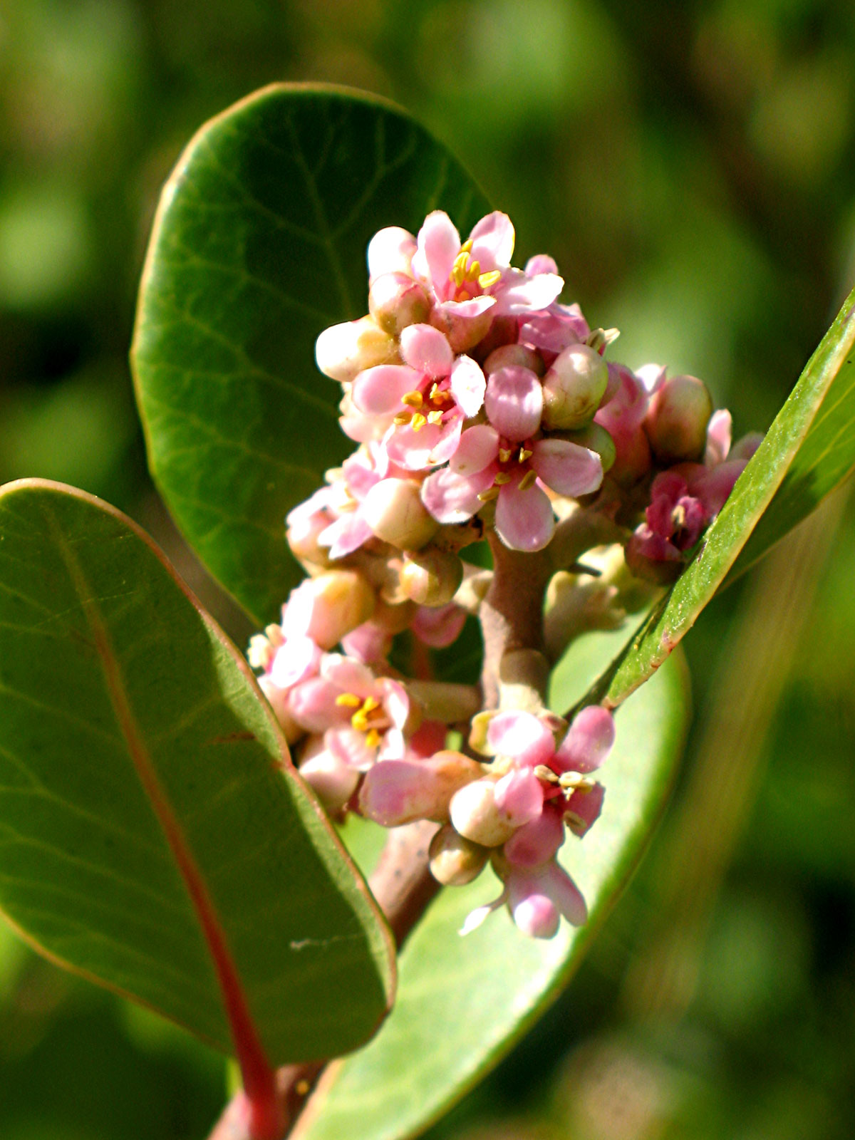
Lemonade Berry
Rhus integrifolia
ANACARDIACEAE - Sumac Family

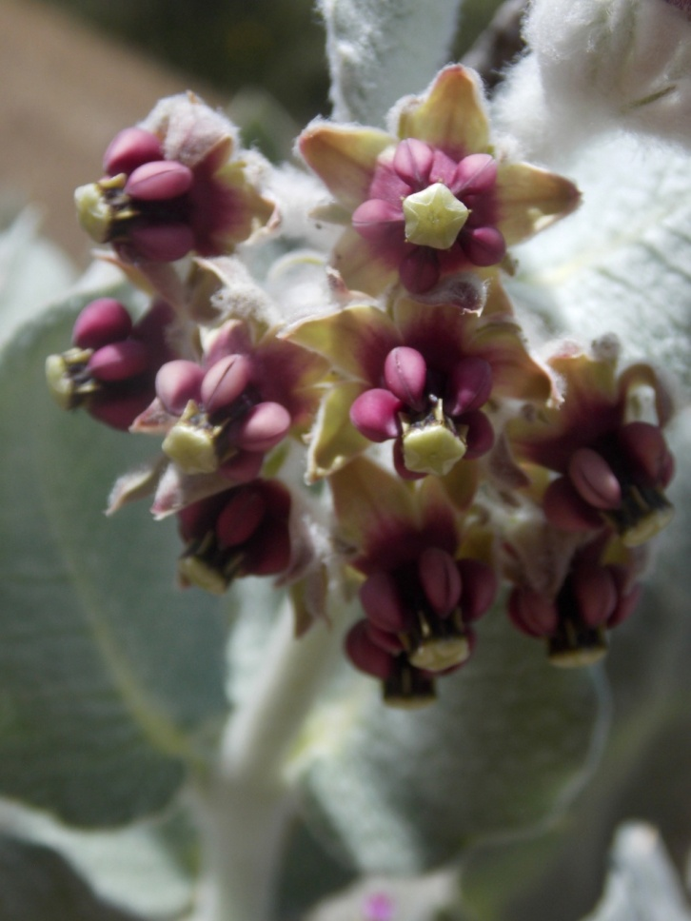
California Milkweed
Asclepias californica
APOCYNACEAE – Dogbane Family

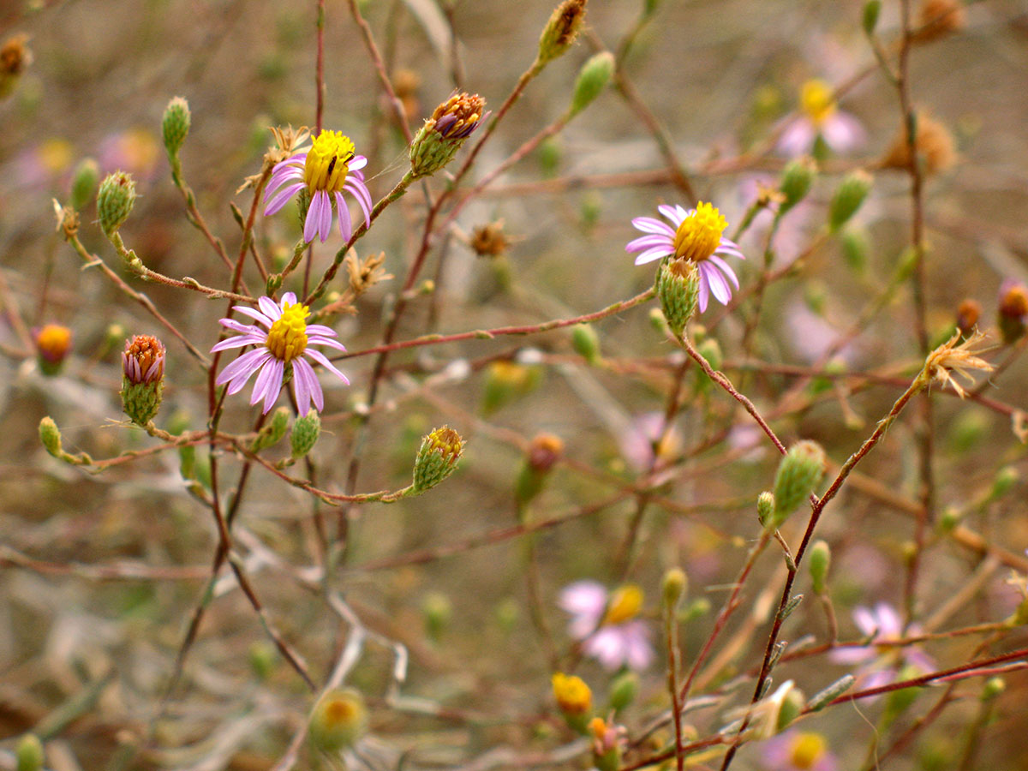
California Aster
Corethrogyne filaginifolia
ASTERACEAE - Sunflower Family

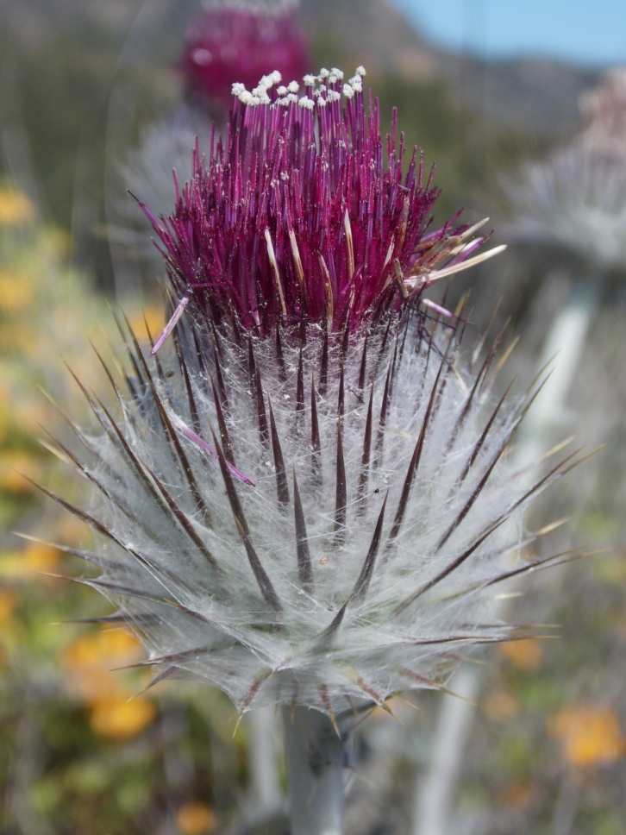
Cobweb Thistle
Cirsium occidentale
ASTERACEAE - Sunflower Family

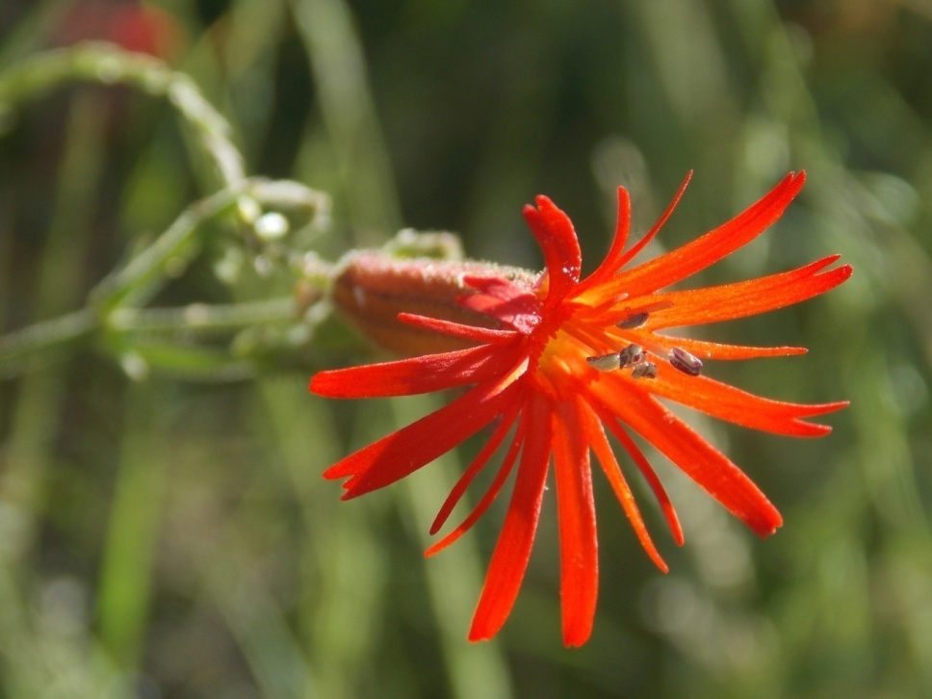
Fringed Indian Pink
Silene laciniata
CARYOPHYLLACEAE - Pink Family

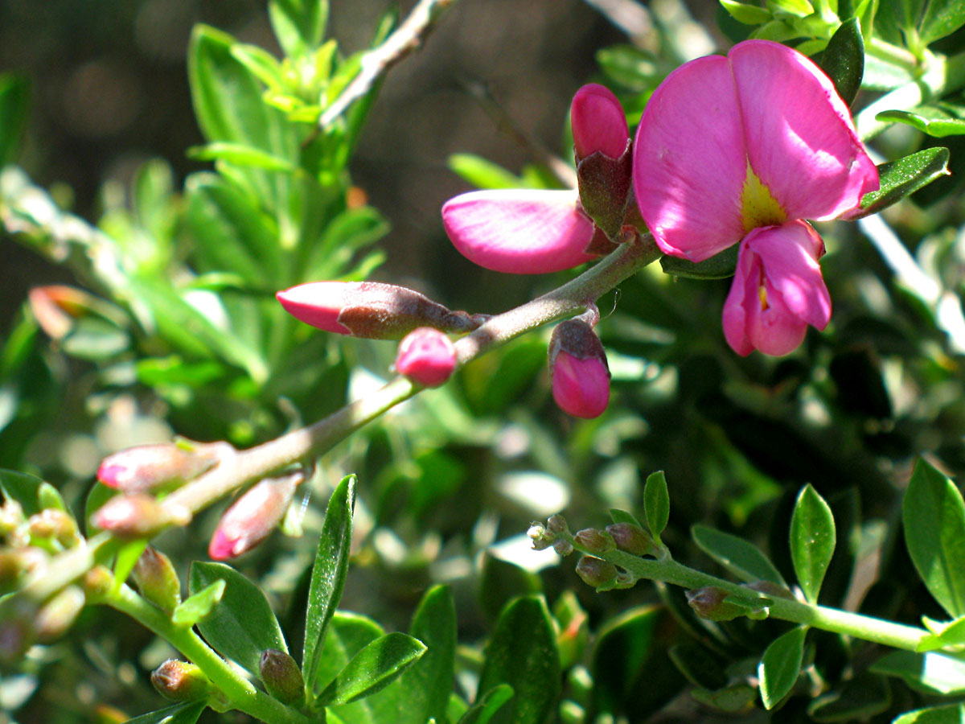
Chaparral Pea
Pickeringia montana
FABACEAE - Pea Family

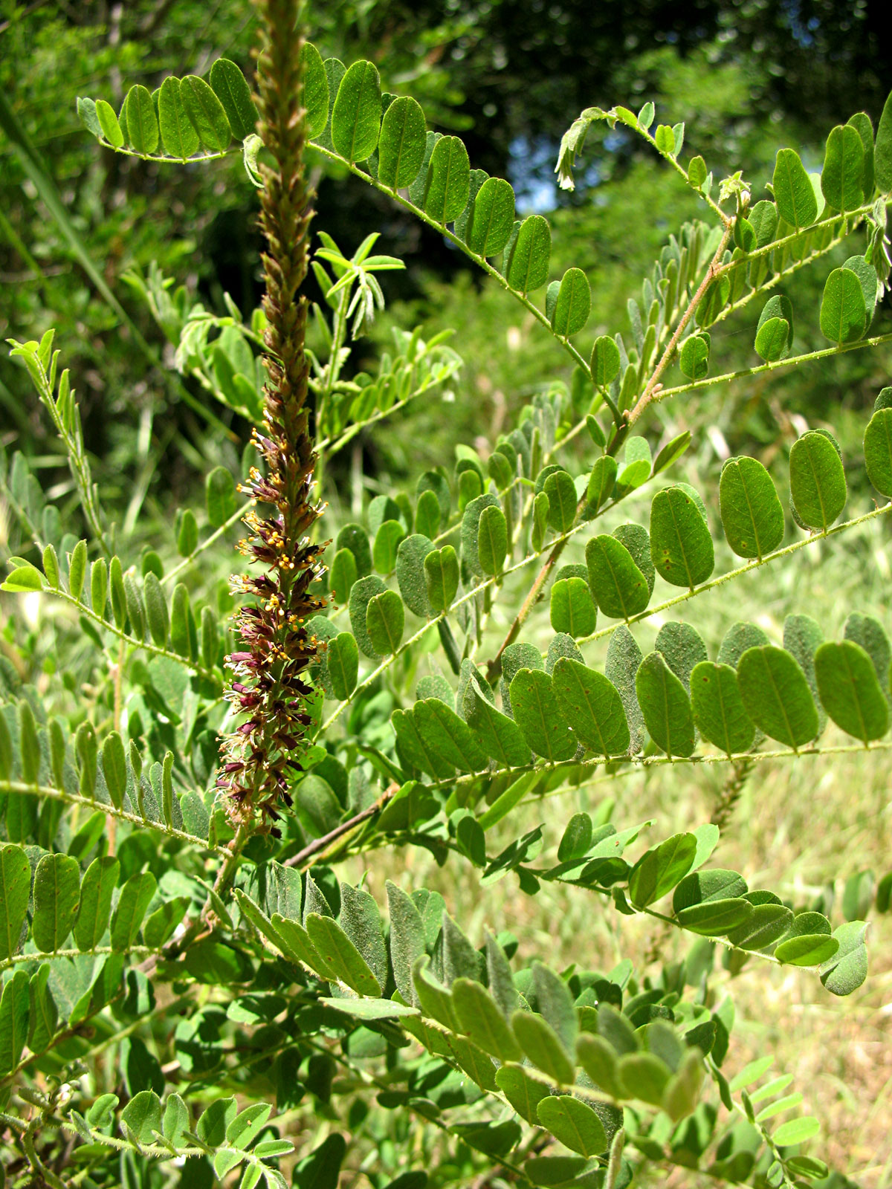
False Indigo
Amorpha californica
FABACEAE - Pea Family

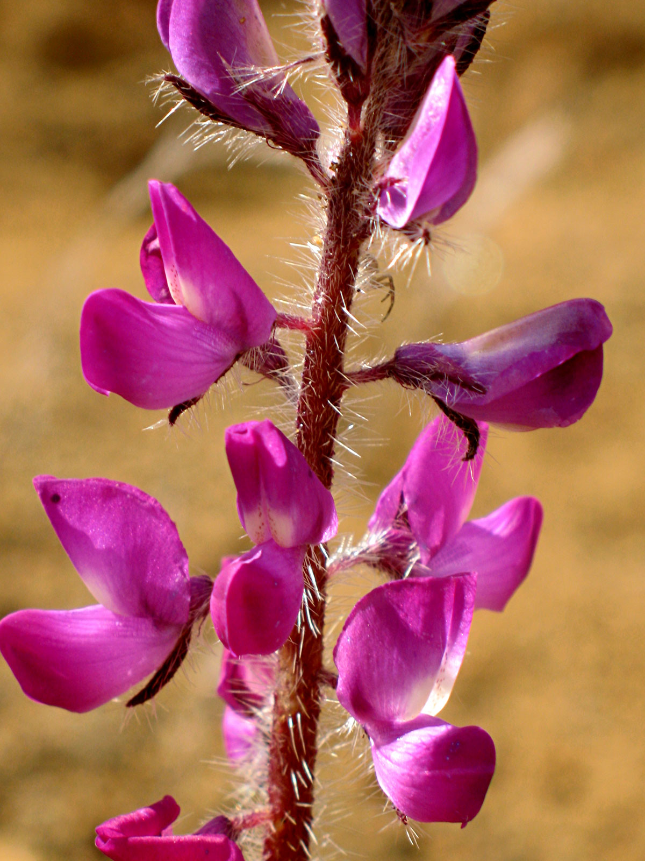
Stinging Lupine
Lupinus hirsutissimus
FABACEAE - Pea Family

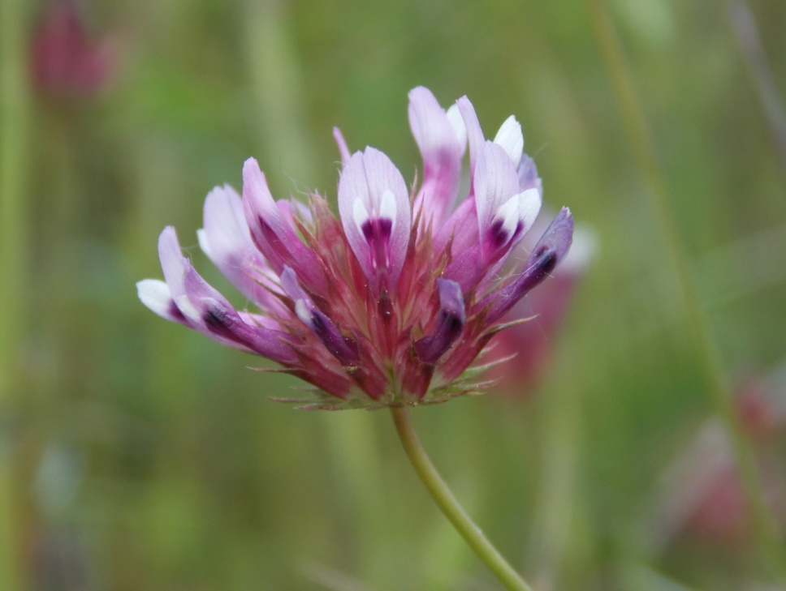
Tomcat Clover
Trifolium willdenovii
FABACEAE - Pea Family

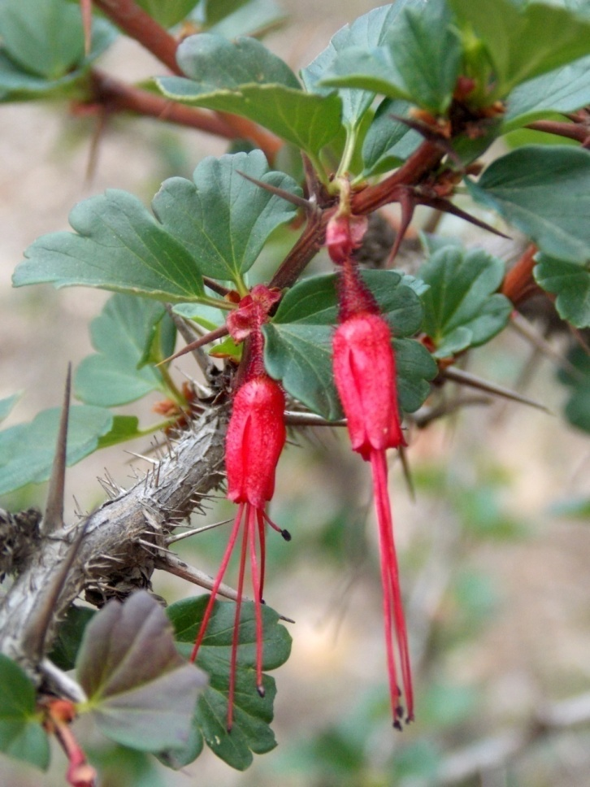
Fuchsia-Flowered Gooseberry
Ribes speciosum
GROSSULARIACEAE - Gooseberry Family

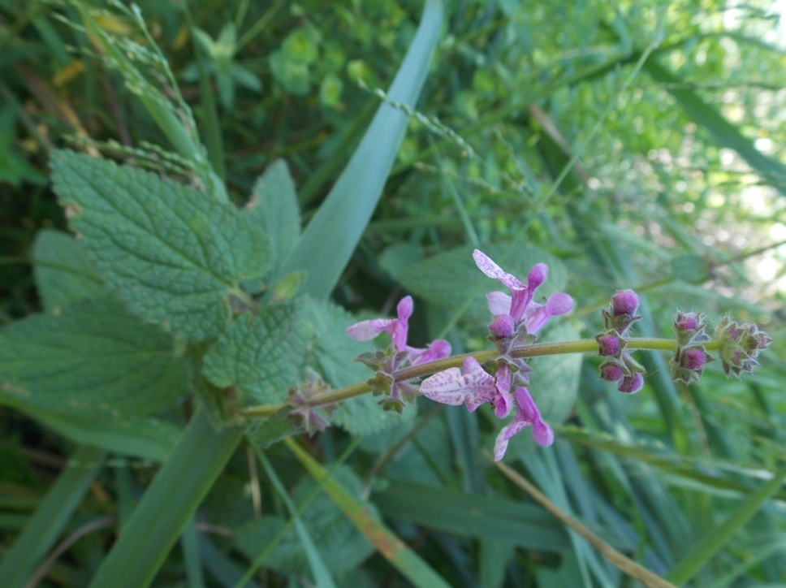
Hedge Nettle
Stachys bullata
LAMIACEAE - Mint Family

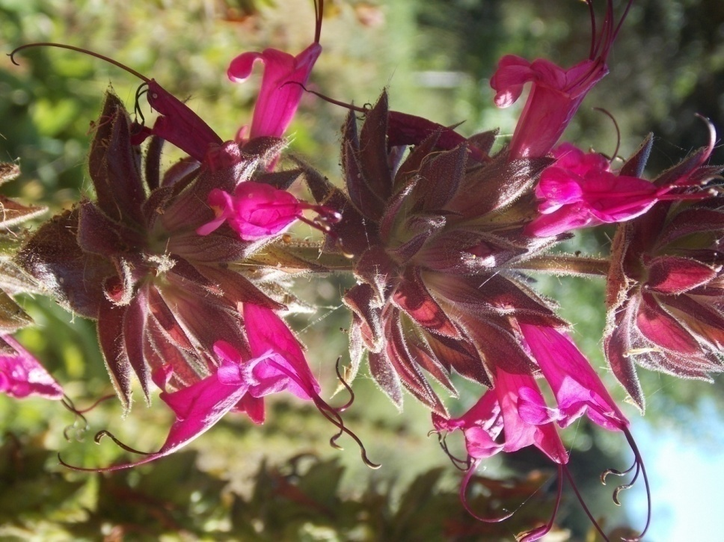
Hummingbird Sage
Salvia spathacea
LAMIACEAE - Mint Family

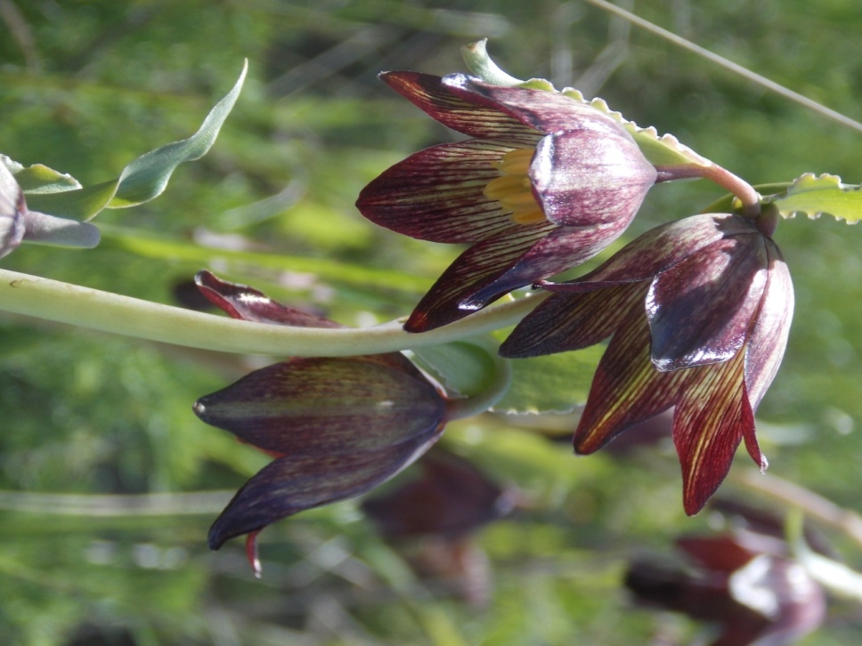
Chocolate Lily
Fritillaria biflora
LILIACEAE - Lily Family

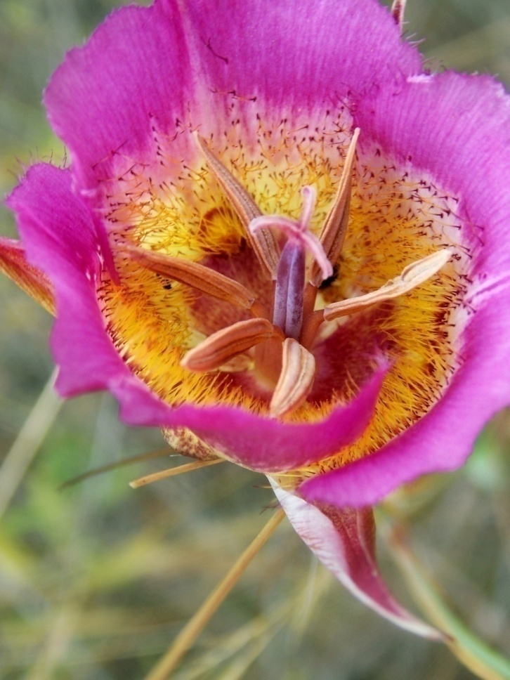
Plummer’s Mariposa Lily
Calochortus plummerae
LILIACEAE - Lily Family

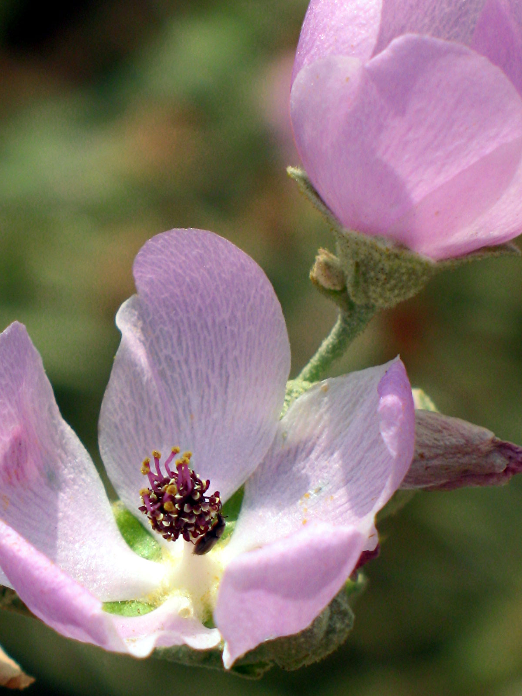
Bush Mallow
Malacothamnus fasciculatus
MALVACEAE - Mallow Family

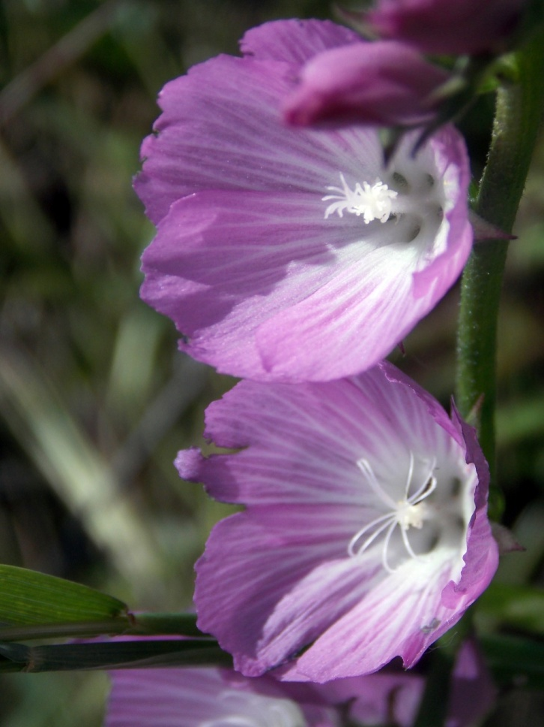
Checker Bloom
Sidalcea sparsifolia
MALVACEAE - Mallow Family

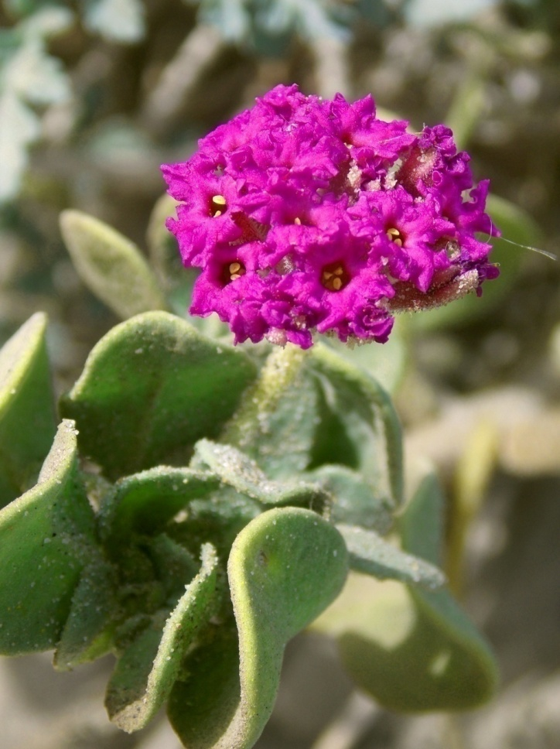
Sand Verbena
Abronia maritima
NYCTAGINACEAE - Four O’Clock Family

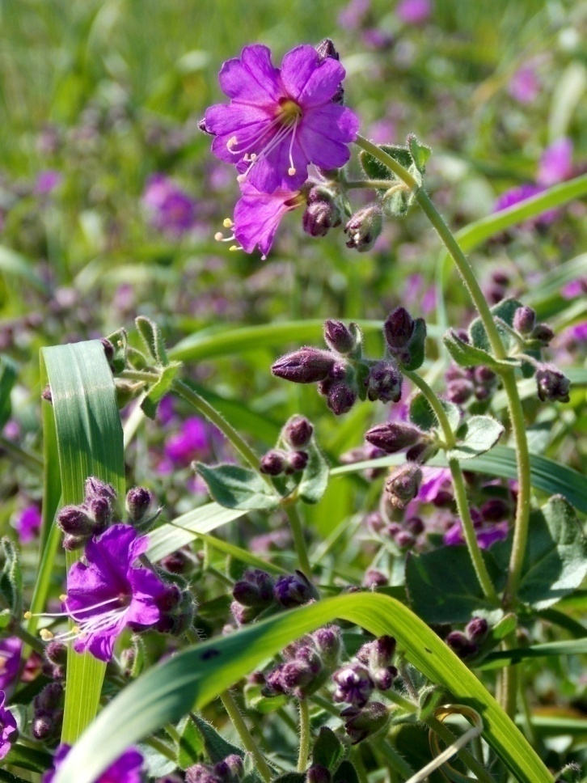
Wishbone
Mirabilis laevis
NYCTAGINACEAE - Four O’Clock Family

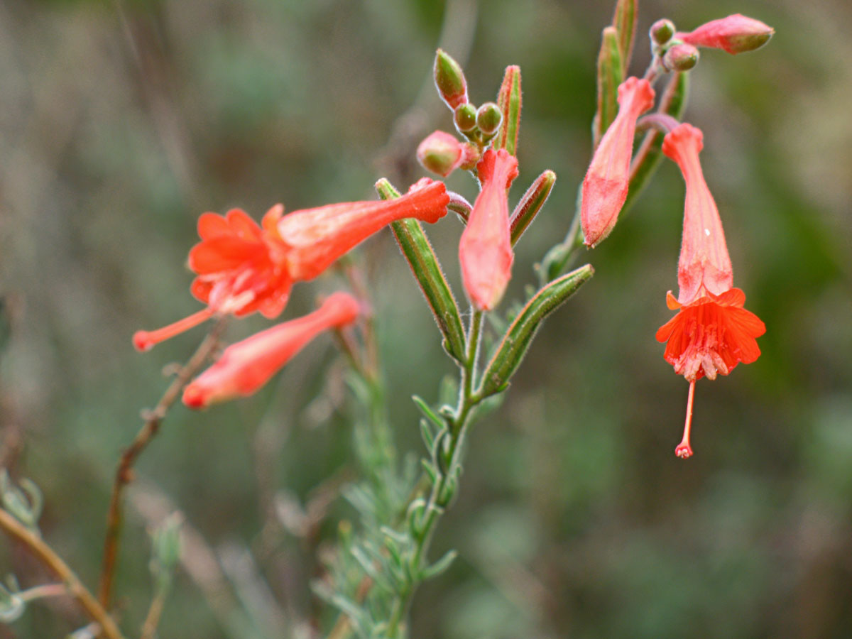
California Fuchsia
Epilobium canum
ONAGRACEAE - Evening Primrose Family

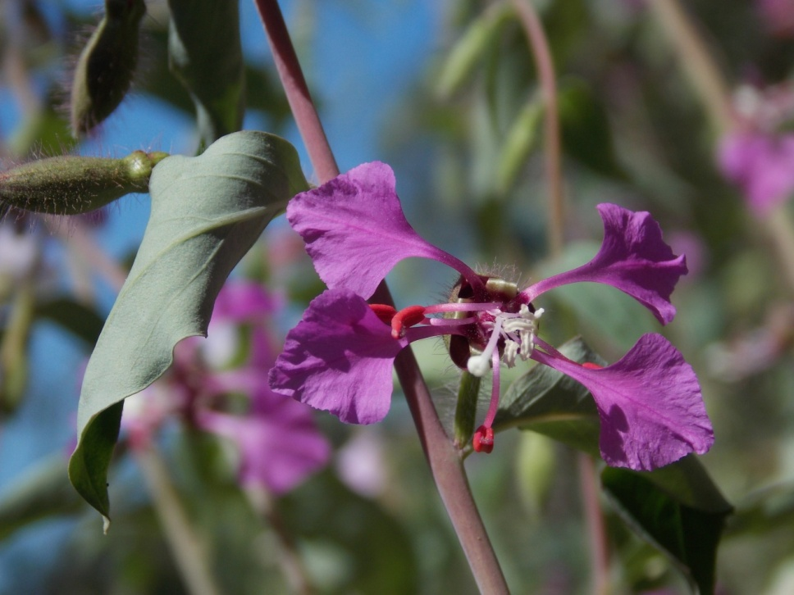
Elegant Clarkia
Clarkia unguiculata
ONAGRACEAE - Evening Primrose Family

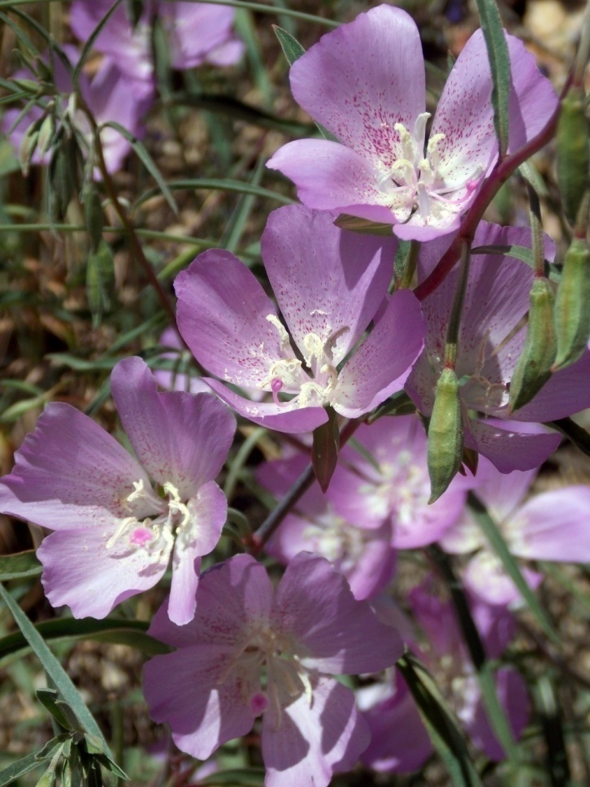
Farewell-to-Spring
Clarkia bottae
ONAGRACEAE - Evening Primrose Family

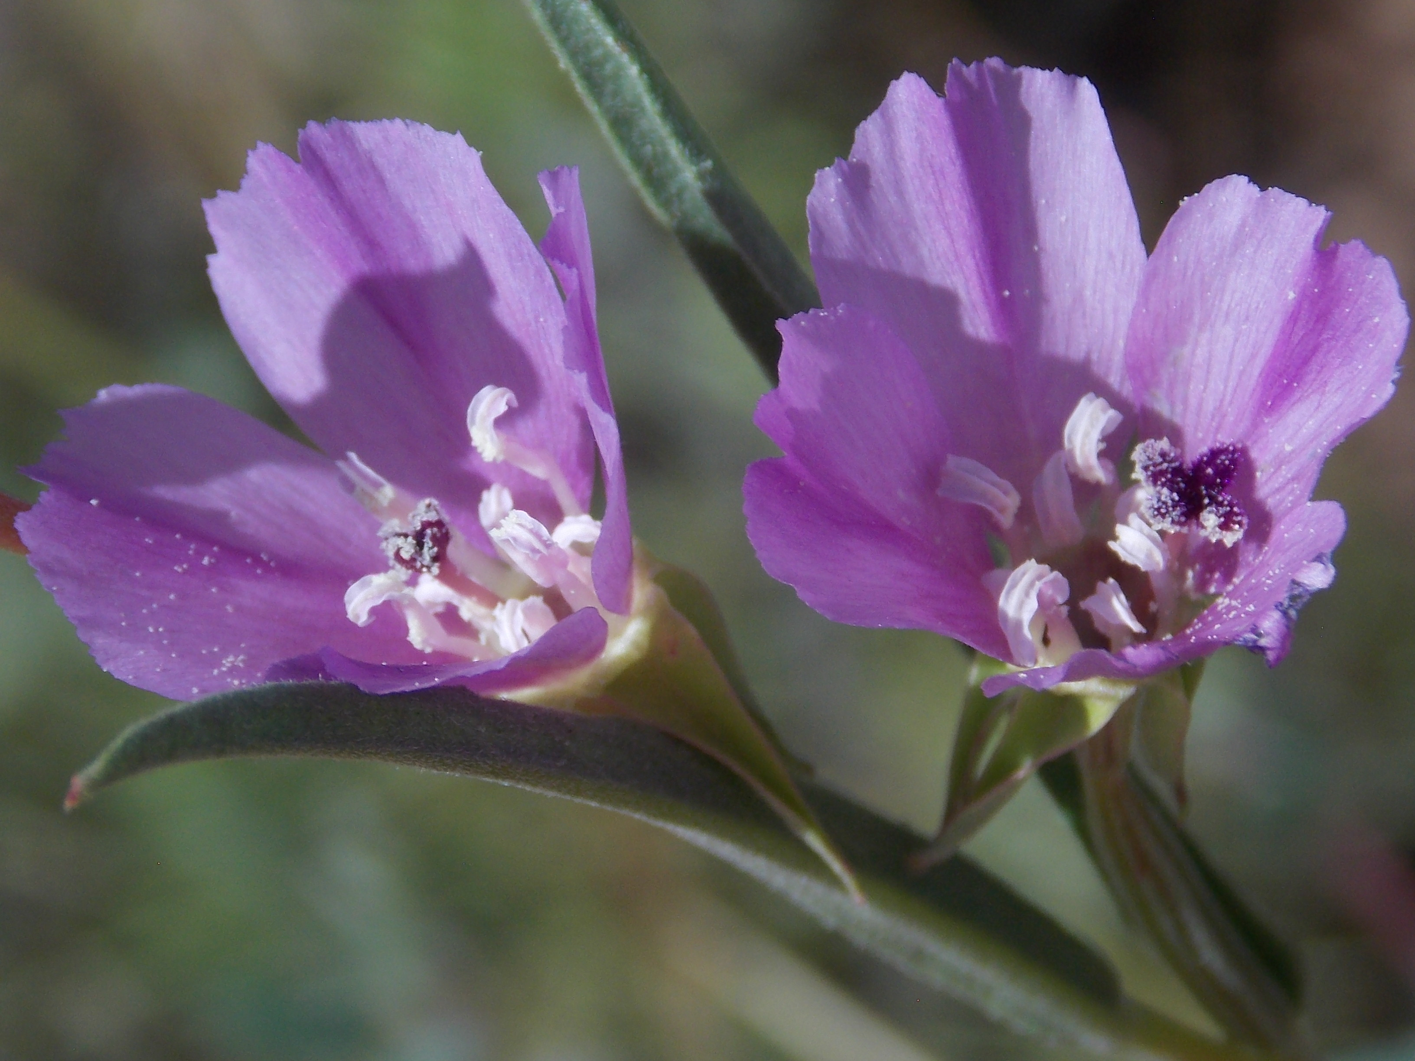
Purple Clarkia
Clarkia purpurea
ONAGRACEAE - Evening Primrose Family

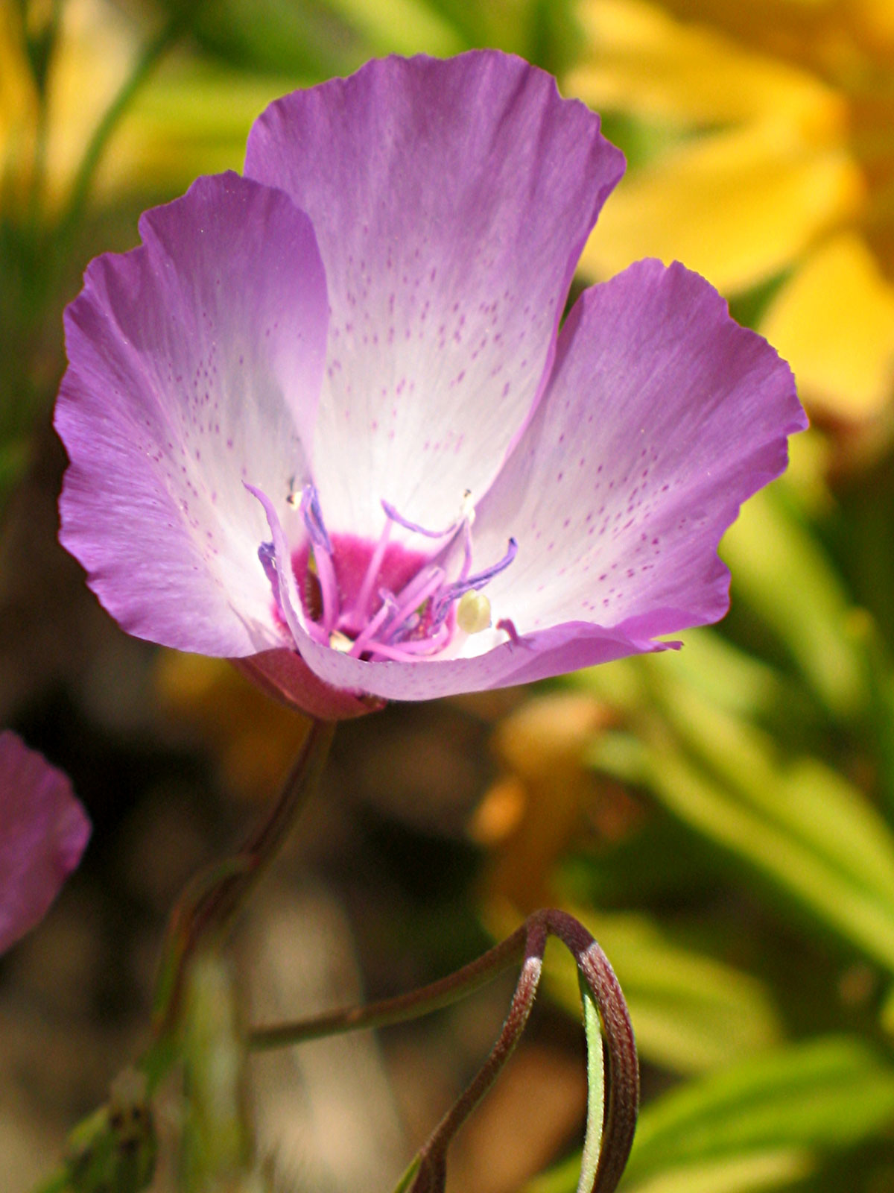
Speckled Clarkia
Clarkia cylindrica
ONAGRACEAE - Evening Primrose Family

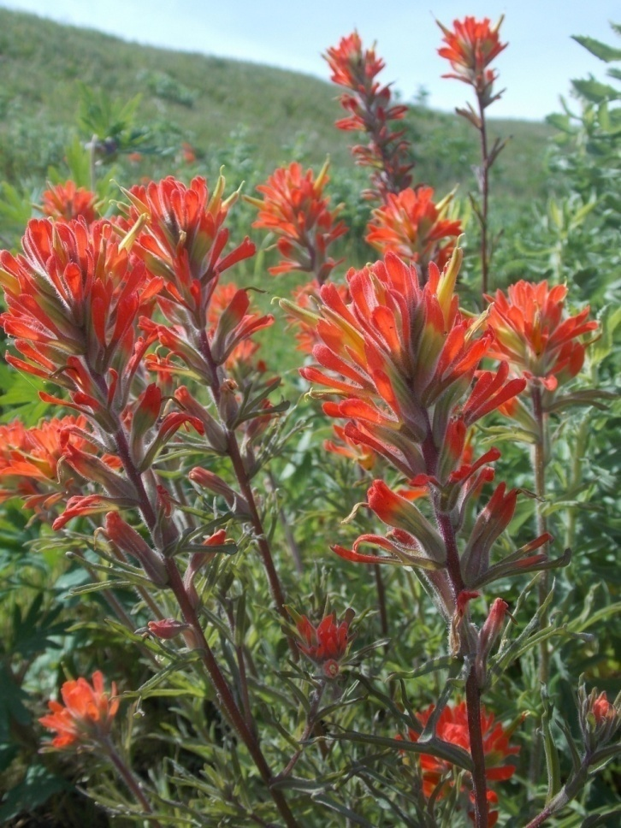
Indian Paintbrush
Castilleja affinis
OROBANCHACEAE - Broomrape Family

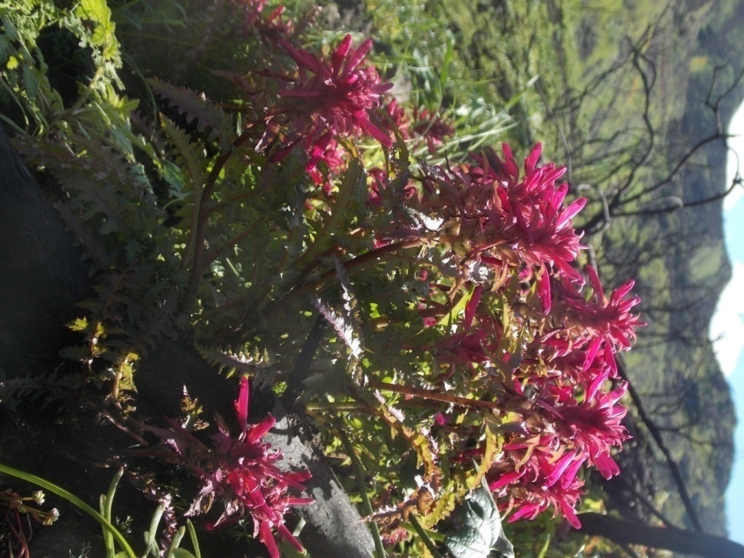
Indian Warrior
Pedicularis densiflora
OROBANCHACEAE - Broomrape Family

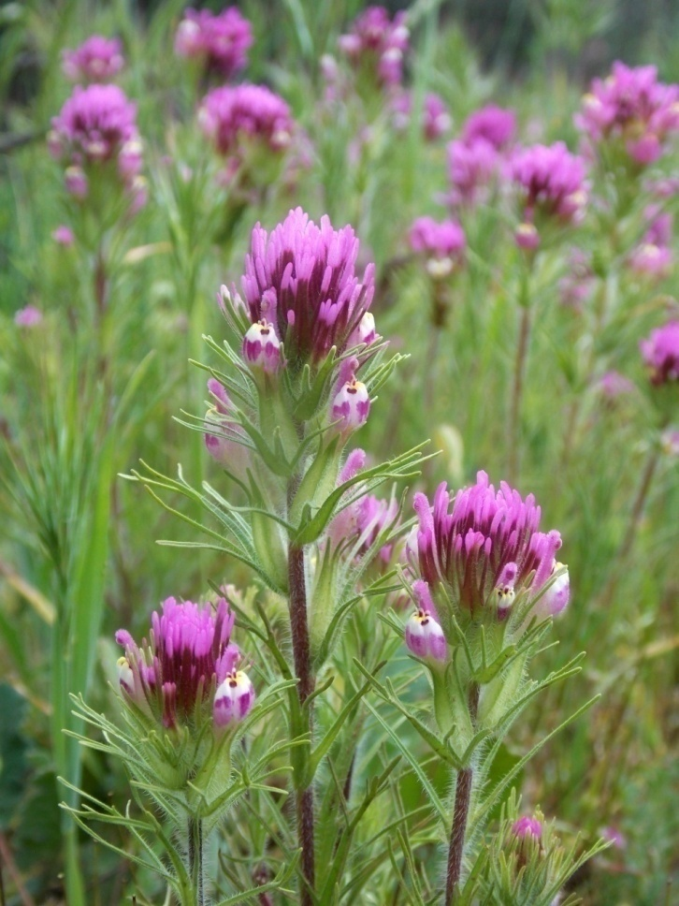
Owl’s Clover
Castilleja exserta
OROBANCHACEAE - Broomrape Family

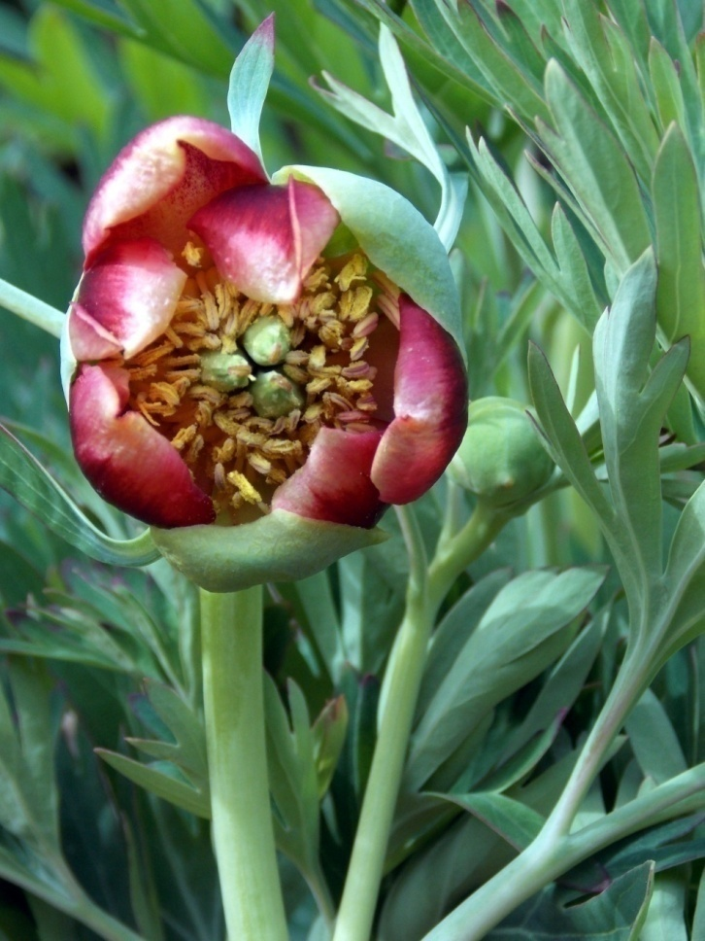
Wild Peony
Paeonia californica
PAEONIACEAE - Peony Family

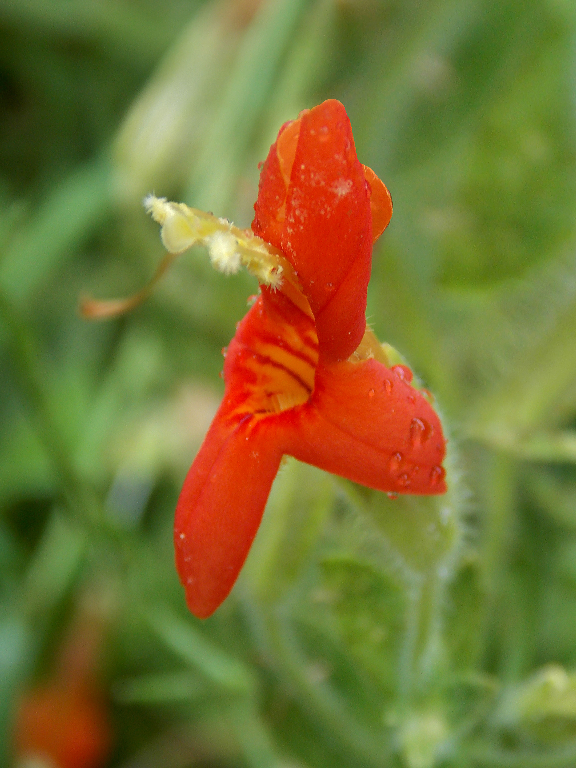
Scarlet Monkey Flower
Erythranthe cardinalis
PHRYMACEAE - Lopseed Family

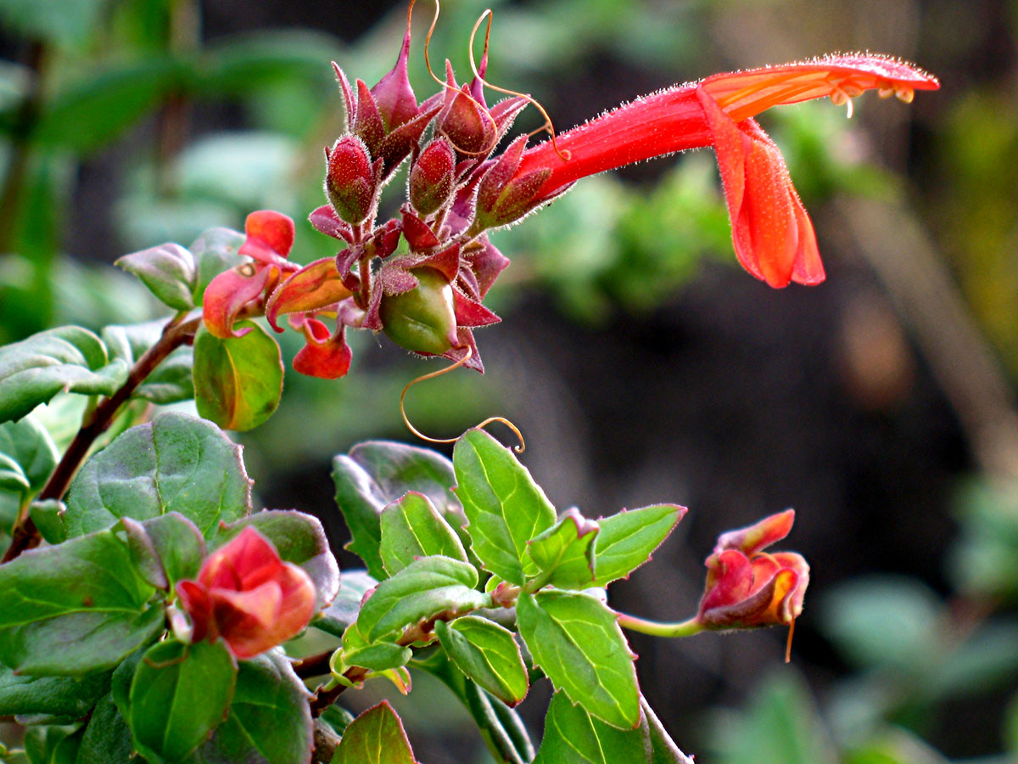
Heart Leaved Penstemon
Keckiella cordifolia
PLANTAGINACEAE - Plantain Family

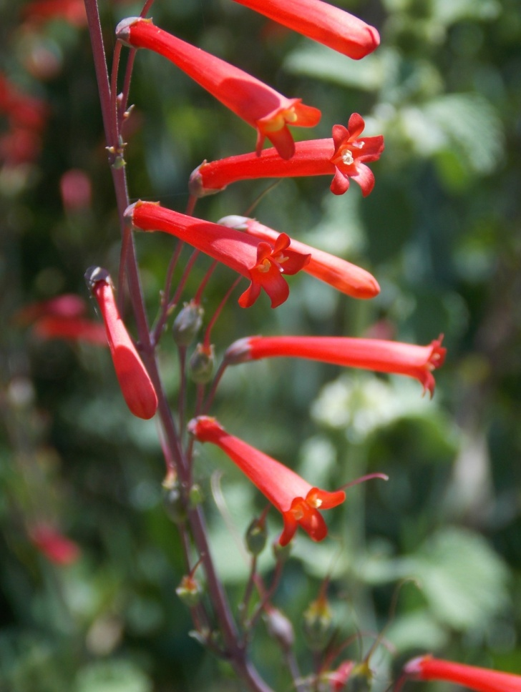
Scarlet Bugler
Penstemon centranthifolius
PLANTAGINACEAE - Plantain Family

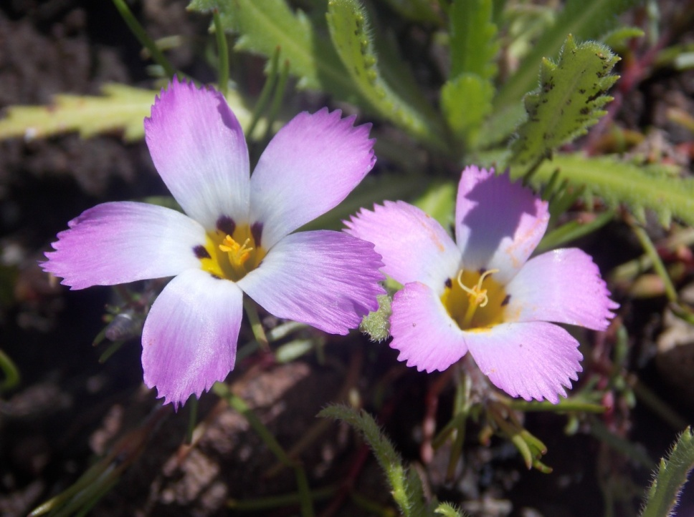
Ground Pink
Linanthus dianthiflorus
POLEMONIACEAE - Phlox Family

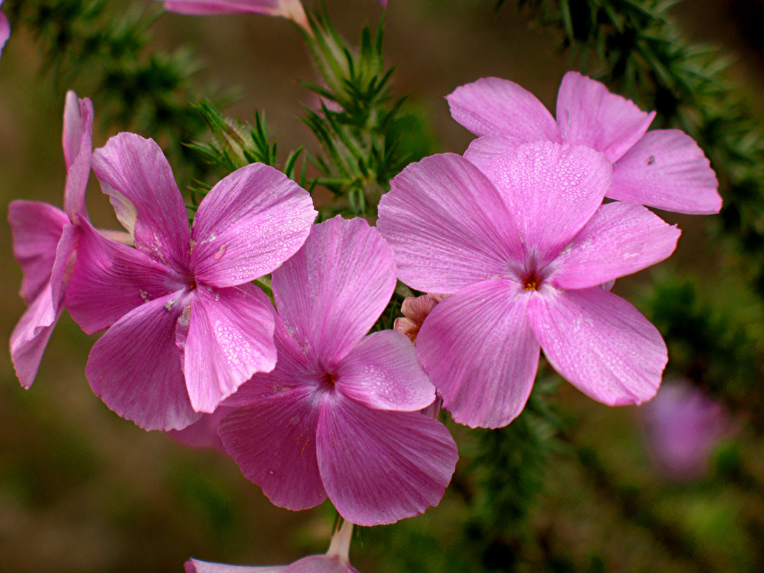
Prickly Phlox
Linanthus californicus
POLEMONIACEAE - Phlox Family

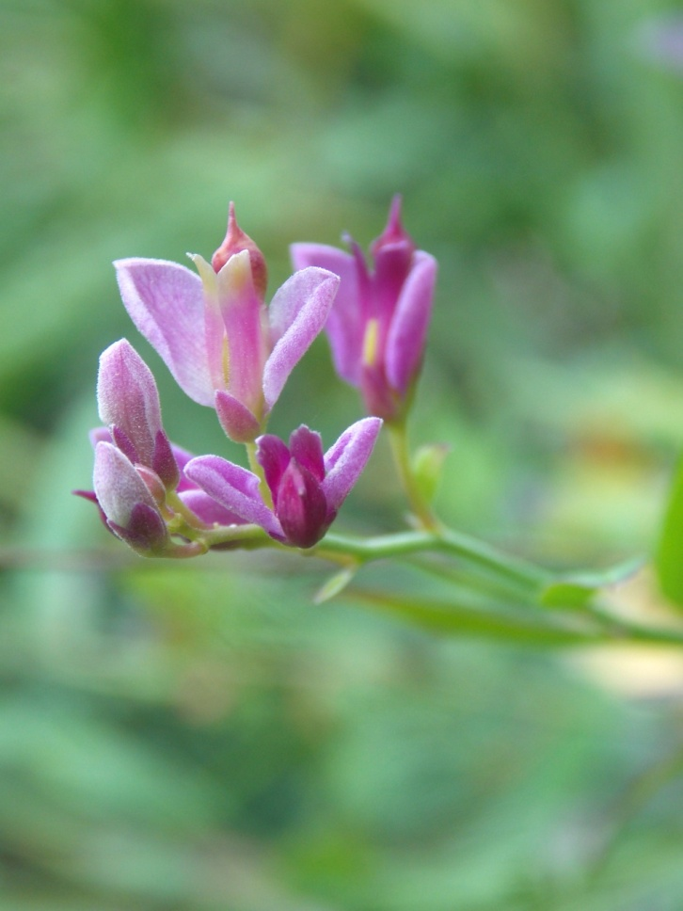
Milkwort
Polygala cornuta
POLYGALACEAE - Milkwort Family

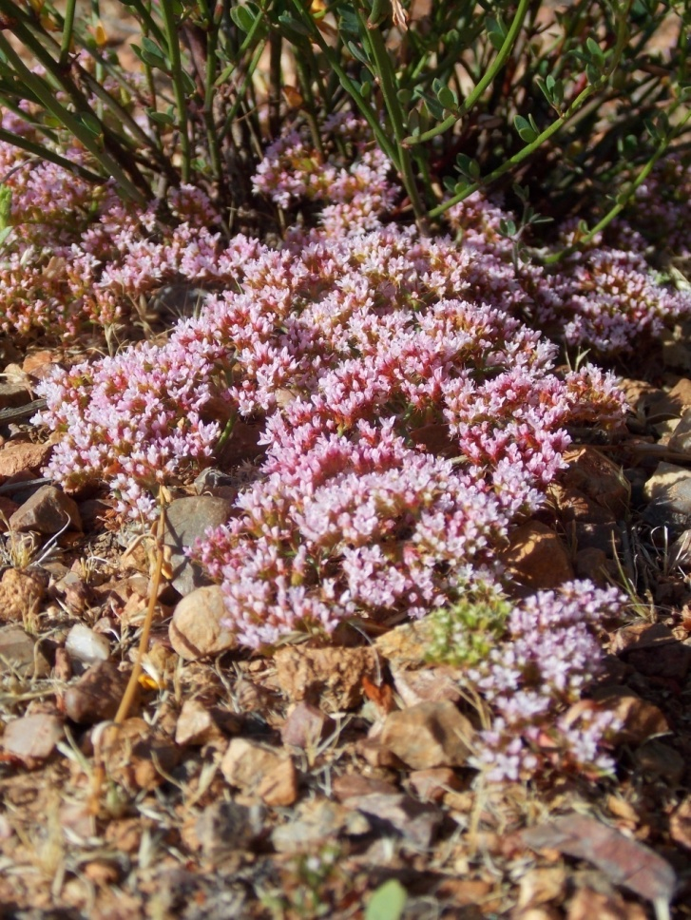
Turkish Rugging
Chorizanthe staticoides
POLYGONACEAE - Buckwheat Family

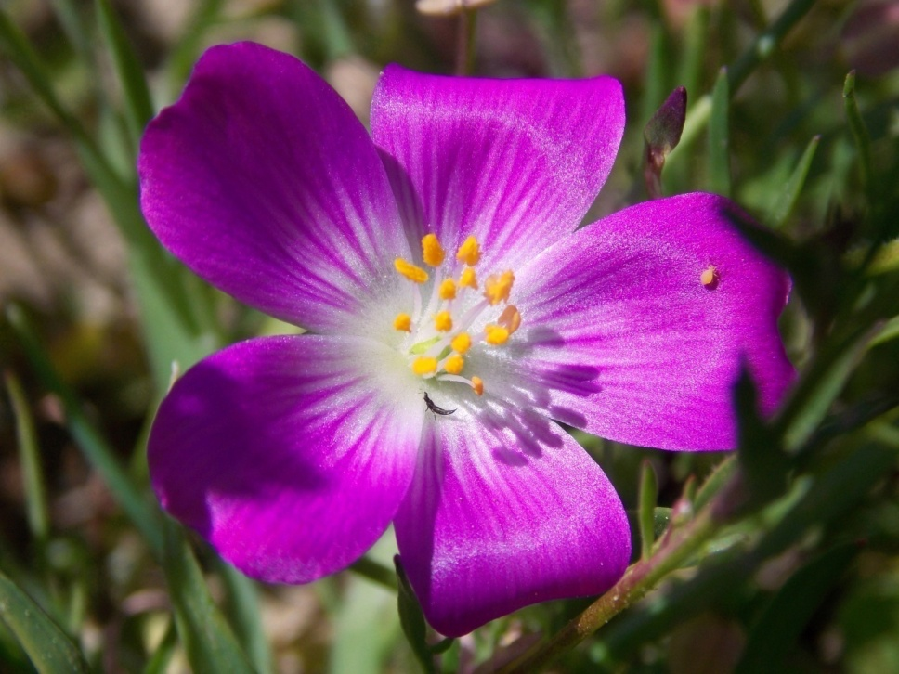
Red Maids
Calandrinia menziesii
PORTULACACEAE - Purslane Family

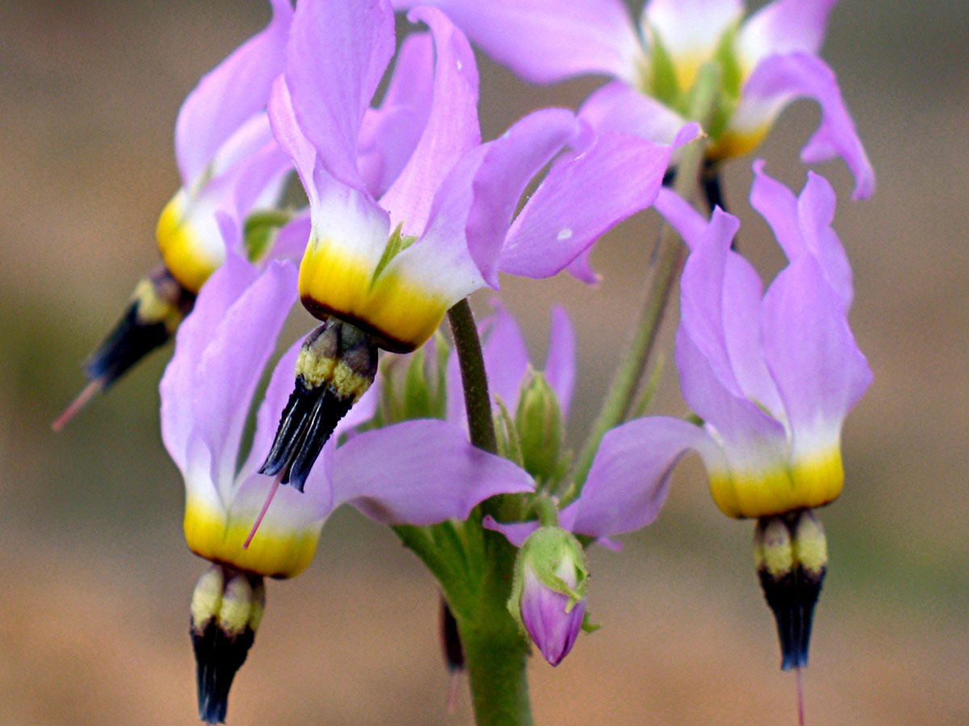
Shooting Star
Primula clevelandii
PRIMULACEAE - Primrose Family

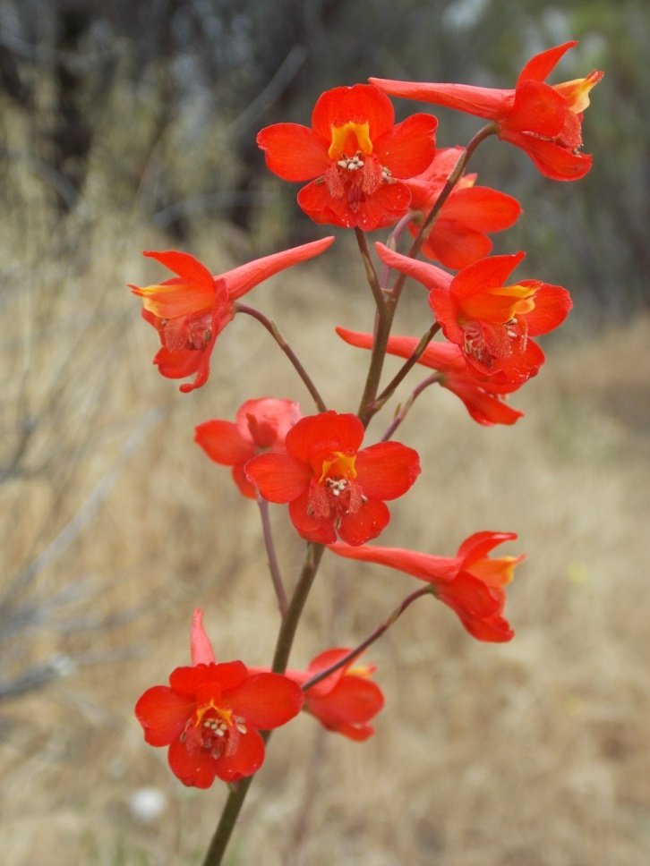
Scarlet Larkspur
Delphinium cardinale
RANUNCULACEAE - Buttercup Family

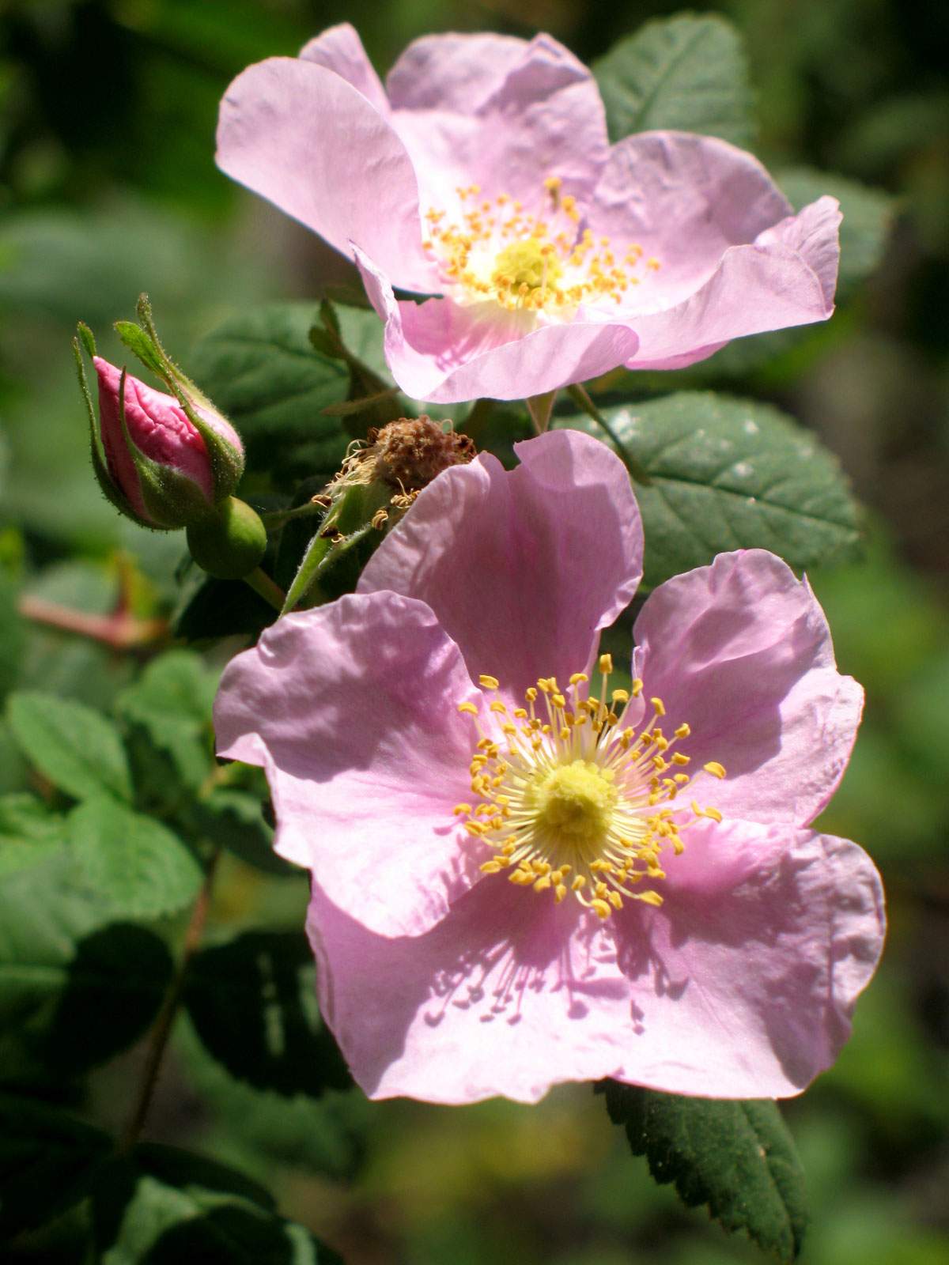
Wild Rose
Rosa californica
ROSACEAE - Rose Family

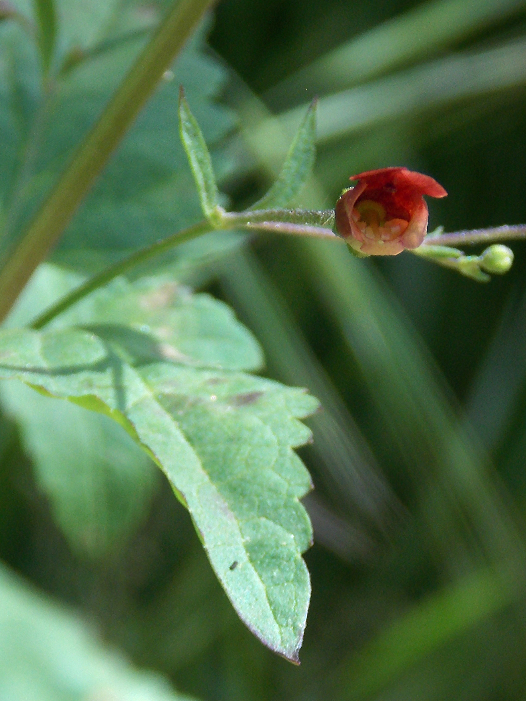
Bee Plant
Scrophularia californica
SCROPHULARIACEAE - Figwort Family

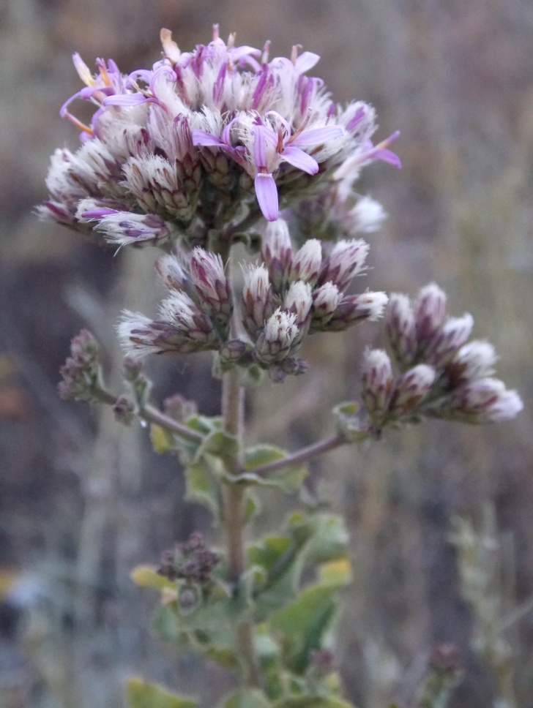
Perezia
Acourtia microcephala
ASTERACEAE - Sunflower Family

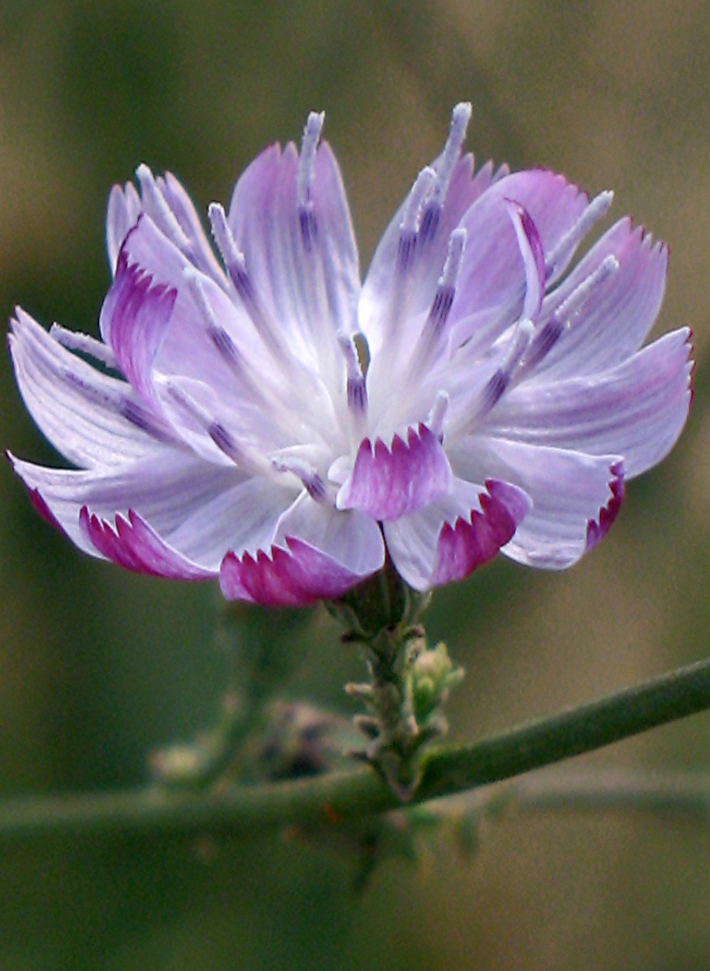
San Diego Wreathplant
Stephanomeria diegensis
ASTERACEAE - Sunflower Family

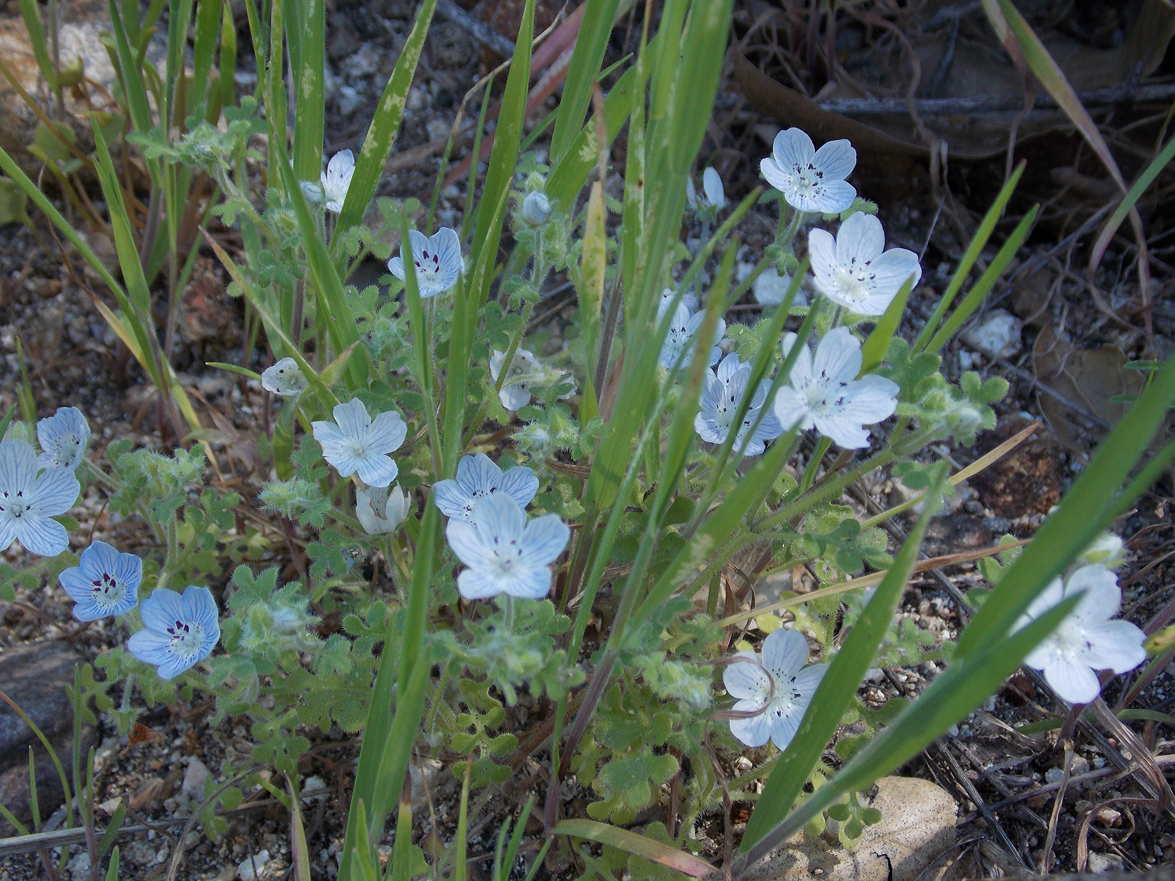
Baby Blue Eyes
Nemophila menziesii
BORAGINACEAE - Borage Family

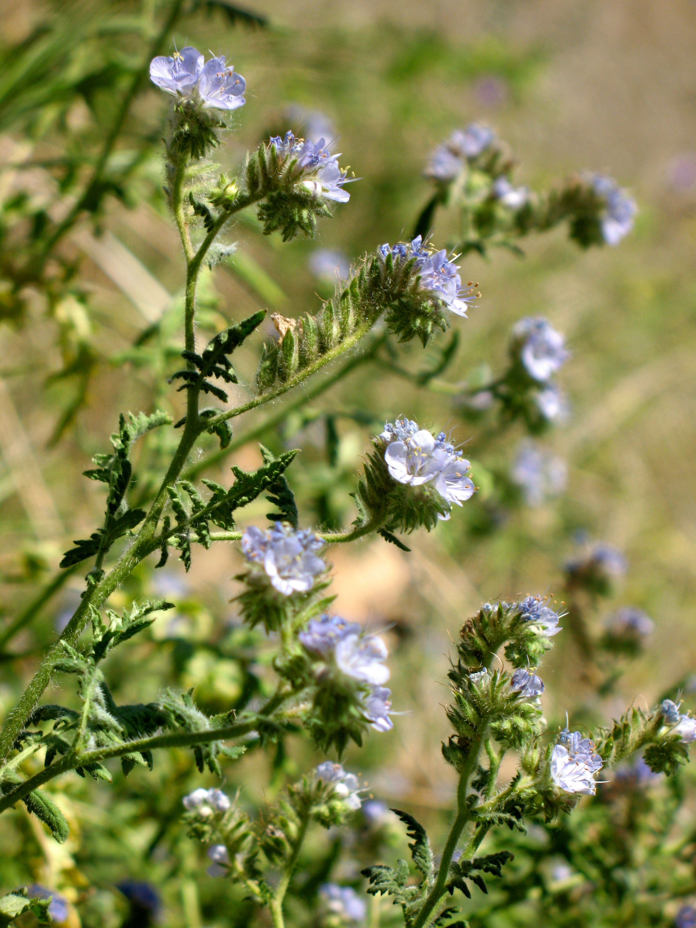
Branching Phacelia
Phacelia ramosissima
BORAGINACEAE - Borage Family

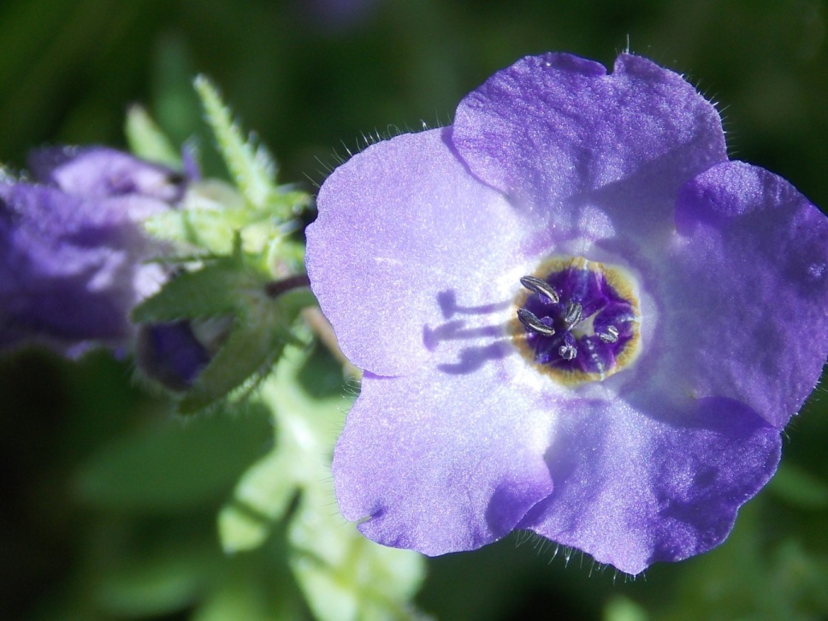
Fiesta Flower
Pholistoma auritum
BORAGINACEAE - Borage Family

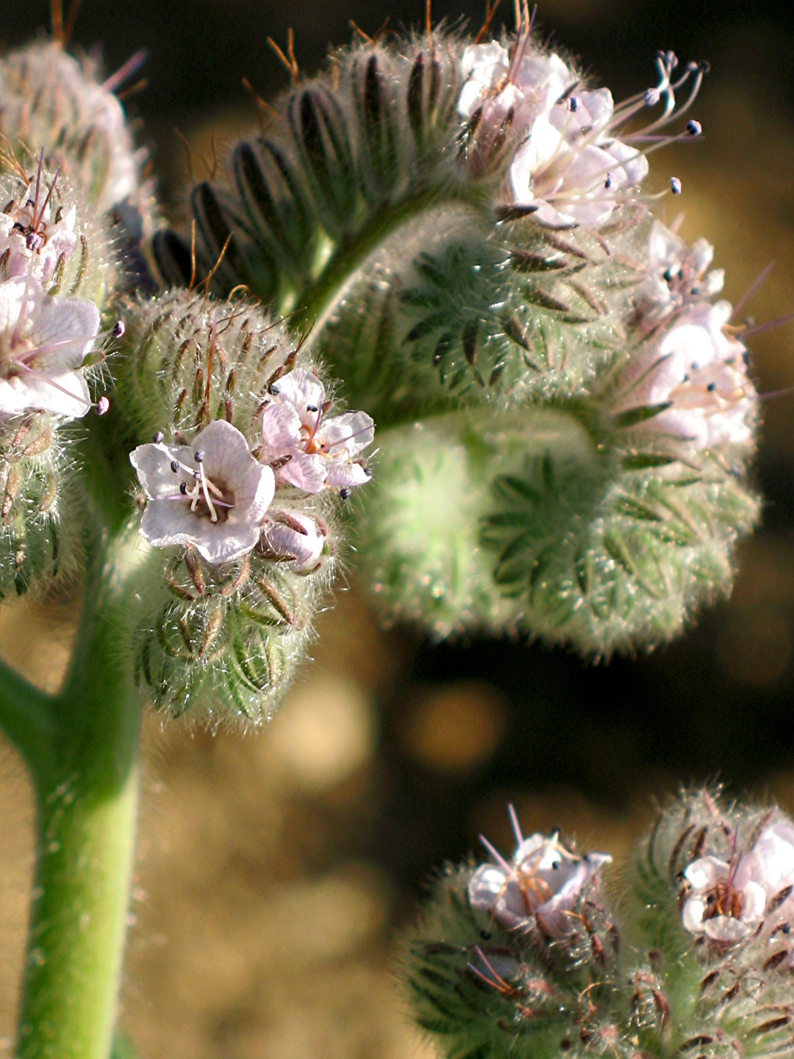
Hubby’s Phacelia
Phacelia hubbyi
BORAGINACEAE - Borage Family

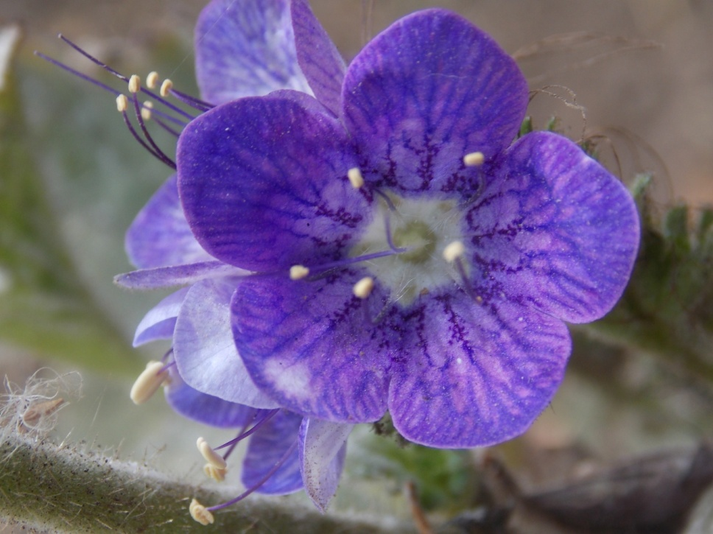
Large-Flowered Phacelia
Phacelia grandiflora
BORAGINACEAE - Borage Family

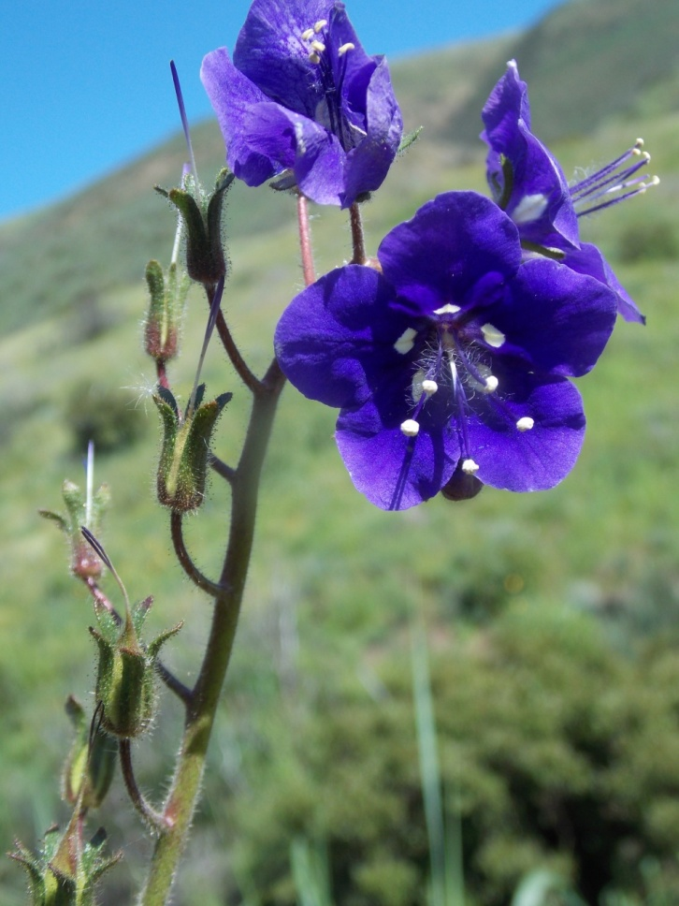
Parry’s Phacelia
Phacelia parryi
BORAGINACEAE - Borage Family

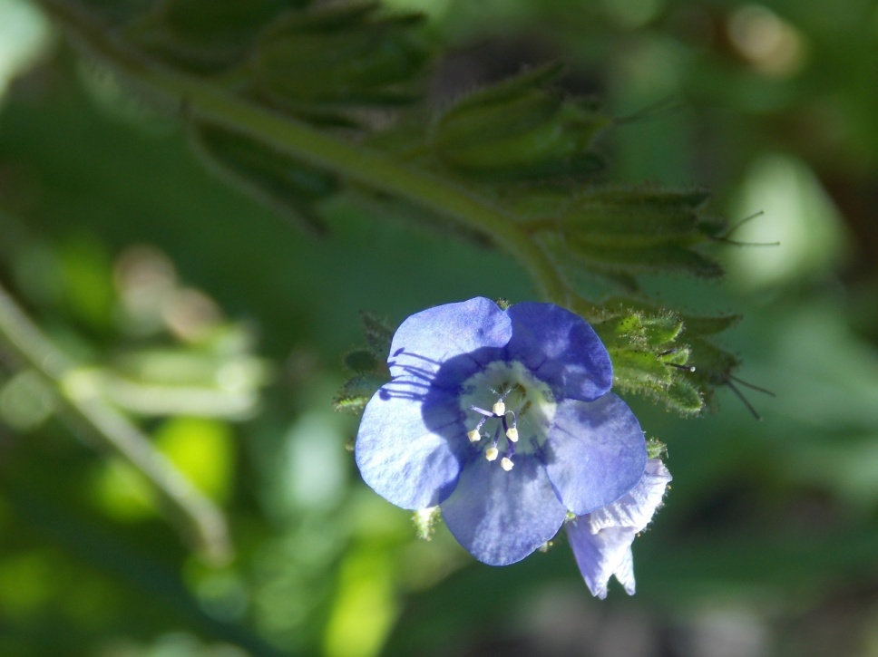
Sticky Phacelia
Phacelia viscida
BORAGINACEAE - Borage Family

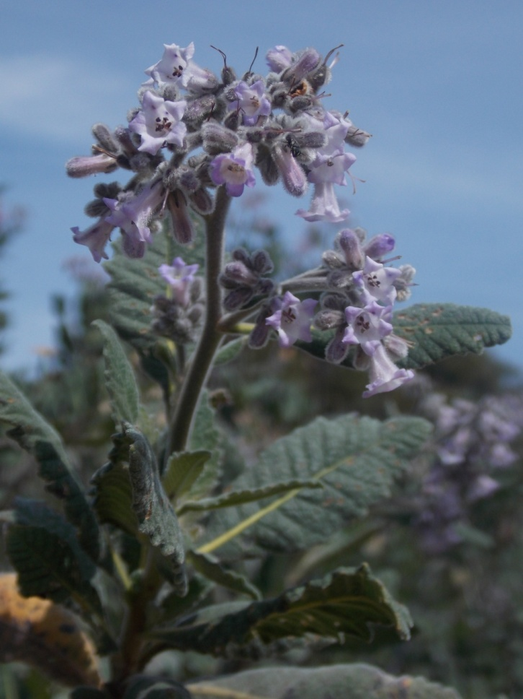
Yerba Santa
Eriodichtyon crassifolium
BORAGINACEAE - Borage Family

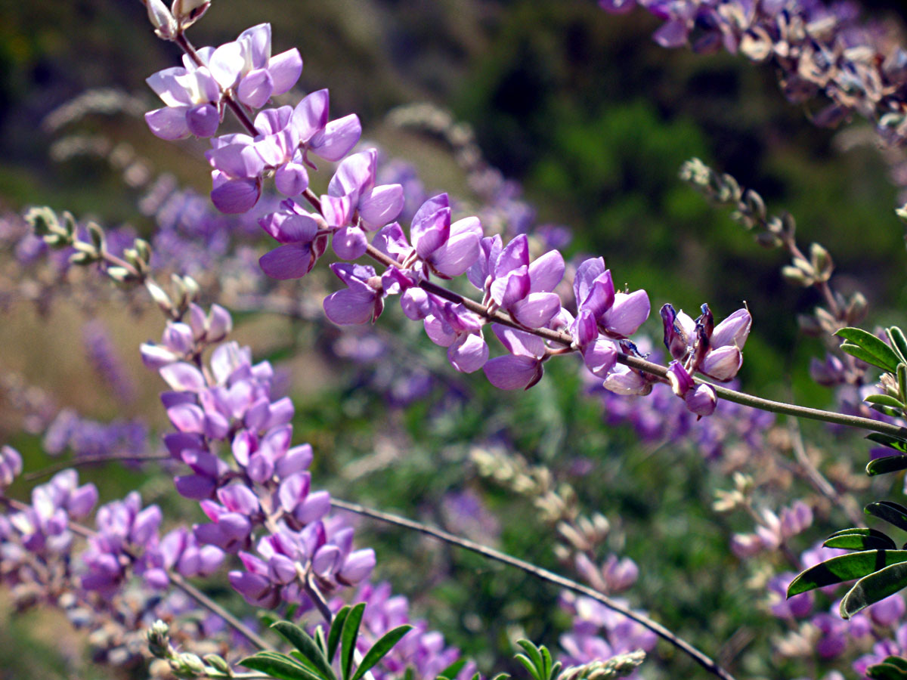
Bush Lupine
Lupinus longifolius
FABACEAE - Pea Family

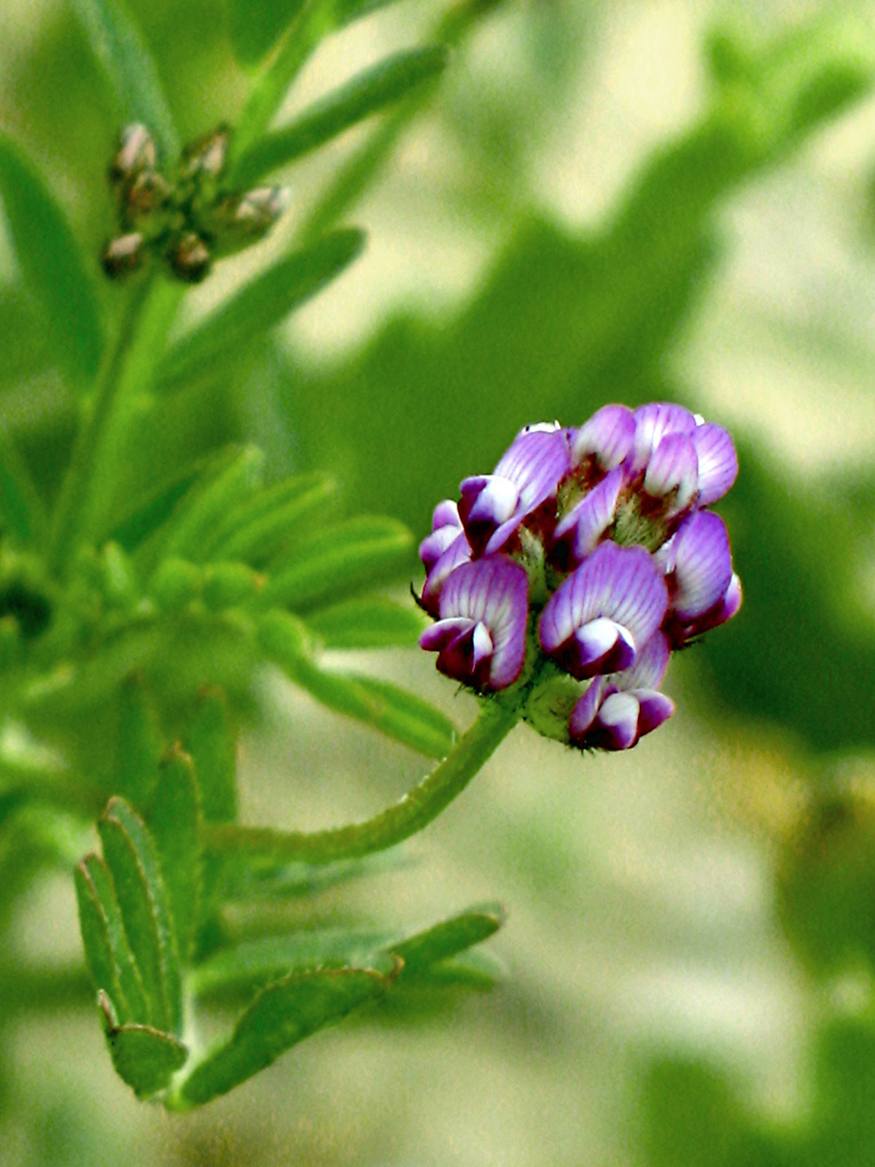
Dwarf Locoweed
Astragalus gambelianus
FABACEAE - Pea Family

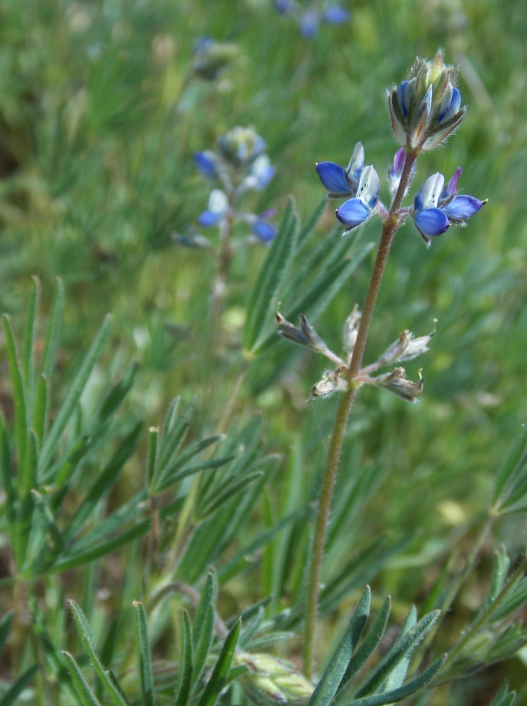
Miniature Lupine
Lupinus bicolor
FABACEAE - Pea Family

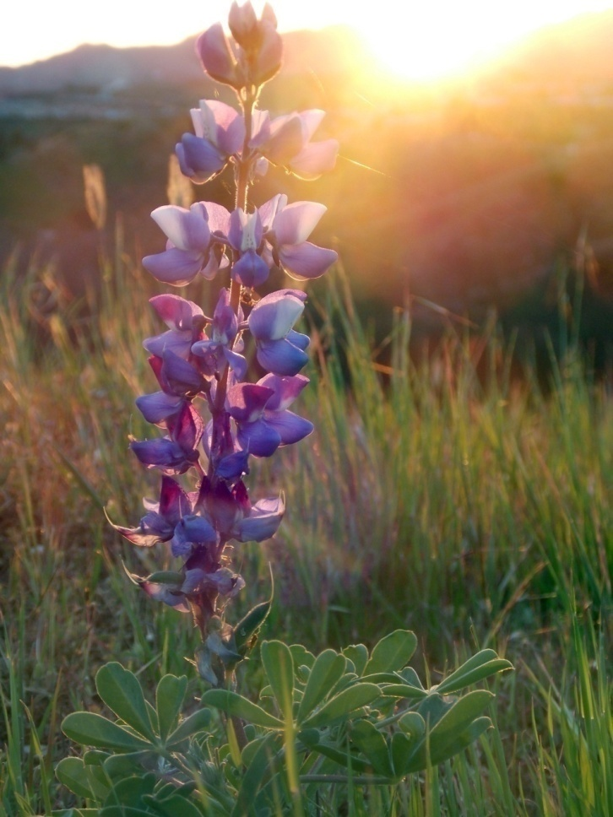
Succulent Lupine
Lupinus succulentus
FABACEAE - Pea Family

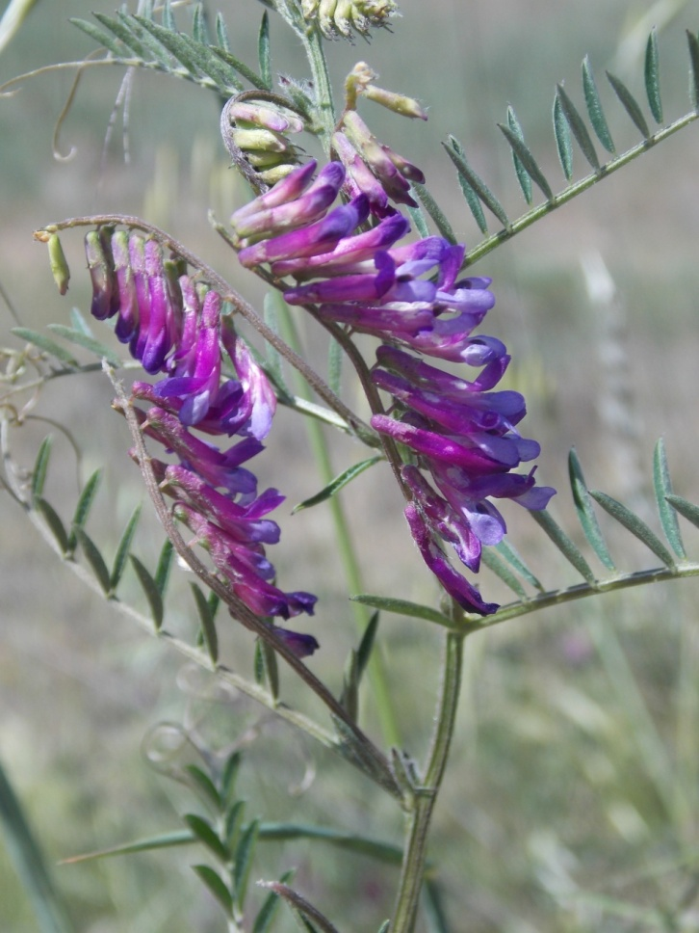
Winter Vetch
Vicia villosa
FABACEAE - Pea Family

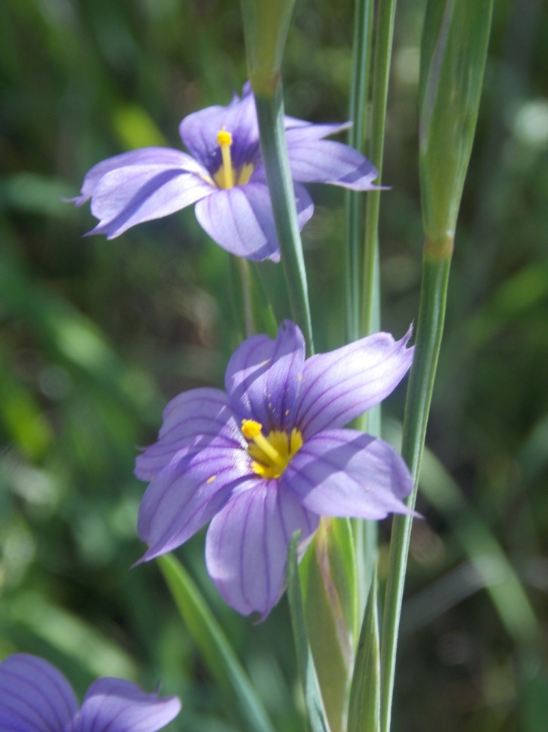
Blue-Eyed Grass
Sisyrinchium bellum
IRIDACEAE - Iris Family

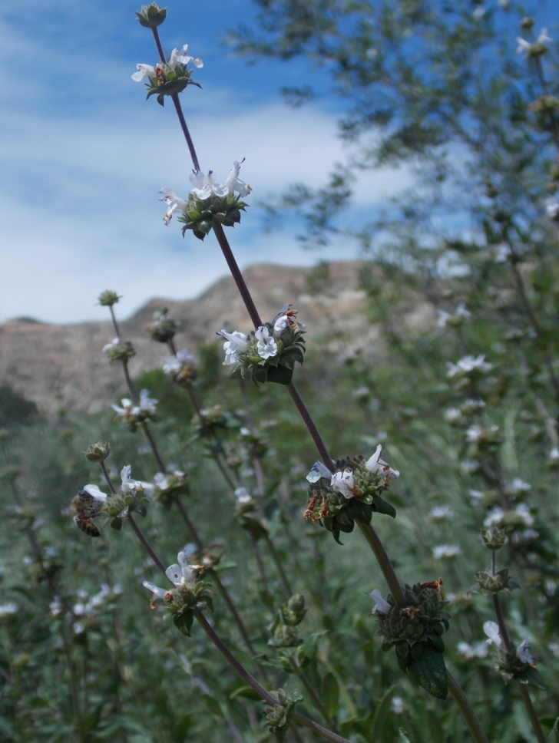
Black Sage
Salvia mellifera
LAMIACEAE - Mint Family

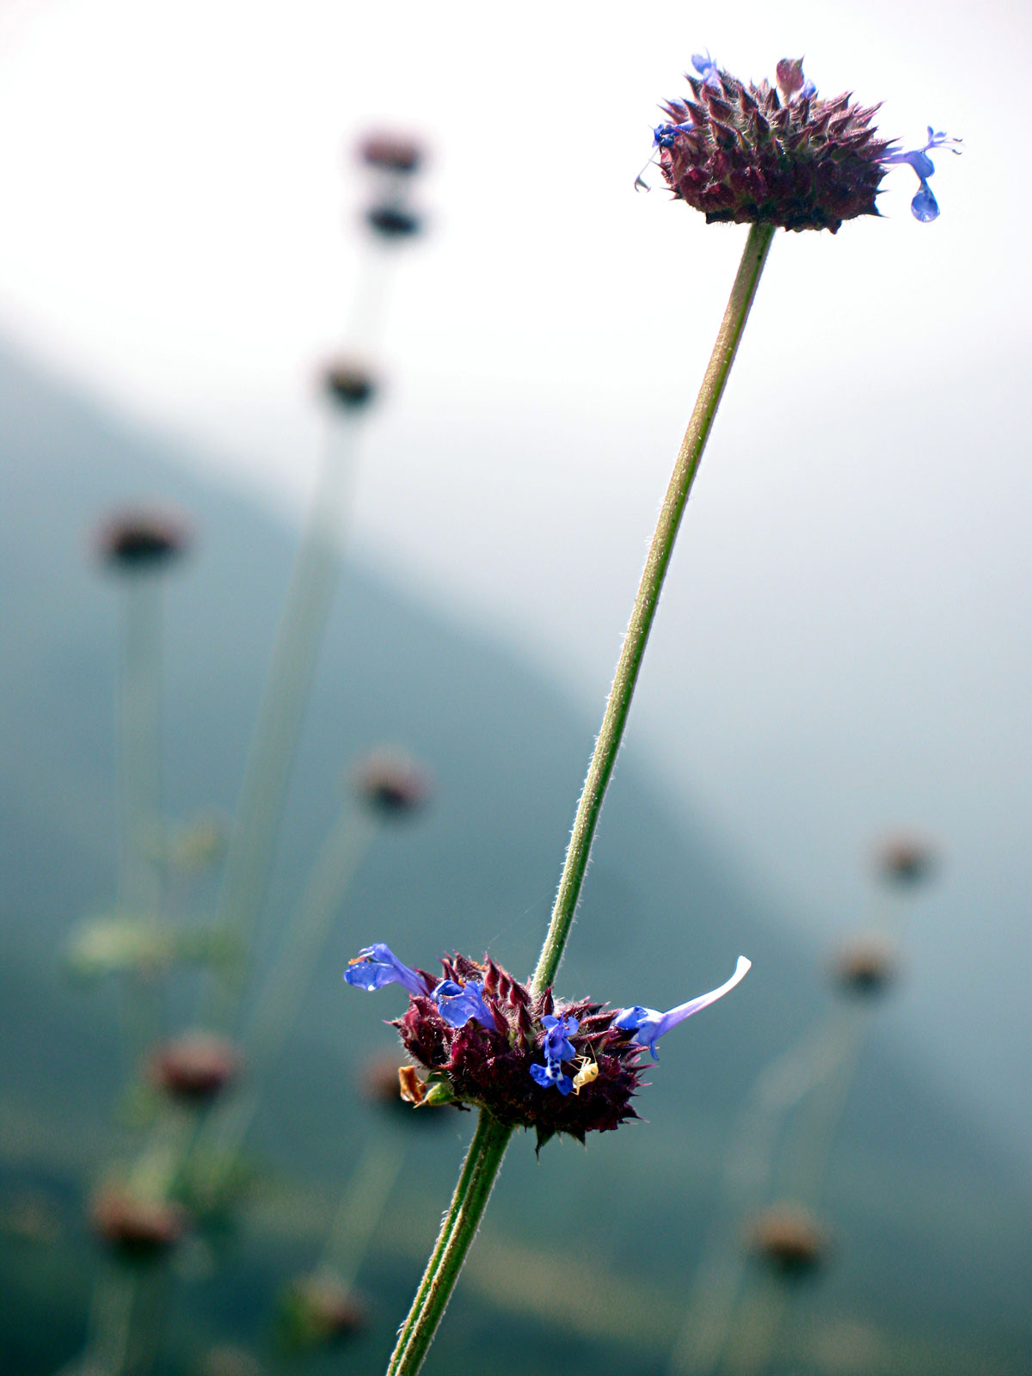
Chia
Salvia columbariae
LAMIACEAE - Mint Family

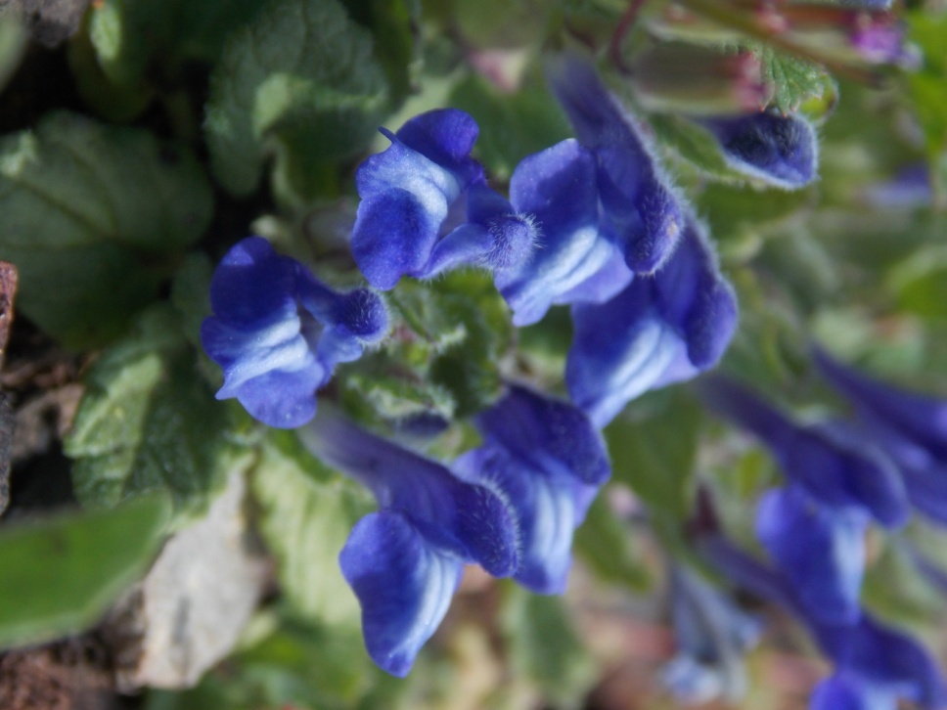
Danny’s Skullcap
Scutellaria tuberosa
LAMIACEAE - Mint Family

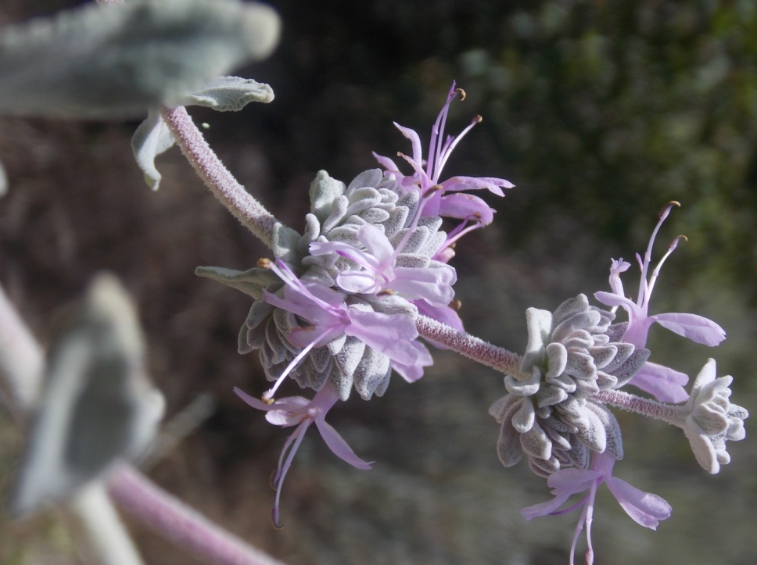
Purple Sage
Salvia leucophylla
LAMIACEAE - Mint Family

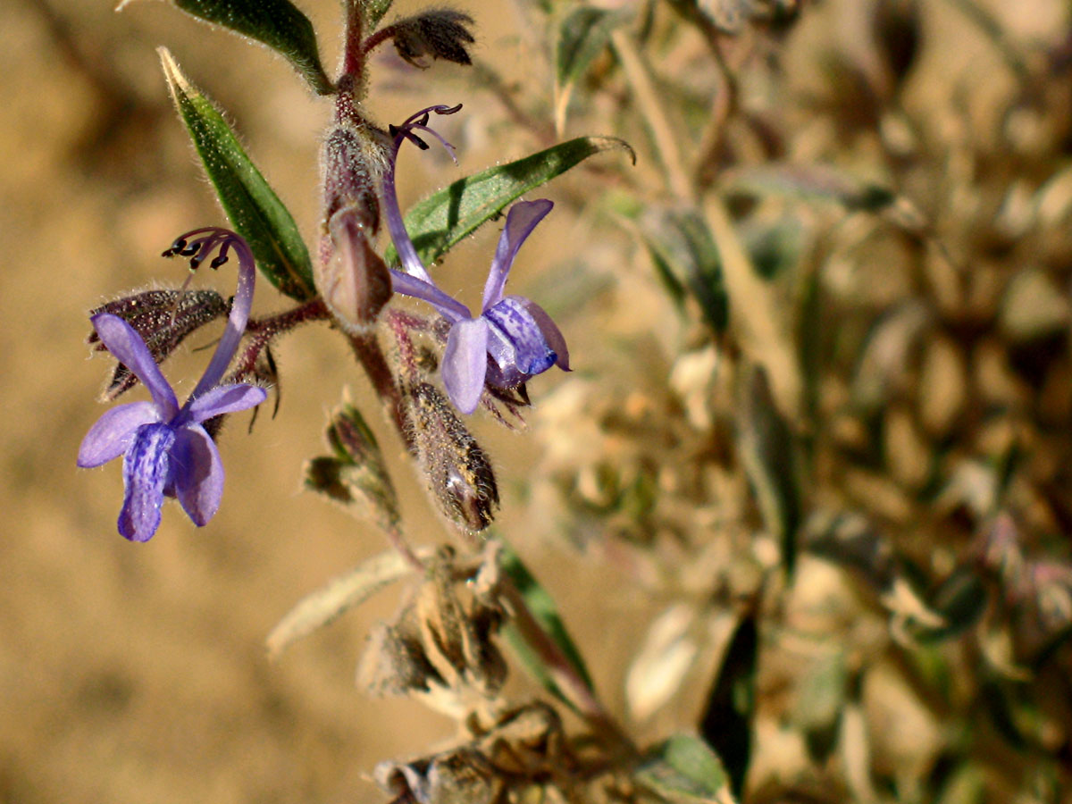
Vinegar Weed
Trichostema lanceolatum
LAMIACEAE - Mint Family

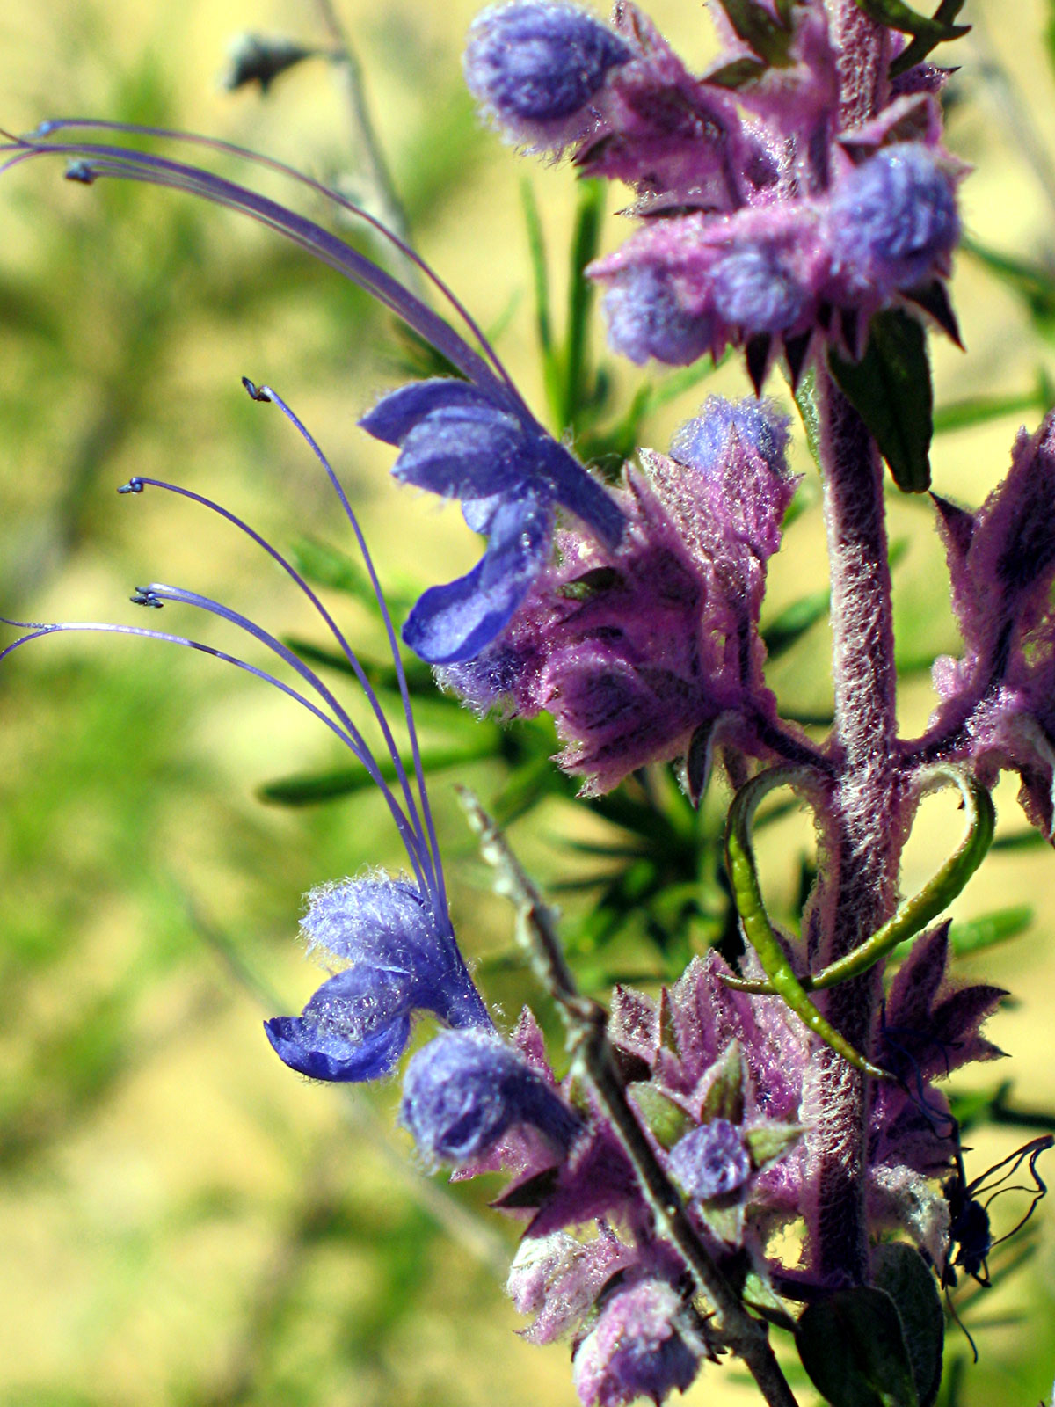
Woolly Blue Curls
Trichostema lanatum
LAMIACEAE - Mint Family

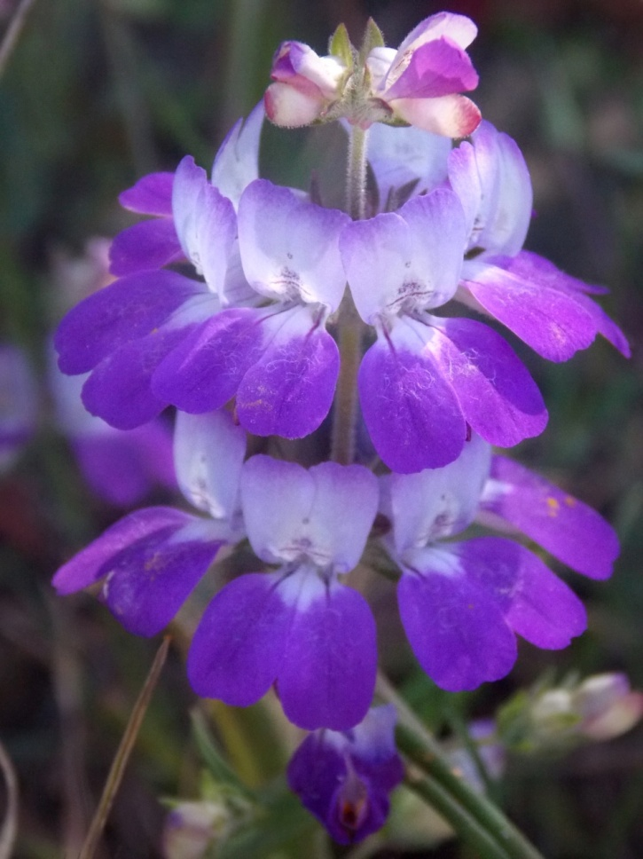
Chinese Houses
Colinsia heterophylla
PLANTAGINACEAE - Plantain Family

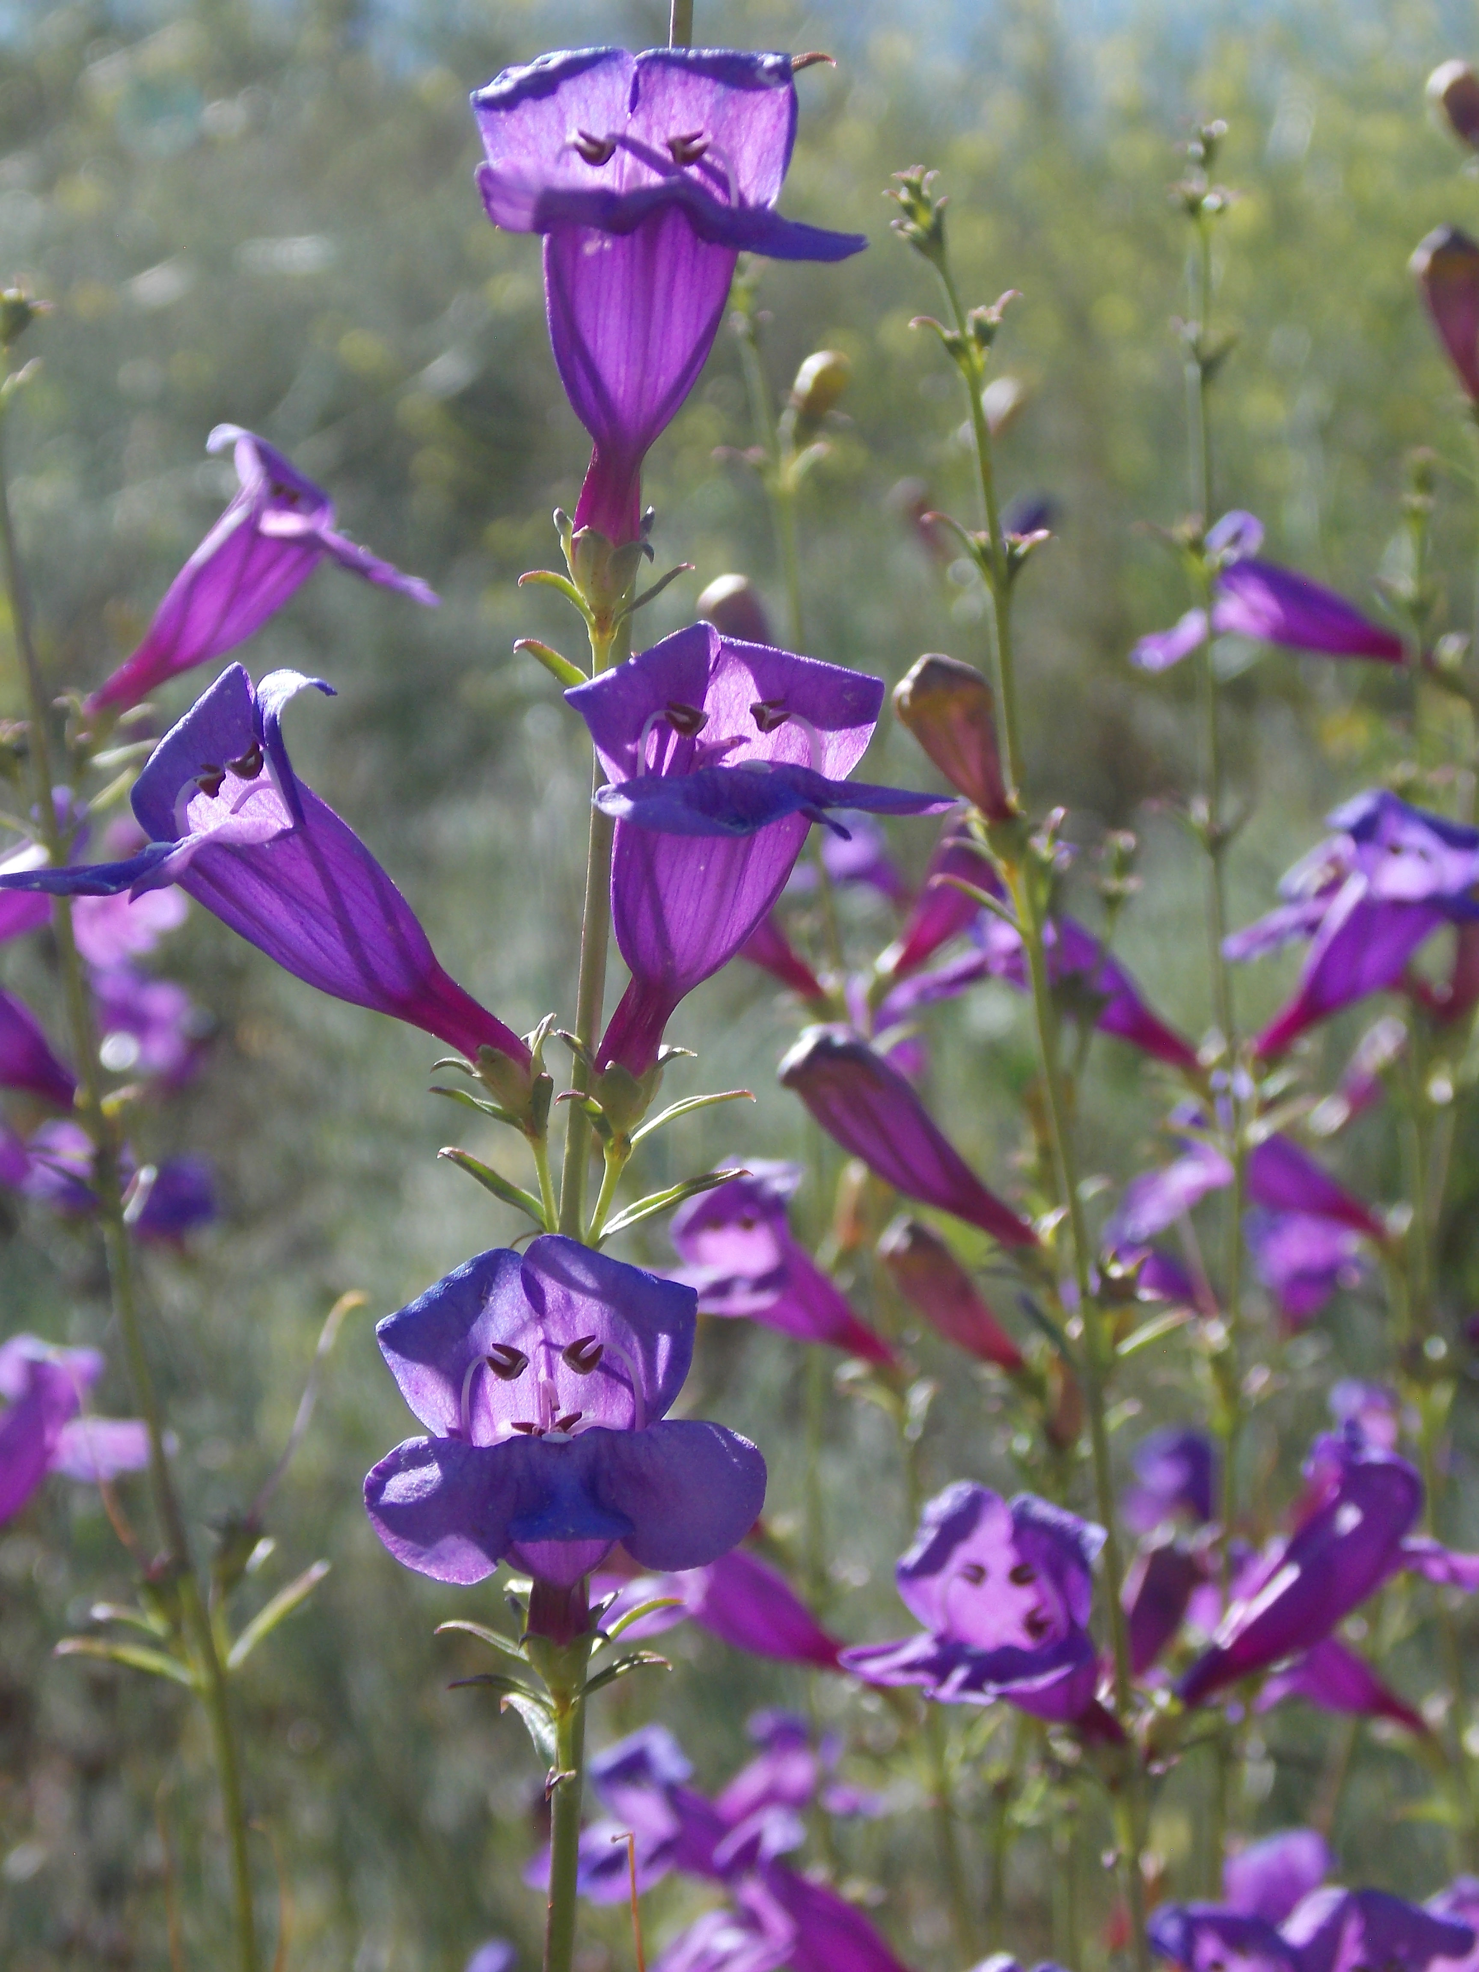
Penstemon
Penstemon heterophyllus
PLANTAGINACEAE - Plantain Family

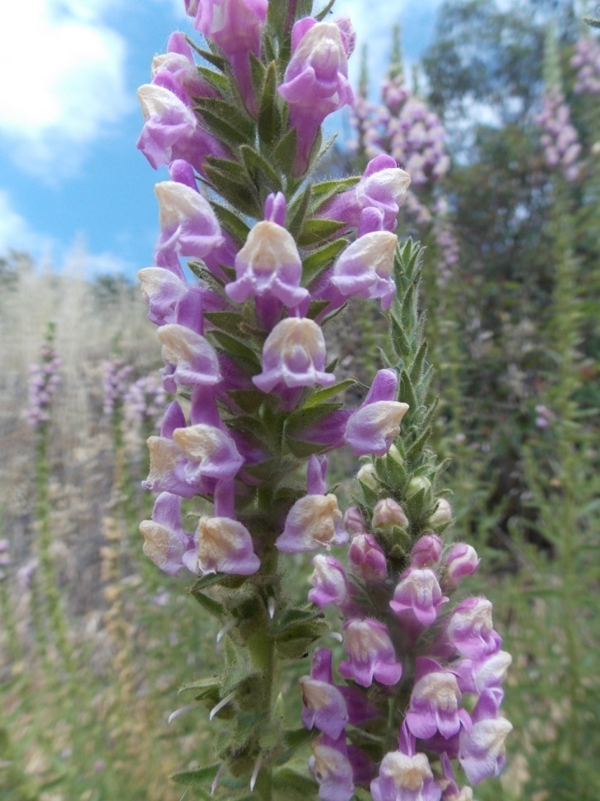
Rose Snapdragon
Antirrhinum multiflorum
PLANTAGINACEAE - Plantain Family

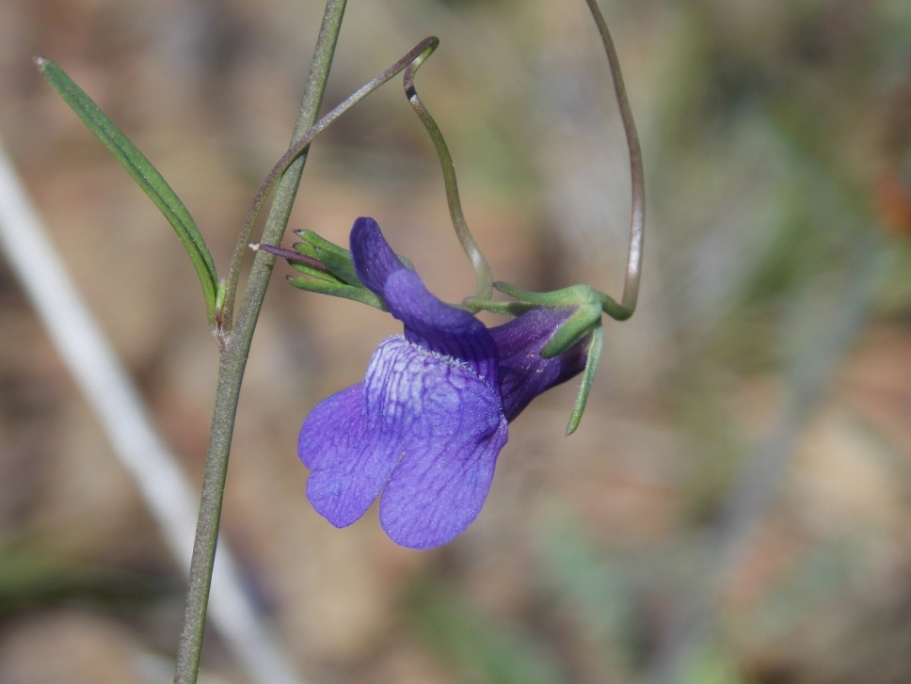
Twining Snapdragon
Antirrhinum kelloggii
PLANTAGINACEAE - Plantain Family

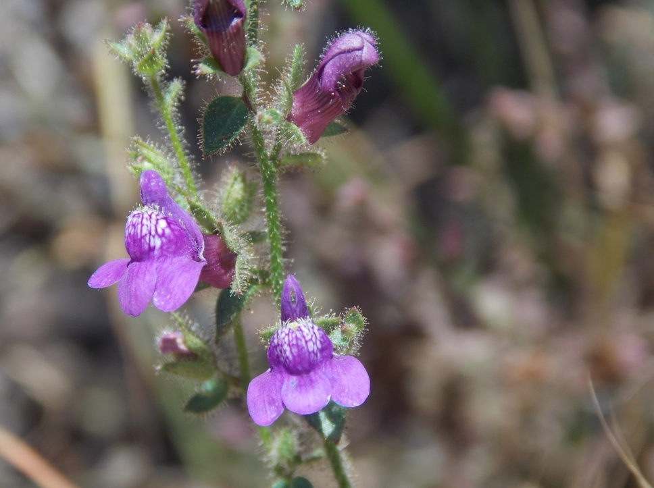
Violet Snapdragon
Antirrhinum nuttallianum
PLANTAGINACEAE - Plantain Family

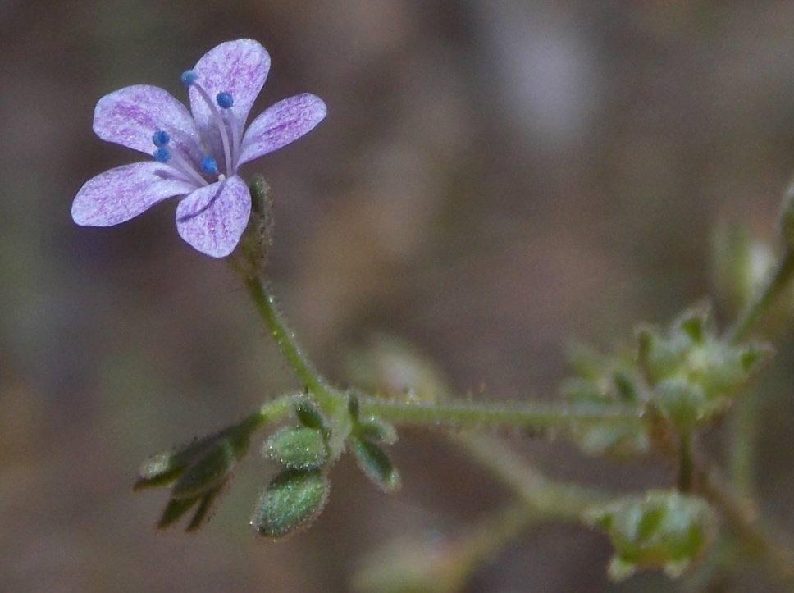
Sticky Gilia
Allophylum glutinosum
POLEMONIACEAE - Phlox Family

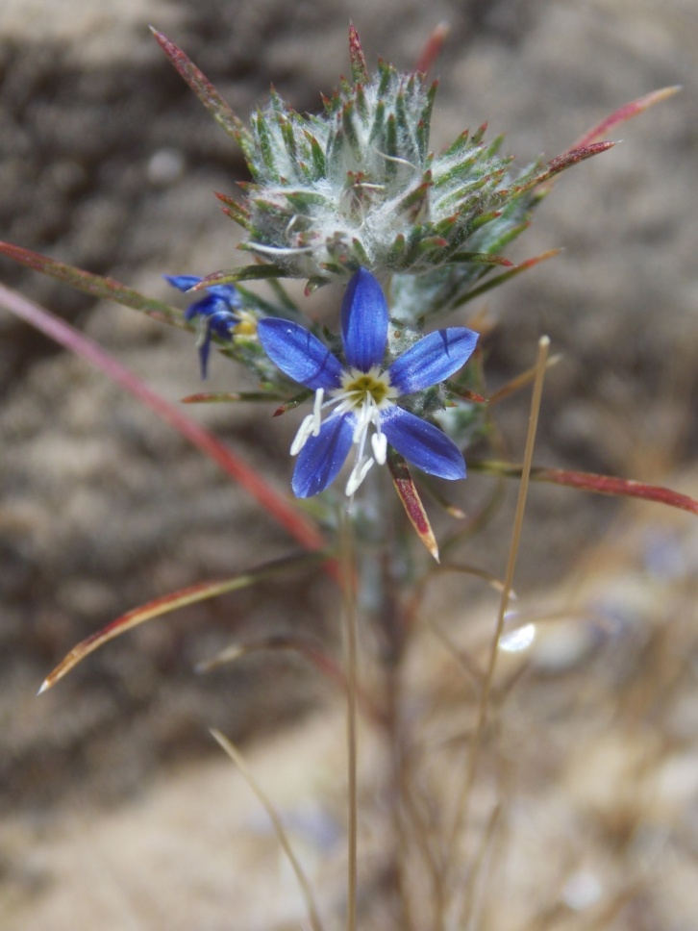
Woolly Sapphire
Eriastrum sapphirinum
POLEMONIACEAE - Phlox Family

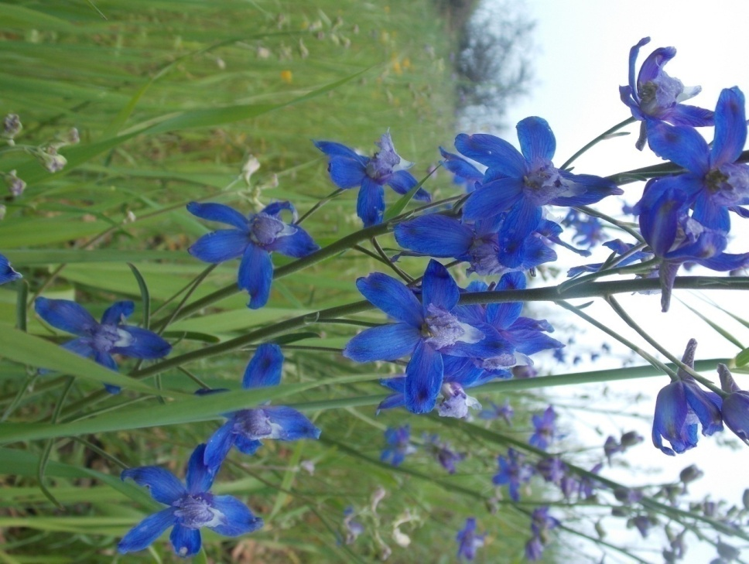
Blue Larkspur
Delphinium parryi
RANUNCULACEAE - Buttercup Family

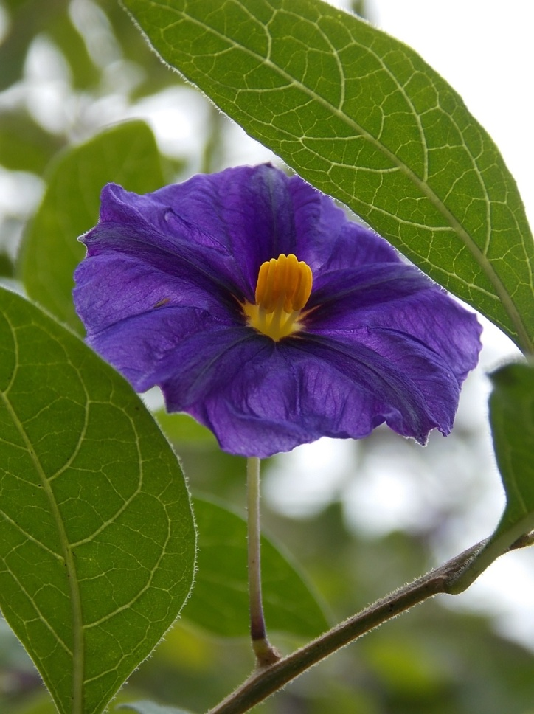
Purple Nightshade
Solanum xanti
SOLANACEAE - Nightshade Family

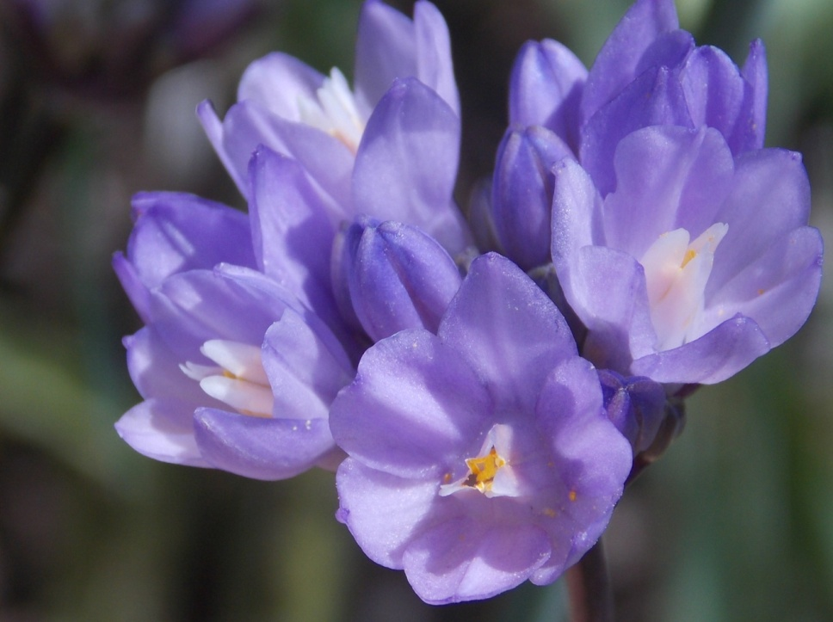
Blue Dicks
Dipterostemon capitatus
THEMIDACEAE - Brodiaea Family

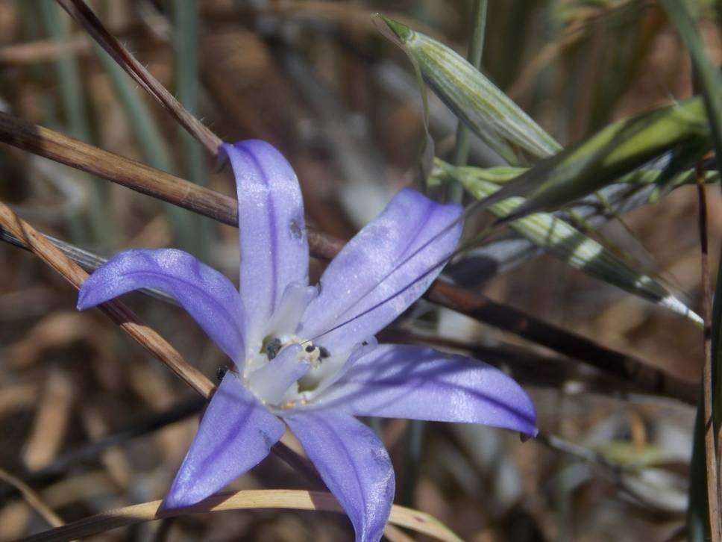
Brodiaea
Brodiaea terrestris
THEMIDACEAE - Brodiaea Family

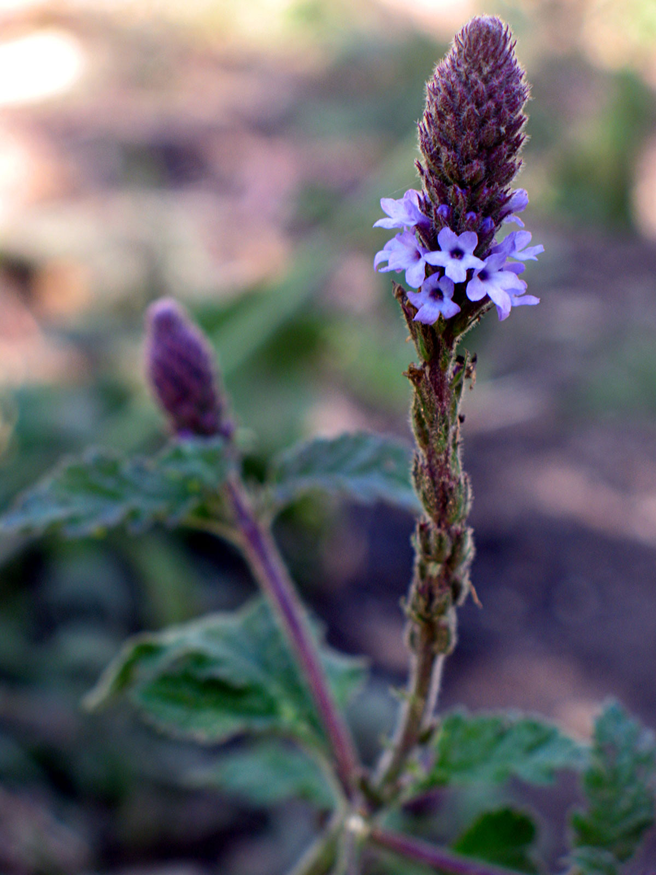
Vervain
Verbena lasiostachys
VERBENACEAE - Vervain Family

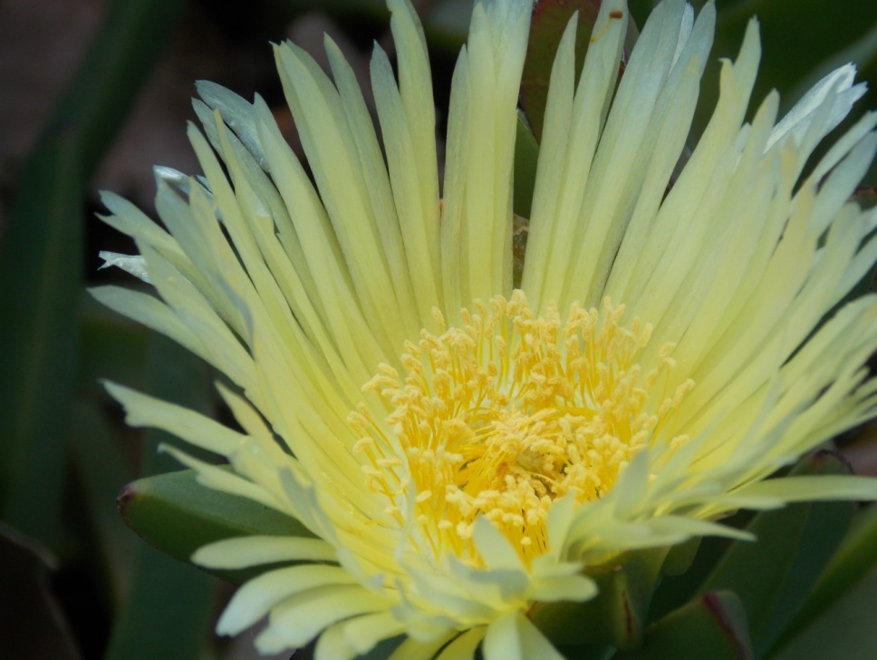
Hottentot Fig
Carpobrotus edulis
AIZOACEAE – Fig-Marigold Family

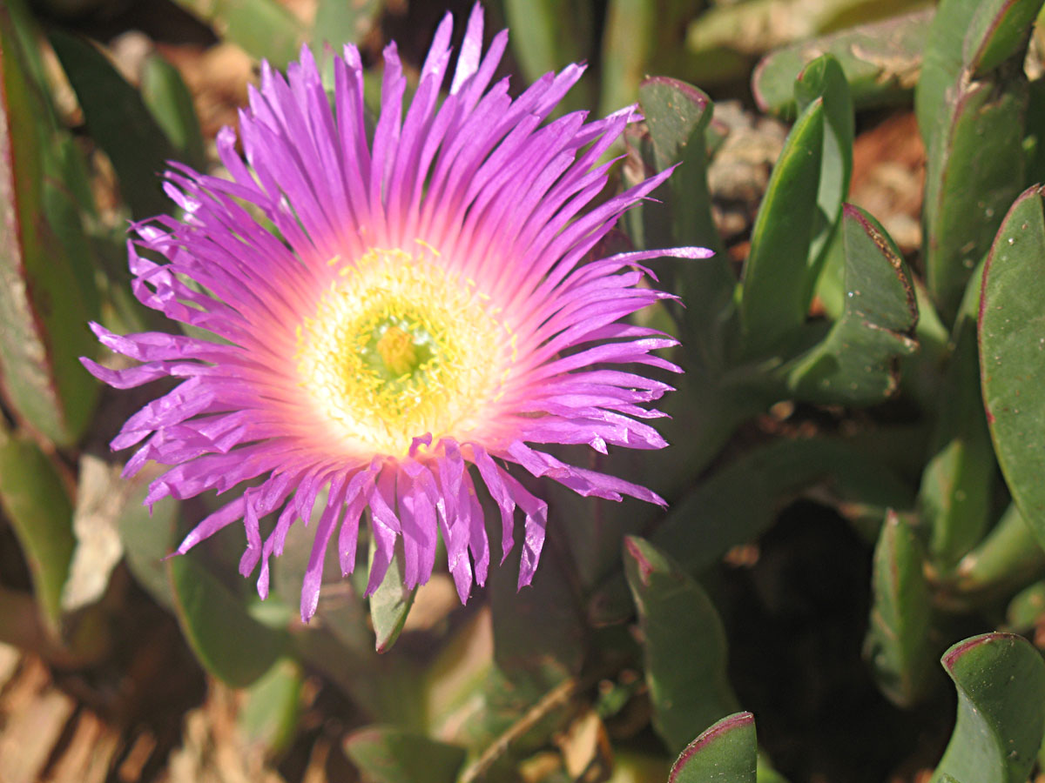
Sea Fig
Carpobrotus chilensis
AIZOACEAE - Fig-Marigold Family

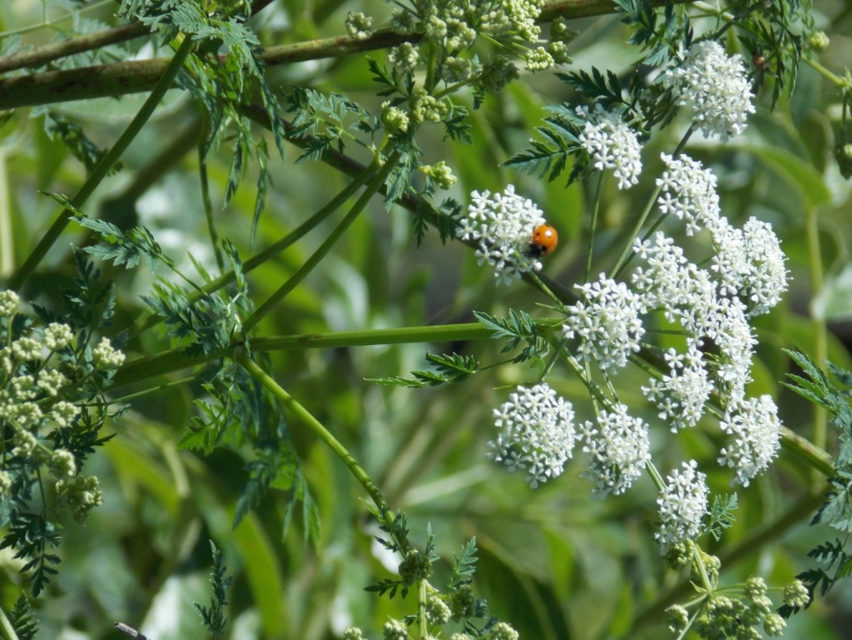
Poison Hemlock
Conium maculatum
APIACEAE – Carrot Family

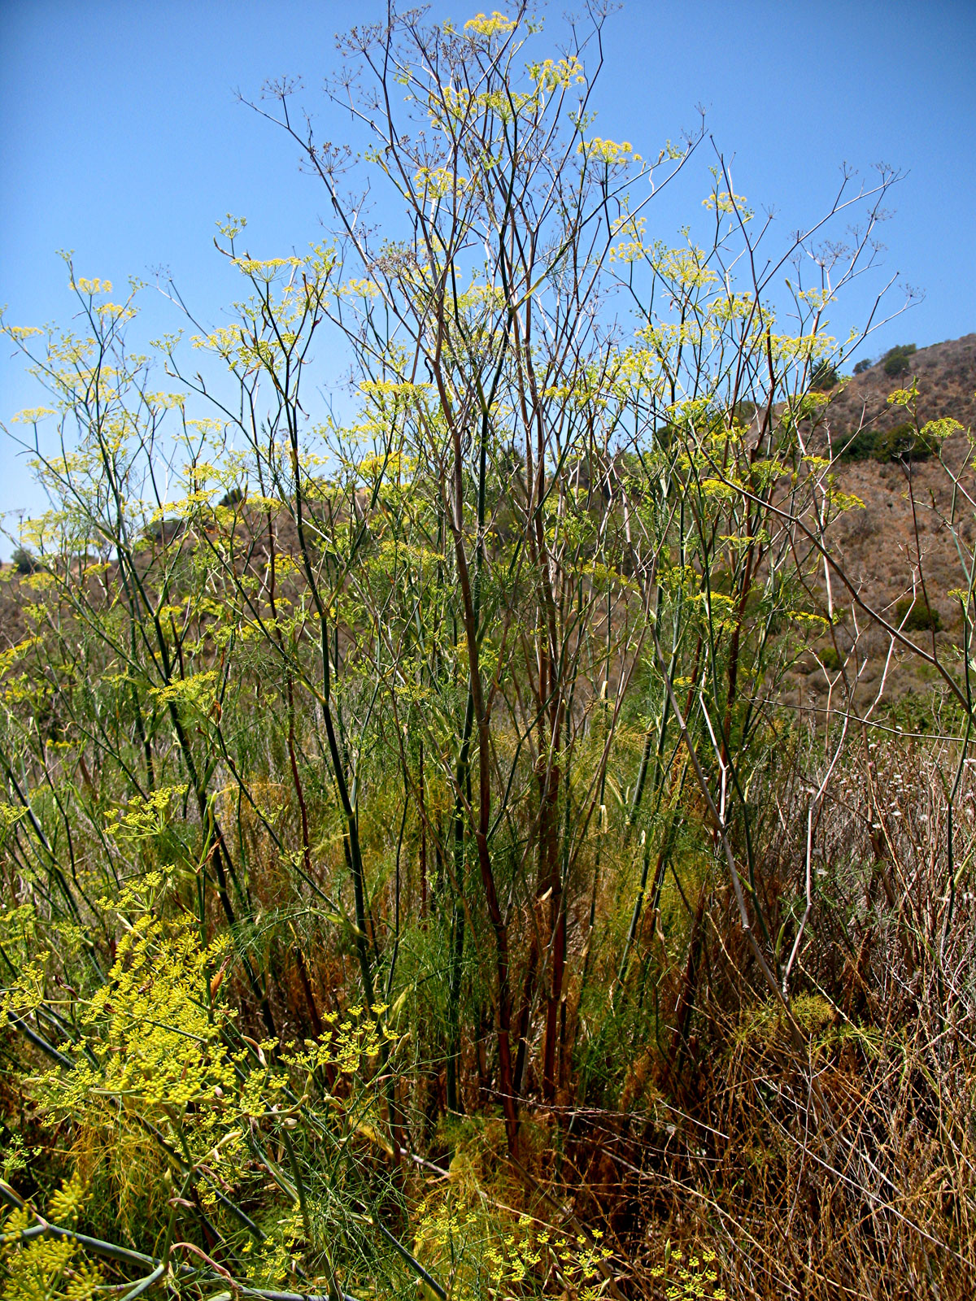
Sweet Fennel
Foeniculum vulgare
APIACEAE – Carrot Family

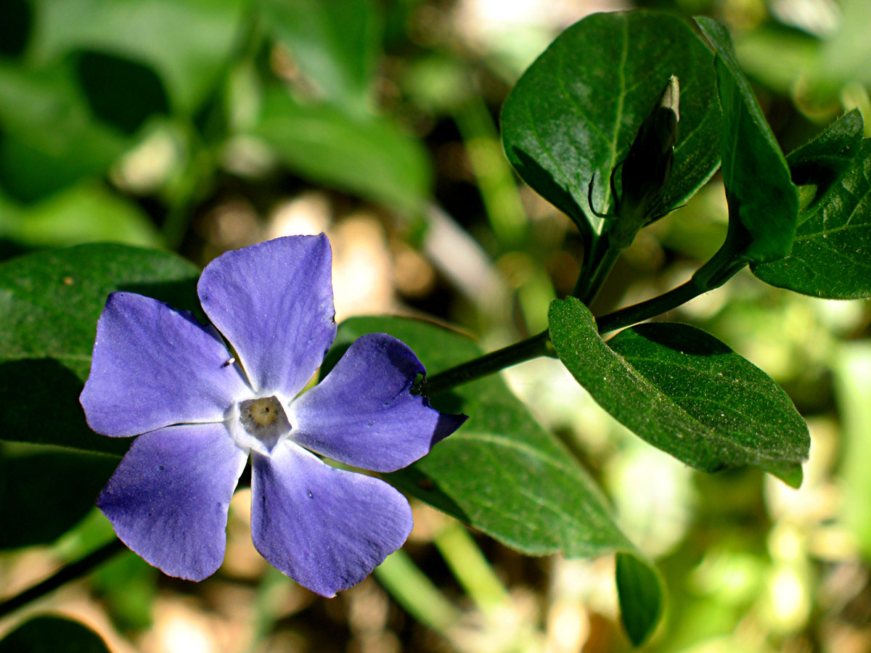
Periwinkle
Vinca major
APOCYNACEAE - Dogbane Family

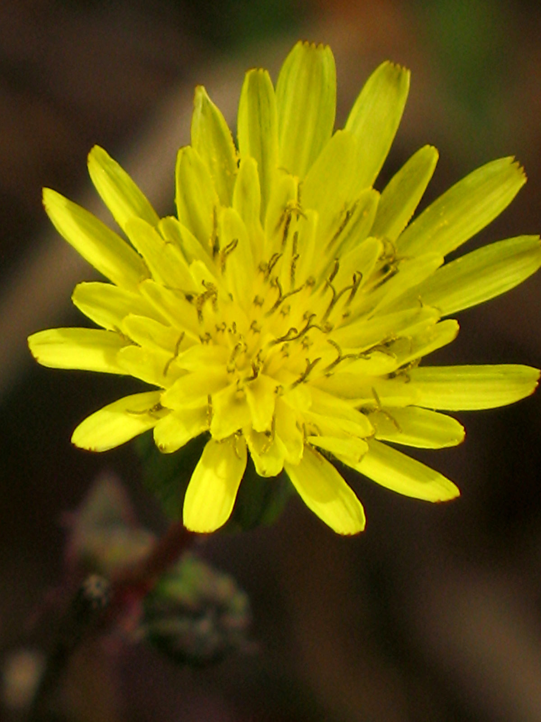
Bristly Ox-tongue
Helminthotheca echioides
ASTERACEAE – Sunflower Family

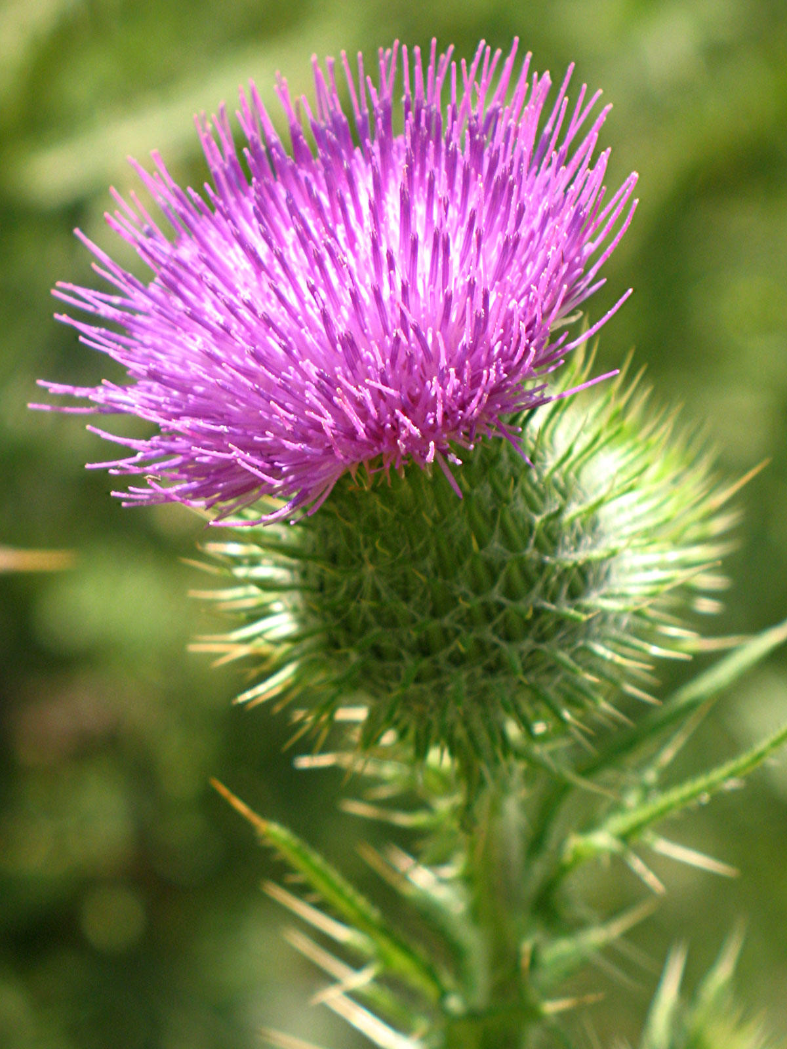
Bull Thistle
Cirsium vulgare
ASTERACEAE – Sunflower Family

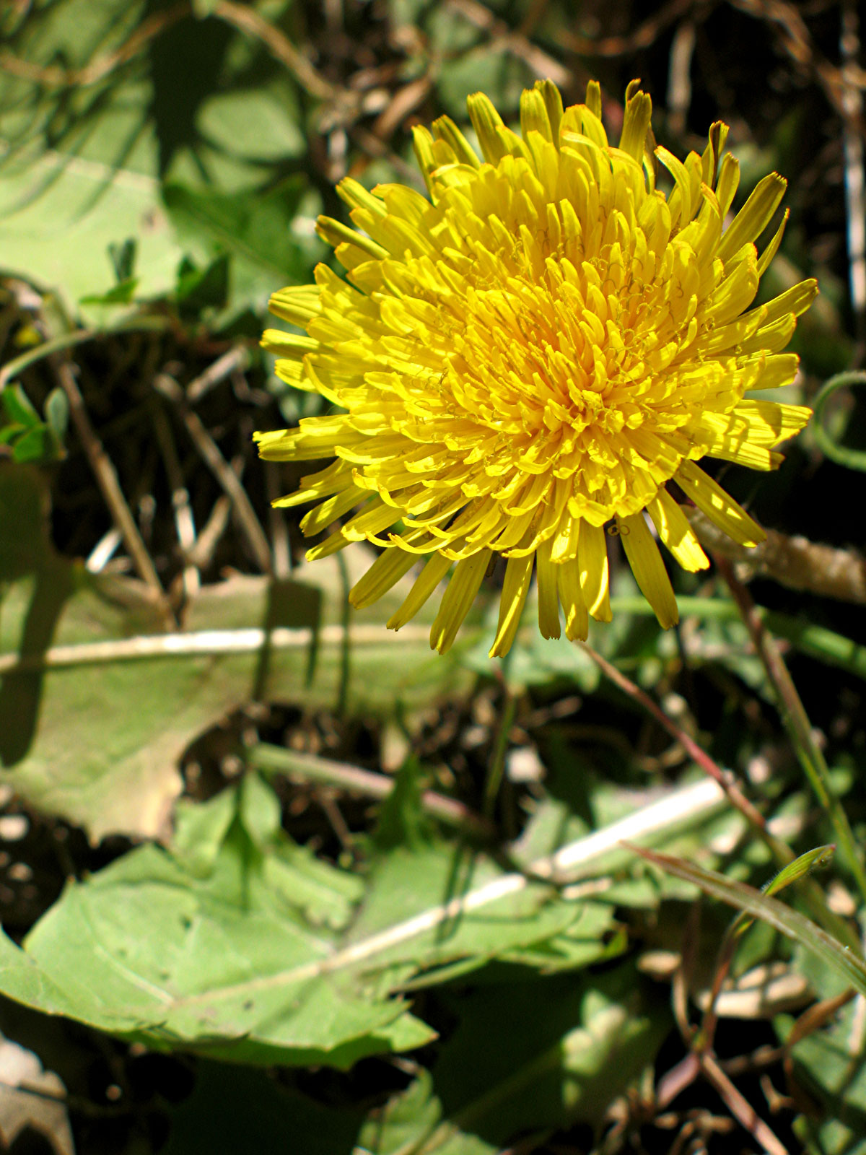
Dandelion
Taraxacum officinale
ASTERACEAE – Sunflower Family

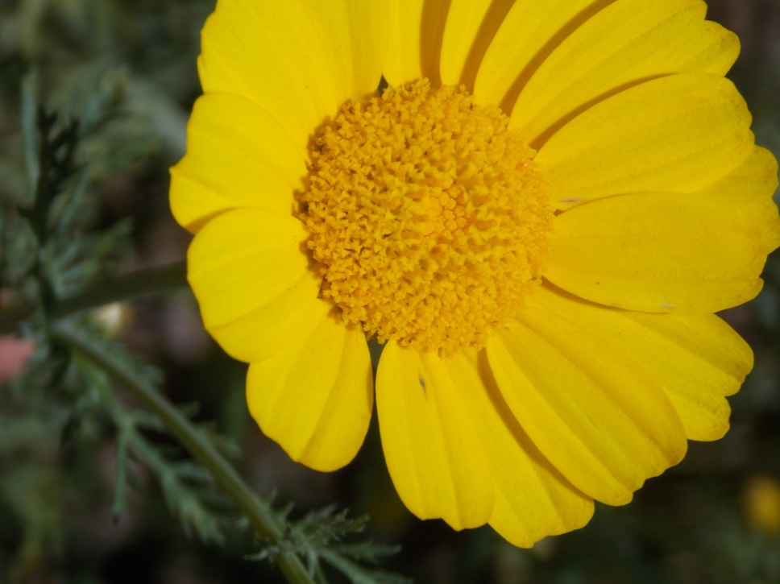
Garland Chrysanthemum
Glebionis coronaria
ASTERACEAE – Sunflower Family

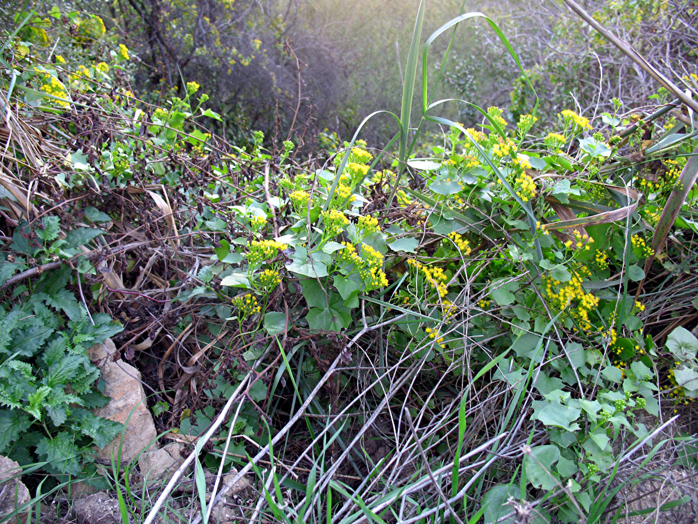
German Ivy
Delairea odorata
ASTERACEAE - Sunflower Family

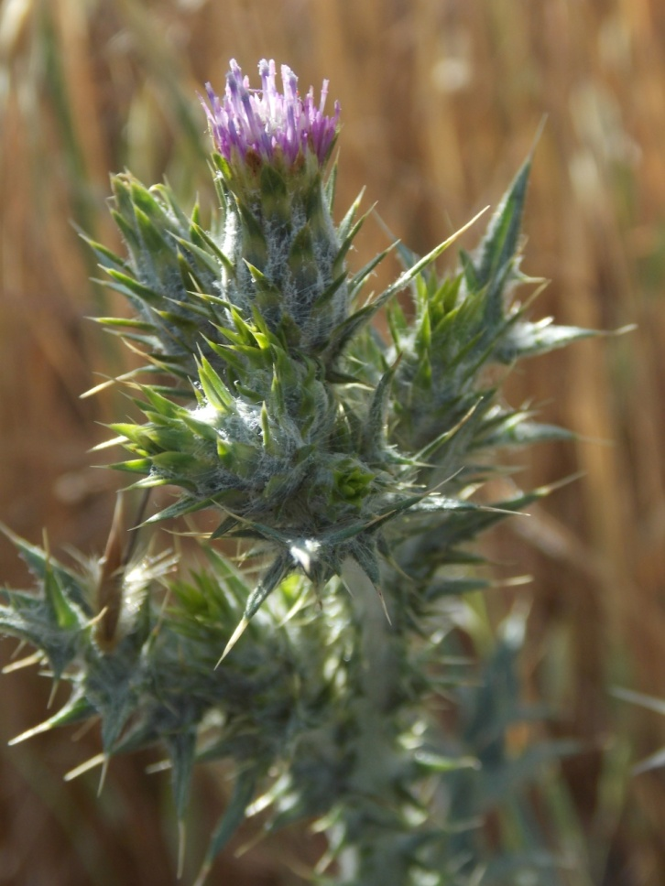
Italian Thistle
Carduus pycnocephalus
ASTERACEAE - Sunflower Family

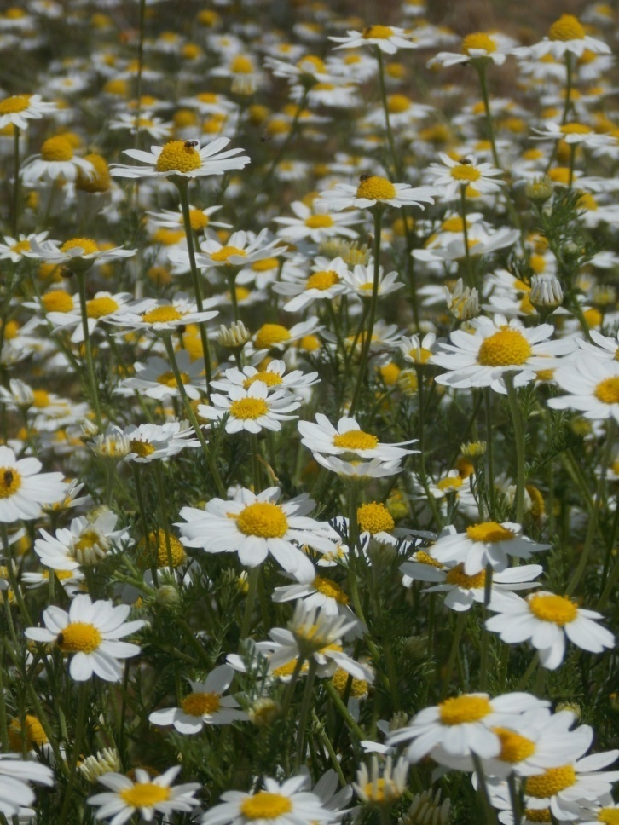
Mayweed
Anthemis cotula
ASTERACEAE – Sunflower Family

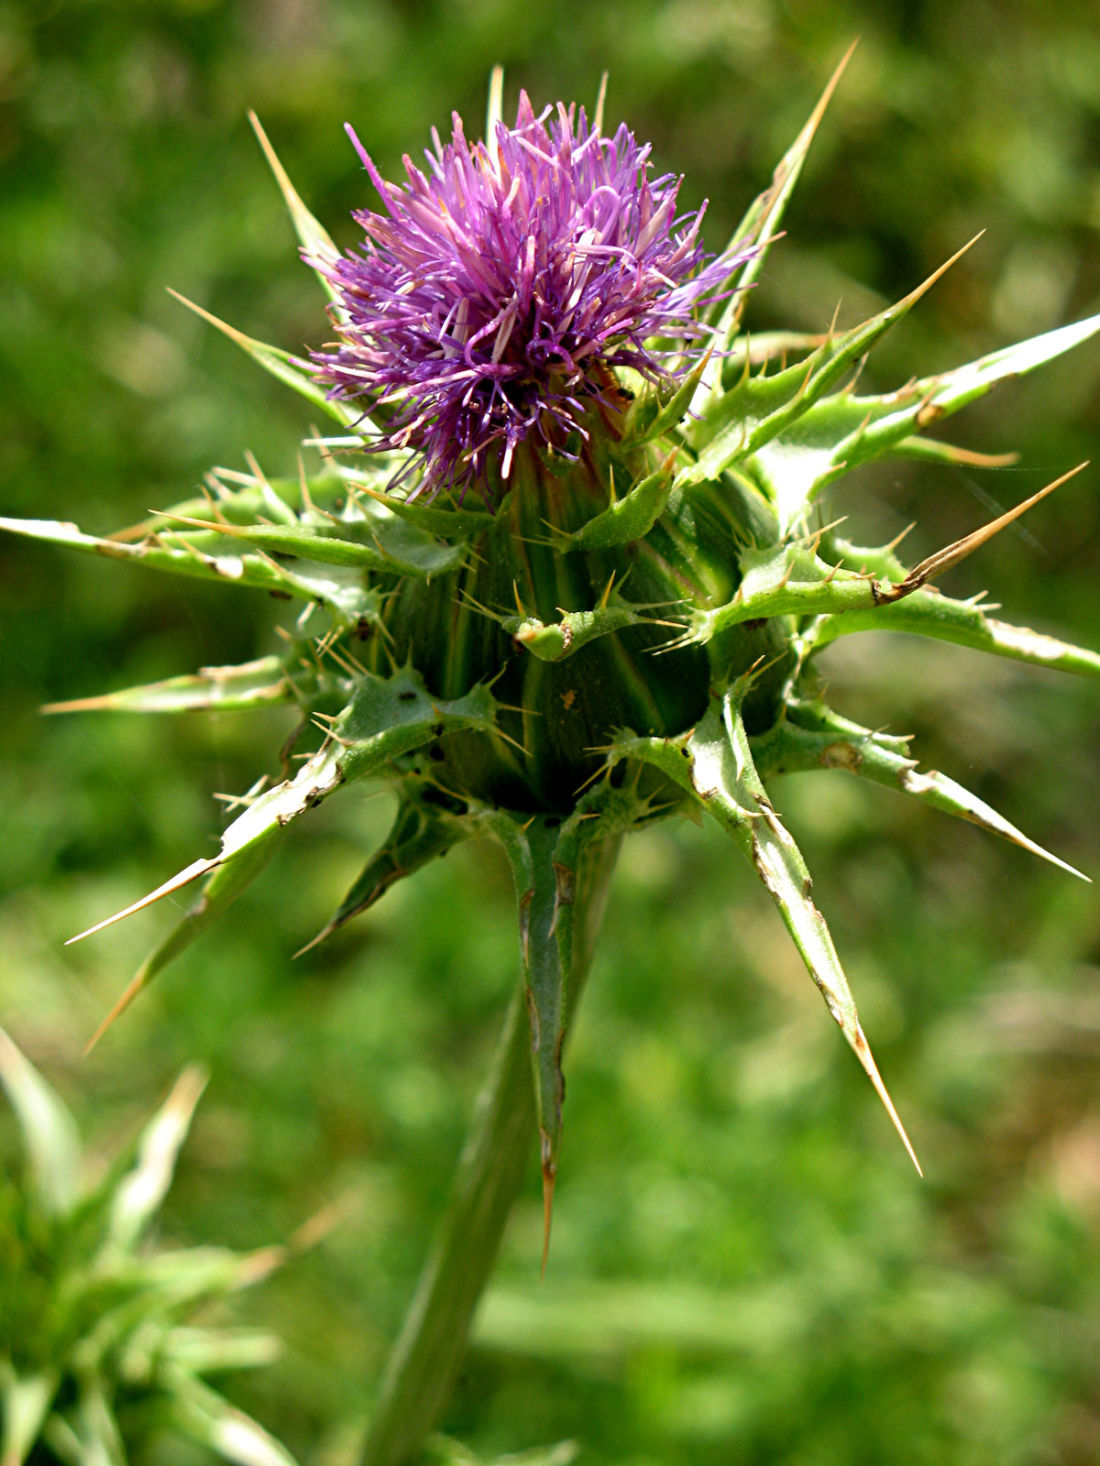
Milk Thistle
Silybum marianum
ASTERACEAE - Sunflower Family

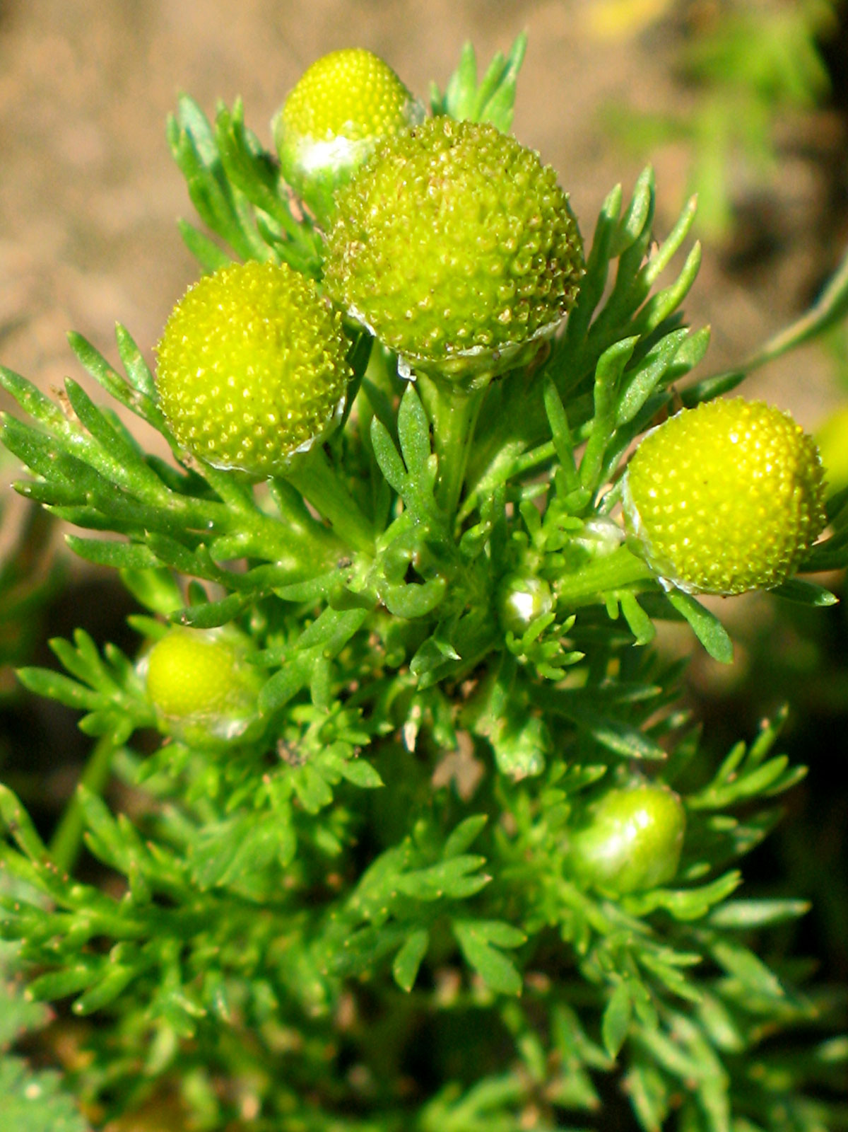
Pineapple Weed
Matricaria discoidea
ASTERACEAE - Sunflower Family

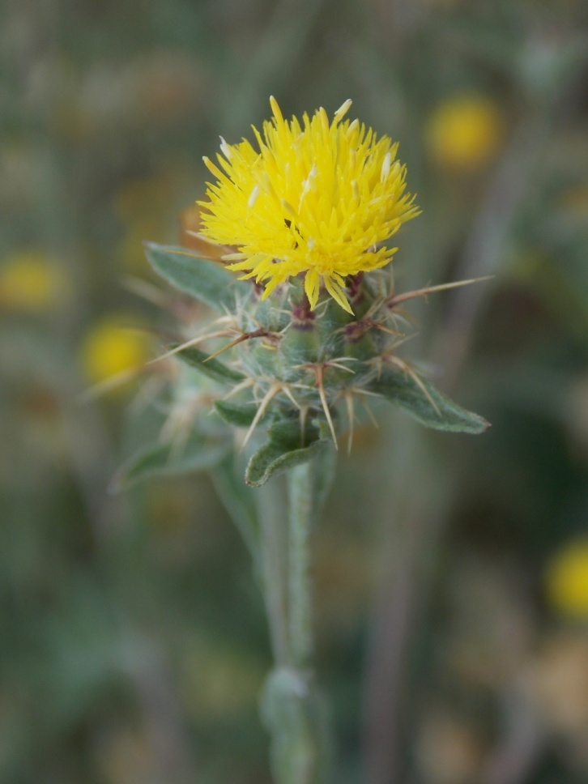
Tocalote
Centaurea melitensis
ASTERACEAE - Sunflower Family

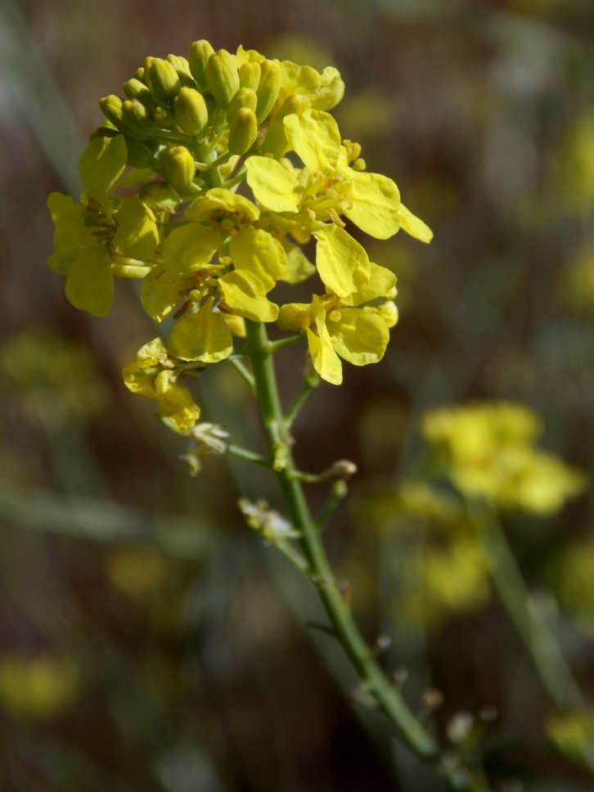
Black Mustard
Brassica nigra
BRASSICACEAE - Mustard Family

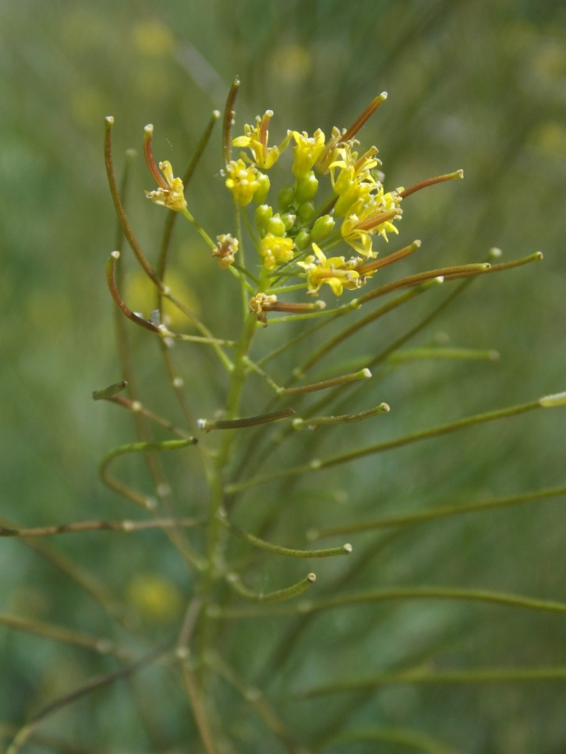
London Rocket
Sisymbrium irio
BRASSICACEAE – Mustard Family

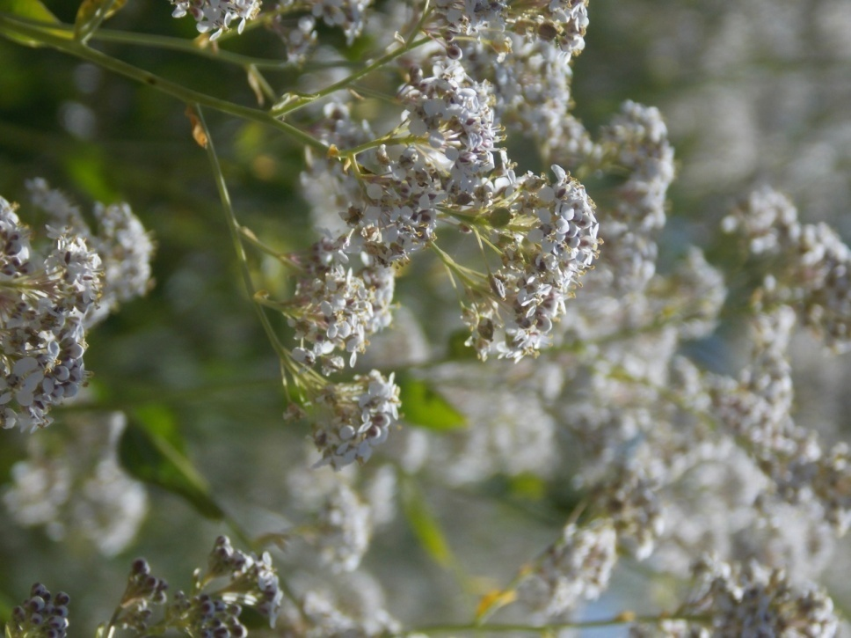
Pepperweed
Lepidium latifolium
BRASSICACEAE - Mustard Family

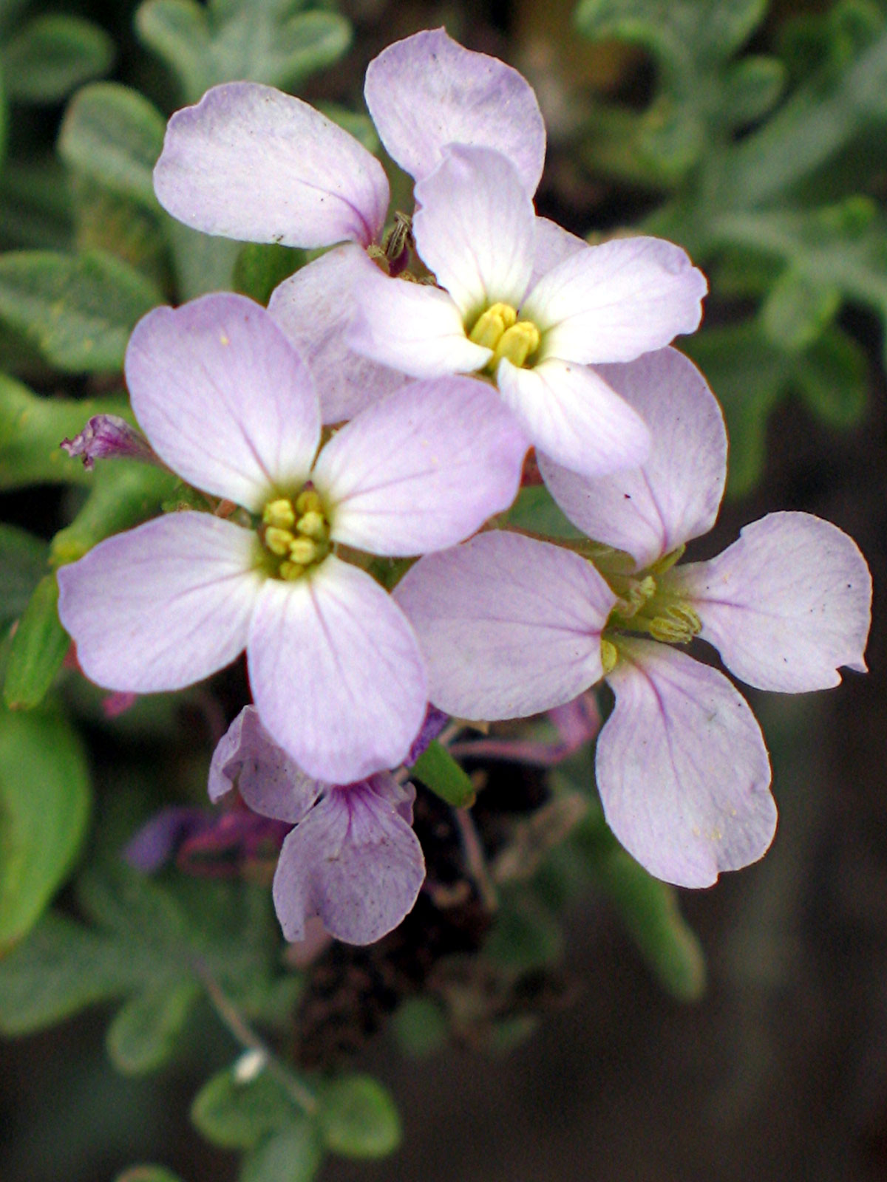
Sea Rocket
Cakile maritima
BRASSICACEAE – Mustard Family

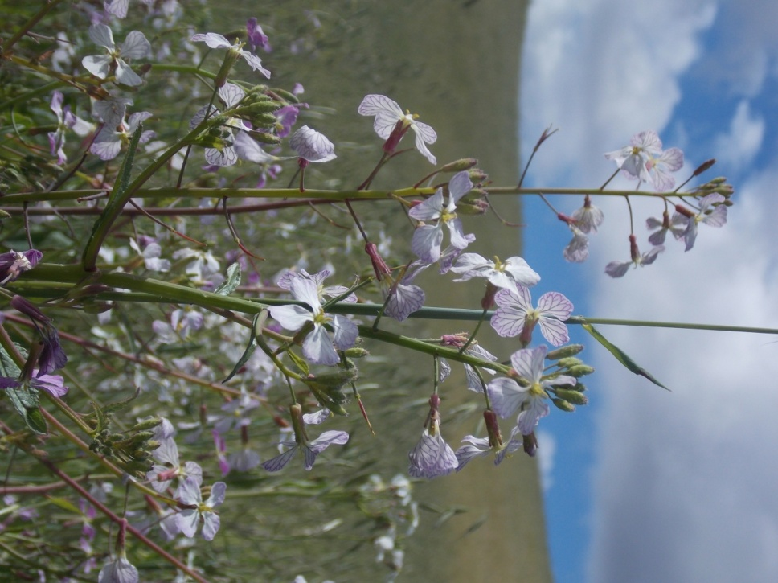
Wild Radish
Raphanus sativus
BRASSICACEAE – Mustard Family

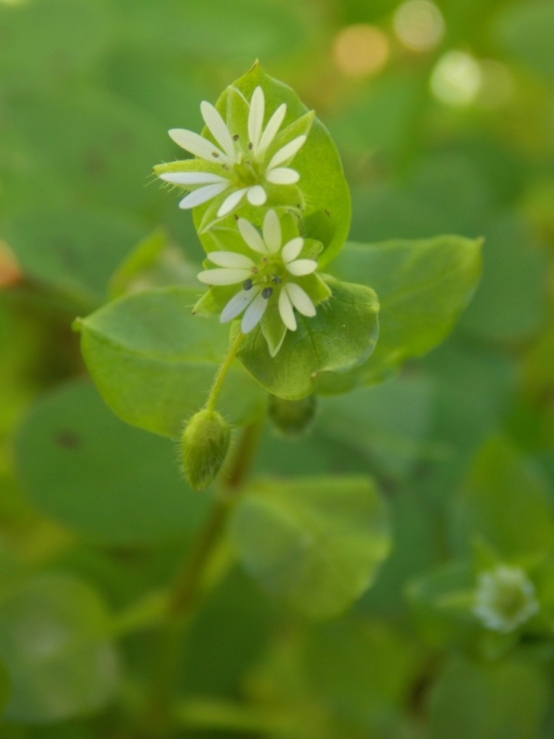
Common Chickweed
Stellaria media
CARYOPHYLLACEAE – Carnation Family

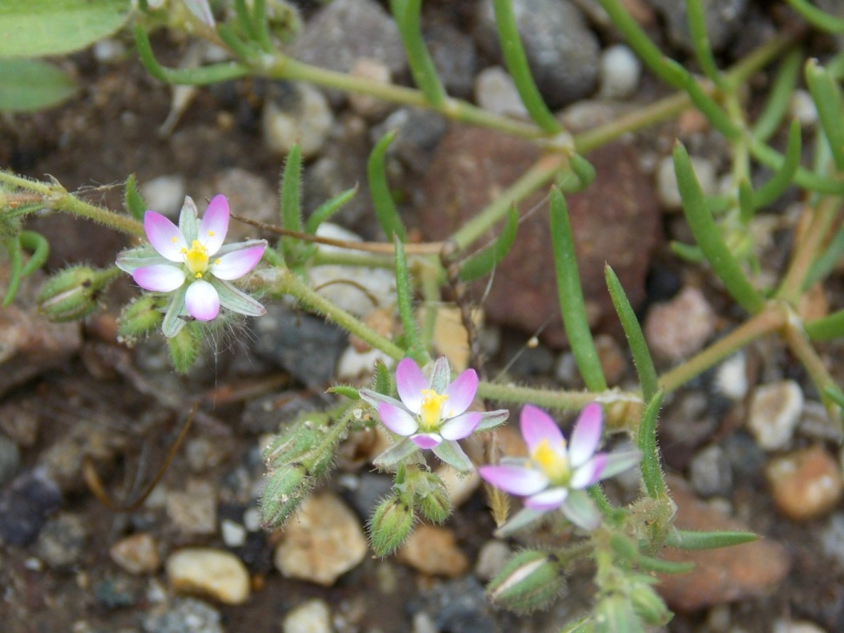
Sandspurrey
Spergularia bocconi
CARYOPHYLLACEAE - Pink Family

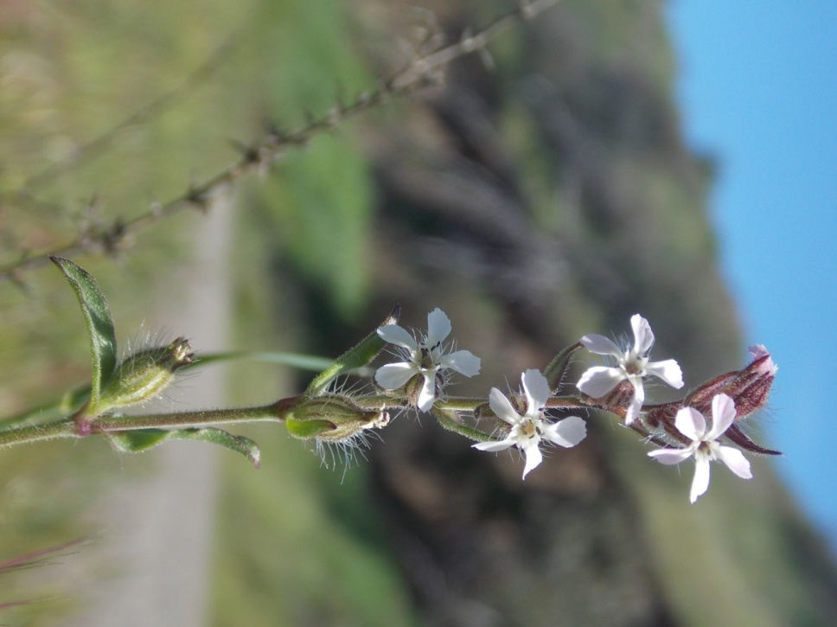
Windmill Pink
Silene gallica
CARYOPHYLLACEAE – Carnation Family

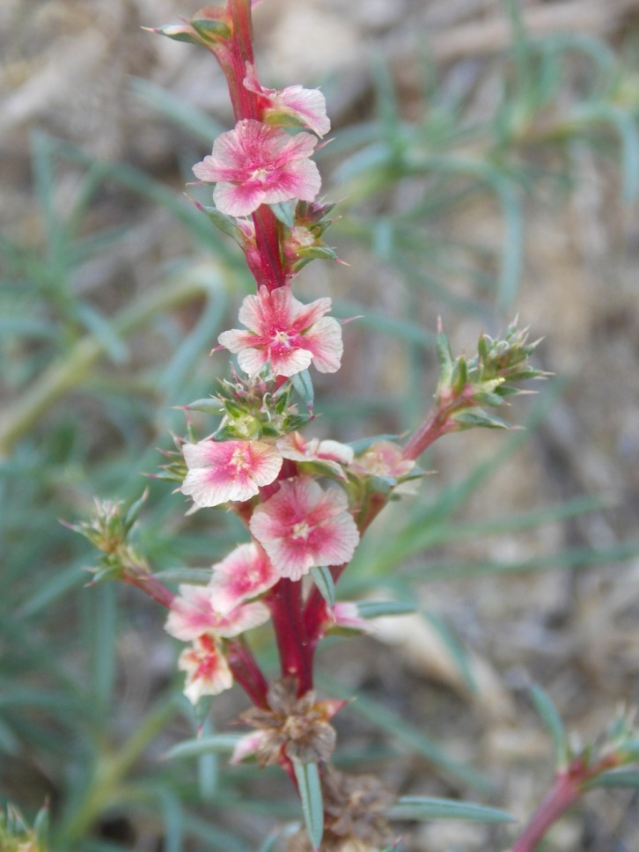
Russian Thistle
Salsola tragus
CHENOPODIACEAE - Goosefoot Family

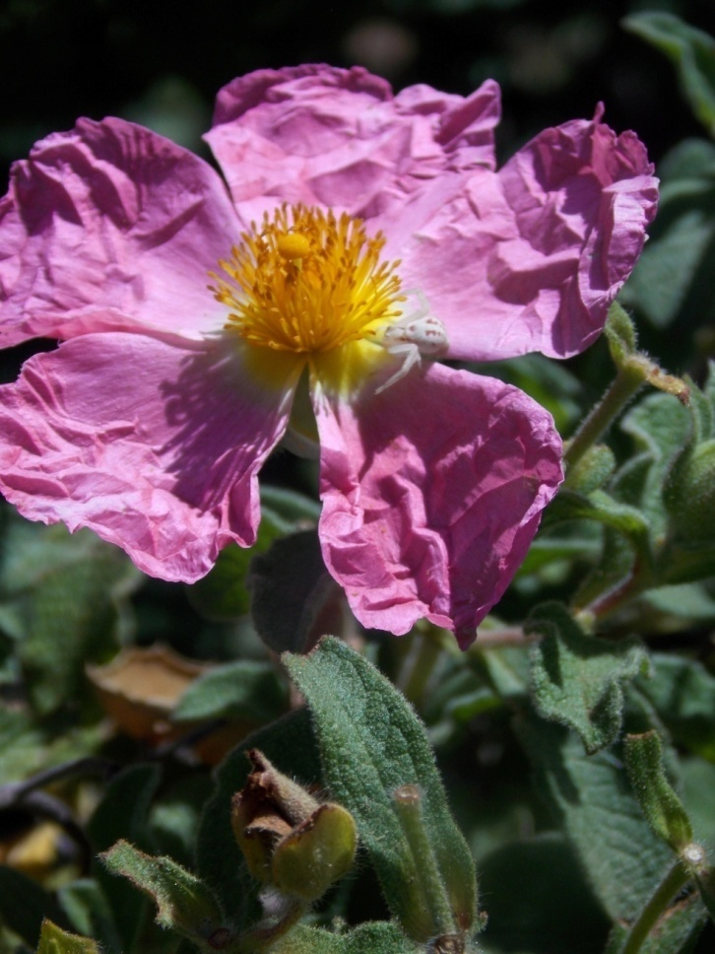
Rock Rose
Cistus incanus
CISTACEAE - Rock-rose Family

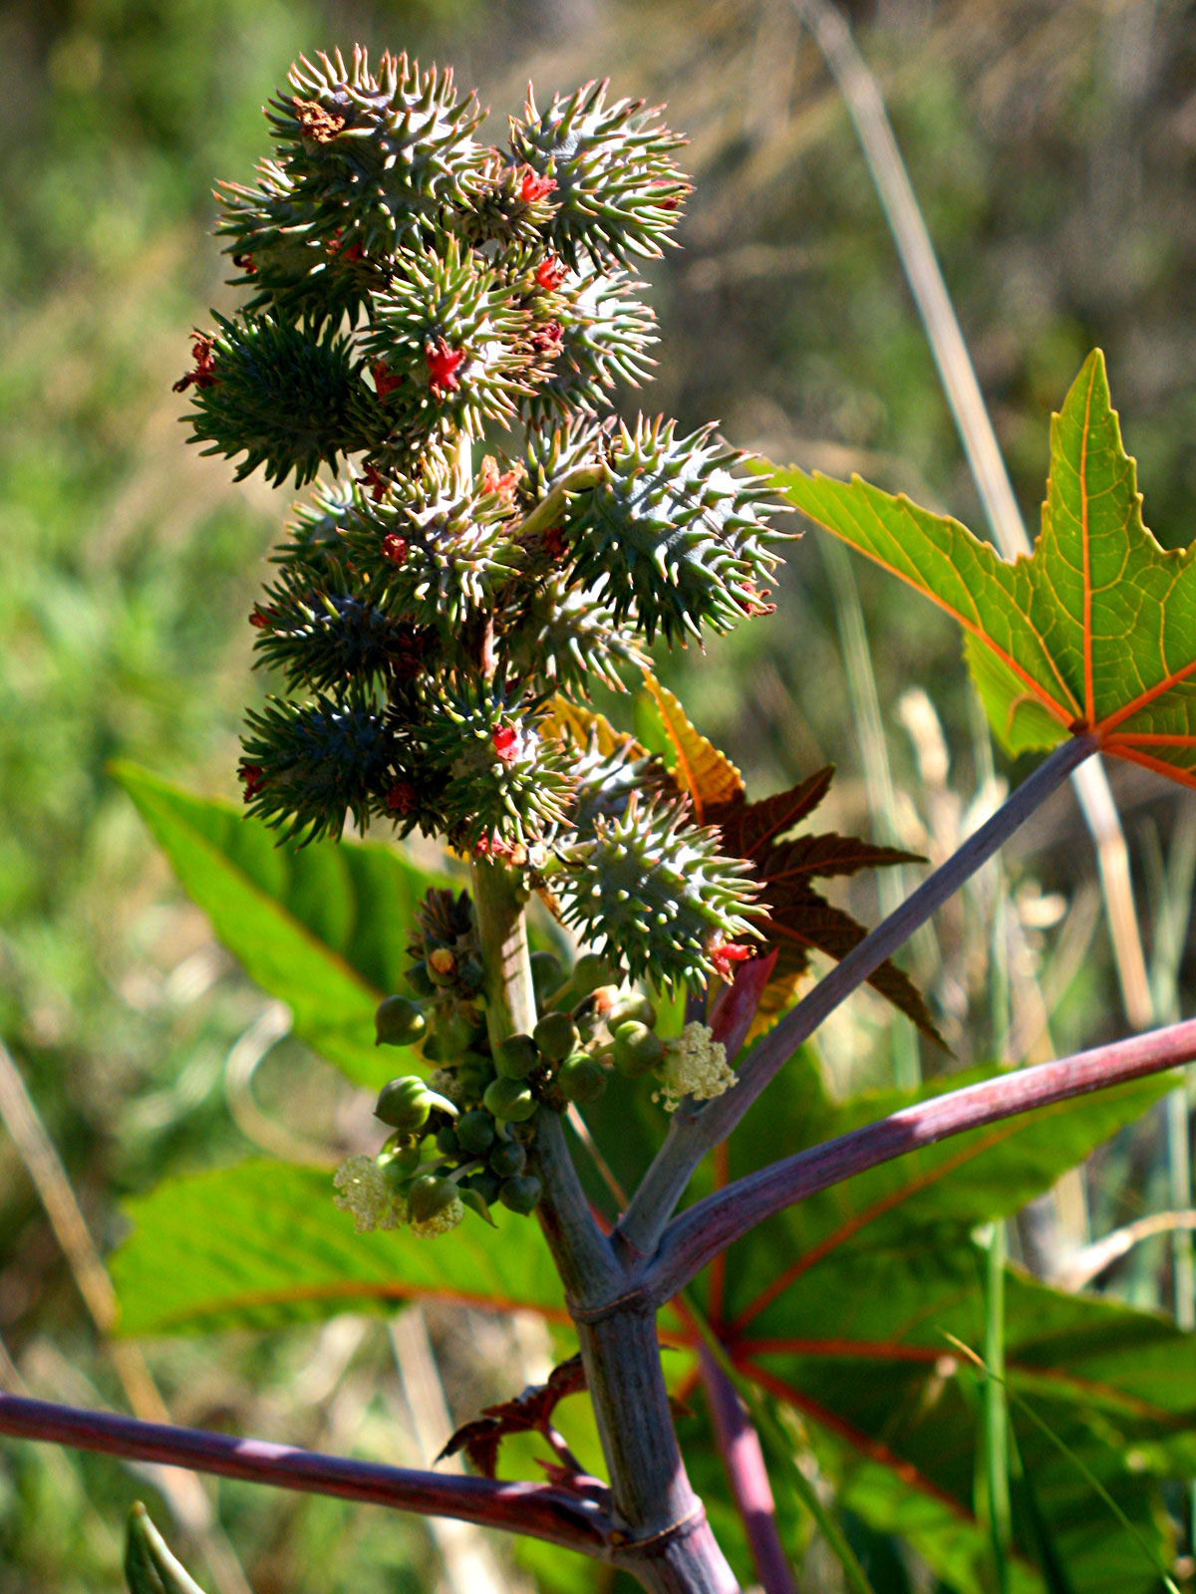
Castor Bean
Ricinus communis
EUPHORBIACEAE - Spurge Family

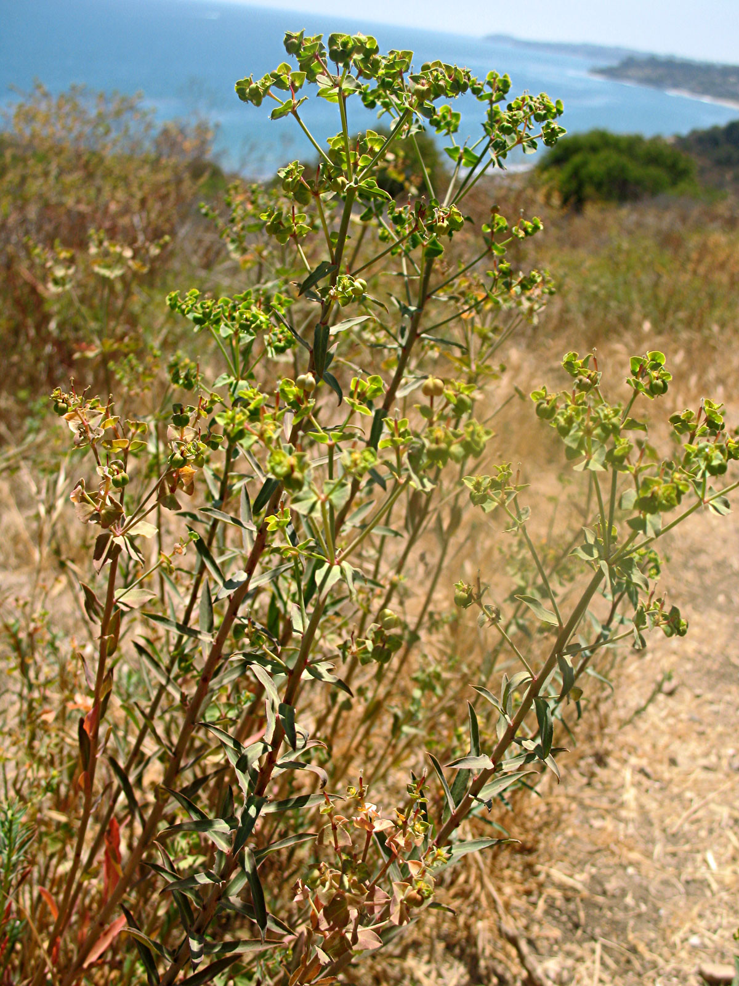
Terracina Spurge
Euphorbia terracina
EUPHORBIACEAE – Spurge Family

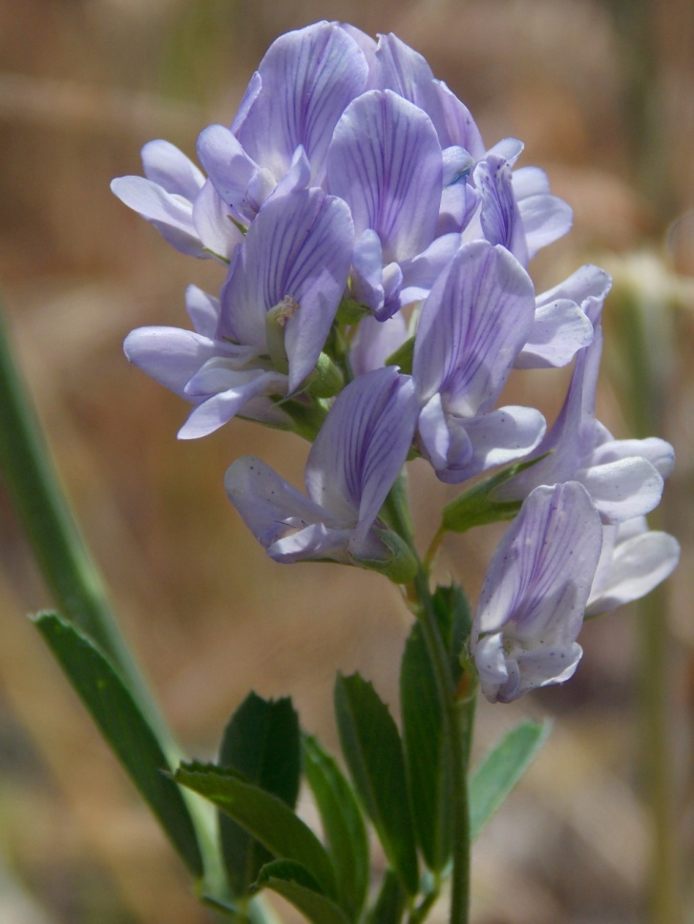
Alfalfa
Medicago sativa
FABACEAE - Pea Family

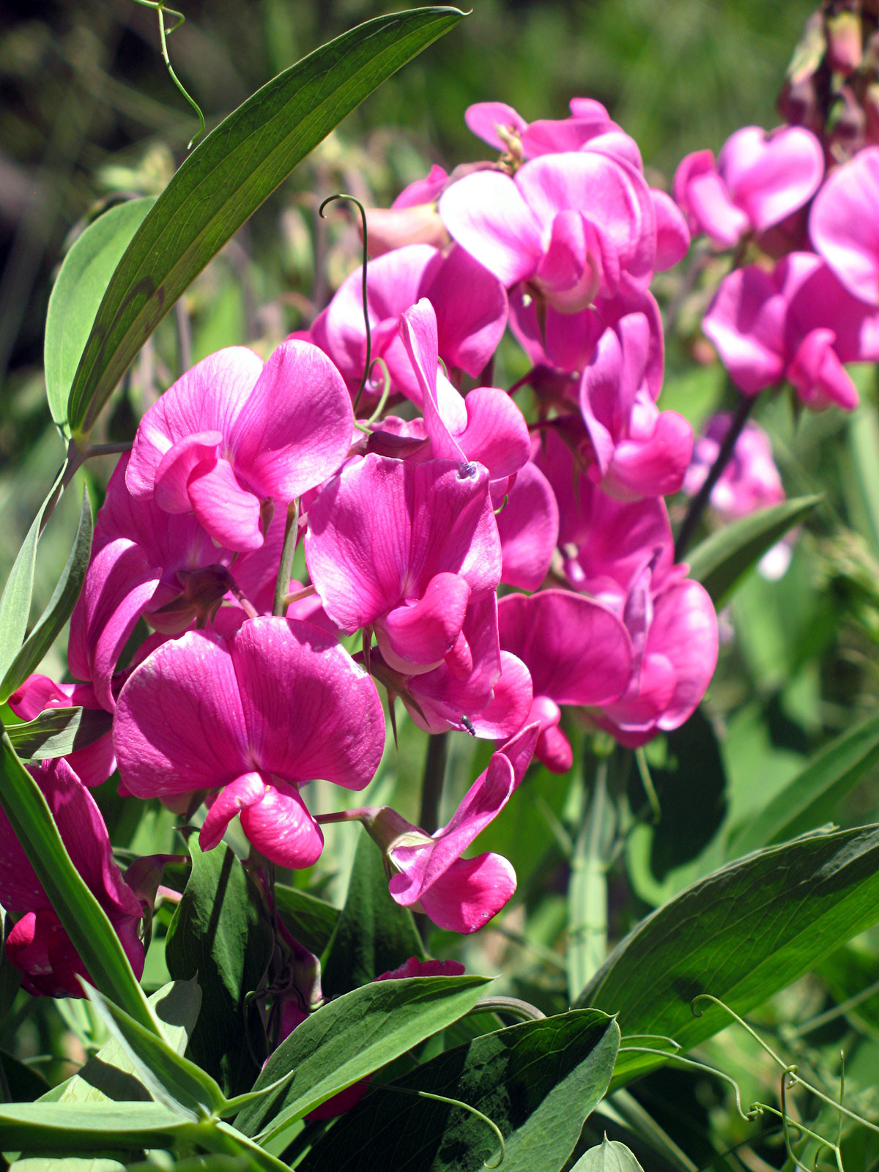
Perennial Sweet Pea
Lathyrus latifolius
FABACEAE - Pea Family

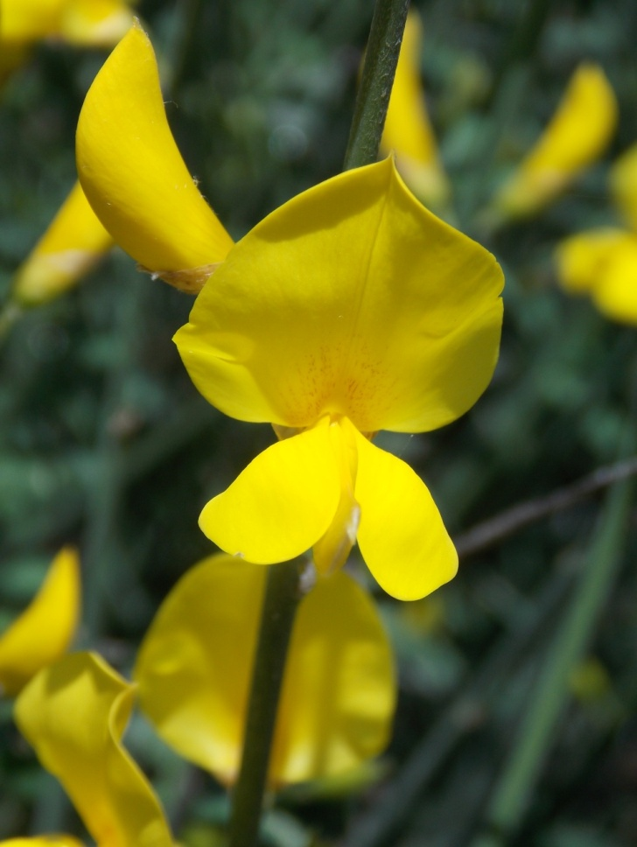
Spanish Broom
Spartium junceum
FABACEAE – Pea Family

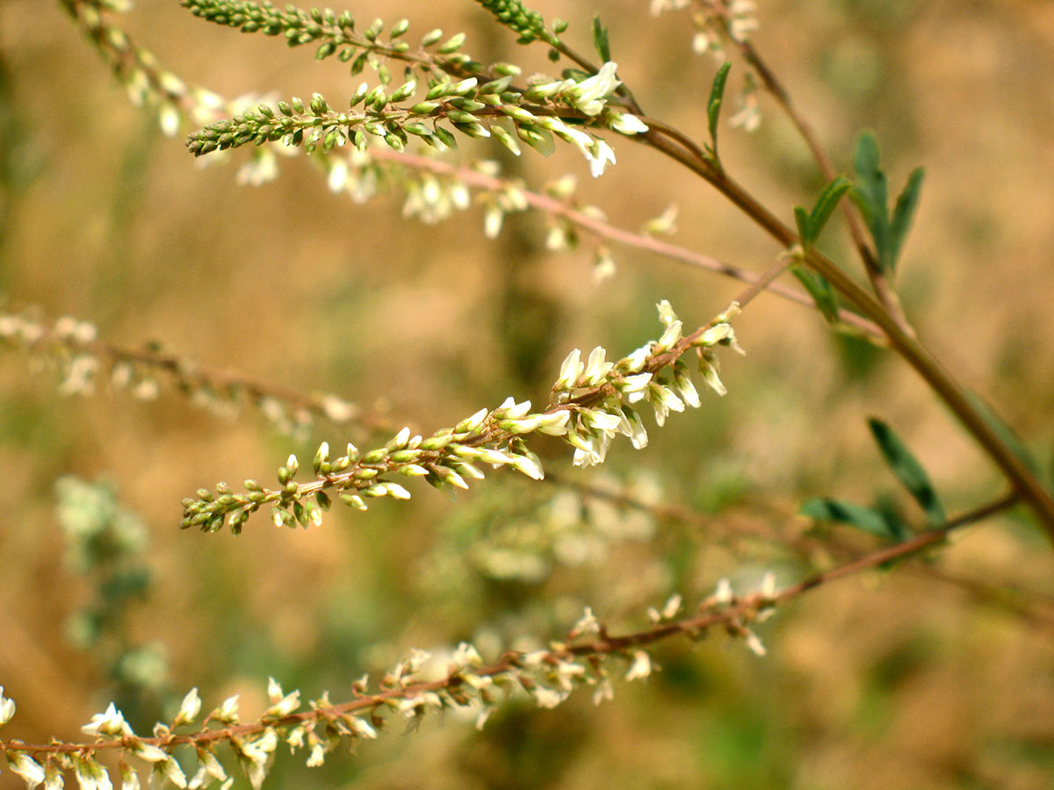
White Sweet Clover
Melilotus albus
FABACEAE - Pea Family

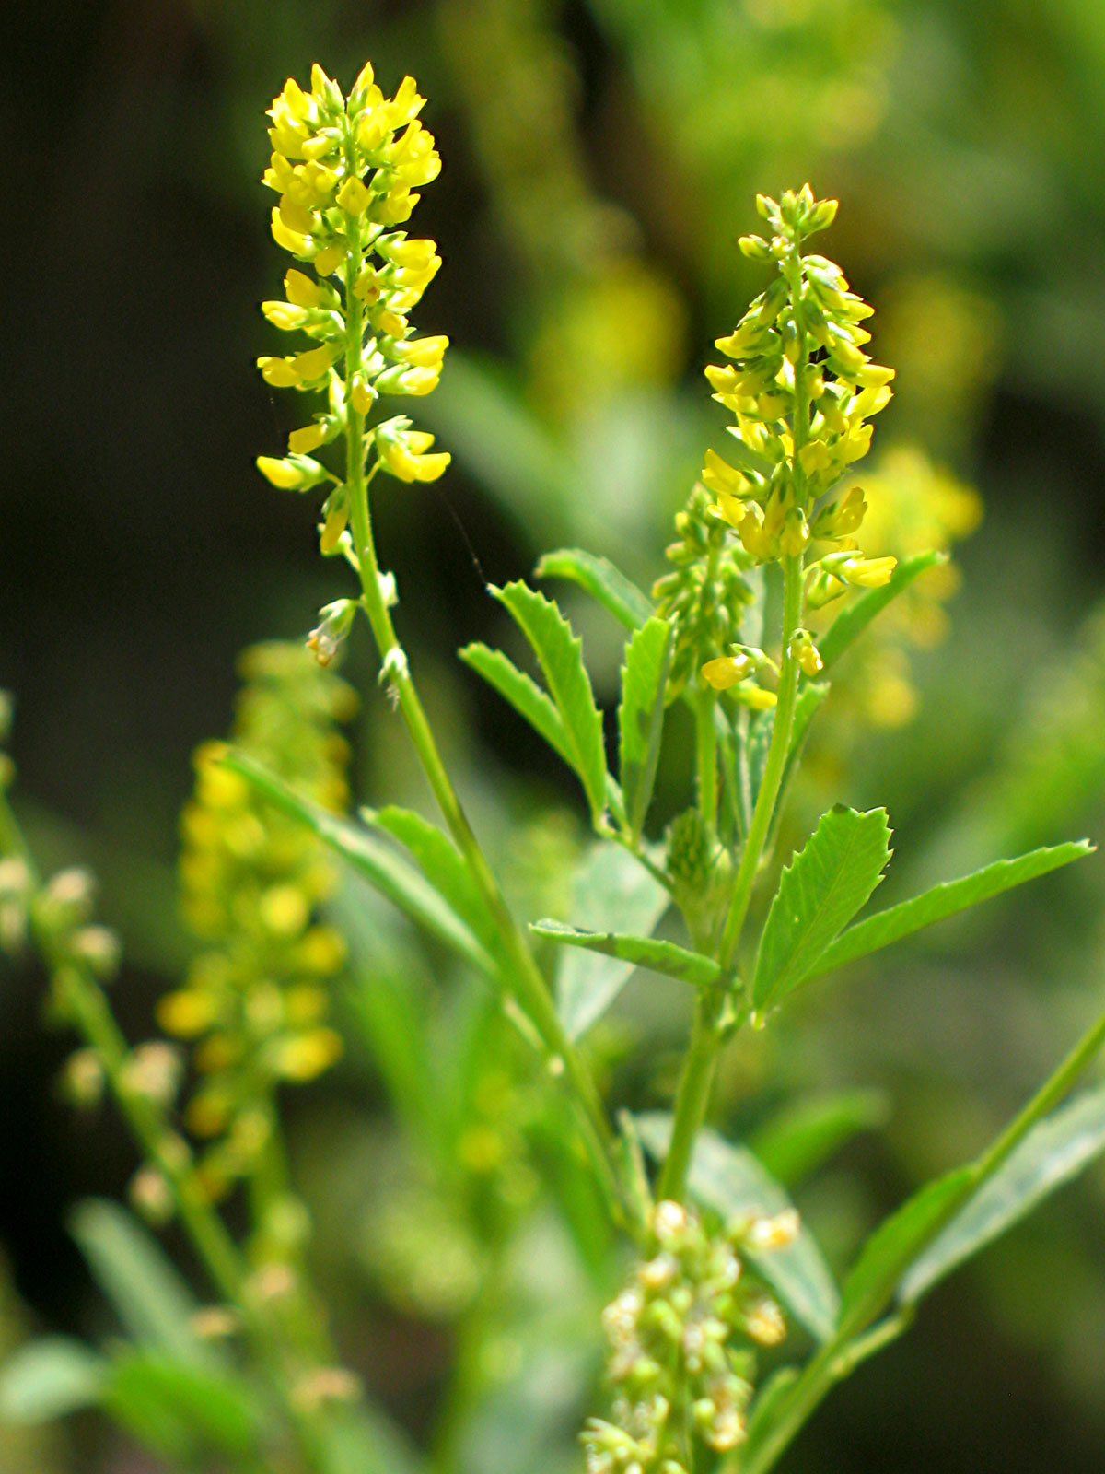
Yellow Sweet Clover
Melilotus officinalis
FABACEAE – Pea Family

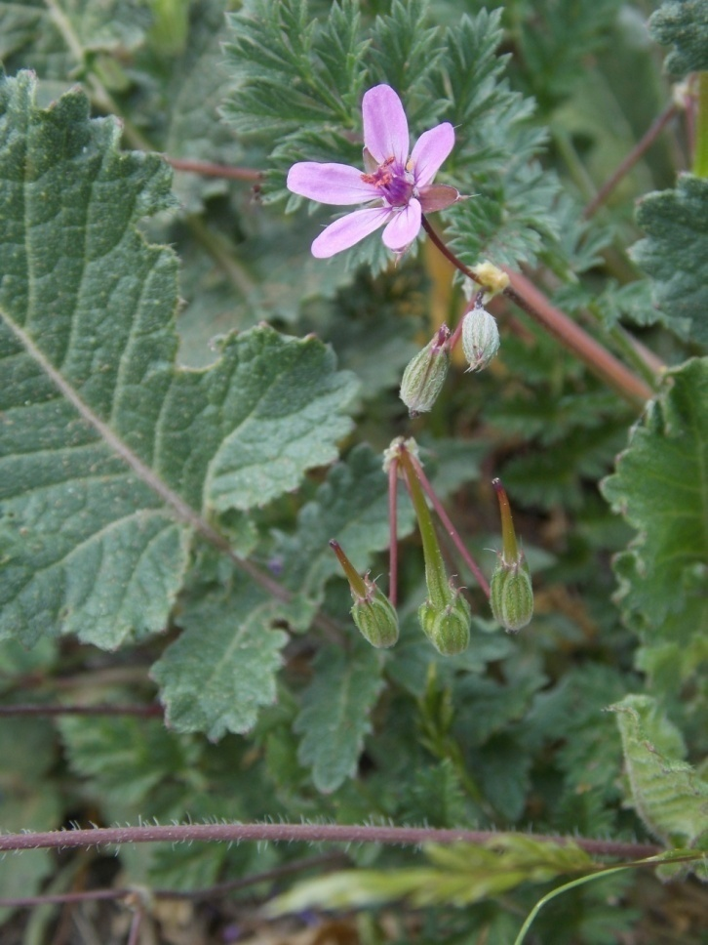
Red-Stem Filaree
Erodium cicutarium
GERANIACEAE - Geranium Family

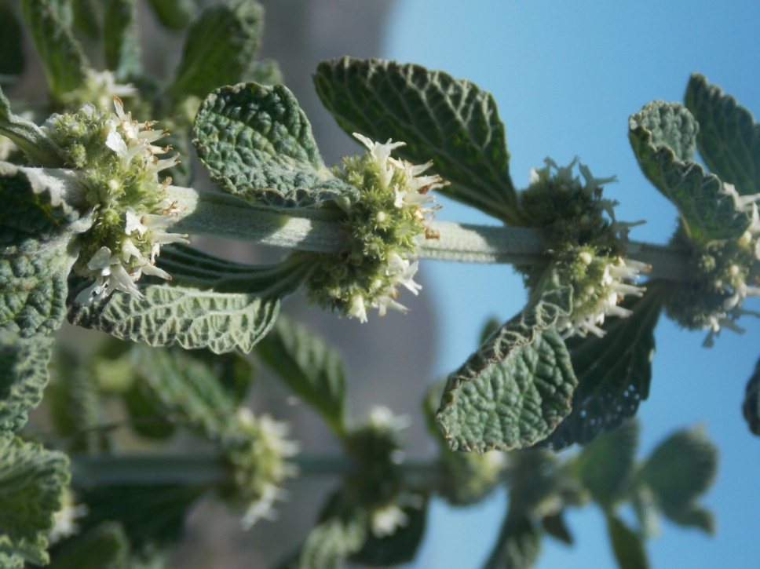
Horehound
Marrubium vulgare
LAMIACEAE – Mint Family

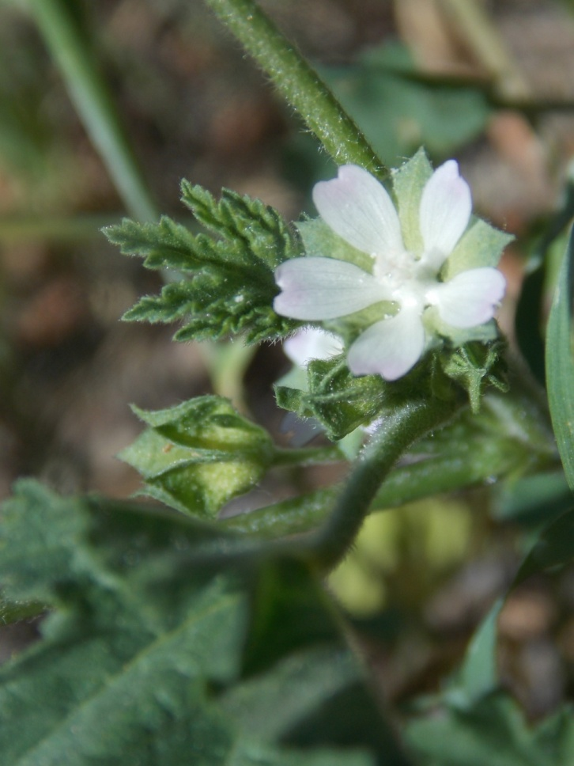
Cheeseweed
Malva parviflora
MALVACEAE – Mallow Family

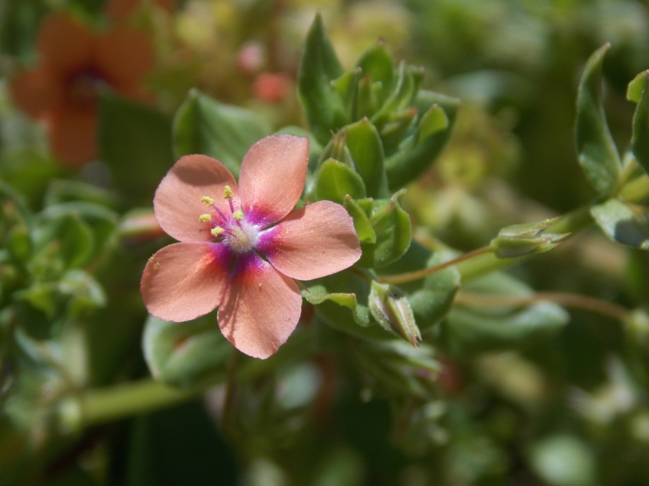
Scarlet Pimpernel
Lysimachia arvensis
MYRSINACEAE - Myrsine Family

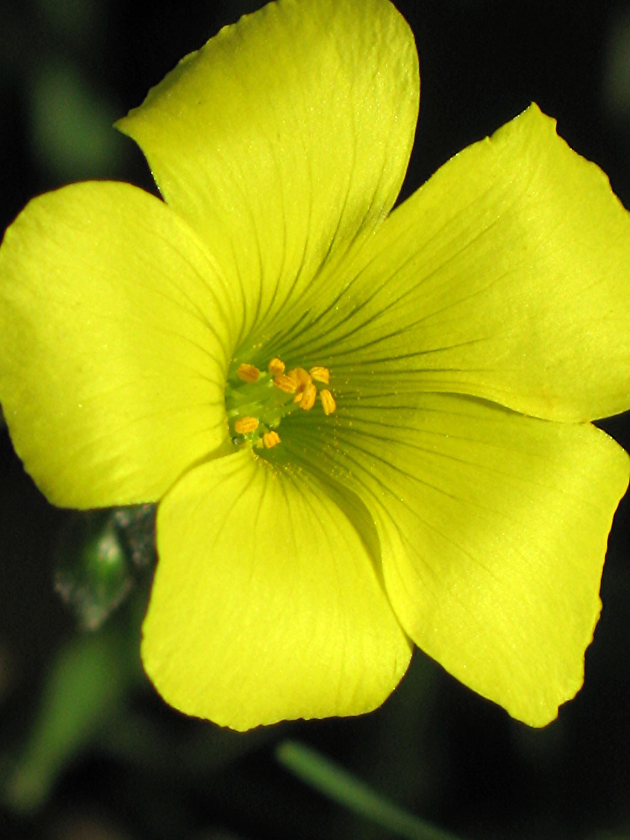
Bermuda Buttercup
Oxalis pes-caprae
OXALIDACEAE – Oxalis Family

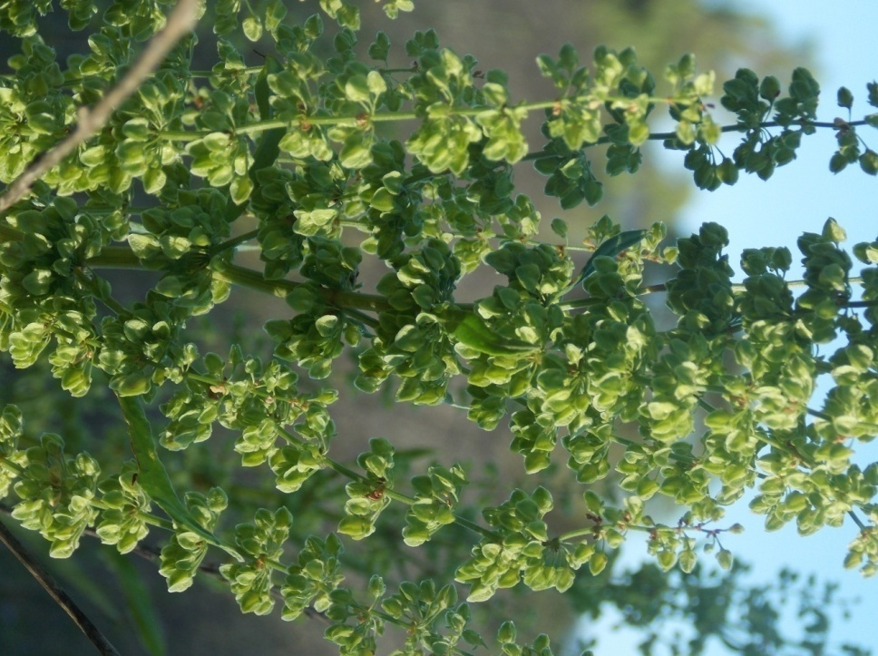
Curly Dock
Rumex crispus
POLYGONACEAE – Buckwheat Family

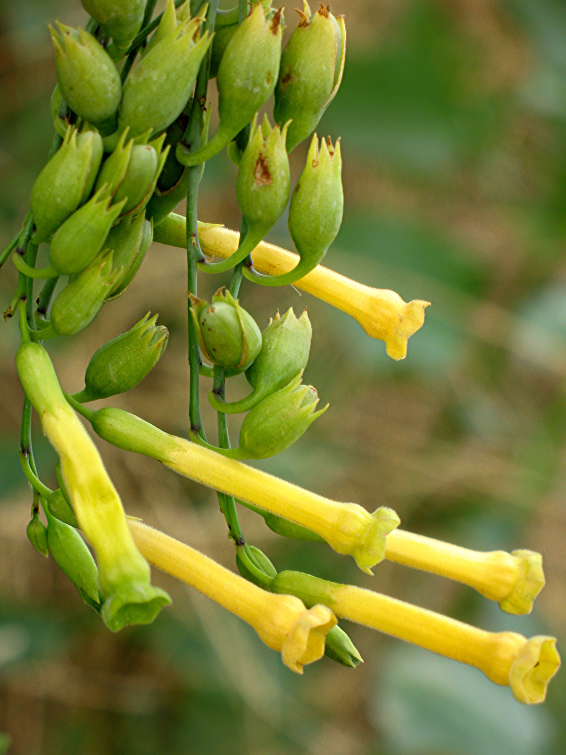
Tree Tobacco
Nicotiana glauca
SOLANACEAE – Nightshade Family

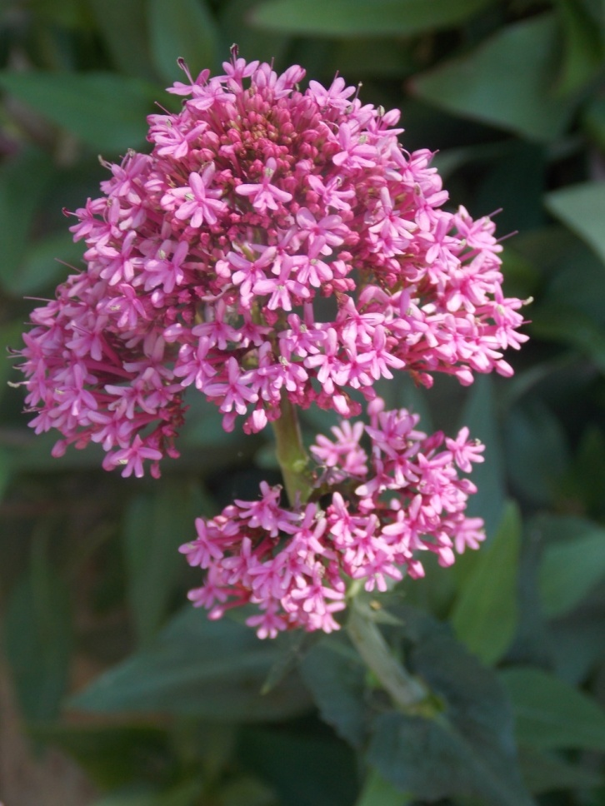
Red Valerian
Centranthus ruber
VALERIANACEAE - Valerian Family
Alfalfa, 218
American Bird’s Foot Trefoil, 79
Angels Gilia, 94
Annual Coreopsis, 1
Ashy Leaved Buckwheat, 97

Baby Blue Eyes, 159
Beach Evening Primrose, 36
Bee Plant, 156
Bermuda Buttercup, 227
Bigberry Manzanita, 75
Big Pod Ceanothus, 100
Bird’s Beak, 90
Black Mustard, 206
Black Sage, 173
Bladderpod, 25
Bleeding Heart, 91
Blue Dicks, 188
Blue-Eyed Grass, 172
Blue Larkspur, 186
Branching Phacelia, 160
Bristly Ox-tongue, 196
Brittlebush, 2
Brodiaea, 189
Bull Thistle, 197
Bush Lupine, 167
Bush Mallow, 132
Bush Monkey Flower, 42
Bush Sunflower, 3
Butterfly Mariposa Lily, 85

Calabazilla, 28
California Aster, 120
California Bay, 84
California Blackberry, 103
California Broom, 29
California Buckwheat, 110
California Buttercup, 45
California Dodder, 72
California Everlasting, 54
California Fuchsia, 136
California Goldenrod, 4
California Lotus, 30
California Poppy, 39
Catalina Mariposa Lily, 86
California Milkweed, 119
Canyon Sunflower, 5
Castor Bean, 216
Chalk Live-Forever, 26
Chamise, 104
Chaparral Honeysuckle, 71
Chaparral Pea, 123
Checker Bloom, 133
Cheeseweed, 225
Chia, 174
Chinese Houses, 179
Chocolate Lily, 130
Cliff Aster, 55
Coastal Prickly Pear, 23
Cobweb Thistle, 121
Cocklebur, 56
Common Chickweed, 211
Common Fiddleneck, 22
Common Goldfields, 6
Common Muilla, 113
Common Sunflower, 7
Coyote Brush, 57
Cream Cups, 92
Creek Monkey Flower, 43
Curly Dock, 228

Dandelion, 198
Danny’s Skullcap, 175
Datura, 111
Doveweed, 77
Dwarf Locoweed, 168

Eastwood Manzanita, 76
Elderberry, 48
Elegant Clarkia, 137
Eucrypta, 63

False Indigo, 124
Farewell-to-Spring, 138
Fiesta Flower, 161
Fire Poppy, 40
Fringed Indian Pink, 122
Frog Fruit, 116
Fuchsia-Flowered Gooseberry, 127

Garland Chrysanthemum, 199
German Ivy, 200
Giant Coreopsis, 8
Globe Gilia, 95
Globe Lily, 87
Golden Currant, 33
Golden Star, 46
Golden Yarrow, 9
Greenbark Ceanothus, 101
Ground Pink, 148
Gum Plant, 10
Heart Leaved Penstemon, 146
Hedge Nettle, 128
Heliotrope, 64
Hoary Leaved Ceanothus, 102
Hoary Nettle, 115
Horehound, 224
Hollyleaf Cherry, 105
Horseweed, 58
Hottentot Fig, 191
Hubby’s Phacelia, 162
Humboldt Lily, 34

Indian Paintbrush, 141
Indian Warrior, 142
Italian Thistle, 201

Johnny-jump-up, 47

Lacepod, 68
Large-Flowered Phacelia, 163
Laurel Sumac, 51
Lemonade Berry, 118
Linanthus, 96
London Rocket, 207
Lyon’s Pentachaeta, 11

Matilija Poppy, 93
Mayweed, 202
Menzies’ Goldenbush, 12
Milkmaids, 69
Milk Thistle, 203
Milkvetch, 80
Milkwort, 150
Miner’s Lettuce, 98
Miniature Lupine, 169
Morning Glory, 73
Mountain Mahogany, 106
Mugwort, 13
Mule Fat, 59
Mustard Evening Primrose, 37

Narrow Leaved Milkweed, 53

Owl’s Clover, 143

Palmer’s Goldenbrush, 14
Parry’s Phacelia, 164
Peninsular Onion, 117
Penstemon, 180
Pepperweed, 208
Perennial Sweet Pea, 219
Perezia, 157
Periwinkle, 195
Pineapple Weed, 204
Hummingbird Sage, 129
Plummer’s Mariposa Lily, 131
Poison Hemlock, 193
Poison Oak, 52
Prickly Phlox, 149
Prickly Popcorn Flower, 65
Purple Clarkia, 139
Purple Nightshade, 187
Purple Sage, 176

Rabbitbrush, 15
Rattlesnake Weed, 78
Red Maids, 152
Red Skinned Onion, 50
Red-Stem Filaree, 223
Red Valerian, 230
Rock Rose, 215
Rose Snapdragon, 181
Rush Rose, 24
Russian Thistle, 214
San Diego Wreathplant, 158
Sandspurrey, 212
Sand Verbena, 134
Santa Susana Tarweed, 16
Sawtooth Goldenbush, 17
Scale Broom, 18
Scarlet Bugler, 147
Scarlet Larkspur, 154
Scarlet Monkey Flower, 145
Scarlet Pimpernel, 226
Sea Fig, 192
Sea Rocket, 209
Shooting Star, 153
Silver Lotus, 31
Slender Mariposa Lily, 35
Slender Tarweed, 19
Spanish Broom, 220
Speckled Clarkia, 140
Star Lily, 88
Sticky Gilia, 184
Sticky Phacelia, 165
Stinging Lupine, 125
Strigose Lotus, 32
Succulent Lupine, 170
Small Flowered Evening Primrose, 38
Sweet Fennel, 194

Telegraph Weed, 20
Terracina Spurge, 217
Tocalote, 205
Tomcat Clover, 126
Toyon, 107
Turkish Rugging, 151
Tree Poppy, 41
Tree Tobacco, 229
Twining Snapdragon, 182

Watercress, 70
Water Pimpernel, 114
Whispering Bells, 66
White Currant, 82
White Nightshade, 112
White Pin Cushion, 60
White Sage, 83
White Sweet Clover, 221
Wild Cucumber, 74
Wild Peony, 144
Wild Radish, 210
Wild Rose, 155
Wild Sweet Pea, 81
Willow Herb Clarkia, 89
Windmill Pink, 213
Winter Vetch, 171
Wirelettuce, 61
Wishbone, 135
Woodland Star, 109
Woolly Blue Curls, 178
Woolly Sapphire, 185

Verity’s Dudleya, 27
Vervain, 190
Vinegar Weed, 177
Violet Snapdragon, 183
Virgin’s Bower, 99

Yarrow, 62
Yellow Monkey Flower, 44
Yellow Pin Cushion, 21
Yellow Sweet Clover, 222
Yellow Throated Phacelia, 67
Yerba Mansa, 108
Yerba Santa, 166
Yucca, 49

